


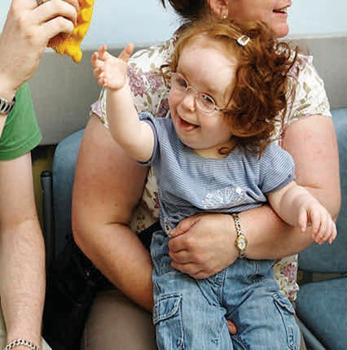
Children and Young People’s
Continuing Care

Information for Parents, Carers,
Children and Young People

Appealing an NHS
Continuing Care Decision and
Making a Complaint

The Difference Between an Appeal and a Complaint

An appeal is described locally as a disagreement raised by a child, young person, parent or carer who do not agree with the decisions made, or outcome of the multi-agency Continuing Care Panel. This panel arrangement is described within the leaflet ‘Children and Young People’s Continuing Care, A Brief Guide for Parents/Carers, Children and Young People’.

A complaint is when a child, young person, parent or carer raises an issue or concern about something they find unsatisfactory, unacceptable or inappropriate.

Appeal Information

What to do if you disagree with the outcomes and/or decisions made by the multi-agency Continuing Care panel?

If you disagree with the multi-agency Continuing Care panel outcomes or the decisions they have made, you can appeal. The Children’s Continuing Care Service from within NHS Deby and Derbyshire Integrated Care Board (ICB) will manage the appeal process. The Children and Young People's (CYP) Clinical Lead within this service will be your point of contact throughout the appeal process (their details can be found at the end of this leaflet).

As a Children’s Service we want to support you as parents, carers, children, and young people, through the appeal process. We would be grateful if you could let us know of your wish to appeal within 28 days from receipt of the panel outcome letter. We want to listen to your concerns and discuss your reasons for appeal at the earliest opportunity, attempting to clarify and seek resolution.

What is the process for an appeal?

Commencement of the appeals process begins when you contact us (details of how to do this are at the end of the leaflet). We will aim to resolve an appeal as quickly as possible, in a sensitive and confidential manner to achieve the best outcomes for you and your child.

If you are the child or young person who the case relates to and you have been advised of the panel outcome and decisions made, and disagree with them, we will listen to your concerns and support you through the appeal process. It is important to us that we capture what these decisions mean to you, and what impact they have. Where necessary we will have discussions with you alongside your parents/carers.

The Children’s Service will ensure that your appeal is acted on in a fair and equitable manner using a transparent process. The timelines for appeal process are indicated below in this leaflet, and we will advise you if the timeframes are not achievable, and why.

Part of the appeal process will require a reason as to why you want to appeal, and we may need additional evidence to support your reasoning. We will advise how to send this evidence and any other information that you feel is necessary.

During the early stages of appeal, communication and correspondence will be kept between the Children’s Continuing Care Service and yourselves however, we may need further involvement of other services as required as part of the ongoing appeal process and will inform you if others need to be involved.

Appeals can be made for the following reasons:

- You disagree with the panel outcome regarding non-eligibility
- You disagree with the type and amount of support agreed by the panel

If you believe that evidence and information was not considered by the panel or was missing, please let us know when you speak to us. We will need to understand what this was and how you can provide it, as part of the process.

The appeal process can be stopped at any point by you.

Stages of the appeal process

First Stage (early resolution)
The first stage of an appeal process includes listening and discussing your concerns with you, to attempt early resolution. The Children’s Complex Care Specialist Nurse will have this discussion with you, and it should take place within 3 working days of your appeal notification.

Second Stage (case heard at multi-agency panel arrangement for the second time)
If mutual resolve is not possible within the first stage, we will arrange for the case to be heard at the next suitable multi-agency Continuing Care panel and will be known as Local Resolution. We will require confirmation that you have not found the early resolution suitable (First Stage) and wish for your child’s case to be heard again at panel. The case should be heard within 20 working days from the date of receiving further appeal confirmation from you.

At this panel, your reasoning for appeal will be presented alongside supporting information and evidence. Prior to this panel we may need to review the Continuing Care Assessment and may need to complete another Decision Support Tool to ensure you/your child’s complex needs are captured effectively, and other relevant information is up to date. The Nurse will discuss this requirement with you.

Third stage (case heard at Independent Review and Resolution panel)
If you or your child disagree with the panel outcome/decisions at the second stage, we will require confirmation of this in writing/email, and the case will proceed to the third stage. This means the case will be presented to an Independent Review and Resolution Panel (IRRP) and should be heard within 40 working days of receiving further appeal confirmation from you. At this stage you will be invited to attend the panel, to present your views and information/evidence.

This panel is made up of professionals who do not know you/your child or have not had any prior involvement with you/your child’s case. The panel members will have all the necessary case information and evidence prior to panel in order to effectively discuss, make decisions and provide recommendations for Children’s Continuing Care Service to consider. At this point Children’s Continuing Care Service may discuss the IRRP recommendations with the Clinical Commissioning Group.

Throughout the entire appeal process you will be given the opportunity to provide information, share your views and preferences. This can be provided in written, pictorial, or recorded format and will be shared at stages two and three with members of that panel, though you will also be given the opportunity to present your case ‘in person’ at IRRP.

Last Stage (Parliamentary and Health Service Ombudsman)
If you or your child remain dissatisfied after the third stage you will be advised how to refer to the Parliamentary and Health Service Ombudsman (PHSO). This service is free and can review a case which has not been resolved by the NHS in England. It is understood that PHSO can consider reviewing cases 12 months from the initial date of the appeal being raised by you to the Children’s Continuing Care Service, and we would advise you contact PHSO as soon as possible after the IRRP outcome, or during the appeal process if warranted. The PHSO carry out reviews in a fair manner without taking sides. Their decision is final.

Complaints Information

If you want to make a complaint this can be done separately by contacting Children’s Continuing Care Service, using the contact details at the end of the leaflet. The Children’s Service will investigate details of your complaint.

Examples of a complaint can include the following (but there may be other examples):

- An aspect, or all the Children’s Continuing Care process has not been explained effectively, or carried out to the best of your knowledge
- The Continuing Care Checklist or Decision Support Tool was not completed correctly or effectively to the best of your knowledge
- The Continuing Care Nurse Assessor and/or multi-agency panel have not followed process to the best of your knowledge
- A professional dealing with the Continuing Care process has not acted in a professional manner

We will manage complaints sensitively, particularly if you want to complain about a member of the Children’s Service or individual work they have carried out.

Please speak to us if you feel you want to appeal or have a complaint, we are here to listen to your concerns about any aspect of the Continuing Care process.

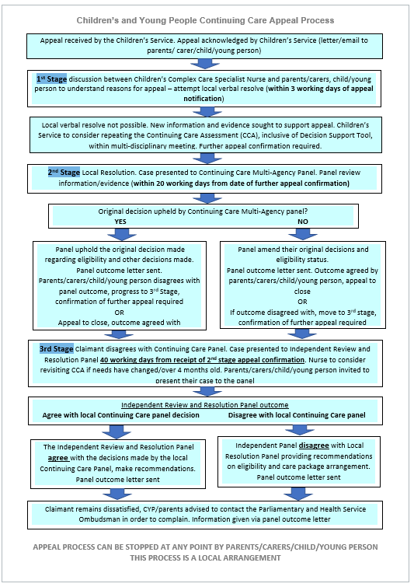
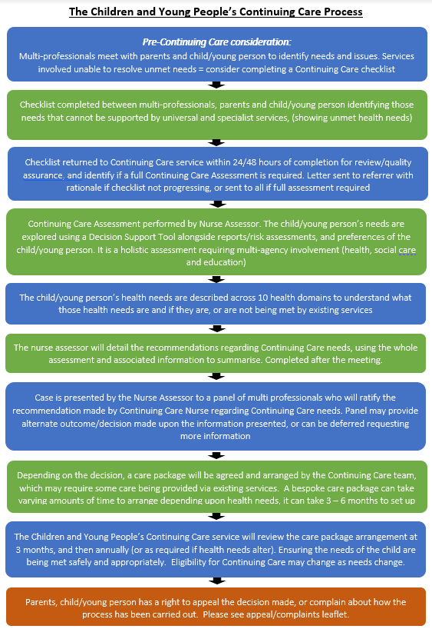
NOTES

If you would like this leaflet to be translated into another language, please liaise with the Children’s Team on the number below

Please send your complaint to the
Children’s Continuing Care Service at the address below:

For any further advice, queries or to appeal please contact number below:

Children’s Continuing Care Team

Scarsdale Nightingale Close, off Newbold Road
Chesterfield
S41 7PF
E: ddicb.cypcc@nhs.net
W: www.derbyandderbyshire.icb.nhs.uk
W: joinedupcarederbyshire.co.uk
Contact Number: 01332 327800

