
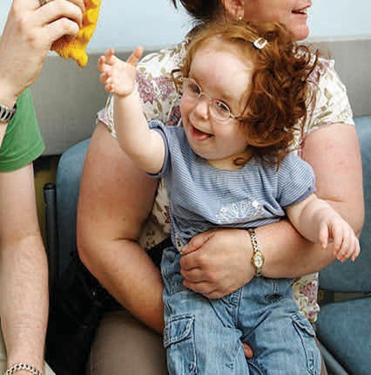
Children and Young People’s
Continuing Care

A Brief Guide for Parents, Carers,
Children and Young People

What is Continuing Care?

Children and young people (0-17) who have complex health needs may require additional support that cannot be met by existing NHS universal and specialist health services. This additional support is assessed and agreed via Continuing Care Assessment process on behalf of Integrated Care Board (ICB) and is delivered through a tailor-made commissioned package of care.

This assessment is needed to understand if a package of care is required to support a child or young person with complex needs and is managed by the Children’s Complex Care Nurse Specialist. The National Framework for Children and Young People’s Continuing Care (2016) is guidance provided by the Department of Health and Social Care, and is used by the Nurse Specialists to manage the process of Continuing Care.

It is recognised that there should be a multi-disciplinary team (MDT) holistic approach throughout the Continuing Care process, which includes health, education, and social care, as well as other agencies involved in supporting your child’s needs. This multi-disciplinary team consists of professionals who represent local services and provision and who are known to your child.
How can you access Continuing Care?

If it is identified that you require some additional support to meet the complex health needs of your child, the multi-disciplinary professionals involved should collectively meet with you as parents/carers as well as your child (where possible).This is to understand your child’s needs and how the collective agencies can provide support by accessing statutory provision, or commissioned support available i.e. NHS services, Local Authority services (social care and education) and other services such as charitable respite or short breaks. The multi-disciplinary team will also gain an understanding of what health needs are not being met, and address this as part of the multi-disciplinary meeting.

Parents are not able to refer directly into Continuing Care it is advisable for them to discuss any concerns with a member of the multi-disciplinary team involved with the child or young person.

If your child requires information about Continuing Care a member of the MDT or the Children’s Complex Care Nurse Specialist will explain the process and will find appropriate ways to communicate effectively. They will listen to your child and support through the process of Continuing Care. Where necessary they will have discussions with your child alongside you.

Any professional involved can initiate an MDT meeting if there are concerns and issues with your child’s complexity of needs. This MDT may consist of several professionals such as your GP, Social Worker, Education Representative, Community Children’s/School Nurse, Specialist Nurse including, Child and Adolescent Mental Health Service, Learning Disability Nurse (amongst others). The complexity of your child’s needs may also become apparent as part of another pre-arranged meeting, such as a Child in Need or Education Health and Care Plan meeting. It is expected that as a parent or carer you will be integral to the MDT meeting, as well as your child (where possible), where all your child’s needs may be discussed.

The MDT need to firstly pursue what is available from the NHS and other services to consider how any current support being provided can be adjusted to meet your child’s needs in an individualised manner. The MDT may also consider making new referrals to other NHS services and pursuing other agency input. This early help and support can in turn can help you to manage your child’s needs more effectively.

If the NHS universal and specialist services, and other local services known to the MDT have been pursued and are not able to alleviate some or all your child’s needs, the MDT members should consider completing a Continuing Care checklist, which is sometimes known as a referral. The checklist is the first stage in the Continuing Care process and should provide an indication of whether a further and more in-depth Assessment is required. The Checklist is a document that will possibly need an hour or so to complete

The following information is required within the checklist
- Personal details, background information and consent from parents/carers (and the child or young person) where possible
- Reason for referral which should be a brief rationale that supports the request for Continuing Care support to be looked at
- Overview of any assessments that have already been undertaken such as Physio reports or plans / Early Help Assessments / Education Health and Care Plan
- Brief summary of the current Health, Educational and Social Care needs of the child or young person.
- All 10 health domains to be considered regarding the level of need they are felt to be at, along with a brief rationale to support the level of needs chosen
- Unmet health needs to be identified, documenting all current support in place and what additional support is felt to be required, in order to meet these needs.

Your child does not become eligible for Continuing Care at the checklist stage, this is determined after the Continuing Care Assessment has taken place (which is described later in this leaflet).

If you disagree with the multi-disciplinary team about the need for a checklist to be completed, you have a right to complain. We advise that you liaise with the healthcare professional completing the checklist about raising a complaint and would be raised to that healthcare professional’s organisation. However, the Continuing Care Team will be able to offer advice and support prior to a complaint being raised. We will work with the multi-disciplinary team to understand the reasons for not completing a checklist, who will offer guidance where necessary.

If the checklist indicates that a full Continuing Care Assessment is needed the Nurse Assessor from the Continuing Care Team will facilitate a meeting with you and your child, and members of the MDT. Please be advised that the assessment can take between 2 to 4 hours on the day. The Continuing Care Assessment gives a deeper understanding and awareness of your child’s needs and should identify any unmet health needs, a document is used to collate the information known as a Decision Support Tool (DST). Following the meeting the Nurse Assessor gathers all the information and makes recommendations as to what health support is required for your child.

The Continuing Care Assessment comprises of 4 parts, which includes

  - Preferences of the child or young person and their family
  - Holistic assessment of the needs
  - Reports and risk assessments
  - Use of a Decision Support Tool

It is important that your child can express their views and preferences in a way that is important to them. If your child is unable to express their views it is important that the Nurse Assessor captures this from you, capturing your child’s story about them including their health, wellbeing, and emotional needs. We also require your views and preferences as a family, along with any supporting evidence you have in relation your child’s level of care, education, and health needs. Supporting evidence can consist of health care logs, a diary of health requirements (such as frequency of suctioning or behaviour interventions), hospital letters, care plans, behavior support plans, specialist reports, educational and social care assessments/reports.

The Decision Support Tool provides a way to assess your child’s complex health needs across 10 health related domains, each of these domains have varying levels of needs showing either
- No additional needs
- Low level of needs
- Moderate level needs
- High level of needs
- Severe level of needs
- Priority needs
Each health domain will be discussed in detail to capture the complexity, intensity, and frequency of that health need and to also understand the demands that this places on you on a 24-hour basis. It is important that we understand and document a realistic picture of what you are managing and dealing with every day/night, in order to support and meet your child's complex health needs in a safe and appropriate way.
The Nurse Assessor will review the overall picture of needs described to them and will provide recommendations relating to any potential complex health needs that are not being managed by locally commissioned universal and specialist NHS services.

Eligibility for Continuing Care is not dependent upon a single or multiple medical conditions, or diagnosis but is focused on understanding your child’s overall complex health needs, which is inclusive of any education and social care needs. These needs can include learning disability, mental health needs, physical disability and challenging behaviours. We need to understand your preferences and views as parents and carers, and additionally important that wherever possible we capture what is important to your child, and what their lived experience of their needs and disability show.

Throughout the whole process we will need to use the information within your child’s Education Health and Care Plan (if applicable). The Continuing Care process should inform, advise, and combine information within this plan to ensure a partnership approach.

The Children and Young People’s Continuing Care service will explain the Continuing Care process and will keep you informed about pertinent aspects by letter, phone, video conferencing or face to face meeting.


Who makes the decisions after a Continuing Care Assessment has been completed? What happens next?

The case is presented by the Children’s Complex Care Nurse Specialist to a multi-agency panel of professionals. These senior professionals represent Education, Social Care and Health and will decide on whether your child has a Continuing Care need based on:

  - The recommendations from the nurse assessor
  - Evidence and information available supporting the levels of health needs across the domains

Depending on the decision, a package of care is then agreed; some of this care may be provided through existing services but some may need to be bespoke commissioned by the Continuing Care Team. Depending on the complexity of health care your child has the package can take up to 3-6 months to be in place. As a service we work with differing providers of care, which will be discussed with you prior to arranging and paying for the package of care.

Personal Health Budgets

A Personal Health Budget is a way of delivering the healthcare support, this gives choice, control, and flexibility on how your child has their care delivered. This will be discussed with you after the outcome from the multi-agency panel, indicating that eligibility has been confirmed.

Personal Health Budget offers choice and control to parents in how the care is delivered in a manner that meets your child’s needs, in a flexible way that you can control.

They can be offered in 3 ways:

  - Notional
  - Third Party
  - Direct Payment

The Continuing Care Review Process

The Children and Young people’s Continuing Care Team will continue to review the package of care to ensure that the needs of your child are being met. The reviews routinely occur at 3 months after care package set up, and then reviewed annually.

Your child’s needs may alter and require a change in care package provision. This can either mean an increase or decrease in hours, or even a change in care provider. In these circumstances the Continuing Care Nurse Assessor will discuss any changes required.

Your child’s eligibility for Continuing Care may change as their needs change and will be discussed within the MDT alongside you and your child (where feasible).

Transition into Adulthood

If your child is in receipt of a Continuing Care package at the age of 14, the transition process should be instigated. From this age the annual review process will consider what is required in relation to their needs when moving into adulthood. The Children’s Complex Care Nurse Specialist will provide you and your child with information and support through the transition process

When your child reaches 18, the adult NHS Continuing Health Care (CHC) arrangements apply (National Framework for NHS Continuing Healthcare and NHS Funded Nursing Care revised 2018). There are significant differences between Children and Young People’s Continuing Care and NHS Continuing Health Care. The CHC Team will assess any young person in receipt of Continuing Care between the ages of 16-17, to see if they are likely to be eligible for NHS Continuing Care when they turn 18.

If your child is eligible for Children and Young Person’s Continuing Care, it is not a guarantee of them becoming eligible for adult Continuing Health Care when they reach 18. The various types of provision and support into adulthood services, which fall outside of Continuing Health Care will be discussed and agreed during the stages of transition, with the relevant services involved.

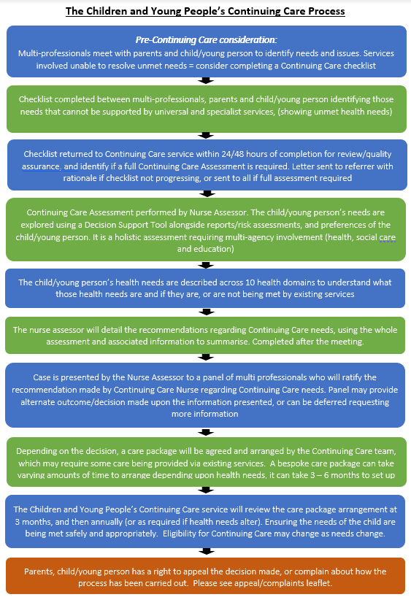
NOTES (for your use)

If you would like this leaflet to be translated into another language or the document adapted for visual impairment, please liaise with the team on the number below

For any further advice please contact number below

Children’s Continuing Care Team

Scarsdale Nightingale Close, off Newbold Road
Chesterfield
S41 7PF
E: ddicb.cypcc@nhs.net
W: www.derbyandderbyshire.icb.nhs.uk
W: joinedupcarederbyshire.co.uk
Contact Number: 01332 327800

