

Joined Up Care Derbyshire Digital & Data Strategy

October 2021 –

Document control

Title | Joined Up Care Derbyshire Digital & Data Strategy
Authors | Andrew Wall
Consultation | JUCD Digital & Data Board  JUCD Strategic Intelligence Group JUCD Programme Leads
Approved by | JUCD board
Approved date | November 2021
Date for next review | November 2024
Version number | V1.1

TABLE OF CONTENTS
- Introduction 5
- Context and Background 6
- Digital & Data Transformation 16
- Strategic Use of Data and Intelligence 21
- Stakeholders/use cases 23
- Our vision 25
- Our principles 25
- Our strategic priorities 26
- Development of our capabilities 31
- Enablers 35
- Appendix A - Plan on a page 39
- Appendix B - JUCD Stakeholder Digital / ICT Strategies 40
- Appendix C - Decision Support Unit Proposal 41
- Appendix D - Remote access to health and Care Services 44
- Appendix E - Digital Inclusion checklist 45
- Appendix F – JUCD PHM framework 47
- Appendix G - Informatics Skills Mapping 47

TABLE OF FIGURES:
Figure 1 - Joined Up Care Derbyshire 6
Figure 2 - Primary responsibility of JUCD 8
Figure 3 - Factors influencing health - Robert Wood Johnson Foundation 9
Figure 4 – ICS Digital, Data And Technology © Hippo Digital 10
Figure 5 - 7 Success Measures of What Good Looks Like Framework 11
Figure 6 - Recent digital achievements 15
Figure 7 - Stakeholders / use cases for data & analytics 17
Figure 8 - Digital exclusion groups/characteristics 19
Figure 9 - Core digital, data & technology principles 25
Figure 10 - Organisation vs System 31
Figure 11 - Digital capability map 33
Figure 12 - Governance Model 36

Introduction
The health and care system in Derbyshire is undergoing a fundamental transformation of service provision. Emphasis is moving from a traditional posture of treating conditions that are already established in the patient to a proactive approach of working to prevent avoidable conditions wherever possible.
The current health and care system is typically reactive and characterised by organisation and role boundaries; it must be replaced by a system that is centred on people and communities.
Digital transformation is necessary to support the shift in care from ‘illness to wellness provide the tools and technologies required to transform to new models of care delivery and help address some of the challenges faced across the system.
As a health, wellbeing and care system we must make many complex and challenging decisions on who, on what and how we best utilise our resources and provide optimal services for our population. The value of effectively utilising data, intelligence and insight, gives us the best chance of making the best possible decisions that are informed, defensible and transparent.
To do this effectively, decisions need to be adequately informed. We must enable knowledge-led decision-making, supporting us to deliver the health and care system quadruple aim of:
  - Improving clinical experience
  - Improving patient experience
  - Achieving better outcomes
  - Lowering cost through efficient and valuable delivery

Delivery of the aims above will also support progress in other domains identified for improvement within Joined Up Care Derbyshire (JUCD), including reduction of health inequalities and achievement of maximum impact with population health management programmes.
The development of the Digital & Data Strategy has been undertaken to ensure that the ‘golden thread’ of “Digital by Default” runs through its plans and digital transformation programmes across the JUCD system. It has been shaped to regulatory requirements together with developments across the Joined Up Care Derbyshire partnership but importantly its primary focus is to use information and technology innovatively to deliver better quality outcomes to the people of Derbyshire.

Context and Background

Local Context

Joined Up Care Derbyshire (JUCD) is the Derby and Derbyshire Health & Social Care Partnership for adults and children; it is made up of providers (NHS, Local Authority and Voluntary Sector) and commissioners.
JUCD became a designated ICS in January 2021 and has made some significant progress:
  - A strong system-wide collaborative approach to covid-19 prevention, protection and recovery, including ongoing strong vaccination programme roll-out
  - 2 Place Partnerships agreed – 1 x Derby City, 1 x Derbyshire County formally agreed
  - 4 Provider Collaboratives at Scale agreed – 1 x Acute, 1 x MH and LD, 1 x UEC and 111, 1 x in and out of hours primary care
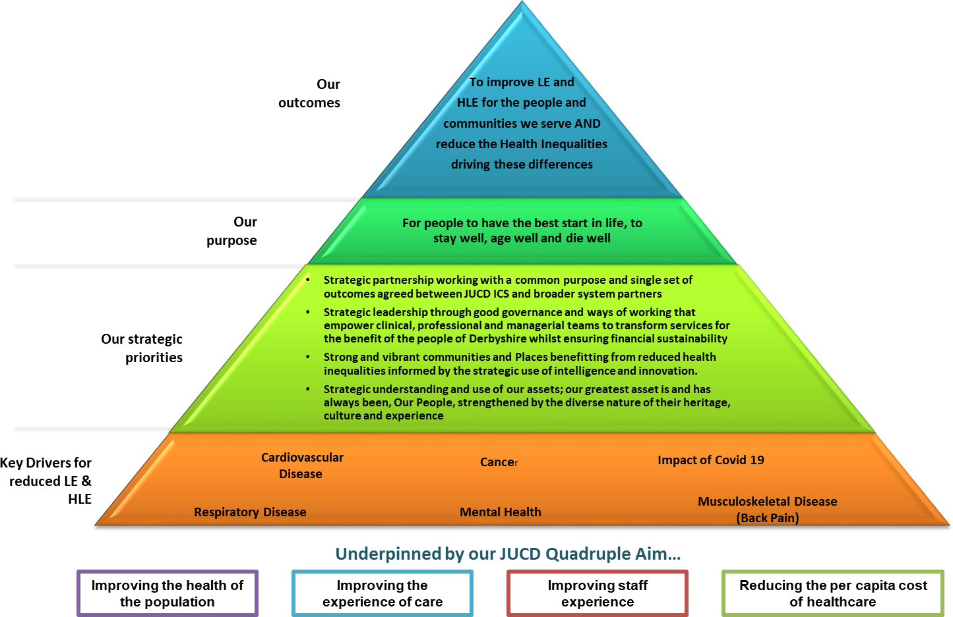

Figure 1 - Joined Up Care Derbyshire

JUCD ICS has identified the following as their key priorities:
- Our system will jointly plan for the health and social care needs of the population; moving from fixing illness to enabling wellness and reducing inequalities
- We will develop an agile workforce to meet the changing approach to population health and system working
- The focus of delivery will be Place Partnerships and Provider Collaboration at Scale rather than organisations where appropriate, supported by strong Primary Care Networks
- Providers will increasingly move to integrate provision and delivery to deliver the outcomes for the population of Derbyshire at both footprint and Place levels within allocated resources
- We will adopt and implement core principles for how we work and challenge each other to uphold them
- We will establish strong system governance with decision-making arrangements agreed
- We will develop a Strategic Intent function to optimize the opportunities identified through population health intelligence, with integrated commissioning encompassing the directly commissioned services currently led by NHS England and join commissioning with Local Authorities
- We will live within our means
- We will restore and recover our planned care and cancer services to ensure people get the right care at the right time

It is important that data and intelligence, converted to knowledge, is available to support decision-making at different levels and for different purposes, including:
  - Effective individual and case management
  - Operational planning and service delivery
  - Identifying, understanding and tracking new and emerging issues
  - System planning for the short, medium and long-term.

Data and intelligence services need to be available at all geographical and organisational levels and provide insight for whole populations, specific cohorts and at an individual citizen level.

Additionally, we need to consider the wider health and wellbeing system – the breadth of drivers and mitigating factors of health and wellbeing and parts of the wider system that manage these. Figure 2 demonstrates the layers of the system which require data and intelligence provision.

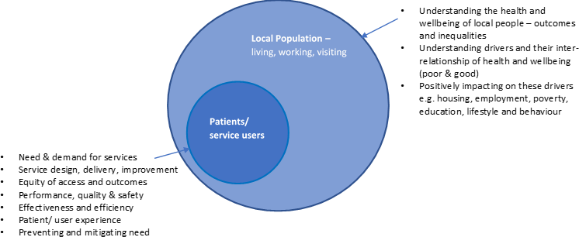

Figure 2 - Primary responsibility of JUCD

The scope of currently commissioned health and care services are only a relatively small contributor to health and, therefore, without consideration of the other contributors to health, we will have limited impact on population health, health inequalities and the present demand for health and care services.

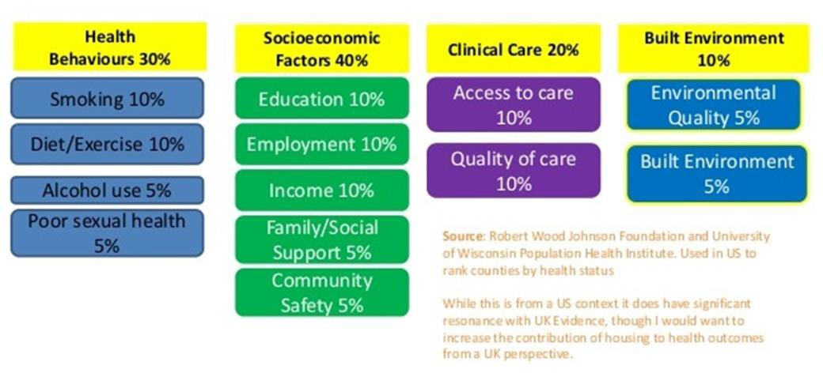

Figure 3 - Factors influencing health - Robert Wood Johnson Foundation

This strategy sets out our vision and priorities for Joined Up Care Derbyshire with a prime ambition to establish an innovative, visible and fit-for-purpose set of digital and analytics capabilities that delivers the needs of the system and supports effective delivery of services to our population.
This Digital and Data strategy sits in support of the wider Joined Up Care Derbyshire priorities, developments and operational plan.

National Context
NHS England and Improvement (NHSE/I) have set clear expectations for ICS’s on digital as part of its “Integrating Care: Next steps to building strong and effective integrated care systems across England”1.
The key recommendations for local ICS digital on this are:
- A named senior responsible officer for digital on the ICS board
- Developing a shared care record to connect health and care services
- Building the digital literacy of the workforce
- Develop shared cross-system intelligence and analytical functions that use the information to improve decision-making at every level, including:
  - actionable insight for frontline teams;
  - near-real-time actionable intelligence and robust data (financial, performance, quality, outcomes);
  - system-wide workforce, finance, quality and performance planning

- The capacity and skills needed for population health management
- Developing a road map for citizen-centred digital channels and services
- Ensure transparency of information about interventions and the outcomes they produce, to drive more responsive coordination of services, better decision- making and improved research.
In addition, NHSE/I, NHSx and NHS Digital will be focussing digital transformation activities across health and care across 3 main domains as outlined in Figure 2 below.
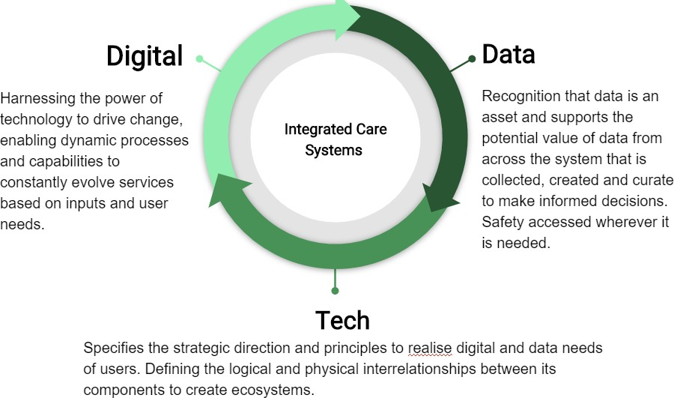

Figure 4 – ICS Digital, Data And Technology © Hippo Digital

1 Report template - NHSI website (england.nhs.uk)

What Good Looks Like

In August 2021 NHSx published its “What Good Looks Like2” framework (WGLL) which sets out what good looks like for Digital Transformation at both a system and organisational level. The framework identifies 7 success measures for ICS’s to work towards as they seek to accelerate digital transformation.
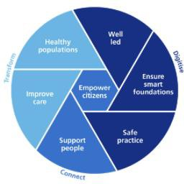

Figure 5 - 7 Success Measures of What Good Looks Like Framework
The framework has been included in both the ICS design framework3 and the NHS Operational Planning and Contracting Guidance4.
Along with the requirements to implement the WGLL framework, a package of support will be provided to include funding, resources and best practices, for ICS’s to leverage.

National Data Strategy

In June 2021 the Department of Health and Social Care published its draft data strategy, “Data saves lives: reshaping health and social care data.5” The strategy sets

2 https://www.nhsx.nhs.uk/digitise-connect-transform/what-good-looks-like/what-good-looks-like- publication/
3 https://www.england.nhs.uk/integratedcare/resources/key-documents/
4 https://www.england.nhs.uk/publication/2021-22-priorities-and-operational-planning-guidance/
5 https://www.gov.uk/government/publications/data-saves-lives-reshaping-health-and-social-care-with- data-draft

out the Secretary of State’s vision for how data will be used to improve the health and care of the population in a safe, trusted and transparent way.
The strategy, which is in the consultation stage, has 3 core priorities:
- build understanding on how data is used and the potential for data-driven innovation, improving transparency so the public has control over how we are using their data
- make appropriate data sharing the norm and not the exception across health, adult social care and public health, to provide the best care possible to the citizens we serve, and to support staff throughout the health and care system
- build the right foundations – technical, legal, regulatory – to make that possible

The draft strategy, currently in the consultation phase, seeks to take the learnings from the use of data during the pandemic, provide citizens with greater control over their data, and provide the regulatory framework for wider information sharing across the health and care system for use in direct care, secondary uses and research.
The themes outlined in the national strategy will provide the policy framework for JUCD and we will ensure that this local strategy and operational plans align closely with national policy as it emerges across the digital, data and technology domains.

Covid 19 Impact

The impact of COVID-19 on the landscape in relation to the delivery of health and care services using digital technologies must not be understated. The pandemic forced health and care systems to rapidly procure, adopt and deploy digital services to support citizens and health & care professionals at a pace never before seen.
As an example Primary Care across Derbyshire rapidly adopted new approaches to triage, adopting a total triage model, and to the mode of consultation, reducing face to face contact and rapidly increasing remote / phone/video consultation
In late Autumn 2020, the JUCD System Executive CEO group reviewed recommendations made by NHSE/I following the “Learning from COVID-19” review and summarised considerations for this Digital Strategy as:
- The continued use of technology to assist the delivery. Remote GP consultations, outpatient clinics and remote monitoring for care homes, should become normalised

- Systems should undertake a thorough evidence-based evaluation of the changes adopted during the COVID-19 pandemic. Benefits, risks and implementation support requirements including staff training need to be identified
- Continued co-production of new technology pathways should occur with the involvement of all parts of the system across multiple disciplines. Blended teams, involving clinicians and digital experts should be constructed to address key delivery challenges to enable the diversity of thinking and stronger outputs
- Systems should be kept abreast of new technologies and improvement capabilities by ensuring high-quality horizon scanning is undertaken. This should go alongside a requirement for systems to articulate real-time unmet needs. Our AHSNs could coordinate relevant work in the West and East Midlands and ensure appropriate interaction with procurement frameworks that must be more receptive to innovation.
Providing data and intelligence support to the JUCD COVID-19 response has accelerated some of the objectives laid out in this strategy and provided a blueprint for achieving joined-up services within this function. From a data sharing perspective, the release of the National Control of Patient Information (COPI) Notice has facilitated data sharing on an unprecedented scale and has allowed Information Governance colleagues to develop local solutions to allow data to continue to shared legally, more freely, after the COPI Notice is rescinded.
Collaborative reporting has also developed as a direct consequence of supporting the COVID-19 vaccination programme, and now colleagues within several JUCD organisations can share and edit reports jointly using the same reporting software. This approach to shared reporting can be developed to benefit other system-wide projects, following an appraisal and agreement of the tools and software JUCD would like to universally adopt.
This collaborative effort has supported us to deliver innovative and sophisticated demand and capacity planning throughout our COVID-19 effort and enable us to effectively, or as effectively as we can, the demand for a range of services and particularly the need for hospital care.
Data management and processing remain the largest barriers to collaborative working, as data files and information are not consistently accessible across the system and rely on individuals sharing data manually. Developing a shared source of data and accompanying standards will be essential in providing validated and reliable insights to all system partners.
There is a clear challenge now in ensuring the initial advancements made concerning the use of digital services now become the new normal but that recognition is made that there will need to be enhanced local support for a period to support both citizen and professionals adoption & exploitation of the advancements.

The continued response to the pandemic including COVID-19 service recovery and vaccination programme, exhausted staff, combined with the additional pressures of a significant underlying financial cost pressure, the general public expecting near-normal service levels and a nationally driven significant organisational change programme have added a new dimension to the challenges now faced across the system.
Significant central assets (platforms, services, data stores) were and continue to be developed in the ongoing response to the pandemic. It is conceivable therefore that as part of the national data strategy these assets will be able to be leveraged and used by local ICS systems as part of their strategies and development plans. Some examples of the types of centralised support that may be available are:
- ICS core data model
- Data made available to support planning and recovery
- PHM to support planning & care
- Common information models (risk stratification / segmentation etc)
The National Data Strategy will likely identify the core required NHS Data and may seek to develop and implement these at a national level.
The emphasis for JUCD therefore will move from developing these capabilities ourselves or with partners across regional footprints, to that of utilisation and exploitation of the capabilities.

Our Achievements

Across the digital domain, Derbyshire has a strong history of collaboration and working together on shared technology implementations & programmes. Already in place are some of the basic requirements for the ICS from NHSE/I (see Section 2.2 above) in terms of leadership, governance and financial management. Recent advancements across the DDAT domains in respect of our digital programmes have included:
- System-wide Exec / SRO identified providing leadership, decision making and strategic direction
- Strong clinical engagement and all stakeholders represented through our CCIO professional reference group
- Pooled investment programmes for system-wide initiatives whilst supporting local priorities ( eg shared care records, Provider digital maturity)
- Support increasing levels of digital maturity across Provider Organisations
- Wider use of transformation resources in support of digital initiatives

- First stage adoption of data workstreams into Digital board

Our support to providing digital assets (tools, infrastructure upgrades, remote access capabilities, vaccination centre support etc) to the pandemic response has been extensive but several other strategic initiatives have also progressed. These are outlined in the diagram below.





Shared Care
Record Procurement
COVID-19 Support
Virtual
Consultation: Outpatient / Primary Care
Total Triage rollout
/ support
Care Home
Digitisation
NHS App
Enablement
Patient /Gov Wifi
deployment
Remote
Monitoring Pilot
Device / W10 /
N365 Rollout
Inter-Trust sharing
/ interoperability initiatives
System migration /
convergence
Pathfinder rollout

Figure 6 - Recent digital achievements

Digital & Data Transformation
Digital is not about technology – it is about changing the way citizens live, work and in the context of this strategy, access, connect and interact with health and care services. Tom Loosemore, Partner at Public Digital, defined digital as:
“Applying the culture, processes, business models and technologies of the internet era to respond to people’s raised expectations.6”
Digital technology presents the opportunity to significantly transform service delivery and citizen experience of public services. Poor tools, lack of cohesive change management/embedding approach, and over-emphasis on technical rather than user experience/user-centric design can adversely affect the adoption of digital services across citizens/health and care professionals.
Digital technologies can also be used to optimise and modernise existing delivery models. Historically our digital strategies have centred on this mode of operation – iteratively/ incrementally improving existing services or overlaying technologies onto inefficient and ineffective processes.
We have ambitions through this strategy to move to a more transformative posture – to be bolder in our ambitions/delivery - to one which our citizens/professionals demand/deserve and which the challenges of the operating environment dictate.

Digital By Default
During the COVID-19 pandemic, social distancing and a restriction on in-person contact led to a rapid increase in the use of digital technology for a large proportion of the UK population.
The adoption of the necessary changes made to the delivery of health and care services during the pandemic has demonstrated that:
- A large proportion of citizens respond positively to new models of care delivered using digital technology and access channels
and
- health and care services can implement and adapt to significant service transformation/change across whole patient pathways/service models
It is vital as we work to adopt and define our approach to “Digital by Default” that we ensure we do not seek to exclude those who struggle to access or use our digital channels/services. We will therefore ensure we are inclusive as possible in our

6 https://public.digital/definition-of-digital

approach to the identification and delivery of service transformation through digital technologies (see section 3.3 below).
One of our Local Authority partners, Derby City Council, has already progressed significantly in this area as part of their own Digital Strategy (see Appendix B) and we will work with them to see how the learning can be scaled across the wider JUCD system.

Data Democratisation
Across the breadth and depth of a health and care system, there are a wide number of stakeholders with varying needs, experience, and levels of data/analytics literacy.
Figure 6 identifies just some of those stakeholders and during the development of this strategy.
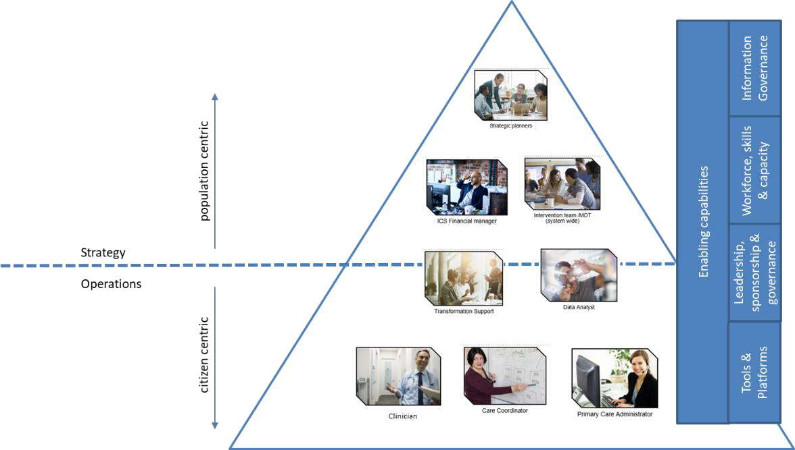

Figure 7 - Stakeholders / use cases for data & analytics
A key thread running through this strategy is the concept of data democratisation which can be defined as:
“…the ongoing process of enabling everybody in an organization, irrespective of their technical know-how, to work with data comfortably, to feel confident talking about it, and as a result, make data-informed decisions and build customer experiences powered by data.”
data_led academy
https://dataled.academy/guides/data-democratization/

We will anchor a number of our data and intelligence strategic priority programmes (see Section 8) around this concept as a means of reducing the churn on our analytics workforce and maximising the use of intelligence for operational and strategic decision- making.

Digital Inclusion
There are clear benefits in terms of cost, efficiency and timeliness for the delivery of services to citizens via digital channels and using advanced technologies to support prevention and self-management of conditions.
As we push a “Digital by Default” vision and help citizens to take control over their health and care needs by providing a range of digital tools, services and information, it must be recognised that there is no one size fits all solution, and the approach taken needs to fit with individual need and circumstance.
The Good Things Foundation7 produces an annual snapshot of digital inclusion/exclusion across the UK through its Digital Nation research and key insights from its 2020 report highlight:

- 9m struggle to use the internet independently
- 7m have no internet access at home
- C19 has exacerbated the digital divide
- 44% of the population manage their health and wellbeing online

More locally from research that focussed on virtual appointments undertaken by HealthWatch Derbyshire highlighted approximately 62,000 people across the county have not accessed the internet in the previous 3 months.
Overall the evidence points towards addressing three main barriers to create a digitally inclusive Derbyshire:
- Access issues – equipment, broadband connectivity,wifi, affordable data packages
- Motivation and support – confidence-building and digital champions
- Digital skills – formal skills training and integration into triage

7 https://www.goodthingsfoundation.org/insights/building-a-digital-nation/

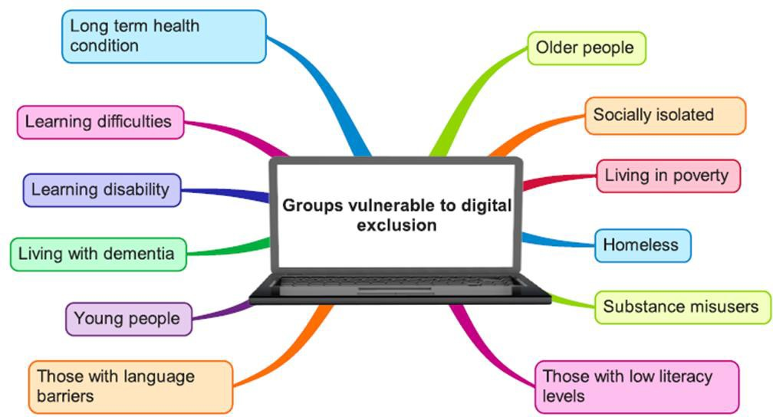

Figure 8 - Digital exclusion groups/characteristics

Locally, there are many learnings we can take from the rapid deployment of digital services under the Covid-19 pandemic and the impacts these have had concerning digital inclusion - these are outlined in Appendix C.
A blended omnichannel offer, including text, phone, video, email, and in-person is likely to provide the best solution. “Digital By Default” cannot exclude our citizens who struggle to adopt or use these services. The pandemic has exposed more than ever before to the digital divide and the correlation between high-risk Covid-19 groups and those with no access to the internet.8
The JUCD System Insight Group have developed a “Digital Inclusion Checklist, Appendix D, to ensure that consideration has been given to the needs of all patients and service users when promoting digital channels and services.
As a key component of our digital strategy and ensuring we fully empower all our citizens to utilise digital health and care services we will support:
- Led by Derbyshire County Council, a 3-year county-wide programme to support identified excluded groups
- The Commissioning of an external organisation to provide expert professional services for the first 18 months of the project. The organisation will build a coherent and coordinated network of digital inclusion activities across Derbyshire.

8 https://business-reporter.co.uk/2021/04/22/pandemic-shows-how-digital-by-default-government- services-exclude-those-who-need-them-most/

- Employ a dedicated team of staff to coordinate and provide linkage across the system for existing and emerging digital services and to develop several projects to address the digital divide.
- Embed the use of the digital inclusion checklist in the design, implementation and rollout of future citizen-facing digital services

Strategic Use of Data and Intelligence

Identifying population health needs
We need to have in place a range of approaches to understanding the needs of our local population and population sub-groups. These include in particular, the Joint Strategic Needs Assessment (JSNA), a statutory requirement, which assesses the health and care needs of the local population and how far these needs are met. This identifies where there is need but inevitably there is more need than there is the resource to support. The JSNA is therefore only part of a wider process of priority- setting and planning action and intervention.
Whilst the JSNA is significant, it is relatively high level and doesn’t, in the necessary detail, indicate the health need of specific communities – either communities of interest, geographical communities or communities with, for example, a specific disease. For this level of granularity, specific health needs assessments are required.
The use of approaches such as Outcome-Based Accountability support translating need into system outcomes and into action and intervention and into evaluating effectiveness.
Embedding methodologies such as Equity Audits is also key, enabling us as a system to identify where different population groups may receive different access to services and different outcomes.
Population segmentation and Population Health Management (PHM) is crucial to support the system in identifying population and patient cohorts who are at increased risk of poor outcomes or where resources could be more effectively used. This then enables us to target effort and resource more effectively through evidence-based interventions on where it is needed most.
Several tools are available now allowing for JUCD to identify and prioritise potential interventions for use in the planning and commissioning of health services. For example, NHSE/I recommends using Bridges to Health for segmenting populations and this tool (and others) are available now for use across JUCD
Established processes, measures and techniques can be then be applied to track, record over time and evaluate the interventions.
We need to better use data and intelligence to support the system in tackling a range of challenges:
Health Need
- Comparatively poor health outcomes for local people
- Further impact on health and wellbeing as a result of COVID

Health Inequalities
- Significant inequalities in health outcomes
- Inequity in access to care. Quality
- Variations in the quality and provision of care. Sustainability
- Unsustainable demand and model of delivery of health and care services

To achieve the successful delivery of programmes that address these challenges, there are several challenges with our current approach to data and intelligence that need to be addressed:
- Duplication of effort and reporting
- Lack of cross-system access to shared data sources, systems and tools
- Ability to release capacity to meet system intelligence need
- Capacity overly focused on monitoring and performance
- Organisational vs. system requirements
- Limited sophisticated and insightful analysis
- Under-utilisation of the skills and capabilities of the Derbyshire data and intelligence workforce
The services, products and assets within the data and intelligence domain need to operate across all levels of the ICS and support varied projects across health and social care, including population health management and research-based programmes. Data and insight need to be democratized across the JUCD system to ensure the best access to information and analytical resource wherever it's needed.
Current data and intelligence services are largely provided in isolation to individual organisations via their in-house teams, an arrangement that has contributed to the ongoing challenges described above. Through the Strategic Intelligence Group (see 10.1 below), there is visibility across the system of current projects and a mechanism to facilitate collaboration where possible. There is, however, an overriding organisation- centric driver which prevents system-wide resource being used optimally.

Stakeholders/use cases

As A Citizen:
  - I have a holistic view of my health and care needs and can access the tools and information required to have control over my clinical and non-clinical care
  - I can communicate using a variety of digital services with the relevant professionals who are involved in my care to support me in staying healthy and promote my wellbeing
  - I don’t have to repeat my story, have trust that my information will be safe, secure and shared with the people involved in my health and care but that I am in control over who sees my information

As a practitioner:
  - I can identify those who most need my care can understand the context in which my patient/citizen lives and how this impacts their health and wellbeing
  - I recognise their preferences and what is important to them
  - I have access to a holistic view of an individuals usage of services across health and social care and can use this information to provide the most appropriate care in the right setting
  - I have the right tools for my job and can deliver the best possible care from the most appropriate location for me and my patient/citizen
  - I can monitor and interact with my patients remotely to empower people to manage their health and wellbeing and provide pro-active care when my patient needs it.

As a planner/designer of services:
  - I understand the needs of the local population and local assets
  - I have meaningful priorities shared with key partners
  - I have an understanding of the best practice and what works
  - I understand the impact of what we deliver and its value
  - I can identify predicted long-term population needs and plan services proactively
  - I can access and use citizen-level linked anonymised datasets, refreshed frequently (daily/weekly) to plan operational and strategic service delivery

As a system / strategic leader:
  - I have a system-wide view of demand and capacity across the full health and social care landscape
  - I can access executive summary level data to inform my understanding of current system pressures and use this information in strategy development
  - Self-service data and intelligence tools, with push/subscription/alerting functionality, allow me to access timely insight when I need it

As a digital / data professional:
  - I have access to a data repository that is quality assured, houses extensive health and social care data sets and can be used to link patient activity across different settings
  - I am capable of using tools and software to analyse data and produce reports and dashboards
  - I am linked to and collaborate with a system-wide network of digital, IT, data and intelligence specialists, from whom I can learn and access support
  - I have a comprehensive learning and development plan to allow me to build my skills in my chosen profession and be an advocate for it across the wider health and care system

Our vision
So that we may exploit the potential of digital services to empower our population, improve outcomes and provide the best digitally enabled health and care, our overarching vision for the JUCD Digital & Data Strategy is:

We will use technology and data to facilitate system transformation and empower our citizens to take control of their health and care, reduce inequalities and improve outcomes.

We will ensure appropriate and accurate data and intelligence is available and accessible to our citizens and their professional care providers, supporting them to make informed, reasonable and transparent decisions in the delivery of joined-up care.

Our principles
The principles set out below will guide all our digital, data and technology work.

We will place the citizen / user needs and experience at the heart of any services we implement or transformation programmes we embark on

We will adopt a "Digital By Default - Digitally Included" position for our programmes

Data driven operational, tactical and strategic decision making that is: person-centred, reasonable and transparent

We will ensure the safety and security of our digital / data services by ensuring all capabilities comply with current regulatory, legislative and industry standards.

We will ensure our technologies adopt open standards and are interopable across our system and the wider health and care system

Support our citizens and staff in the adoption of technology and exploitation of data for decision- making whilst transforming service delivery

We will seek to reduce duplication, inefficent processes through the introduction of automation and machine learning

Figure 9 - Core digital, data & technology principles

Our strategic priorities

Provide new digital services that improve the patient experience, transforms delivery models and reduces the overall cost of care
  - Embed digital transformation experts into pathway transformation programmes across JUCD to help identify ways of using digital technology to reimagine care pathways, improve outcomes and join up care across boundaries
  - Extend remote/home monitoring pilots to support the transformation of care pathways and proactive patient management
  - Develop ICS wide visibility of patient flows

Delivering and extending our Shared Care Record programme
  - Minimum viable solution specification implemented across all JUCD stakeholders9
  - Care coordination and shared workflows for integrated multi-disciplinary teams/professionals
  - Deploy shared care records to care homes, community pharmacies and ambulatory use-cases
  - Pilot integration of remote / home-monitoring services with shared care record
  - Develop integration with neighbouring/regional shared care records platforms

Develop our ecosystem of digital products and services
  - Promote the NHS App as the “digital front door” Citizen Portal across Derbyshire and promote interoperability with other 3rd party citizen tools
  - Support our health and care partners in developing their digital capabilities
aligned to (inter)national maturity models/standards
  - Design and implement target ICS wide enterprise architecture for technical services utilising internet-first and cloud-first principles, reducing duplication and inefficient operational support services

9 NHSx Minimum Viable Solution Specification (MVS)

  - Develop a sustainable pro-active digital transformation office/support service to support the identification of opportunities for digital intervention and transformation of services through technology

Supporting and developing our citizens and workforce in the user and adoption of digital services
  - Resolve mobility and other obstacles for staff that act as barriers to the adoption of digital technologies
  - Engage with workforce development in the adoption of Health Education England Digital Readiness Programme and “Health and Care Digital Capabilities Framework” 10 to implement a “Developing digital practitioners” programme across JUCD
  - Identify and support digital inclusion, ensuring no loss of access to health and care services generated through our “Digital by Default” vision
  - Create a network of digital champions/ambassadors across the system to spread new ideas, bring innovations to the front line service delivery and work as digital embedded resources in wider ICS workstreams to help surface the “art of the possible.”
  - Encourage collaboration between citizens/patients and health &care professionals through an integrated digital citizen engagement platform

Deliver a system-wide approach to the delivery of population health Intelligence:
  - Enabling the effective planning, delivery and commissioning of services

  - Create a holistic view of each citizen and the JUCD population that incorporates wider determinants of health to improve the physical and mental health outcomes and wellbeing of the population at a place, network and system level.
  - Using segmentation and stratification techniques to provide actionable intelligence and insight to identify groups of patients/population cohorts and target specific interventions to improve their health and wellbeing

10 https://www.hee.nhs.uk/our-work/digital-literacy

  - Scale the outputs of the Wave 3 PHM programme across all PCNs / Places

  - Encourage evidence-based decision-making at all levels of the ICS

We will implement system-wide health and care analytics function which will:
  - Proactively collaborate across the system delivering skilled multi-disciplinary analytical teams to provide support to places, networks and system
  - Advise on the health needs of the population and examine wider determinants of health, including the drivers of good health to support better clinical and care planning decision making
  - Formalise the remit of the Scientific and Technical Advisory Cell (STAC), following its significant contribution to the pandemic response, to deliver proactive & innovative system-wide research and insight projects
  - Develop collaborative partnerships outside the health and care system, to expose specialist insights, innovation and transformation opportunities for application across JUCD
  - Proactively identify possible interventions that will deliver improvements in health outcomes, health inequalities, equity of access to services, patient experience, cost efficiency and workforce wellbeing
  - Support all JUCD constituent organisations to deliver their operation priorities and statutory duties

The democratisation of system-wide data products and intelligence by:
  - Provide senior leadership, by recruiting a Chief Data Officer/Chief Analyst, to drive through the data and intelligence strategy components, and promotes the widest use and adoption of data products and services across the JUCD system
  - A system-wide view of service access and usage, we will identify areas for development and optimise efficiency such as integrated case management
  - Place / PCN clinical teams to access and utilise relevant near real-time insights into their patient and citizen cohorts
  - Decision Support for Clinical and Social Care Teams through the integration of analytics capabilities into the Derbyshire Shared Care Record

  - Building on the current work of the pathways group, develop a near real-time system-wide view of demand and capacity
  - Wider and deeper use of data & intelligence through self-serve and supported by a system-wide analytics education and training development programme
  - Giving citizens access to their healthcare analytics fostering a culture of trust and transparency of data use across the population

Providing an active learning and development environment for future data scientists and continual development of our analytical workforce by:
  - Adopt the NHSE/I Integrated data and analytics workforce development framework via the Regional Strategy Unit to build a high-quality local data analytics service for JUCD
  - Introduce a Joint Induction programme including insights and introductions to staff across health, public health, and social care. To also introduce our principles of working and core approaches such as OBA and PHM
  - Establish a Derbyshire Analyst Network
  - Provide analytical staff with opportunities to see front line teams in action, where appropriate, so that they understand the processes and decisions involved in data capture and entry, relevant to people and populations
  - Build on existing and develop new academic relationships and opportunities

Develop a fit-for-purpose data architecture and reporting capability including integrated data sets that are accessible system-wide by:
  - Completing baseline assessment of tools/products/data flows and current platforms in use across the system (See Appendix E)
  - Developing a target data architecture/ecosystem suite of data capabilities, providing system-wide access to linked citizen-centric datasets, building on existing system capabilities and those leveraged through regional (CSU) and national (National Data Strategy) platforms/contracts/services
  - Ensuring alignment with the capabilities outlined in the NHS National Data Strategy and ensuring compliance with current regulatory requirements

concerning Information Governance and use of data for secondary use/analytics purposes
  - Developing and exploiting existing, shared and system-wide PHM analytics and reporting capability with intuitive and meaningful data visualisation e.g. DSCR, RAIDR

Development of our capabilities
In the future, we will develop and mature more and more of our capabilities at a system rather than organisational level. Many of the capabilities that have historically been built have been aligned to the individual organisation’s digital strategies and previous local digital roadmaps(LDR). The current digital strategies of JUCD stakeholders are included in Appendix B.
We will need to agree on what capabilities are built at a system level and what will be done individually. Ownership of that will sit within the relevant parts of the governance structure (i.e technical capabilities lie with the design authority).
Not everything will be delivered at a system level but we will:
  - continue to support our stakeholder’s strategies and digital ambitions
  - adopting a set of common standards, architectures and (where it's sensible to do so) products & technologies.
  - collaborate on deployment activities and change management aspects through the ICS digital office
  - manage the tension of organisation vs system through transparent open dialogue, collaboration and shared governance

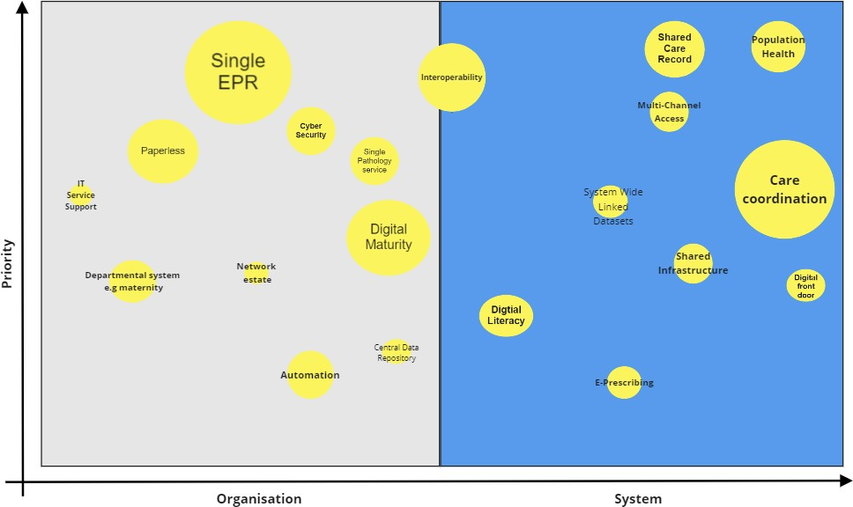

Figure 10 - Organisation vs System

Working together we will deliver a sustainable, highly resilient and secure set of digital capabilities delivered through a rich ecosystem of partners, vendors, national NHS delivery and in-house teams. We will reduce complexity, rationalise infrastructure and reduce duplication where appropriate to reduce costs and ensure it works to supports the delivery of safe and efficient patient care whilst enabling service transformation and integration.
A key principle of “do once” will be followed and we will align our core infrastructure with recognised industry standards and national best practices.

Capability Map
We have identified a set of core capabilities that the Digital Strategy will prioritise investments around and progress maturity in. We will adopt an enterprise architecture approach to the future development of these capabilities and as such can be classified as follows:

Digital Capabilities | Strategic digital assets, capabilities and products
Data Capabilities | Key data, knowledge and intelligence artefacts (tools, processes and platforms)
Technical Capabilities | Comprise the fundamental technical underpinnings required across the JUCD stakeholders. From common technical architectures, current IT landscape, cyber posture
Core enablers | These are the fundamental requirements for the digital ecosystem to operate and include governance and regulatory requirements

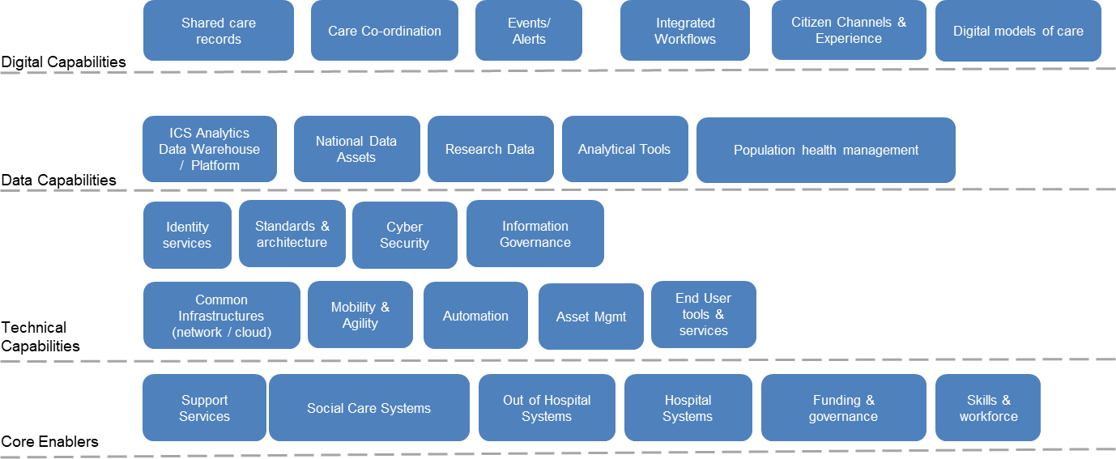

Figure 11 - Digital capability map

Who Pays For What (WPfW)
In 2021/22, NHSx will consolidate national funding for transformational tech projects into a single fund and take steps to support ICSs to make better investments.
From 2022 to 2023, they propose to start moving away from central funding of frontline tech, and ICSs will increasingly be given control over the resources with which to deliver their tech plans.
In 2021, NHSx has brought together several national technology funds. They have called this the Unified Tech Fund.
For the Unified Tech Fund, they have set out what the funding is intended to achieve, how the funding process will work and what areas the funding will address:
  - Frontline digitisation
  - Shared care records
  - Cyber security infrastructure
  - Digital productivity
  - Pharmacy, optometry, dentistry, ambulance, community (PODAC)
  - Diagnostics
  - Digital maternity
  - Digital child health

2022 to 2023 onwards
ICSs will be expected to fund the delivery of their tech plans from their own budgets, the total funding envelope available to ICSs and their constituent organisations. JUCD, through the D3B, will be given control of more resources with which to do so. NHSx will move away from central funding of frontline tech.
ICS funding will cover:
  - applications such as EPRs - procurement, development and management
  - cloud services and data centres
  - core kit and supplies including laptops, printers, telecoms and networks
  - local cybersecurity measures
  - IT programme management
  - training
  - IT service management
  - system transformation, for example shared care records

National funding will cover:
  - national products such as the NHS App
  - national infrastructure
  - pilots linked to the NHS Long Term Plan commitments in advance of national scaling
  - things that need to be done across multiple ICS areas - such as Office 365

Accordingly, D3B will encompass this as part of its oversight and direction role on behalf of the ICS.

Enablers

Digital & Data Governance
Our current governance structure has been through several iterations over recent years and has developed into an engaged cross-discipline, system-wide stakeholder board which prioritises digital investments and tracks progress on delivery of several strategic digital programmes. The board has strong clinical engagement together with system- level CEO oversight.
In 2021, we will formally align the system-wide analytics, data, research and intelligence domains under the Digital Board.
The existing Digital Board will be renamed as the Derbyshire Digital and Data board (D3B) to incorporate a greater role and dedicated workstream/strategy concerning the use of data, knowledge and intelligence across the ICS.
The digital and data board will oversee the execution of both this strategy and the associated Derbyshire Knowledge and Intelligence Strategy and will be responsible for:
  - Executive direction setting and decision making with regard to digital capabilities to support the JUCD ICS plan
  - Provides leadership and accountability for the delivery of Digital & Data Strategy
  - The direction of system-wide resources to support the delivery of the Digital strategy
  - Prioritising and oversight of digital investments and technology initiatives
  - Alignment of this strategy to clinical strategy, JUCD priorities/plans
  - Manage system vs organisational conflicts/priorities
  - Receives recommendations from Digital Implementation Group on initiatives, programme status etc.

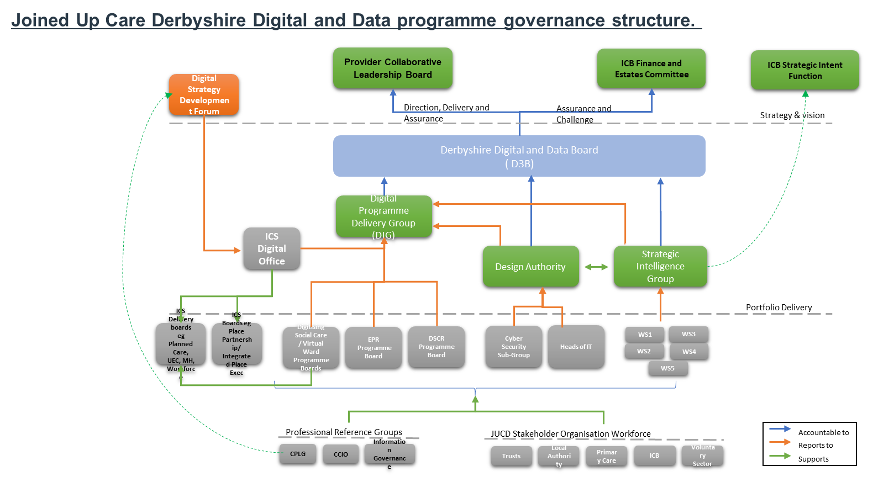Figure 12 - Governance Model
In conjunction with the expansion of the remit of the D3B board, we will establish a number of formal sub-committees:

Design Authority (DA):
The DA will be responsible for setting out and agreeing on the requirements, solution designs, roadmaps, standards etc for the system-wide systems, technologies, enterprise architecture. It engages with the relevant system-wide transformation programmes to ensure the correct technical input and subject matter expertise is applied across domains such as security, compliance, functional alignment and delivery capability.

Strategic Intelligence Group (SIG):
The Strategic Intelligence Group, which comprises members from across the JUCD system including the data management partner North of England Care Support (NECs) CSU was established in 2018. The SIG was established with a remit to share ideas and encourage collaborative working and does not currently sit formally within the formal JUCD system governance model.

The Strategic Intelligence Group will oversee the development of the delivery model for data and intelligence across the JUCD system (establishment of the DSU, embedding STAC and alignment of BI services) and in the future will need to strengthen its posture across the system to hold the delivery DSU to account for the delivery of its services to JUCD.

Digital Implementation Group
The existing Derbyshire Informatics Delivery Board (DIDB) will be re-scoped and will have a prime purpose in managing the delivery of the system-wide Digital & Data project/programmes in line with an agreed annual Operational Plan.

In addition to these formal groups, we will continue to operate and extend, as required, specific professional reference groups to cover topics such as clinical engagement (CCIO), IG and Primary Care. All sub-groups together with D3B provide implementation & delivery and strategy & assurance input to wider system-level committees/groups/boards as required and in line with the JUCD Governance Model.

ICS Digital Office
To deliver coordinated transformation across the JUCD system, there is a need to establish a central transformation, oversight and delivery capability for this strategy.
The ICS Digital Office will consist of a combination of people, processes, metrics and tools which will be used to manage and provide assurance on the delivery of digital initiatives across the ICS.
This does not aim to replace, constrain, duplicate or otherwise interfere with local IT and change projects and teams but may draw on that existing resource to support the delivery of system-wide programmes that potentially span multiple years.
The ICS digital office will go beyond the traditional programme management function and will provide an essential support service to the D3B Board in delivering:
  - Digital Strategy management and oversight
  - Optimise procurement and use of system-level digital funds
  - Design and deliver system digital transformation services
  - Build and mature digital, data and technology capabilities
The ICS Digital Office will also look outwards and provide not only a link into wider system-level programme boards and committees but will proactively drive the exploration of digital opportunities as part of the system-level development plans. Specifically, the ICS Digital Office will link closely to the JUCD Transformation and PMO office to provide a key digital link to the wider transformation agenda.
The ICS digital office will take stewardship of the Digital Strategy, provide the mechanisms to harness the wide range of digital and technology skills, experience and

knowledge across Joined Up Care Derbyshire, and utilise to provide effective cross- functional delivery teams. A recent example of the success of this approach has been the rapid procurement and initial implementation of the Derbyshire Shared Care Record.

Appendix A - Plan on a page

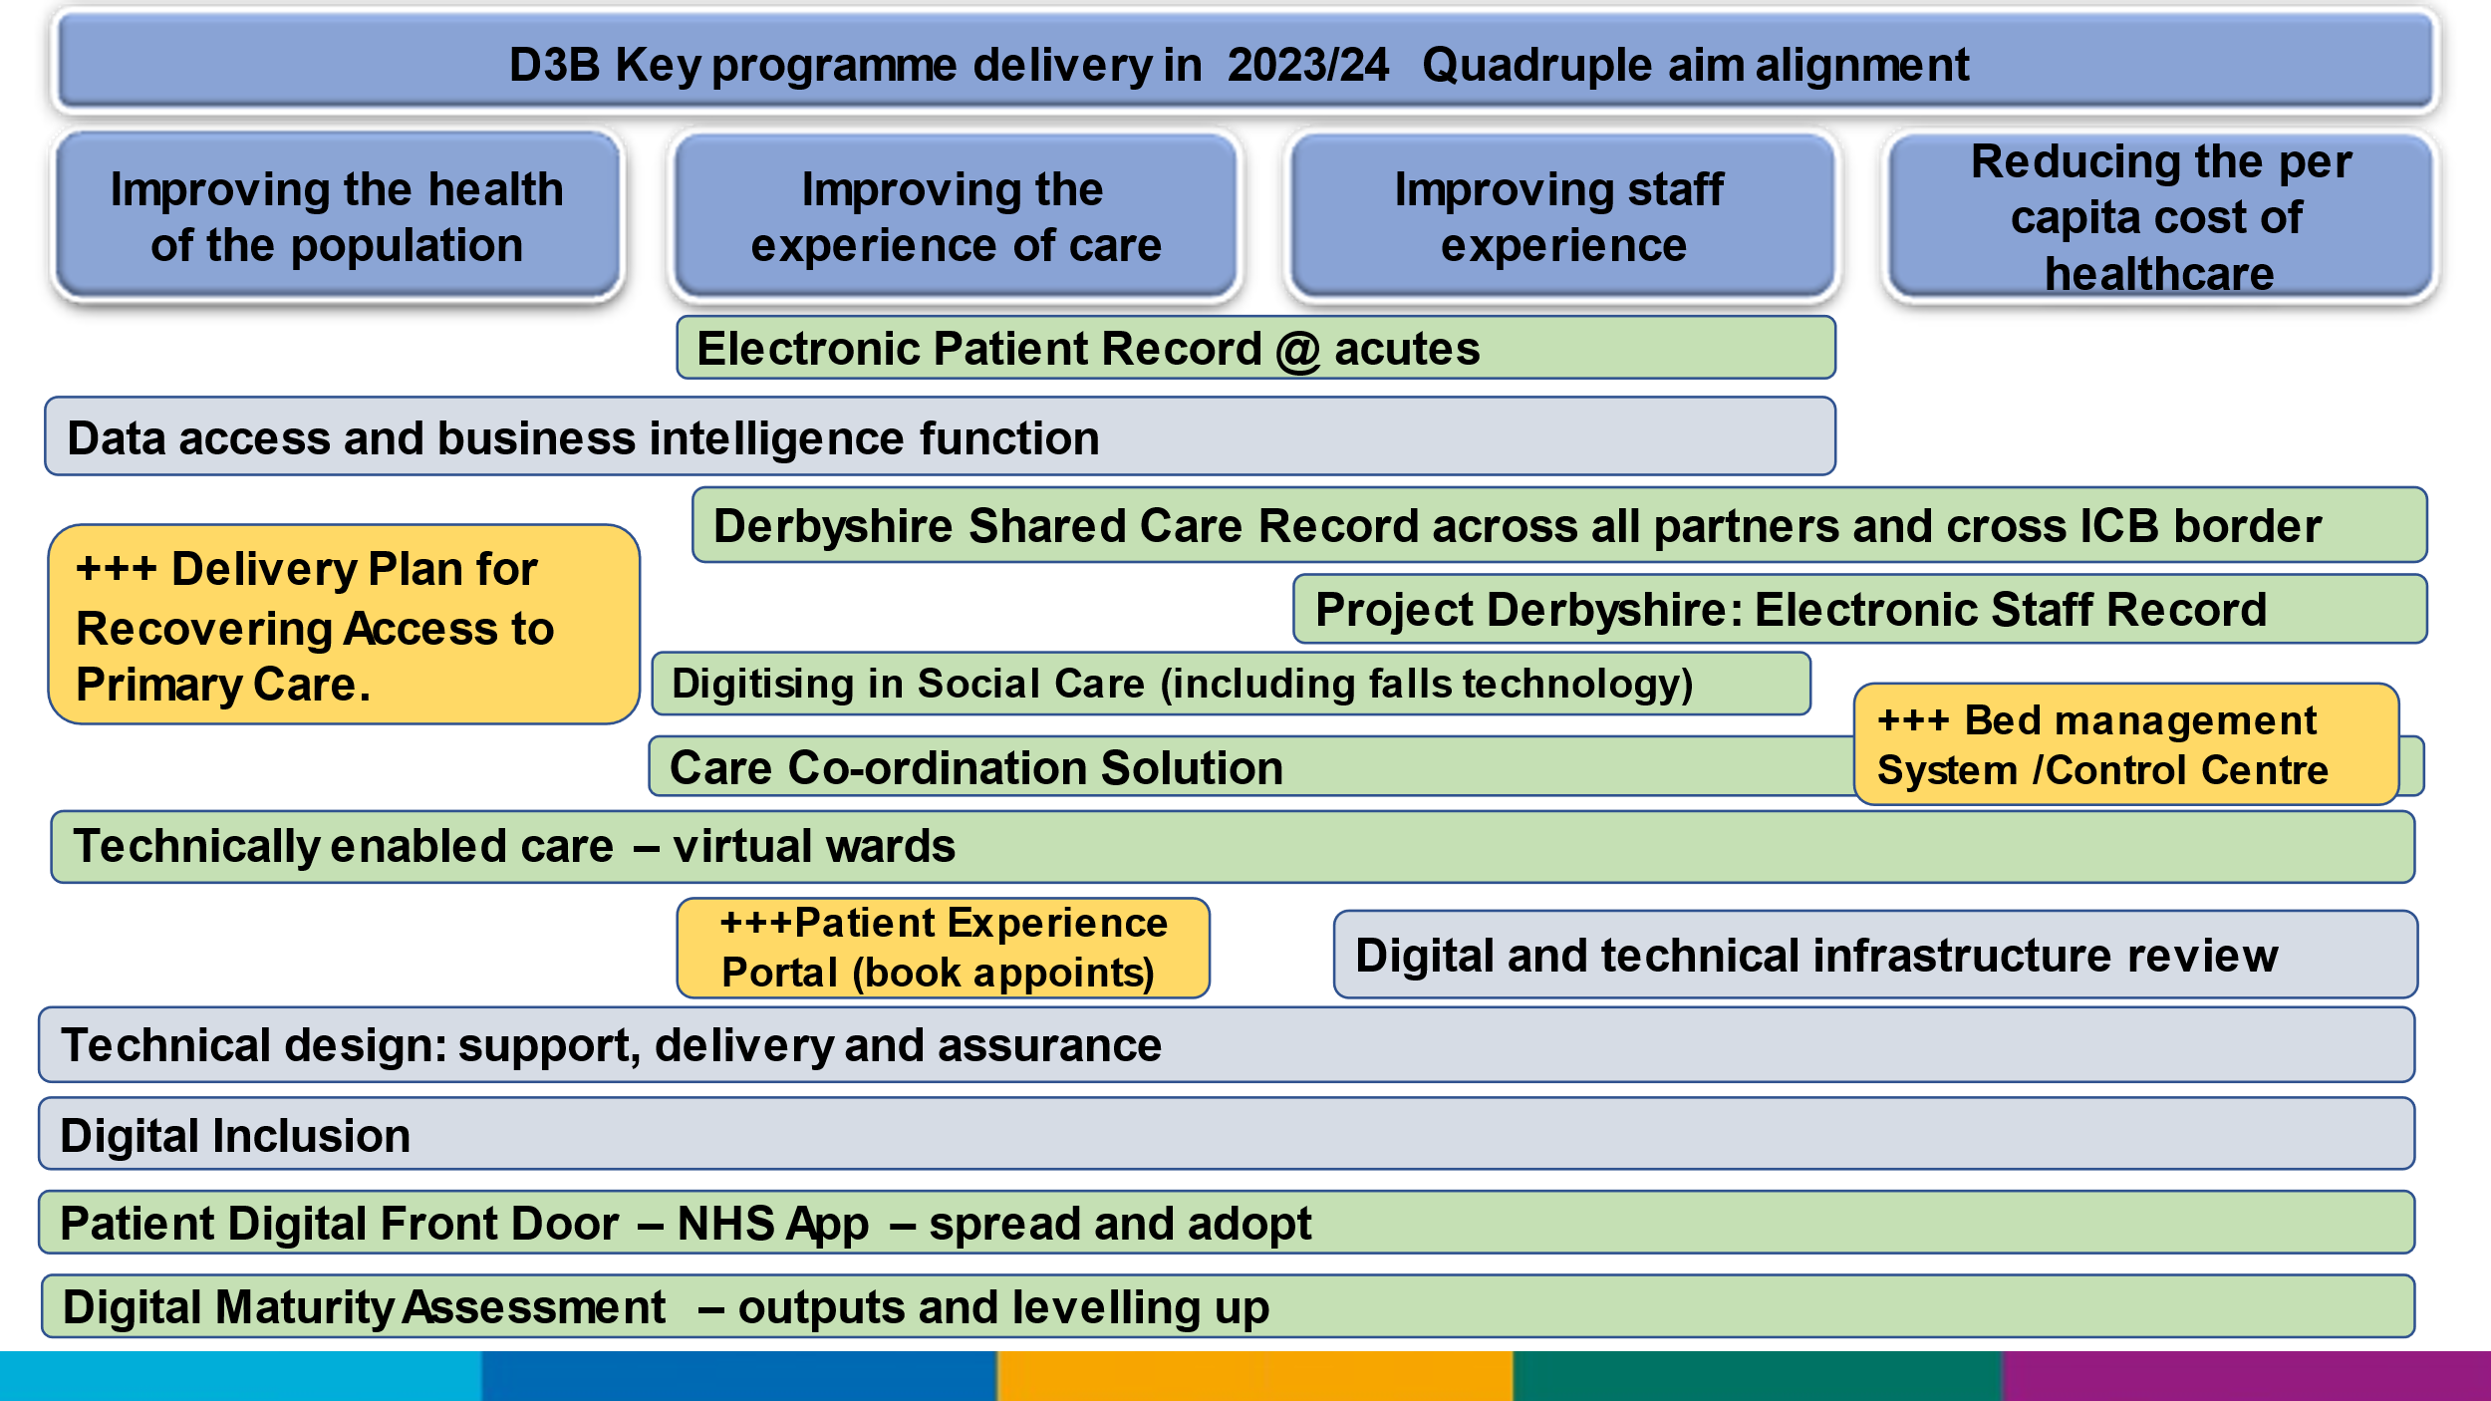
Joined Up Care Derbyshire Digital & Data Strategy - October 2021

Appendix B - JUCD Stakeholder Digital / ICT Strategies

 | 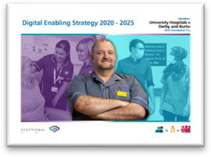  UHDB DIGITAL-2020-2025.P |  | DyCC -  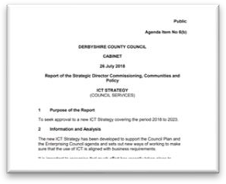  ict-strategy.pdf
 | 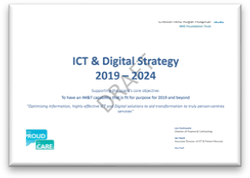  CRHFT_IM&TStrate gy_2019Review_Draf |  | 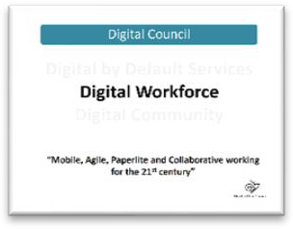  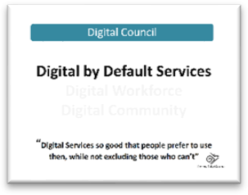  DCC - Derby - Digital Workforce O  DCC - Derby - Digital by Default O
 | 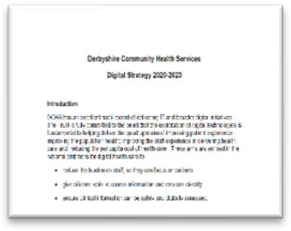  DCHS -Informatics Strategy 2020-23.pd |  |   DHCFT - IMT  Strategy.pdf

P a g e | 40

Appendix C - Decision Support Unit Proposal

Purpose
The Joined Up Care Derbyshire (JUCD) Decision Support Unit (DSU) will be a newly formed team of data and intelligence specialists, responsible for the development and completion of time-limited, strategic projects which are relevant to multiple organisations within the ICS.
The offering of the DSU team will be distinct from existing programmes of work and will focus on the top two tiers of the pyramid in Figure 1 delivering innovative and value-adding system programmes of work.
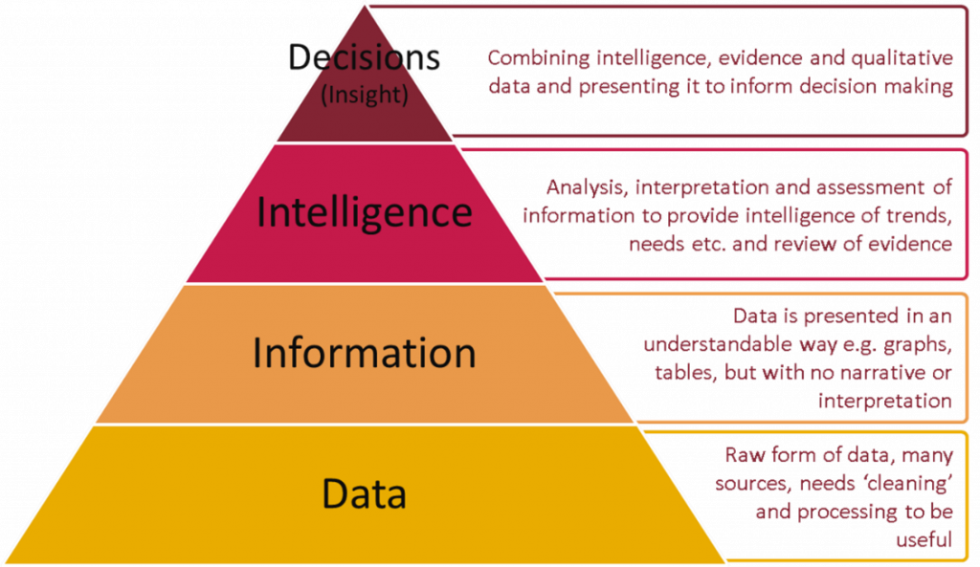
Figure 1: Data to decisions pyramid
Taken from PHE https://publichealthmatters.blog.gov.uk/2018/12/05/from-data-to-decisions- building-blocks-for-population-health-intelligence-systems/

The benefits to the ICS of the DSU offering will be:
- The provision of specific projects focused on understanding and improving population health and health inequalities
- Embedding research, evidence and qualitative analysis alongside quantitative, statistical and predictive modelling to support decision-making
- Guidance to system leaders on converting data into insight and insight into action
- Development of evidence-based and robust analytical methods and tools for use across the system
- Linkage into Midlands Region Decision Support Network for wider pieces of analysis and training/development
- Link to wider intelligence expertise and capability e.g. local universities, AHSN etc.

Structure
The DSU team will include intelligence specialists, managers and leaders seconded and operating autonomously from system partners as a core team. Depending on the scope of the DSU's programme of work, the additional specialist resource will be requested via business cases from the ICS as needs arise. Very specialist expertise e.g. health economics, statistician, will be accessed externally as needed.
As an initial set-up, it is recommended that a core team of 5 individuals is established on a 12 month fixed-term or secondment basis, with an annual budget of approximately £200-£250k.
Further work to adequately evaluate the optimal structure for the DSU is required, which we recommend forms part of the responsibility for the fixed term roles appointed to progress the actions and recommendations laid out in this strategy.

Operating Model
Maximum benefit will be gained from a DSU, by emphasising the novel approach to system- wide intelligence projects which the DSU can embed. This means that the DSU should not operate as a group from which requests can be made and the programme of work developed should be strategic and not operational in nature.
To develop and complete projects aimed at improving the health of the entire Derby and Derbyshire population, outcomes-based accountability (OBA) and population health management (PHM) frameworks should be guiding principles that are embedded within the operating model and work programme of the DSU.
The OBA and PHM frameworks are approaches that promote data-led decision making and outcomes-focused projects, which will effectively enable JUCD to address known issues in our system:
- Comparatively poor health outcomes for local people
- Significant inequalities in health outcomes
- Variations in the quality of care
- Inequity in access to care
- Unsustainable demand and model of delivery of health and care
A further framework that is based on principles of collaborative working and improving wellbeing whilst reducing health inequalities is Joint Strategic Needs Assessments (JSNAs). Completing JSNAs is currently a statutory duty for local authorities and CCGs, which is overseen by our Health and Wellbeing Boards (HWBs). To date, JSNAs locally have not gained traction in the wider system and are not extensively used by any organisation. Could the DSU be an opportunity to be innovative and do our JSNAs differently?

Governance
Organisational accountability for the DSU will be through the statutory ICS organisation and the strategic Intent function.
The DSU activities will be overseen by the system-wide Strategic Intelligence Group (SIG) which reports through to the Derbyshire Digital & Data Board

Appendix D - Remote access to health and Care Services

Remote Access to ENC 7 - Digital
Health and Care Ser Inclusion Derbyshire

Appendix E - Digital Inclusion checklist

To ensure inclusivity when using remote access to Health and Care Services
Remote access to health and care services, for example, having a GP appointment over the phone, or via a video consultation, for many is a positive development, which people have reported to find convenient, quick, and in some instances making appointments more accessible.
However, for others, it can be a negative experience, with people reporting technical difficulties, fear and mistrust of appointments done in this way. Clinicians need to be aware of groups of people being left behind, for example, people with learning disabilities, autism, older people, and those digitally excluded because they don’t have access to the internet and/or have low levels of digital literacy may not fit neatly into a ‘digital by default approach. This imbalance must be proactively addressed so that as some services continue to deliver elements of their services remotely people are not left behind, perpetuating, and compounding existing factors that lead to inequalities.

The following checklist, compiled from extensive insight gathered by the Joined Up Care Derbyshire (JUCD) System Insight Group, aims to support this approach by ensuring that consideration has been given to the needs of all patients and service users, to create an equal space for health and care providers and patients to interact.

Theme | Have you considered? | Yes/No
Digital Literacy: Not all individuals will know how to use digital methods of communicating, e.g. email, text, or video consultation platforms. | Do you always consider this before making an appointment with an individual?
Availability of hardware and internet access: Not all individuals will have the correct hardware, with the right specifications, to enable video consultations to take place, or to follow links in text messages. They may also not have readily available internet access. | Do you always consider this before making an appointment with an individual?
 | When sending out text messages including links to book appointments, or access information, do you provide an alternative option for those without sufficient hardware or internet access?
Red Flags: Clinicians need to consider how they might change the assessment process to increase screening for red flags and sinister pathologies, to offset limitations of conducting assessments remotely, and concerns  about missing signs of safeguarding issues. | Do you have a process in place for screening for red flags?
Appropriateness: Not all appointment types are appropriate for remote consultations. In-person appointment may be more appropriate for communicating bad news, where confidential environment is not available, and obviously where a physical examination or test is required. | Do you have a process in place to consider the ‘appropriateness’ of offering a remote appointment with an individual before the appointment is made?  Do you have a process in place to allow where requested the option for patients to exercise their personal choice and move from remote to face to face, for example, if the patient feels that a  remote appointment is not fully addressing their needs?

Quality Conversations: There is a need for as much time and effort to be put into quality conversations through remote access, as there is face to face, if not more so, e.g. time to check understanding, especially  during phone conversations, where it is not possible to read non-verbal cues. | Do you consider this aspect of care?
Support patients need to find a safe place, and prepare themselves for the appointment: It’s important that clinicians respect people’s time and opportunities to fit in appointments with their lives, ensuring there is a time window for the appointment, which allows patients to find a confidential and safe  place to talk and prepare for the conversation. | Do you give out allotted appointment times, or appropriate time windows for appointments?
Provide Guidance: It is important that service providers offer guidance and set clear expectations prior to remote appointments. This includes guidance about how the appointment will work, and how long it will take. Clear joining instructions, and guidance on how to use any technology, and what to do if something goes wrong, should be sent out when using video consultation software.  Service providers should provide a clear explanation of their appointment process via their website, reception teams, and written communications. | Do you have a process in place for communicating your remote appointment procedures, and written guidance available?
How the experience is evaluated: As with any other service, it is important to design the remote experience with individuals. Hence it is important to have methods  in place to seek feedback about the individuals experience and use feedback to improve the service. | Do you have a process in place to seek feedback from individuals accessing your service?
Acknowledging and giving reassurance on the exchange of data: It is important that there are robust systems in place for acknowledging receipt of data submitted by individuals, e.g. receipt of photographic images. This should include communicating information  to individuals about how the information will be stored, and when/how the individual will be contacted. | Do you have a policy in place for handling data submitted in this way?
Communication issues and barriers: People whose first language isn’t English, people with Learning Disabilities or Autism, and people with sensory impairments may all find it more difficult to use remote methods of accessing appointments. Some individuals may also need the assistance of their carer to communicate their problem, or a young person may need their parent present for support. | Do you always consider communication requirements before making an appointment with an individual?

Appendix F – JUCD PHM framework
JUCD PHM
Framework v2.ppt

Appendix G - Informatics Skills Mapping
Skills Mapping Report- Derbyshire

