Consent Form for Dynamic Support Pathway

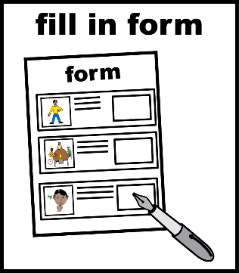 | This is a consent form for the Dynamic Support Pathway.  A consent form is for you to say something is OK.
The NHS will keep your details on a list. This list is called the Dynamic Support Register.

For more details about data security and protection, visit: https://www.derbyshirehealthcareft.nhs.uk/about-us/data-security

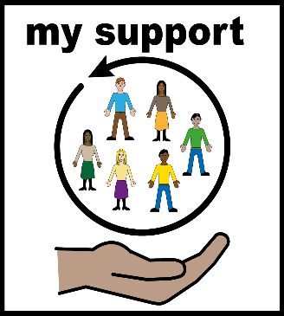 | The Dynamic Support Pathway helps to make sure you get the right support when you need it.
There is a leaflet that goes with this form.

The leaflet is called ‘Guidance notes for individuals, their families, and their carers.’

 | It is important that you and your carer read the leaflet.
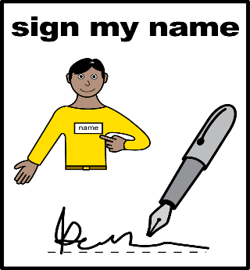 | If you are happy to be on the Dynamic Support Register you will need to sign this form.  You can change your mind and ask to be removed from the Dynamic Support Register at any time by emailing: dhcft.ndpat@nhs.net  If you ask to be removed, you can be added again at any time if you would like to.

I am happy to be on the Dynamic Support Pathway

Date:
Full name:
Signature:
Date of birth:
NHS number:
Home address:

Details of professional consenting person:

Print name:
Signature:
Role:
Date/time:

