Consent Form for the Keyworking service

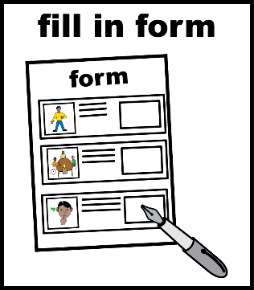 | This is a consent form for the Keyworking service.  A consent form is for you to say something is OK.
 | The Keyworking service supports people up to the age of 25.  The NHS will keep your details on a list. This list is called the Dynamic Support Register.  For more details about data security and protection, visit: https://www.derbyshirehealthcareft.nhs.uk/about-us/data-security
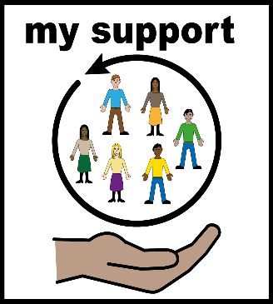 | You will be allocated a Keyworker to help you get the support you need at the right time. The Keyworker will help you understand your care plans.
 | There is a leaflet that goes with this form about the Keyworking service.  The leaflet is called “Keyworking service in Derbyshire”.  Further information about the Keyworking service can be found on their website Derbyshire Keyworker service | Affinity Trust
 | It is important that you and your carer read the leaflet.
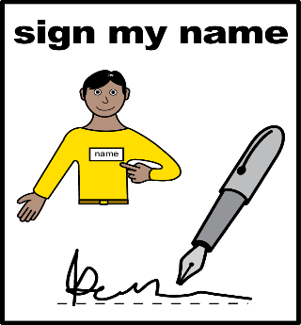 | If you are happy to be referred for a Keyworker you will need to sign this form  You can change your mind and ask to be removed from the Keyworking service at any time by emailing: dhcft.ndpat@nhs.net

I am happy to be referred to the Keyworking service.

Date:
Full name:
Signature:
Date of birth:
NHS number:
Home address:

Details of professional consenting person:

Print name:
Signature:
Role:
Date/time:

