EDS Domain 2 scoring report

The Integrated Care Board (ICB) Chief People Officer and Assistant Director of Human Resources and Organisational Development led an engagement event with colleagues from all directorates on 13th February 2025.

Representatives from all directorates, with a broad range of protected characteristics as specified in the EDS2 guidance' were invited to attend the event.

A presentation was given on how the ICB has enabled and embedded services to support our ICB workforce in relation to health and well-being activities and initiatives against the EDS2 Domain 2 standards.

Colleagues were asked to score on how mature they thought that these services were embedded and effective with the ICB using the nationally prescribed scoring system.

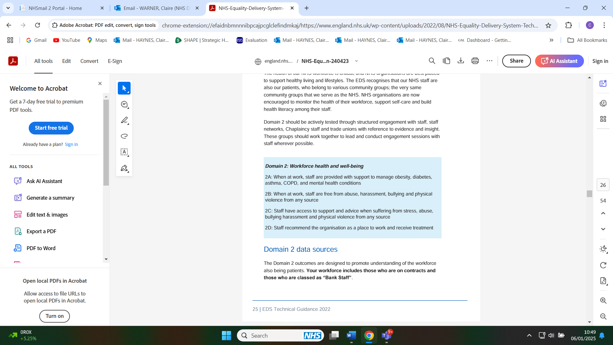

Scores were

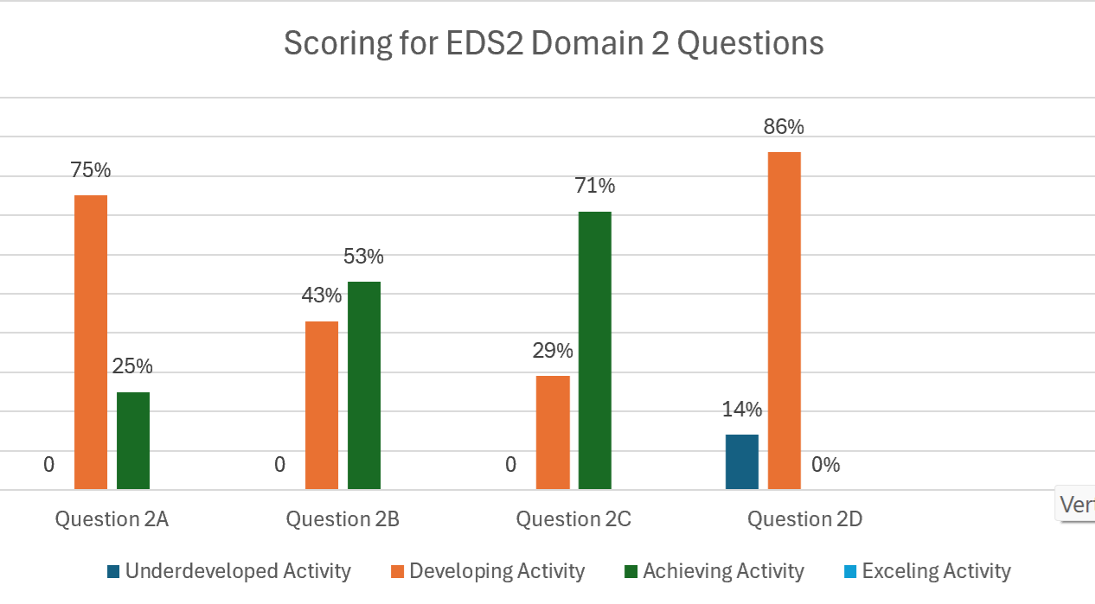

The results show that colleagues feel there is still developing work needed to take place in supporting staff with long term conditions at work and significant improvements needed to recommend the ICB as a place to work.
There are positive results for the majority of colleagues needing access for support and advice for a range of well-being themes and is embedded into the organisations culture.
The results show a mixed view from staff experiencing abuse at work.

Feedback was sought from colleagues on what further improvements they would like to see to improve the effectiveness of these services. The information below provides an overview of the key feedback themes for each question.

Question 2A
- Acknowledgement that a lot of well-being support is available to staff but is not necessarily visible or embedded in the organisation.
- Variable line management experiences affect the way well-being offers are being communicated or made visible in local teams.
- Unless line managers buy into the vision of well-being as part of our culture then staff support and experience will remain variable.

Question 2B
- Unacceptable behaviour from colleagues in the system towards ICB staff was identified as a theme that needed addressing.
- Line managers need to create a psychologically safe environment to allow staff to speak up and avoid bullying.

Question 2C
- Support services feel embedded in the organisation
- Unacceptable external partner behaviours are an ongoing source of stress.
- Variable line management experiences affect the way well-being offers are being communicated or made visible in local teams.

Question 2D
- The organisation feels fragile after the restructure and is constantly firefighting.
- Significant and constant change from the Government and NHSE.
- Colleagues feeling disempowered by line managers.
- Long decision making, risk aversion and over complicated governance arrangements
- Perceptions of merging with Nottingham ICB.

Summary and next steps

The scores from this engagement process have fed into the ICB's overall EDS2 rating which legally has to be published on the ICBs public website by 28th February.

The feedback will be used to create an action plan which will align to the wider ICB OD plan aimed at creating an inclusive and compassionate culture and making the ICB an even better place to work.

The development of the action plan will be supported by the ICB Diversity and Inclusion Network and OEIG with regular updates to the Executive Team.

