Enjoyed the Quality Conversations Programme but want to reinforce your learning?
Do you want a quick refresh and chance to practise some Quality Conversations techniques in a safe & friendly environment?

Why not bring your awkward conversations to…
*** 1 hr Embedding your learning session ***
How will the Session help me?
Bring a conversation scenario to the session, practise your QC techniques, listen to others, give and receive feedback and refresh your knowledge in a safe and friendly environment.

What’s the training like?
The interactive online session lasts just one hour. It will be a quality conversation.
Groups are small with just 6 people per session. We need a minimum of 4 people to attend to make the session viable.

It’s straightforward to join, you just need access to a computer with a web-cam and microphone in a quiet room with internet access.

This interactive learning session is free and available to all staff across Derbyshire working in acute care, primary care, community services, social care and voluntary services who have attended a QC course.
See below for dates and email to apply for a place.

Date | Time
23rd Aug | 3pm to 4pm
7th Sept | 10am to 11am
13th Sept | 4pm to 5pm
4th Oct | 3pm to 4pm
1st Nov | 3pm to 4pm

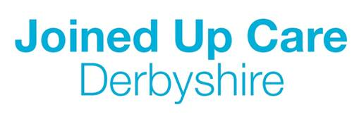
Places are limited so don’t miss out. Reserve your place by email: alison.merriman@nhs.net

