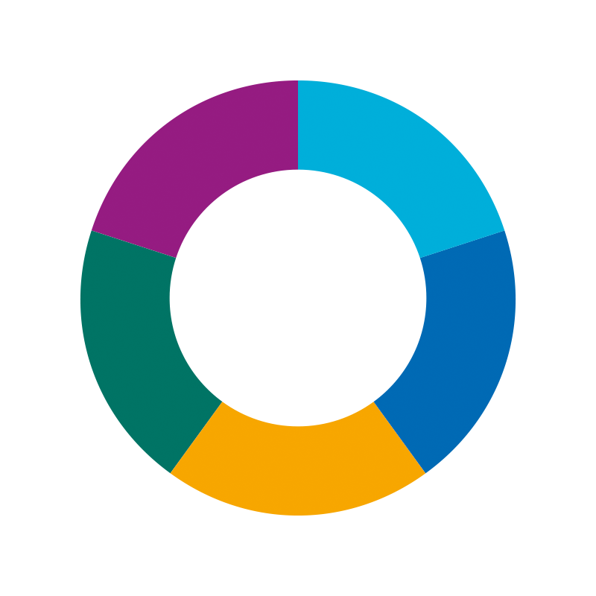
East Midlands Fertility Policy Review
East Midlands Fertility Policy Review
Case for Change Summary
NHS Derby and Derbyshire ICB

Case for Change – Summary Version

(You can find the full version here)

1. Glossary of Acronyms
- AI – Artificial Insemination – means the same as IUI, see link to definition below.
- BMI – Body Mass Index
- DI – Donor Sperm Insemination – donor sperm is used to fertilise an egg inside your body. Used in IUI, see link to definition below.
- ICB – Integrated Care Board – ICBs are statutory NHS organisations which plan and manage health services for a local population.
- ICSI – Intracytoplasmic Sperm Injection – this is an infertility treatment, which involves injecting sperm into a person's eggs in a laboratory. Used in IVF – see link to definition below.
- IUI – Intrauterine Insemination
- IVF – In Vitro Fertilisation
- LB – Live Birth – a live birth occurs when a baby exits the mother showing definite signs of life.
- NICE – National Institute for Health and Care Excellence

2. Executive Summary

Infertility is when a women cannot get pregnant (conceive) despite having regular unprotected sex.

A 'Fertility Policy' outlines the treatment an individual can receive from the NHS in the area they live in if they are struggling to get pregnant.

The East Midlands region covers Derby and Derbyshire, Nottingham and Nottinghamshire, Northamptonshire, Leicester and Leicestershire, Rutland and Lincolnshire.

At the moment, there are differences in Fertility Policies across the East Midlands Region – these differences relate to things such as a person's age, BMI (a calculation to determine someone's healthy weight) and the number of cycles of NHS funded treatment available. There are also different access criteria for same-sex couples, those with children from previous relationships, and single people.

This review of fertility treatment in the East Midlands, suggests that we should create a shared Fertility Policy for the East Midlands region, meaning that everyone gets access to Fertility treatment using the same criteria. The proposed changes are detailed on pages 6, 7, and 8.

At this stage, the proposals are suggestions. Following approval by decision making groups within each Integrated Care Board (ICB), there is now a period of engagement to understand the impact of these proposed changes on our communities and gather feedback to write the final shared policy.

3. Introduction

Fertility refers to the ability to get pregnant, while infertility is the difficulty or inability to get pregnant naturally without help. Infertility is diagnosed when a couple has been trying to get pregnant unsuccessfully for a long period of time, and medical help may be needed.
- Over 80% of couples under 40 will become pregnant within a year of regular unprotected sex.
- For those who don’t become pregnant in the first year, about half will do so in the second year, bringing the overall chance of becoming pregnant to over 90%.
- It’s estimated that 1 in 7 couples in the UK (around 3.5 million people) struggle with becoming pregnant and having a baby.

Risk factors for infertility include:
- Increasing age
- Being underweight or overweight
- Smoking

Common causes of infertility include:
- Irregular ovulation – Ovulation is the term for when a mature egg is released from the ovary. It’s part of the menstrual cycle (period) and plays a major role in pregnancy.
- Semen quality, e.g. low sperm count.
- Blocked or damaged fallopian tubes which can mean the sperm can't meet the egg to fertilise it.
- Endometriosis – Endometriosis is where cells similar to those in the lining of the womb (uterus) grow in other parts of the body. This can impact on getting pregnant.

Please Note: Fertility Treatment may also be accessed by same-sex couples, single women and trans-men, who need support with fertility treatment, not just those experiencing infertility issues.

Treatment options vary based on the cause and may include:

- Intrauterine Insemination (IUI): helps to increase the chances of getting pregnant, by putting sperm directly into the womb (uterus) when a woman is ovulating. It's also called artificial insemination.

- In Vitro Fertilisation (IVF): during IVF, an egg is removed from a woman's ovaries and fertilised with sperm in a laboratory. The fertilised egg, called an embryo, is then returned to the woman's womb to grow, and develop. It can be carried out using a woman's own eggs, and a partner's sperm, or eggs and sperm from donors.

In the East Midlands, five Integrated Care Boards (ICBs) manage health and care services:
- NHS Derby and Derbyshire
- NHS Nottingham and Nottinghamshire
- NHS Northamptonshire
- NHS Leicester, Leicestershire and Rutland
- NHS Lincolnshire

Each ICB has its own Fertility Policy, outlining treatment guidelines.

4. Reasons for Reviewing the Fertility Policy

4.1. Differences in Policies across the East Midlands

There are significant differences in Fertility Policies across the East Midlands,
especially when it comes to age, BMI, and the number of cycles offered. Additionally, these policies often have different access criteria for same-sex couples, those with children from previous relationships, and single people. This review aims to create one fairer policy for everyone in the East Midlands, with priority given to those with confirmed fertility issues.

Most ICBs are following an old national policy from 2014 that no longer reflects
current laws or the views of the people the policies are written for. The new NICE guidelines on fertility may not be available until 2025. Because this is a long time to wait, this review of Fertility Policies in the East Midlands will go ahead now.

Recent boundary changes in the East Midlands have caused more policy gaps within ICB regions, so a joined up approach is needed. This is relevant to NHS Derby and Derbyshire ICB where the decision has been taken to move the area of Glossopdale from Greater Manchester into Derbyshire, and NHS Nottingham and Nottinghamshire where the decision has been taken to move the area of Bassetlaw from South Yorkshire into Nottingham and Nottinghamshire.

4.2 Financial Pressures

The NHS faces growing financial and operational challenges because of a rising
demand for services and constrained resources. It is the job of the Integrated Care Boards to make sure that all services are value for money and are affordable.

The cost of fertility treatments across the East Midlands ICBs from 2019/20 to
2022/23 is outlined in the tables below.

Table 1 shows the estimated costs of IVF/ICSI and AI/DI/IUI cycles across the East Midlands ICBs from 2019/20 to 2022/23. Detailed financial analysis is included in appendix A of the full Case for Change that can be found here.

 | 2019/20 | 2020/21 | 2021/22 | 2022/23 | Total
IVF/ICSI cost*
NHS Derby and Derbyshire ICB | £584,800 | £479,600 | £472,800 | £542,000 | £2,079,200
NHS Leicester, Leicestershire, and Rutland  ICB | £417,600 | £523,400 | £522,800 | £515,400 | £1,979,200
NHS Lincolnshire ICB | £281,000 | £260,400 | £254,600 | £251,200 | £1,047,200
NHS Northamptonshire ICB | £472,000 | £218,200 | £352,000 | £372,200 | £1,414,400
NHS Nottingham and Nottinghamshire ICB | £596,800 | £473,200 | £571,200 | £441,000 | £2,082,200
TOTAL FOR 5 EAST MIDLANDS ICBs | £2,352,200 | £1,954,800 | £2,173,400 | £2,121,800 | £8,602,200
 | 2019/20 | 2020/21 | 2021/22 | 2022/23 | Total
AI/DI/IUI cost
NHS Derby and Derbyshire ICB | £825 | £2,475 | £825 | £1,650 | £5,775
NHS Leicester, Leicestershire, and Rutland  ICB | £172,425 | £94,875 | £141,900 | £112,200 | £521,400
NHS Lincolnshire ICB | £14,025 | £16,500 | £14,025 | £10,725 | £55,275
NHS Northamptonshire ICB | £1,650 | £1,650 | £2,475 | £825 | £6,600
NHS Nottingham and Nottinghamshire ICB | £0 | £0 | £0 | £0 | £0
TOTAL FOR 5 EAST MIDLANDS ICBs | £188,925 | £115,500 | £159,225 | £125,400 | £589,050

5. Evidence-Based Decisions

Evidence-based decisions are choices made using the best available information, research, and facts, rather than opinions or guesses.

A specialist Public Health Consultancy was asked to review current fertility policies across the East Midlands ICBs. The report provided different situations to illustrate the impact of changing policies, such as BMI, age criteria, and the number of IVF cycles. You can find more information about their conclusions in the full version of the Case for Change that can be found here.

6. Proposals (recommendations) for East Midlands Fertility Policy

ICBs must consider these things when deciding on policy criteria:
- Number of patients treated
- Outcomes (e.g. the number of babies born safe and well)
- Cost to the NHS at a time when finances are strained
- The capacity of local services to delivery fertility treatment
- Impact of changes on the waiting list
- Quality of provision, in terms of ensuring services are safe, clinically effective, and provide a good experience for patients

With these factors in mind, these are the proposals for the combined policy:

6.1. Surrogacy

Surrogacy is when a woman agrees to carry and give birth to a baby for someone else who cannot have a baby on their own. After the baby is born, the child is given to the person or couple who arranged the surrogacy.

In line with NHS England policy, surrogacy treatments are not funded by the NHS. The East Midlands Fertility Policy will not provide support for treatments involving surrogates.

6.2. Number of Cycles

Most areas in the East Midlands only offer one cycle of In Vitro Fertilisation (IVF), except Bassetlaw and Glossopdale. The more cycles offered, the greater the cost. Therefore, as there is no additional money available for fertility treatment, it is proposed that the East Midlands Fertility Policy offers one cycle of IVF treatment.

6.3. IUI/DI Funding and Cycles

It is proposed that intrauterine insemination (IUI), and donor insemination (DI), is
offered. It is proposed to offer up to three cycles of unstimulated IUI/DI for
couples/individuals where intercourse is not possible, and there are no other identified fertility issues before considering IVF.

It is proposed that single women or trans men with no known fertility issues will also be offered up to three cycles of unstimulated DI.

As the success rate for these procedures is low, it is proposed that going straight to IVF can be discussed with the person wishing to become pregnant. There does not need to be intrauterine insemination (IUI) or donor insemination (DI) before considering IVF.

6.4. BMI and Age

It is proposed that the new policy should align with NICE guidance on BMI and age criteria.

For heterosexual couples, the age criteria apply to women only.

For same-sex couples, BMI and age criteria should apply to the pregnancy carrier and egg provider.

The age range is recommended to be 42 and under. The BMI is recommended to be in the range of 19-30.

6.5. Smoking/Vaping

It is proposed that the policy will need all parties involved in treatment to be non-smoking or have quit smoking/vaping, due to the negative impact of smoking on
fertility and pregnancy.

Studies have shown that people who smoke can take longer to get pregnant. It can also increase infertility. Research has also shown that those who smoke and are carrying a baby, risk complications, this can include premature (early) birth. It can also cause low birth weight, which can cause serious health problems for some babies.

6.6. Living Children

It is proposed that the policy will maintain the requirement that neither partner should have a living child from their current or previous relationships, as most current East Midlands policies stipulate.

6.7. Partners Who Have Been Sterilised

Female sterilisation is a permanent type of contraception, where the fallopian tubes are blocked or cut to stop sperm meeting an egg. Male sterilisation, referred to as Vasectomy, is a procedure that stops sperm being ejaculated from the penis during sex. Sterilisation is offered within the NHS as an irreversible method of contraception.

It is proposed that the policy will not fund fertility treatments for couples where
infertility is related to sterilisation of either partner.

6.8. Same-Sex Female Couples

It is proposed that same-sex female couples will be recognised as requiring fertility support and get a referral for fertility treatment if they meet all other criteria.

6.9. Single Women/Trans Men

It is proposed that single women and trans men will be recognised as requiring
fertility support and get a referral for fertility treatment if they meet all other criteria.

6.10. Gametes Storage

Gametes are the reproductive cells involved in making a baby. They carry half
of the genetic material needed to create a baby. In humans, eggs are the female
gametes and sperm are the male gametes.

It is proposed that the policy will include funding for the storage of gametes if the
patient is about start treatment likely to permanently affect their fertility, e.g.
treatment for cancer.

6.11. Duration of Storage

The legal duration of storage of gametes is governed by legislation and regulations. It is proposed that NHS funded storage of gametes or embryos will be available for up to three years.

7. Next Steps

There will be a period of engagement for 2 months with residents of the East
Midlands region, to give individuals the opportunity to feedback on the suggested proposals and have opportunity to say how these proposals may impact on them.

The feedback gathered from this engagement will be collated and fed into the
development of the final East Midlands Fertility Policy.

You can read the full Case for Change here.

