First Floor
Cardinal Square
10 Nottingham Road
Derby
DE1 3QT

Tel: 01332 868730
Email: ddicb.foi@nhs.net
Web: www.derbyandderbyshireicb.nhs.uk

Date: 6 September 2022

FREEDOM OF INFORMATION – DECISION NOTICE

Dear Sir / Madam,

FOI Reference Number: 1657

I refer to your email of 24 August 2022 requesting information in respect of costs for abortion procedures.

I can confirm on behalf of Derby and Derbyshire Integrated Care Board (DDICB), and in accordance with S.1 (1) of the Freedom of Information Act 2000 (FOIA) that we do hold the information that you have requested. A response to each element of your request is detailed below:

I would like to know how much the Integrated Care Board (ICB) pays providers for a variety of abortion services in the context of the NHS England national tariff payment system.

Below is a partial table of the national tariff prices (2022/23) for abortion procedures, as set out by NHS England: https://www.england.nhs.uk/wp-content/uploads/2020/11/22-23NT_Annex-DtA-National-tariff-workbook.xlsx (tab APC & OPROC, rows 1,704 to 1,713)

To respond to the FOI, please can you fill out the third column of the table below with how much the ICB pays providers for each procedure set out in the first column. The second column is the rate for each procedure according to the national tariff system.

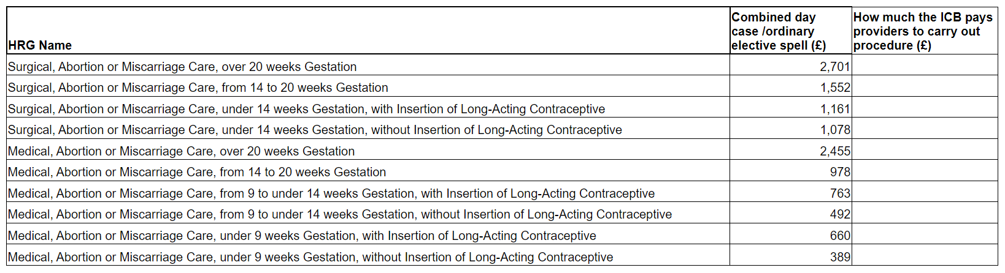

Our response:

I can confirm that we follow the national tariff, as detailed above.

I hope that this answers your queries with the information we currently hold, but if I can be of any further assistance please do not hesitate to contact me.

If you are dissatisfied with the handling of your request, you have the right to ask for an internal review. Internal review requests should be submitted within two months of the date of receipt of the response to your original letter and should be addressed to:

NHS Derby and Derbyshire ICB
FOI Team
First Floor
Cardinal Square
10 Nottingham Road
Derby
DE1 3QT

Or:

ddicb.foi@nhs.net

If you are not content with the outcome of our review, you may apply directly to the Information Commissioner for a decision. Generally, the ICO cannot make a decision unless you have exhausted the complaints procedure provided by the ICB.

The Information Commissioner can be contacted at: Information Commissioners Office, Wycliffe House, Water Lane, Wilmslow, Cheshire SK9 5AF, telephone 0303 123 1113, email casework@ico.org.uk.

Yours faithfully,

Kathryn Jacklin
FOI Officer
Derby and Derbyshire Integrated Care Board

All information we have provided is subject to the provisions of the Re-use of Public Sector Information Regulations 2015. Accordingly, if the information has been made available for re-use under the Open Government Licence (OGL) a request to re-use is not required, but the licence conditions must be met. You must not re-use any previously unreleased information without having the consent from the ICB. Should you wish to re-use previously unreleased information then you must make your request in writing (email will suffice) to the FOI Lead via ddicb.foi@nhs.net. All requests for re-use will be responded to within 20 working days of receipt.

