Guidance - Trust 2 Action Model

A community‑powered engagement and
accountability cycle

- Building trusted relationships
- Empowering communities
- Embedding community priorities
- Delivering accountable actions
- Addressing health inequalities
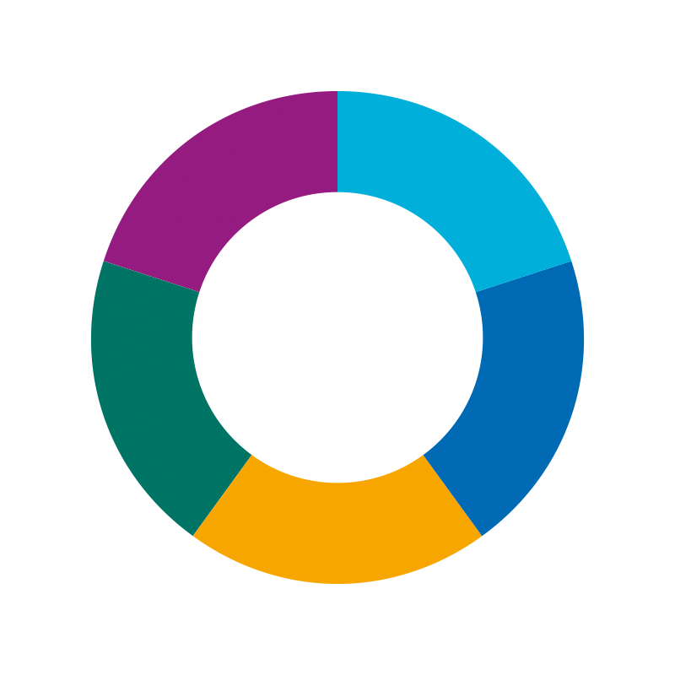

What This Model Is
The Trust 2 Action Model (T2A) is a relationship-centred approach to reducing health inequalities by working with communities, not doing things to them. It brings together the strongest elements of best practice, models, frameworks and approaches such as:

- Community empowerment
- Trusted Leaders, Trusted Voices, Trusted Places (3Ts)
- NICE community engagement guidance (NG44)
- Coproduction, community organising and trauma‑informed practice
- Population health and health inequalities frameworks
- Working in partnership with people and communities: statutory guidance
- Asset‑based and strengths‑based approaches

T2A is designed to support proportionate, inclusive and accountable engagement, particularly with communities experiencing the greatest unfairness. It recognises communities as holders of insight, expertise and lived experience that must shape decisions, priorities and solutions
Why Health Inequalities Matter
Health inequalities are unfair and avoidable differences in health outcomes, access and experience. They are shaped by the wider conditions in which people are born, grow, live, work and age.
People from marginalised or disadvantaged communities are more likely to:
- Develop long‑term conditions earlier
- Experience poorer maternity and mental health outcomes
- Access services later or not at all
- Face barriers such as stigma, fear, language, culture, discrimination or past harm
Understanding inequality is the starting point for working fairly. Engagement must be proportionate to need, not evenly distributed.
Why has this framework been developed?
Communities are often asked to engage with health and care systems without adequate preparation, influence or follow‑through.
Engagement is frequently shaped by system priorities, with limited power‑sharing and unclear expectations.
When insight is gathered but not acted on, or when feedback is slow or absent, trust is damaged. Over time, people disengage.
T2A was developed to move engagement away from one‑off conversations and towards a long‑term, accountable way of working, where community insight leads to visible change and system learning.
Guiding Principles
These principles shape every stage:
- Build trust through consistent, long‑term relationships.
- Treat communities as equal partners and value lived experience as expertise.
- Focus on those facing the greatest inequity and exclusion.
- Prepare, support and safeguard people to take part safely.
- Share power honestly, even when this feels uncomfortable for systems.
- Turn insight into action and show clearly what has changed.
- Be realistic about time, capacity and the pace of trust‑building.

Overview of the T2A Model
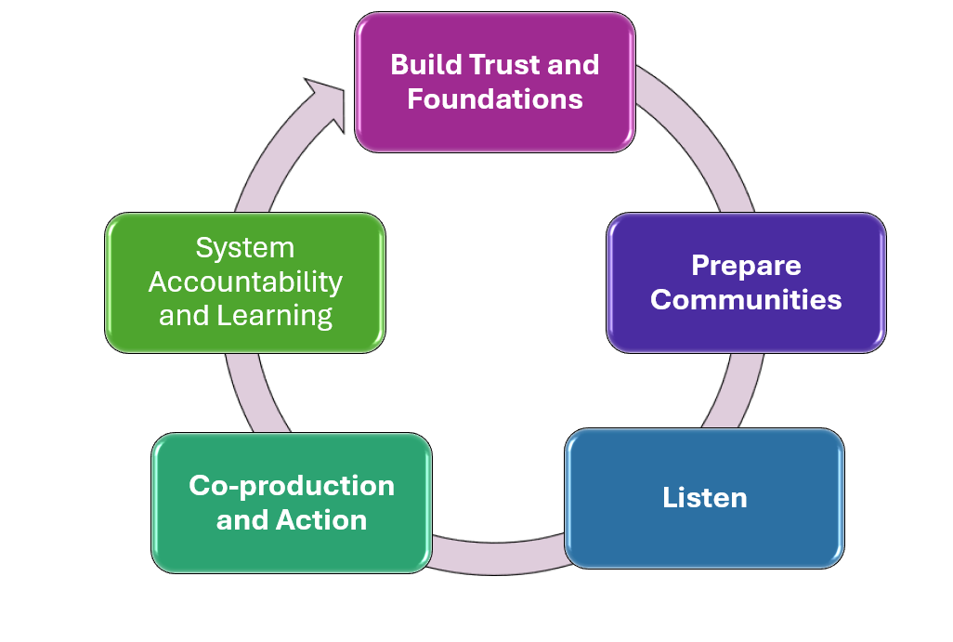
The Framework is a continuous cycle of:
- Build Trust and Foundations
- Prepare and Empower Communities
- Listen
- Co-production and Action
- System Accountability
Each stage builds the conditions for meaningful, ethical, sustainable involvement.

Build Trust and Foundations
Purpose
To build relationships, understand inequality and create the ethical and structural foundations for engagement.
What You Do
- Create an Overview / Case for Change Document:
  - Define the health inequality being addressed
  - Use population health data, JSNAs and local insight
  - Describe who is most affected and why
  - Map inequalities, inequities and disparities
- Stakeholder mapping to identify Trusted Leaders, Trusted Voices and Trusted Places
- Build early relationships and establish a steering group (community, VCSE, NHS, local authority)
- Agree a shared Theory of Change with communities
- Create an Ethical Consideration Log and mitigations
- Develop an engagement approach with communities
Inclusion Prompt
At this stage, explicitly consider:
- Who may be missing or less visible?
- Who holds less trust, voice or social capital?
- Who holds the power? How can this be moved?
- Are there groups within the community whose experiences differ significantly?
Key Message
Start slowly. Trust‑building takes time and early outcomes may be relational rather than measurable.
Example - of a Case for Change Documents - Maternity and Neonatal Services Community Engagement - Derby City

Prepare and Empower Communities
Purpose
To ensure communities have the skills, confidence, support and information to take part safely and equally. The training required will depend on your target group, your chosen method of engagement, ethical considerations, and input from the communities involved.
Some elements might be:
- Training for community leads (how the systems work, engagement skills, data skills, trauma-informed practice, attending meetings) – this could develop into Champion programmes creating an infrastructure of informed and enthusiastic leads across a system.
- Clear expectations: roles, time, communication preferences
- Emotional support and wellbeing resources
- Accessible materials (plain English, culturally adapted, visually clear)
- Regular catch up and reflective sessions
Why this matters
People cannot participate meaningfully without preparation. Support reduces harm, builds confidence and enables equal partnership.
Tips
- Never assume people “just know” how to engage — prepare everyone.
- Check understanding regularly.
- Ask communities want they want to know or learn to feel empowered and safe.
- Offer support proactively.

Listen
Purpose
The key purpose is to listen to what matters to communities. Gather insight and build relationships in places and through people that communities trust. Aims of the engagement should be informed by the Theory of Change.
What this includes
- Where possible engagement led by community facilitators
- Activities happening in safe, culturally familiar venues
- Methods designed with communities, not for them
- Culturally adapted, health-literacy-friendly materials
- Transparent, accessible public-facing information
Examples of community-led methods
- Community Led engagement
- Conversation cafés
- Peer-led small groups
- Listening events
- Pop-ups in community spaces
- Home-based small-group discussions
Tips
- Go where people already are.
- Let community leaders shape the approach.
- Keep sessions small, safe and conversational.

Co-production and Action
What you do
- Review insights with communities and system partners together
- Identify shared priorities
- Co-design solutions
- Create a joint Action Plan with:
  - Clear owners
  - Timeframes
  - Measures that matter to communities
  - SMART based targets so actions are measurable
Tip
- Never finalise actions without community sign-off.
- Manage expectations and be clear what is in and out of scope.
- If areas cannot be influence be clear about this and why.
Example – systemwide engagement turning into action and reporting back to communities. Improving Women's Health Services

System Accountability and Governance
What you do
- Set up Coproduction Working Groups – with communities and key stakeholders
- Set up governance processes within the organisation for actions/feedback to be reported to and escalated.
- Monitor progress and barriers
- Report updates openly and regularly back to communities
- Ensure community leads are equal partners
- Regular evaluate – use the Annual Evaluation Template
- Use methods like ripple-effect mapping for evaluation
Tip
- Feedback must be timely, visible and honest - otherwise trust breaks down.
Example - developing a working group - Community Health Alliance: Partnership Between the Black Community and the NHS
Evidencing Success
Success may include:
- Increased community confidence and capability
- Stronger relationships and trust
- Changes in system behaviour, culture or decision‑making
- Improved quality and relevance of services
- Health outcomes may take time and should not be the sole measure of value.
Sustainability, Capacity and Resourcing
Trust‑based engagement requires time, skill and emotional labour. Sustainability depends on:
- Realistic workforce capacity within statutory organisations
- Fair resourcing and support for VCSE partners and community leads
- Long‑term commitment rather than short‑term projects
- Without this, engagement risks becoming extractive or unsustainable.
What Good Looks Like
- Communities feel listened to and respected
- Feedback loops are clear, timely and honest
- Community insight visibly influences decisions
- Power is shared, not just consulted on
- Relationships continue beyond individual projects
Closing or Transitioning Engagement Responsibly
When engagement activity ends or changes:
- Communicate clearly and early
- Share learning and outcomes
- Thank and recognise contributions
- Support transition into longer‑term opportunities where possible
- Avoiding cliff‑edge endings is essential to maintaining trust.

Final Reflection
Trust is not an input; it is an outcome of consistency, honesty and shared power. The Trust 2 Action Model is designed to support long‑term cultural change, not quick wins, and to embed community voice at the heart of tackling health inequalities.

Useful documents and information
Examples of good practice:
The 3Ts
‘Trusted leaders, trusted voices and trusted places’ approach bears fruit in Enfield - Case Study Hub - Futures
London Anti-Racism Collaboration for Health: Learning and Engagement Event 3 - Riyadul Karim on Vimeo
Derby Health Inequalities Partnership
Home | DHIP
Useful documents and links
Framework for engaging with people and communities to address health inequalities
The aim of the framework is to support ICSs to have honest conversations, gather insights and develop practical actions to improve how they tackle health inequalities through engagement linked to people and community strategies.
Framework for engaging with people and communities to address health inequalities - Care Quality Commission
Insight Framework
A self-reflection tool to look at power - Insight Framework » Joined Up Care Derbyshire
Guidance on working with people and communities - statutory guidance
Working in partnership with people and communities is statutory guidance for integrated care boards, NHS trusts and foundation trusts and policy for NHS England. It supports them to meet their public involvement legal duties and the new ‘triple aim’ of better health and wellbeing, improved quality of services and the sustainable use of resources.
NHS England » Guidance on working with people and communities

Local guidance on PPI legal duties
Derby and Derbyshire PPI legal processes
NHS – Race and Health Observatory
The NHS Race & Health Observatory works to identify and tackle ethnic inequities in health and care by facilitating research, making policy recommendations and enabling long-term transformational change. NHS – Race and Health Observatory
Coproduction Resources
National - NHS England » Co-production
Derby and Derbyshire - Local - Co-production Framework » Joined Up Care Derbyshire
Mental Health Together - Good Practice Guide: Co-designing services with voices of lived experience Good Practice Guide: Co-designing services with voices of lived experience » Mental Health Together
Community Organising
What is community organising? - Community Organisers
Trauma informed Practice
Working definition of trauma-informed practice - GOV.UK

Check List - How to Put This into Practice (Step-by-Step)
Step 1: Build foundations
- Build relationships
- Form your steering group
- Understand the community
- Map inequalities – create an overview / a case for change documents
- Create ethical consideration log and put in place mitigations
Step 2: Prepare your community leads
- Provide training and support
- Agree roles, expectations, boundaries
Step 3: Co-design your engagement
- Choose trusted venues
- Co-design questions, activities and formats
Step 4: Run listening community-led engagement
- Use trusted facilitators
- Keep conversations safe
- Capture insight respectfully
Step 5: Turn insight into action
- Prioritise what matters to the community
- Write a shared action plan
- Agree governance
Step 6: Report back
- Feedback early, often and visibly
Step 7: Repeat the cycle
- Review what worked, adapt, continue
Step 8: Evaluation, reflect and learn
Annual evaluation
Final Tips for People New to This Work
- Start with relationships, not tasks.
- Listen more than you speak.
- Let communities set the pace.
- Make everything accessible and jargon-free.
- Never collect insight unless you can act on it.
- Trust is the outcome of consistency.

