**Health Overview and Scrutiny Committee (HOSC)**

**Guidance**

**What health scrutiny functions do the Local Authority have?**

Under the Regulations, the Local Authority (Public Health, Health and Wellbeing Boards and Health Scrutiny) Regulations 2013 local authorities in England have the power to:

* review and scrutinise matters relating to the planning, provision and operation of the health service in the area. This may well include scrutinising the finances of local health services
* require information to be provided by certain NHS bodies about the planning, provision and operation of health services that is reasonably needed to carry out health scrutiny
* require employees, including non-executive directors of certain NHS bodies, to attend before them to answer questions
* make reports and recommendations to certain NHS bodies and expect a response within 28 days
* have a mechanism in place to respond to consultations by relevant NHS bodies and relevant health service providers on substantial reconfiguration proposals
* have a mechanism in place to deal with referrals made by local Healthwatch organisations
* Request a "Call In" if to the Secretary of State until the new reconfiguration provisions take effect, if they consider that:
  + The consultation has been inadequate in relation to the content, or the amount of time allowed
  + The NHS body has given inadequate reasons where it has not consulted for reasons of urgency relating to the safety or welfare of patients or staff
  + A proposal would not be in the interests of the health service in its area.

Note: The Health and Care Act 2022 introduced the new 'call in' power for the Secretary of State (SoS) to intervene in local service reconfigurations. These powers relate to complex and substantial changes to services. There is a legal obligation to provide the SoS with information to support the exercise of this power, and duty on commissioners to notify the SoS of substantial reconfiguration of services. This does not change local authorities’ scrutiny responsibilities for service change. These powers were enacted on the 31st January 2024.

**How is health scrutiny conducted in Derby and Derbyshire?**

In Derby and Derbyshire these functions are carried out by Health Overview and Scrutiny Committees (HOSC). In Derbyshire there are two HOSCs, one for each Local Authority - Derby and Derbyshire. Joint HOSC Sessions can be arranged for systemwide issues that are across local authority boundaries.

The HOSC membership is made up of local councillors from all parties. The Chair is from the current elected party, and hence can change following a local election, as can the membership of the wider board.

They meet in person, approximately every three months. County HOSC meets in Matlock Council Chambers and City HOSC meets in the Derby City Centre Council Chambers.

Meetings are held in public, and **papers are available in the public domain**.

Agenda items are usually a mix of items that we wish to take to the HOSC and those that the Chair and other members have decided they want to ask us about. Regular requests usually include response to winter pressures, GP access, health finances and service changes.

**What is the main aim of health scrutiny?**

The primary aim of this health scrutiny function is to act as a lever to improve the health of local people, ensuring their needs are considered as an integral part of the commissioning, delivery, and development of health services.

This health scrutiny function is the fundamental way by which democratically elected local councillors can voice the views of their constituents and hold relevant NHS bodies and relevant health service providers to account.

In Derby and Derbyshire, they help to assure the level of patient and public involvement in health decisions alongside the Public Partnership Committee, which is a formal committee that sits beneath the Integrated Care Board (ICB).

One of the aims of HOSC is to get involved when the NHS are proposing a change to health services, this could be transforming, improving, or just generally wanting to do things differently. Temporary changes are included in this remit.

HOSC are a key part of deciding if a change to services is 'substantial' enough to warrant a full public consultation. There is no single definition of what constitutes a ‘significant’ or ‘substantial’ service change.

**When should papers be presented to HOSC?**

We have put considerable time and effort into building effective working relationships with our scrutiny committees in recent years. This does not mean we will always agree. They do not like surprises, so it is important we engage scrutiny members in good time and in the most appropriate way. If a committee feels that they have been kept in the dark or misled over an issue this can have a huge impact on relationships. Hence:

* They should be consulted early on in any change process, preferably when there is a case for change. They can then scrutinise the change, discuss the engagement approach and be part of the process of agreeing if a change is significant enough to warrant consultation. Close engagement, regular updates, and a real ability to input and influence are key and are viewed favourably by The Independent Reconfiguration Panels (IRP). *North Cumbria CCG’s Healthcare For The Future programme (2019) IRP Judgement
* They should be consulted throughout the lifecycle of the change – so it is not a one-off conversation in many instances.
* All substantial/significant service change should be discussed with HOSC at the earliest possible stage; this may be via a presentation at the Committee meeting or initially via a briefing paper, i.e.:

The PPI Form is a tool used to record that commissioners of health services have fully assessed whether the legal duty to inform, involve or consult individuals to whom the services are being or may be provided, and their carers and representatives, has been considered.

Guidance on the completion of this form and the legal duties can be found [here](https://joinedupcarederbyshire.co.uk/download/patient-and-public-involvement-assessment-and-planning-form/).

* + That may result in a consultation
  + That may result in a substantial piece of engagement
  + That may be considered contentious, or cause reputational damage
  + That may be notifiable to the Secretary of State.
* HOSC will also be made aware of all other decisions regarding the assessment of legal duties for service changes via the Patient and Public, Involvement, Assessment, and Planning Form Log (PPI Log). This is sent to HOSC at two monthly intervals to coincide with papers being prepared for the Public Partnership Committee who are also in receipt of this log. HOSC are advised that they can request further information about any of these decisions.
* There should be a timely response to any request that someone attends to discuss a topic they need more information on.
* You should consider local election cycle and potential pre-election periods in your programme planning, and timescales for consultation and decision-making.

**How do I liaise with HOSC?**

The process for liaising with HOSC is via the Engagement Team who liaise directly with the scrutiny officers to field, suggest and agree items for forthcoming agendas.

Committee Chairs will suggest items and we will have items that we want to take to the Committee to demonstrate engagement and seek support or feedback.

The Engagement Team:

* Cannot refuse to bring an item to scrutiny
* Are able to suggest that items should be delayed if we feel there will be further information available (e.g. results of a consultation) for a future meeting.
* Meet with the Chairs of the Committees once a year to discuss their proposed work plan.
* Liaise with the Local Government Officers, for city and county, 6-8 weeks before each Committee meeting to agree the agenda – this conversation will include what we feel should be included on the agenda, information about a change to services we are proposing, or something they would like to be on the agenda, e.g. information about the current financial situation. The agenda should be confirmed at least four weeks before the meeting is due to take place, to allow time to identify appropriate presenters and pull together papers.
* Will inform you of the deadlines for delivering cover papers/presentations for agenda items in a timely manner to allow for adequate preparation; final, signed off agenda presentations for the committees’ packs are generally required one week before the meeting date. Hence, they need to arrive with the Engagement Team at least 10 days before the committee meeting to allow the papers to be reviewed (this includes communications oversight), before being published in the public domain.
* Provide advice and support on papers for submission, but you and your teams are the subject experts and should do the initial information gathering and production of draft presentations. Once papers are agreed and ready to go you also need to include the email address and name and title of all presenters so they can be sent information about the meeting.
* Will ensure you receive an invite to the meeting by providing contact details to the Government Officer who is responsible for sending out the invite.
* Will liaise with you following the meeting to answer any questions that the Government Officer has sent through that were not answered at the time or that require additional information.
* Will liaise with you about any public questions that are submitted prior to the meeting taking place. These will need to be answered and checked by comms before returning to the Government Officer.

**Top tips**

* Use any templates we provide. There is currently only a template for County HOSC, and this can be found [here](https://joinedupcarederbyshire.co.uk/download/cover-sheet-scrutiny-committee-template/).
* Aim for a maximum of six slides
* Avoid using too much text on a slide
* Avoid using complex diagrams with text that is too small to read
* Avoid acronyms and NHS jargon. Write in plain English as much as possible
* Tailor your information and language as though you’re writing for interested members of the public
* Remember all scrutiny papers are put into the public domain, so be mindful of the information you are sharing, and the language used. Do not share anything that is commercially sensitive. There may be the option to send a confidential briefing paper for items that are extremely sensitive.

**Who are our current Local Government Officers?**

* Jackie Wardle – county
* Dominic Monahan – city

**Who are the current Chairs?**

* Cllr Wharmby - county
* Cllr Roulstone – city

**What does this mean for Commissioners/Project Leads?**

* A requirement to attend HOSC (City and County):
  + Either at the request of the Scrutiny Boards
  + Or to inform them of a service change, to allow them to have adequate scrutiny.
* A requirement to acknowledge that this is mandatory.
* To provide a paper, coversheet, and the name of presenters in a timely manner – we will liaise with Executive Directors to ensure that this is a suitably qualified, senior, and accountable member of the commissioning team, who is able to answer all questions about a specific project. This is important due to the public scrutiny and likely journalist attendance at HOSC.
* To agree to papers being available in the public domain, unless expressly agreed that they should be confidential.
* To respond to reports and recommendations within the 28 days.

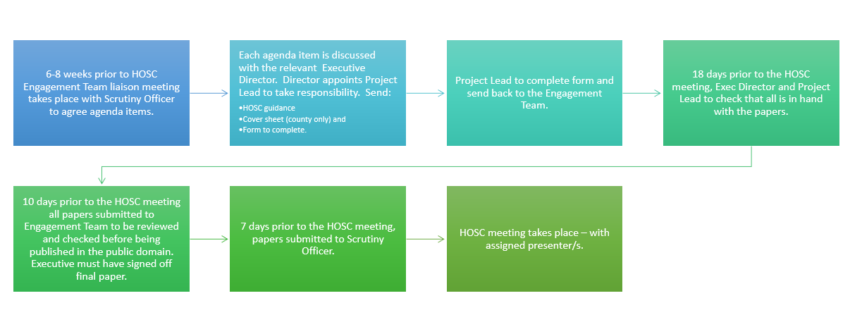**Timeline and Checklist**

|  |  |
| --- | --- |
| Key Information |  |
| Name of Paper: |  |
| Lead Contact: |  |
| Paper to be written by: |  |
| Executive sign off by: |  |
| Presenter/s at the meeting: |  |
| Cover sheet needed (County only) |  |
| Date papers are due to the Comms Teams for sense checks: |  |
| Date the papers must be submitted to HOSC: |  |
| Date and time of meeting:  These are face to face meetings, please block the time in your diaries. |  |
| County HOSC tends to be at 10am at Matlock Council Buildings more information can be found [here](https://democracy.derbyshire.gov.uk/ieListMeetings.aspx?CommitteeId=138).  Derby City HOSC tends to be at 6pm at the City Council House more information can be found [here](https://democracy.derby.gov.uk/Committees/tabid/101/ctl/ViewCMIS_CommitteeDetails/mid/734/id/1943/Default.aspx). | |