NHS Violence, Aggression & Discrimination Campaign – What's in this toolkit
Health and care staff are experiencing an increased volume and severity of instances of violence, aggression, and discrimination. This appears to have escalated post-pandemic and is affecting staff in all services, but in particular, Emergency Department and general practice. Instances in general practice are seemingly linked to the increasing perception that practices are not open for business and/or not offering face to face or timely appointments.
The system has resolved to develop a unified zero tolerance policy to manage instances of violence, aggression, and discrimination. This will be supported by appropriate security advice, training and public messaging to ensure staff are fully equipped to manage, escalate and seek support for instances of violence, aggression and discrimination.
Communications campaign
The CCG and Local Medical Committee (LMC) have been working collaboratively to develop an appropriate campaign to challenge this behaviour and will shortly be launching an adapted version of Humberside LMC's campaign and sharing Derbyshire's NHS organisations.
The full resource kit includes:
- Posters
- Digital plasma screens
- Digital graphics and animations (inc. plasma screen images)
- Email signatures
- Audio MP4

We are keen to ensure there is a system-wide approach to the campaign. We would like to share these resources with you, our system communications lead, to use and promote within your own organisations once these are finalised
Below is guidance on how to use these resources within your organisation.

Posters
We have produced PDF and JPEG versions of posters that can be printed off and used on notice boards in practices, urgent treatment centres, ED, clinics and other health and care settings.
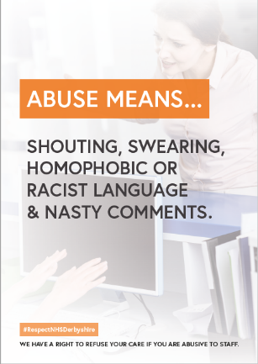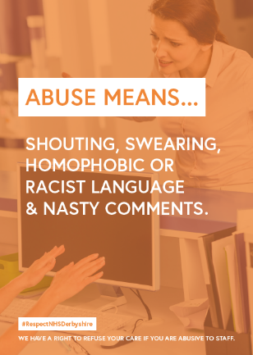
There are a range of posters for you to choose from and the examples above cover all examples of abuse in one message.
Digital Plasma Screens
You can use these as laptop screensavers or share them on waiting room plasma screens.
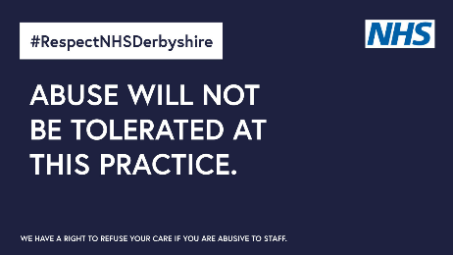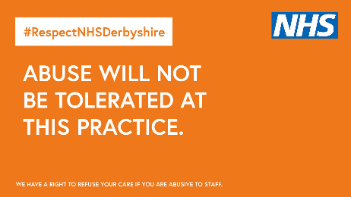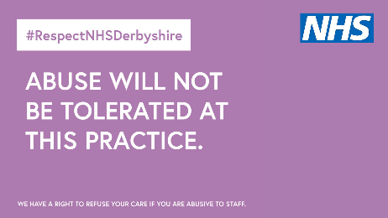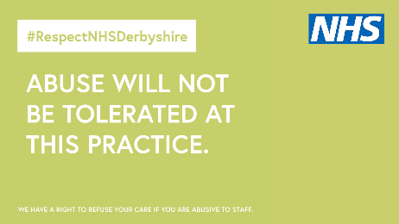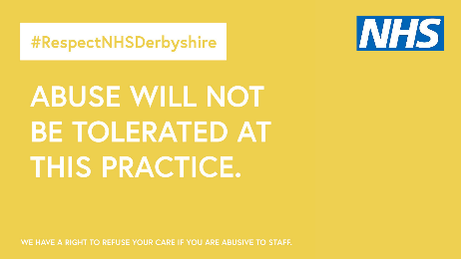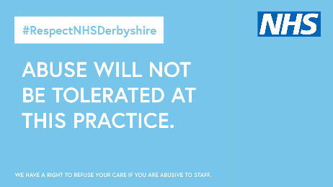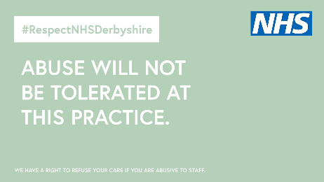

Digital Graphics and Animations
The below digital graphics and animations (in the zip file) have been produced for digital sharing, mainly websites and social media messaging. Please feel free to utilise these and schedule across your social.
[Use with either animations or graphics available to download]
- Abuse will not be tolerated at this practice. #RespectNHSDerbyshire
- Our staff have the right to refuse your care if you are abusive towards them. #RespectNHSDerbyshire
- Our staff are trying their best to give you the best quality care. Abusive behaviour will only reduce the quality of care you will receive, please think before you speak to staff. #RespectNHSDerbyshire
- If you think we can improve the way our practice operates, please contact your local Healthwatch to raise an issue / follow our practice procedure (whichever fits your practice) and we can try to resolve the issue or improve to give you the best care possible. #RespectNHSDerbyshire
- NHS primary care services have the right to refuse your care if you are abusive to our people. Times are tough and we all need to do our bit to be kind to each other. Thank you. #RespectNHSDerbyshire
- To patients, abuse means that you won't receive the best possible care and you will be refused treatment. #RespectNHSDerbyshire and we do not tolerate abuse.
Abuse means -
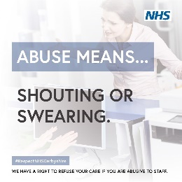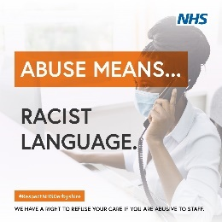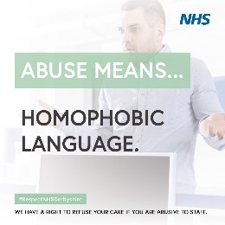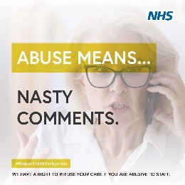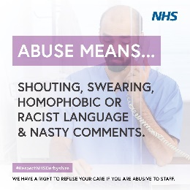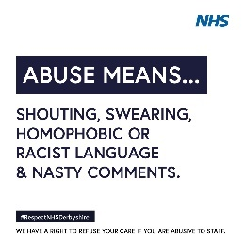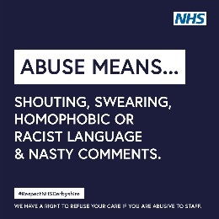
Abuse not tolerated
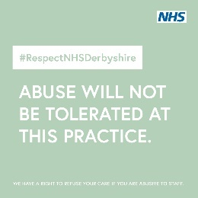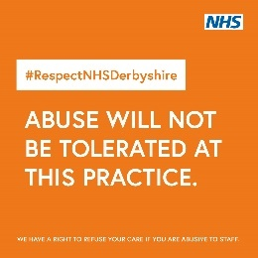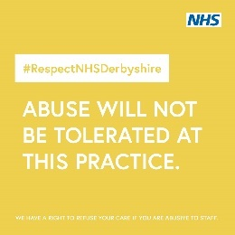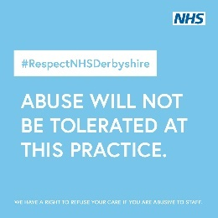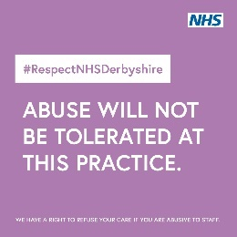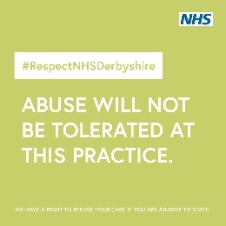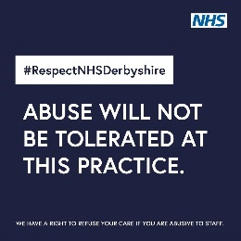
Quote images
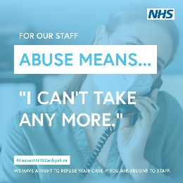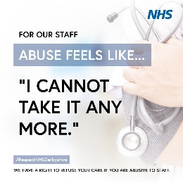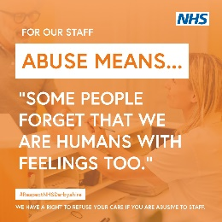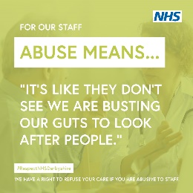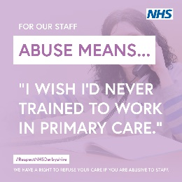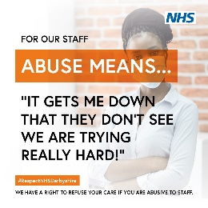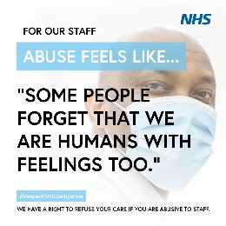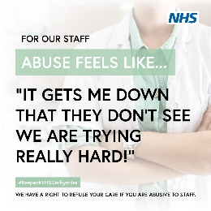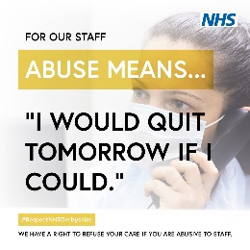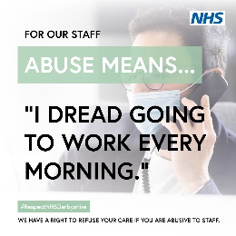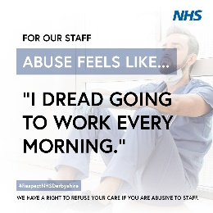

Email Signatures
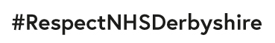

Audio MP4
This following audio has been developed for usage as a holding message in general practice. You have the option to use this if you wish.

