Improving Women's Health – Derby and Derbyshire Inclusivity Checklist, Action Plan and
Resource Package

Primary Care Focus

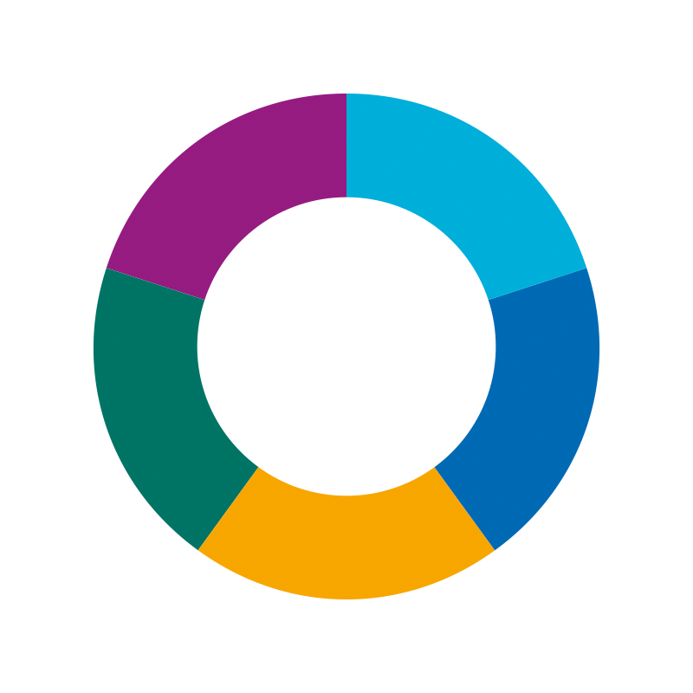

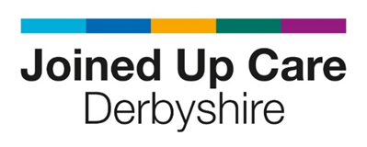

Introduction
This checklist and action plan are for your practice’s own use only. It is not a performance measure, and you do not need to provide detailed evidence. It is to support in reflecting on how inclusive and accessible your services are for women and people with cervixes, and to support improvement at your own pace.
Every practice and organisations is different. Use this tool as a conversation starter with your team, patients, and community partners.
Links and resources are provided to explore different aspects raised.
This tool can support your CQC (Regulations 9, 10, and 17), CPD, and quality improvement work. It is designed to fit with your existing quality conversations.

How to Use
- For each question, mark your current status and add comments if helpful.
- Use the action plan section to note next steps, responsibilities, and support needed.
- Explore the resources for ideas and support.

Self-Assessment Checklist
Access & Flexibility
Statement | Status (tick one) | Comments/Context
We offer some appointments outside of standard hours (like evenings, weekends, or walk-in/drop-in clinics), or we are exploring how to do this. | ☐ Not yet started  ☐ Planning to start  ☐ In progress  ☐ Achieved
We have asked patients how they prefer to access our services (e.g., surveys or informal feedback). | ☐ Not yet started  ☐ Planning to start  ☐ In progress  ☐ Achieved
We make sure our digital tools (like online booking or the NHS App) are easy to use for everyone. | ☐ Not yet started  ☐ Planning to start  ☐ In progress  ☐ Achieved
We clearly let people know about non-digital options. | ☐ Not yet started  ☐ Planning to start  ☐ In progress  ☐ Achieved

Respect, Communication & Health Literacy
Statement | Status (tick one) | Comments/Context
Our staff have had some training or discussion about trauma-informed care and listening well to patients. | ☐ Not yet started  ☐ Planning to start  ☐ In progress  ☐ Achieved
We try to give health information in plain English and in different formats or languages if needed. | ☐ Not yet started  ☐ Planning to start  ☐ In progress  ☐ Achieved
Interpreter services are available and used when needed, with care for privacy and dignity. | ☐ Not yet started  ☐ Planning to start  ☐ In progress  ☐ Achieved
Cultural Sensitivity & Representation
Statement | Status (tick one) | Comments/Context
Staff have had training or conversations about:  - Gender identity  - Sexuality  - Cultural differences  - Neurodiversity  - Learning disabilities  - Sensory needs  (including the use of respectful language, name pronunciation maintaining privacy and dignity, and knowing where to signpost for further support) | ☐ Not yet started  ☐ Planning to start  ☐ In progress  ☐ Achieved
We let patients know they can ask for a clinician of a specific gender for women’s health concerns. | ☐ Not yet started  ☐ Planning to start  ☐ In progress  ☐ Achieved
We understand the importance of using correct names and pronouns and know how to update patient records appropriately where needed. | ☐ Not yet started  ☐ Planning to start  ☐ In progress  ☐ Achieved
The photos, posters, website and general information in our practice show a mix of people from our local community. | ☐ Not yet started  ☐ Planning to start  ☐ In progress  ☐ Achieved

Community Engagement & Local Context
Statement | Status (tick one) | Comments/Context
We have some contact with local community groups or leaders to help us reach more people. | ☐ Not yet started  ☐ Planning to start  ☐ In progress  ☐ Achieved
We share health messages through places or channels that local people trust (like SMS, posters, WhatsApp, or community spaces). | ☐ Not yet started  ☐ Planning to start  ☐ In progress  ☐ Achieved
We think about things like transport, rural location, or digital exclusion when planning services or clinics. | ☐ Not yet started  ☐ Planning to start  ☐ In progress  ☐ Achieved
Women’s Health Services
Statement | Status (tick one) | Comments/Context
We have dedicated women’s health clinics or hubs available for our patient population. | ☐ Not yet started  ☐ Planning to start  ☐ In progress  ☐ Achieved
We try to focus on early support and prevention in women’s health (like menopause, contraception, or screening). | ☐ Not yet started  ☐ Planning to start  ☐ In progress  ☐ Achieved

Reflection and Action Plan
For each theme, use this table to plan next steps.
Theme | Where are we now? | Where do we want to be? | How do we get there? | Action | Who? | By when?
Access & Flexibility

Respect, Communication & Health Literacy

Cultural Sensitivity & Representation

Community Engagement & Local Context

Women’s Health Services

Resources
We have developed a comprehensive package of local and national resources that provides an overview of a wide variety of topics you may wish to explore or enhance. To access and download these resources, please visit the link provided. Improving Women's Health Services

With Thanks
This document was developed in collaboration with patient and public partners from our local community and from drawing on insights from the Improving Women’s Health Services Engagement report. The Sexual Health Inclusivity Workstream sincerely appreciates everyone who helped develop this tool and looks forward to it being a useful resource for encouraging meaningful conversations and promoting growth throughout our system.

