

Derby and Derbyshire NHS' Five Year Plan 2023/24 to 2027/28

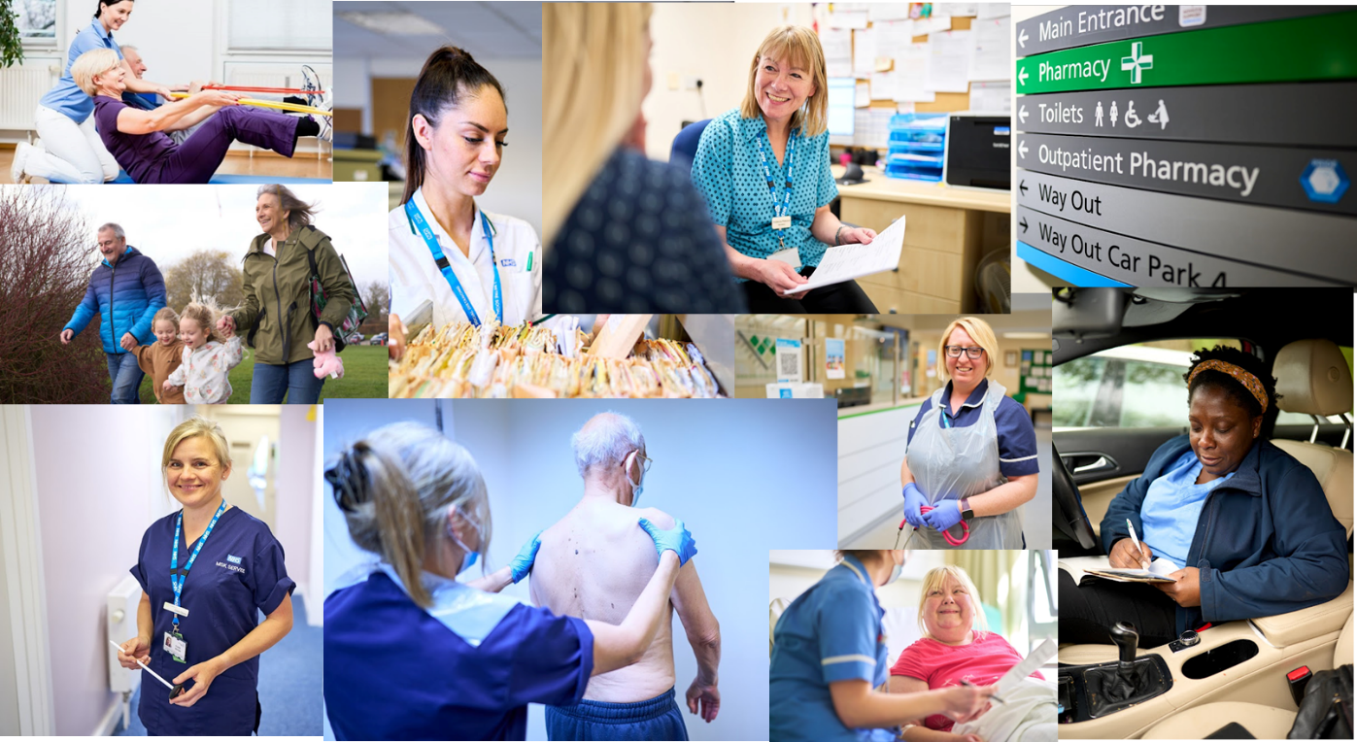

Contents
Foreword 4
Acknowledgements 5
List of Figures and Tables 8
Executive Summary 10
Engagement 13
Engagement activity undertaken to date to help produce this Plan 13
Going further 13
1. Introduction 15
1.1. Policy and Legislative considerations 16
The Long-Term Plan (2019) 16
The Derby and Derbyshire Integrated Care Strategy 16
Next steps for integrating primary care: Fuller stocktake report 18
The Major Conditions Strategy 19
The NHS Mandate 2023 19
How all the different strategies 'fit together' 20
1.2. Derby and Derbyshire Healthcare System Development 21
The Derby and Derbyshire Integrated Care Board as a Strategic Commissioner 21
The design and delivery of care at PLACE 22
Provider Collaboration 23
1.3. Our NHS Plan – its positioning and core focus 24
The NHS Plan within the wider effort to improve population health 24
The significance of Primary Care in the NHS Plan 25
The structure of this document 26
2. The Case for Change 27
2.1. Key challenges for the Derby and Derbyshire Health System 28
A backdrop of a deterioration in the population's health 28
The burden of disease 30
Preparing for the change in demography 32
Public expectations and insights 32
Advancements in technology 33
Improving productivity 34
The care quality gap 35
The cost of provision 36
Our estate 37
Delivering improvement with significant workforce constraints 39
2.2. Key issues that the Derby and Derbyshire NHS will seek to resolve 44
How we invest financial resource to bring about the change we need 44
The type of workforce that we invest in over the next 5 years 45
The nature of the care that we deliver 46
3. Our guiding policies for action 47
Allocate greater resource to activities that will prevent, postpone, or lessen disease complications and reduce inequity of provision 47
Give the teams working in our localities, the authority to determine the best ways to deliver improvements in health and care delivery for local people 48
Give people more control over their care 49
Identify and remove activities from the provision of care which result in time and cost being expended but do not materially improve patient outcomes 49
Prioritise the improvement of the System's Intelligence Function and the capacity and capability of its research programme 50
4. The action that we are taking in 2023/24 52
4.1. Allocate greater resource to activities that will prevent, postpone, or lessen disease complications and reduce inequity of provision 52
Primary prevention 52
Secondary prevention 53
Tertiary prevention 54
4.2. Give the teams working in our localities, the authority to determine the best ways to deliver improvements in health and care delivery for local people 55
4.3. Give people more control over their care 55
1. The use of digital technologies 55
2. Personalised Care 56
3. Choice of Elective Surgery 57
4.4. Identify and remove activities from the provision of care which result in time and cost being expended but do not materially improve patient outcomes 57
1. Use of acute resource 57
2. Urgent and Emergency Care triage 57
4.5. Prioritise the improvement of the System's Intelligence Function and the capacity and capability of its research programme 58
5. Building on this action and going further 59
5.1. Creating the conditions for change to happen 59
Immediate issues that we will focus on – July 2023 to November 2023 59
Prioritisation 59
Financial 59
Workforce 60
Data 60
Other vital enabler development work 60
Working with the Voluntary, Community and Social Enterprises Sector (VCSE) 60
Estates 61
Research and innovation 61
Digital and Data 62
Workforce and the People Services Collaborative 62
Our Green Plan 64
Support broader social and economic development 64
5.2. The Integrated Care System's Improvement Programme 65
Hard wiring the objective reducing health inequalities in our improvement work 65
Summary of improvement works 66
7.1 Oversight 70
7.2 System Roles 70
7.3 Improvement and change management methodologies 71
7.4 Tracking delivery 71
7.5 Risks 71
Conclusion 73
Appendix A – Derby and Derbyshire Health Index 74

Foreword

Through the continued development of our Integrated Care System across Joined up Care Derbyshire, we recognise and value the importance of positive relationships and collaboration in order to deliver the best possible health care for the citizens of Derby and Derbyshire.

To best meet their health and care needs, we must be clear on the role the NHS 'family' will play over the next few years to have the highest impact, particularly in supporting an approach to deliver more preventative health care and closing the inequality gaps we see between our many different communities.

In producing this five-year plan for the NHS across Derby and Derbyshire, we have engaged with our Integrated Care Board and Integrated Care System partners to best reflect the views, experiences and recommendations for how we significantly reset our approach to delivery. We are clear that we must fundamentally develop our approach, particularly in how we allocate our resources, become more efficient in our care and ensure people and patients are in more control over the decisions concerning the care they receive.

As described in our recently published Integrated Care Strategy, the health of our population in recent times has been negatively impacted owing to many factors, including the Covid pandemic and the cost of living. We have a difficult balancing act to achieve of focusing on today's challenges, whilst also tackling more strategic issues over the medium and long term.

Through creating the right conditions for our multi-disciplinary teams to determine the best ways to deliver improvements in health and care delivery and by fostering an environment that builds on our collaborative working to date, we will deliver better care, in a more co-ordinated and joined up manner.

As the Chair and Chief Executive of the Derby and Derbyshire Integrated Care Board, we think this Plan sets a clear direction of travel for the next few years. Publishing this Plan is not the end of the process, but instead the start of ensuring the Derby and Derbyshire NHS is prioritising effectively and adapting its approach to delivering improved health for the local population.


Richard Wright Chris Clayton
Chair Chief Executive

Acknowledgements

We are grateful to our partners for providing extensive feedback in the formulation process of our Plan. We recognise there is more work to do beyond this initial publication and more time is required to fully reflect on all the feedback and to further iterate our Plan together. We will therefore publish an updated version of this plan in Autumn 2023 so that we are on the front foot in ensuring this strategic Plan drives the 2024/25 NHS Operational Plan (year two of the five-year plan) and the years up to 2027/28.

Written feedback has been received from the following organisations and groups:

- Chesterfield Royal Hospital NHS Foundation Trust
- Derbyshire Community Health Services NHS Foundation Trust
- Derbyshire Healthcare NHS Foundation Trust
- East Midlands Ambulance Service NHS Trust
- University Hospitals of Derby and Burton NHS Foundation Trust
- Provider Collaborative Leadership Board
- Derby City Health and Wellbeing Board
- Derbyshire Health and Wellbeing Board
- Integrated Place Executive
- GP Provider Board
- Clinical and Professional Leadership Group

The feedback received and how it has been considered falls into three broad categories.

Recommendations that fall outside of the scope of the agreed parameters for this NHS Plan and are more appropriate for inclusion in other system strategies and plans

Some of the feedback received are within the scope of Health and Wellbeing Strategies, the detailed implementation plans for the Integrated Care Strategy, the annual NHS Operational Plan, or plans overseen by System Delivery Boards. We have sought to avoid duplicating content in this NHS Plan but will ensure relevant feedback is shared with partners for action.

Based on the feedback received we have however added content that emphasises the critical links between the aims in this Plan and the wider determinants of health, including referencing the Turning the Curve indicators. These wider determinants of health are not explored in detail in this NHS Plan given the roles of the Health and Wellbeing Boards and the Local Authorities in leading on these areas, but additional content has been included on NHS responsibilities for primary, secondary, and tertiary prevention and its contribution to a much wider partnership effort – led by our Health and Wellbeing Boards.

Some comments related to specific operational and enabling requirements, for which plans are agreed through the annual NHS Operational Plans and are overseen by the System Delivery Boards. This in no way denudes the importance of the issues flagged, but this document is the not the right vehicle for including more detailed improvement plans.

Recommendations that are within the scope of this Plan and need to be addressed in the next version

Several recommendations are pertinent to the scope and purpose of the Plan, and support implementation of the guiding policies, but they have not been included or fully incorporated at this stage. This is due to the need for further discussion and co-production, during Quarter 2, which will result in further content being included in the next iteration of this NHS Plan relating to the themes listed below.

Themes:

- More specific and measurable actions under the guiding policies, including timescales.
- Triangulated plans covering finance, workforce, and activity for the five-year period, and how we will deliver challenging financial savings working in partnership.
- Co-produced approach for how investment and disinvestment, and resource re-distribution decisions will be made, particularly given the current financial constraints
- Further engagement with communities and patients.
- Greater focus on buildings and the estate as key enablers.
- Need for more specific actions to tackle health inequalities.
- More visibility of public health commissioned (NHS delivered) services.
- How the workforce challenges will be addressed, including specific challenges relating to the fragility of services.
- Clarity on accountability, responsibility and authority for decision making and implementing the content of this Plan.
- More information on how we will re-design key pathways including the roles of primary care, clinical networks, and the ambulance service.
- Further recognition and exploration of the importance of relationships within the system.
- Increased focus on the role of anchor institutions and the anchor partnership.

Recommendations that have resulted in changes to the content of this Plan

This includes comments now reflected through the proposed actions under the guiding policies, as well as comments received on wording and emphasis within the document.

Themes:

- Greater clarity on the purpose and collective responsibilities for this Plan.
- Support for strengthening the approach to shift care and associated resources into preventative, proactive, community-based models.
- Increased reference to Health and Wellbeing Strategies and the role of the NHS in implementation.
- Focus on delivery of the 23/24 Operational Plan.
- The challenge of prioritising actions to improve population health and quality of life, whilst focusing on delivering Year 1 operational targets, given the extremely challenging operating environment.
- The need to stay within our resources.
- The need to translate the content into a narrative that the public and all staff can understand and engage with.
- Increase the focus on mental health, learning disabilities and autism – noting that whilst additional content has been included, we will continue to test whether we have the balance right between physical and mental health.
- Increased emphasis on research, innovation, and system intelligence.
- Increased emphasis on the role of the NHS in prevention.
- Increased content on our sustainability plans (more information is included in the Duties Document attached to this Plan).

List of Figures and Tables

Figures
Figure 1. Vision for Population Health in Derby and Derbyshire.
Figure 2. Strategic aims for Integrated Care.
Figure 3. Life expectancy, healthy life expectancy and the inequality in both – Derby, Derbyshire, and England.
Figure 4. How are the different Strategies fit together.
Figure 5. The Derby and Derbyshire Integrated Care Board's Strategic Framework.
Figure 6. Drivers of health.
Figure 7. The construct of the Office for National Statistics (ONS) Health Index
Figure 8. The sub-domain elements of the Healthy People Measure of the Health Index – difference between the 2021 measure and the 2015 baseline index value
Figure 9. Disability Adjusted Life Years (DALYs) per 100,000 population.
Figure 10. Cause of Disability Adjusted Life Years (DALYs) per 100,000 population.
Figure 11. Proportion of the Derby and Derbyshire population with a range of clinical conditions – snapshot as at 30/06/21.
Figure 12. Derby and Derbyshire population projections.
Figure 13. Summary of issues arising from the NHS @75 engagement event.
Figure 14. Number of Medical FTEs working in elective care specialities and the total number of RTT admitted and non-admitted pathways – with 2016 as the base year.
Figure 15. Summary of opportunities to improve specific aspects of healthcare over the next five-years.
Figure 16. Some examples of waste inherent in the way care is currently delivered.
Figure 17. Age of the Derby and Derbyshire NHS Provider estate.
Figure 18. Projection of fully qualified permanent GPs in Derby and Derbyshire needed vs. forecast supply.
Figure 19. Projection of registered nurses in Derby and Derbyshire needed vs. forecast supply.
Figure 20. Percentage of the full-time equivalent fully qualified GP workforce (excluding GPs in Training Grade) joining or leaving.
Figure 21. NHS Leavers Rate (Registered Nurses) – 12 month rolling position ending February 2023.
Figure 22. NHS Leavers Rate (Midwifes) – 12 month rolling position ending February 2023.
Figure 23. NHS Leavers Rate (Medical and Dental) – 12 month rolling position ending February 2023.
Figure 24. General Medical Acute Doctoring Index vs. General Practice Doctoring Index (2016 as the base year) and General Practice and Community Based Nursing Index vs. Acute Based Nursing Index (2017 as the base year).
Figure 25. The five guiding policies of our NHS Plan for the next five years.
Tables
Table 1. Health Index Score with domain breakdown – Derby and Derbyshire.

Executive Summary

This is our five-year Derby and Derbyshire Plan for the period 2023/24 to 2027/28. It sets out a guiding policy for changing the way the NHS operates and the actions it needs to take to improve population and healthcare outcomes, reduce inequalities, enhance productivity, and support broader social and economic development.

The following schematic summarises the expected requirements for this Plan and how is its structured:

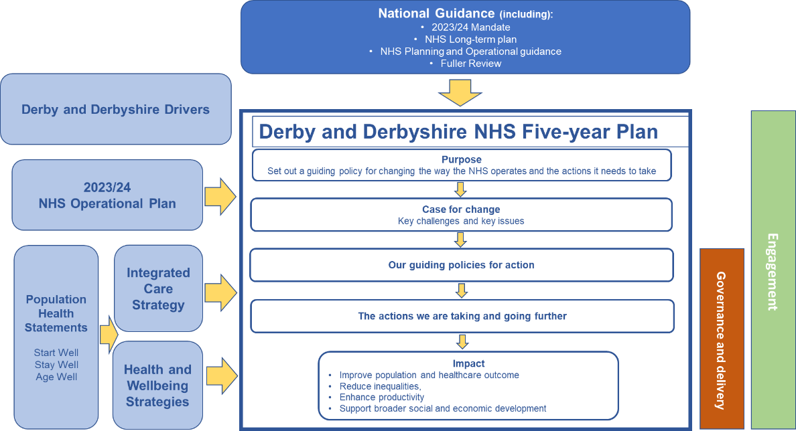

The Plan should be read alongside the Derby and Derbyshire Integrated Care Strategy, which sets out broader Integrated Care Partnership ambitions to ensure all citizens start their lives well, live well, and age well, and the strategies produced by our two Health and Wellbeing Boards. The aim is to ensure this Plan aligns with these key local strategies and provides clarity on the role the NHS will play in helping to implement them.

The case for change included within this Plan is compelling, the challenges include:

- Deterioration in avoidable mortality and infant mortality in Derby and the reduction in the wellbeing of the Derbyshire population

- The need to change the way in which the NHS targets the conditions which drive the greatest disease burden across the Derby and Derbyshire population - cancer; cardiovascular disease, musculoskeletal disorders; mental disorders, neurological disorders, and chronic respiratory disease

- The growth in multi-morbidity intersected with older age is going to require a fundamental shift in how the NHS in Derby and Derbyshire operates.

- Evidence shows that patients feel less in control over the healthcare they receive, despite wanting it. It is imperative that we tackle this particularly given the proven benefits of better clinician relationships, improved adherence to advice and increased satisfaction with the outcome of treatment.

- The growth and expansion of new technology will revolutionise healthcare over the next five years and beyond, presenting both opportunities and challenges for us.

- The recruitment and retention of General Practitioners and community-based nurses is a pre-requisite over the next five year-period.

- The financial, productivity and environment challenges over the next five-year period go hand in hand. There are significant opportunities to reduce waste which must be realised to get the system on a better financial footing.

- Whilst the causes of these challenges are multifactorial and complex, we can positively affect them by reforming: (i) what our clinical workforce does in the future and type of skills we invest in; (ii) the way in which we allocate financial resource within the NHS and (iii) changing the nature of the care that we deliver for patients.

The guiding policy headings for this Plan and the actions that sit beneath them will drive annual NHS operational planning over the next five years and guide the development of a joined up and strategic approach to the commissioning and provision of healthcare across Derby and Derbyshire - to address the challenges we face, building on existing improvement activities.

Guiding policy headings:

- Allocate greater resource to activities that will prevent, postpone, or lessen disease complications and reduce inequity of provision.

- Give the teams working in our localities, the authority to determine the best ways to deliver improvements in health and care delivery for local people.

- Give people more control over their care.

- Identify and remove activities from the provision of care which result in time and cost being expended but do not materially improve patient outcomes.

- Prioritise the improvement of the System's Intelligence Function and the capacity and capability of its research programme.

We are currently three months into implementing the NHS Operational Plan for 2023/24, and there is an unwavering focus on delivering Year 1 targets, including access, and waiting times across primary, community, mental health and acute pathways, across our NHS organisations. A summary of the 2023/24 plan can be read on the ICB's website.

It is within this context that we must agree improvement actions for the four following years, recognising the careful balancing act of managing immediate and short-term operational priorities with longer-term ambitions, as illustrated in the diagram below:

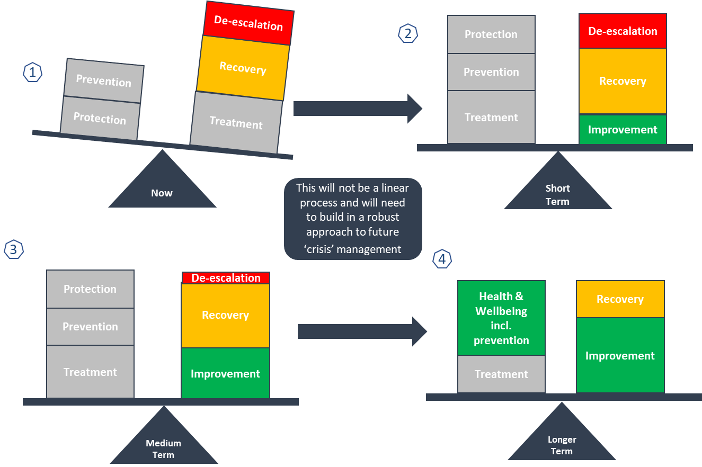

During the development of this Plan, we have heard from NHS providers of the current challenges they face in prioritising actions that will improve population health and quality of life, at the same time as focusing on delivering Year 1 operational targets, given the extremely challenging operating environment.

Recognising this constraint, we will work collaboratively with partners and the public during Quarter 2 of 2023/24 to agree and prioritise improvement actions and implementation timescales, and in parallel produce triangulated and aligned financial, workforce and activity plans for the next five years.

Improvement actions should build on examples of good practice in Derby and Derbyshire, such as our ‘Team Up’ approach for the development of community services. Staff from across the NHS, local authorities, and the voluntary sector work together as one team, so when people need care in their home, including people with complex needs, an integrated team delivers this care. This approach is a great illustration of our guiding policy in action.

There are several key considerations for implementing the guiding policy included in this Plan, many of which present challenges that need to be overcome, these include:

- Allocating our NHS resources more proportionately towards activities which will prevent, postpone, or lessen disease complications and reduce inequality in provision is one of the actions we wish to take. Within this, we must operate within the allocations we receive each year to commission and provide a range of health care services. To do this we will need to focus on being as productive and efficient as we can, so that we can target our resource at the areas which need it most.

- People are a key pillar to our overall local NHS Plan. From a staff perspective, our workforce on the front line of delivery, working at Place and locality level, require the capacity of teams working in and across communities to deliver improvements in health care.

- Our citizens and patients require more autonomy and control over their healthcare. This needs to be achieved through initiatives to improve their active involvement in decision-making in relation to their healthcare.

We are grateful to our partners for providing extensive feedback in the formulation process of our Plan. We recognise there is more work to do beyond this initial publication and more time required to fully reflect on all the feedback and to further iterate our Plan together. We will therefore publish an updated version of this plan in Autumn 2023 so that we are on the front foot in ensuring this strategic Plan drives the 2024/25 NHS Operational Plan (year two of the five-year plan) and the years up to 2027/28.

Finally, for this Plan to be impactful, the content will need to be converted into a set of key messages to engage staff and the public, in ways that create excitement and prompt debates about future plans for healthcare services and how the ambitions stated in this document can be delivered. We are therefore publishing a shorter guide for the public, staff, and our stakeholders, to sit alongside the complete Plan.

Engagement

Engagement activity undertaken to date to help produce this Plan

To produce this plan, an extensive range of perspectives have been sought from organisations across the NHS in Derby and Derbyshire, partners from the wider Integrated Care Partnership as well as insights drawn from the Public via a recent engagement event about the NHS@75.

However, this is just the start of a substantive period of engagement with all stakeholders, as we are committed to ensure that it connects with people who both deliver and receive the care that this plan is about. We therefore expect the content to change and develop over time.

Going further

We are committed to working in partnership with people and communities to form the right plan of action to improve the health service and build trust with the people that we serve. Moreover, we recognise that trust is an outcome, generated by decision making that is open and transparent, inclusive, and deliberative.
To therefore ensure we develop and implement a systematic approach to involving people and communities in developing this plan, the NHS in Derby and Derbyshire and its partners will deploy a range of supporting frameworks to guide the work that is necessary. These frameworks are in different stages of development and being produced with system partners, people, and communities:

Governance Framework | Critical to the success of all our frameworks, providing the necessary interface between people, communities, and the ICS, allowing insight to feed into the system and influence decision-making.
Insight Framework | Looks at how we identify and make better use of insight that is already available in local communities to inform the work of the ICS. All components of this framework have been or are currently being co-produced with a wide range of system partners.
Engagement Framework | The most developed of the frameworks and outlines a range of methods and tools available to all our system partners to support involvement of people and communities in transformational work.
Co-production Framework | Will embed, support and champion co-production in the culture, behaviour, and relationships of the ICS, including senior leadership level. This is still in the early stages of development and will be underpinned by the other frameworks.
Evaluation Framework | It is important that we are continually examining our public involvement practice and the impact this has on our work, people, and communities. It will outline how we measure and appraise our range of methods and support ongoing continuous improvement. This is in the early stages of development.

The intelligence gained via the deployment of our Insight Framework will support the continuous conversation that needs to take place around the plan. This activity will take place alongside specific engagement pieces, to ensure that we are constantly appraising the views of the public so that we are better placed to make informed decisions.

Introduction

The Derby and Derbyshire NHS operates within a complex strategic context, shaped by a variety of factors to which we have varying degrees of control.
However, the NHS in Derby and Derbyshire has the opportunity and ability to improve the health of the population – both in terms of resources, its reach into communities and the status the NHS has as an institution that is valued by the public. Overall, we want to keep people healthy and make people healthier through actions which the NHS has direct control over and through being a valued partner and contributor where the NHS has less direct control. The importance of partnership across our Integrated Care System (Joined up Care Derbyshire), is key to this.
The purpose of this Plan is to set the NHS in Derby and Derbyshire on a course over the next five-years to change the way it operates. In doing so it has formed a set of guiding policies for action, informed by a detailed analysis of the challenges that the NHS faces and the issues it needs to grapple with. Turning this into specific actions is the next step and as part of this, choices will need to be made.
The course, as set out in this Plan, will see the NHS changing its operating model so that it becomes more preventative in nature; more personalised for the citizen; intelligence led; and the clinical sectors/organisations are integrated by design in how they interact with patients and citizens.
By all partners committing to this course and taking the action that is necessary, we will be able to improve the quality of provision, reduce cost and maximise the NHS' contribution to the wider agenda of improving population health.
For this NHS Plan to be impactful, the content will need to be translated into a set of key messages to engage our staff and the public, in ways that create excitement and prompt debates about future plans for healthcare services and how the ambitions stated in this document can be delivered.

The content has been produced to reflect the requirements of the national guidance to create a "Joint Forward Plan".The duties relating to the production of this Plan are covered in a separate Annex. This document is Derby and Derbyshire's Joint Forward Plan but is referred to as an "NHS Plan" throughout its content, to be clear to the reader what the scope of its ambitions and priorities are.

Policy and Legislative considerations

The content of this NHS Plan has been influenced by a series of national and local imperatives, including those set out below.

The Long-Term Plan (2019)

The NHS Long Term Plan (LTP) established a series of ambitious health improvement objectives for the NHS to deliver, including but not limited to:
- Halving the neonatal mortality rate.
- Reducing the number of heart attacks and strokes by 10%.
- Increasing the number of cancers diagnosis at stage 1 and 2 level.
- A major expansion in the number of adults and children who receive care for their mental ill health.
The COVID-19 pandemic had a significant impact on our improvement plans for the first three-years of a ten-year time horizon. Therefore, this NHS Plan period constitutes the most substantive part of the LTP timeline, which requires improvement at a pace and scale that will be ambitious and unprecedented.

The Derby and Derbyshire Integrated Care Strategy

The recently published Derby and Derbyshire Integrated Care Strategy (DDICS), establishes a vision for population health and a set of supporting strategic aims for how the Integrated Care Partnership (ICP) will work together, to improve the health of the Derby and Derbyshire population – as shown in Figures 1 and 2.
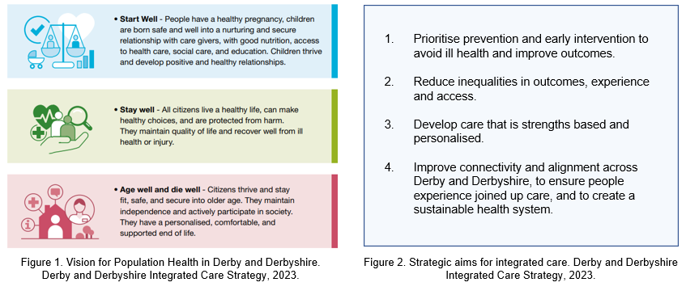
The DDICS has been developed in the context of the two Joint Local Health and Wellbeing Strategies and the two Local Authority plans, which are expected to be updated during 2023.

A major focus of the DDICS is on increasing life expectancy and healthy life expectancy and reducing inequalities – by tackling the leading causes of early death and time spent in ill-health.

On this front, the current situation is stark. As summarised at Figure 3, in Derby, the life expectancy and healthy life expectancy of both males and females is either lower or the same as it was almost a decade ago. Across Derbyshire (viewed at a county level), whilst the life expectancy of a male has slightly increased over the last decade, more of that time is living in ill-health. For females there has been no discernible improvement or decline.

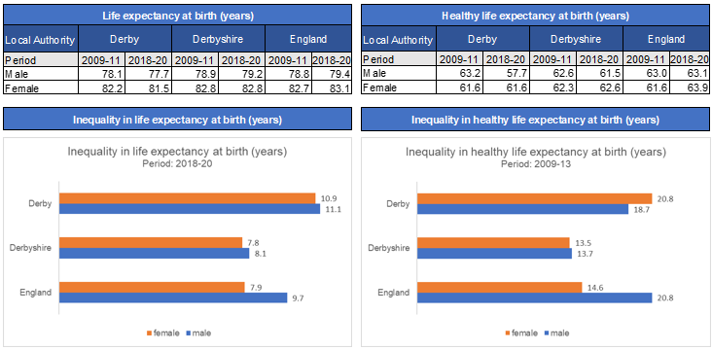
Figure 3. Life expectancy, healthy life expectancy and the inequality in both – Derby, Derbyshire, and England

The inequality in both life and healthy life expectancy, as shown at Figure 3, clearly demonstrates the impact of deprivation. Poorer outcomes are linked to areas of socio-economic deprivation and certain groups including, but not limited to, those from Black, Asian, and minority ethnic backgrounds, those with serious mental illness, people living with disabilities, LGBTQ+ people and people currently homeless.

In response to this, the DDICS has set out a range of markers – referred to as ‘Turning the Curve’ indicators – that the ICP are aiming to affect, tackling key risk factors for early death, ill-health (physical and mental) and health inequalities.

'Turning the Curve' Indicators
- Reduce smoking prevalence
- Increase the proportion of children and adults who are a healthy weight
- Reduce harmful alcohol consumption
- Improve participation in physical activity
- Reduce the number of children living in low-income households
- Improve mental health and emotional wellbeing
- Improve access to suitable, affordable, and safe housing
- Improve air quality.

Next steps for integrating primary care: Fuller stocktake report

The Fuller Report sets out a new vision for integrating primary care, improving the access, experience, and outcomes for communities, which centres around three essential offers:
  - Streamlining access to care and advice for people who get ill but only use health services infrequently - providing them with much more choice about how they access care and ensuring care is always available in their community when they need it;

  - Providing more proactive, personalised care with support from a multidisciplinary team of professionals to people with more complex needs, including, but not limited to, those with multiple long-term conditions; and

  - Helping people to stay well for longer as part of a more ambitious and joined-up approach to prevention.
The Derby and Derbyshire Health System recognises that implementing all aspects of the Fuller stocktake requires a significant change in culture and approach underpinned by strong local leadership.

The Major Conditions Strategy

The Government has launched a call for evidence to inform its landmark Major Conditions Strategy to tackle the main causes of ill-health, ensure care is patient focussed and relieve stress on the health and care system. Their call for evidence seeks views on how best to prevent, diagnose, treat, and manage six major groups of conditions that contribute to the burden of disease in England, specifically:
- Cancers;
- Cardiovascular (or circulatory) diseases, including stroke and diabetes;
- Chronic respiratory disease;
- Dementia;
- Mental ill health; and
- Musculoskeletal disorders
The significance of this development through 2023 going into 2024, has contributed to the framing of action within this NHS Plan to date and will continue to do so.

The NHS Mandate 2023

The NHS Mandate for 2023 sets out the Government's priorities for the NHS for this year:
- Cutting NHS waiting lists, recovering performance for cancer, A&E, ambulance category 2 response times and general practice access;
- Supporting the workforce through training, retention and modernising the way staff work;
- Delivering recovery using data and technology; and
- Delivering financial balance.
These priorities make clear the need for our local NHS to continue to prioritise recovery and access in conjunction with our strategic aim to improve population health and to reduce inequalities.

How all the different strategies 'fit together'

This section demonstrates the significant amount of work that has been (and continues to be) undertaken to align the strategies of a range of actors that have a role in improving the health and wellbeing for our local population. The relationship between the key strategic outputs generated by various partners within the Health and Care System is shown in Figure 4.

However, the one thing that links all partners in the Health and Care System together is the unified clarity of purpose to deliver the strategic aims of the Integrated Care System (ICS):

- Improve outcomes in population health and healthcare;
- Tackle inequalities in outcomes, experience, and access;
- Enhance productivity and value for money; and
- Help the NHS support broader social and economic development.

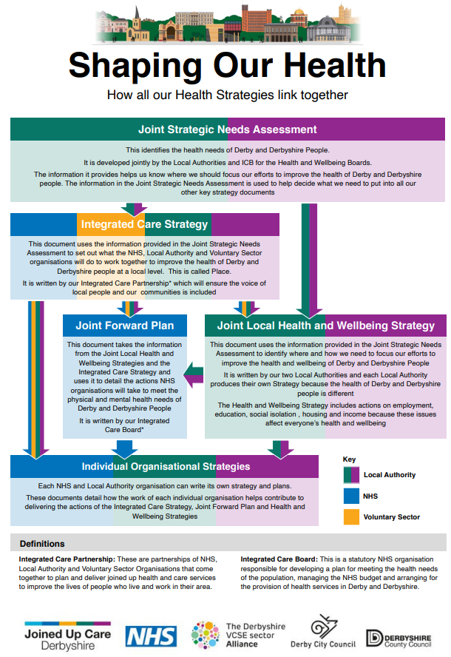
Figure 4. how all the different Strategies fit together

Derby and Derbyshire Healthcare System Development

This five-year period will see the continued development of how the NHS operates as part of the Integrated Care System. This will involve changes to the responsibilities and functions of different parts of the NHS, including where and how decisions are taken.

The Derby and Derbyshire Integrated Care Board as a Strategic Commissioner

The Derby and Derbyshire Integrated Care Board's (DDICB) role in the new architecture of the NHS, is focused on created a systematic and proactive approach to planning, procuring, and delivering NHS services for all communities of the Derby and Derbyshire population.
As a new organisation formed in 2022, the DDICB is evolving to achieve its ambition to be seen as a valued partner in the wider collective effort to improve population health and reduce the inequity in healthcare provision. Indeed, the broader constituency of the Board provides us with the means to do this and maximise performance against our statutory duties.
In this context, the recently published 'Strategic Framework' for the DDICB – as shown in Figure 5 – provides clarity of purpose for the organisation over this five-year period and the key leadership role it has in driving the integration of health and care services.
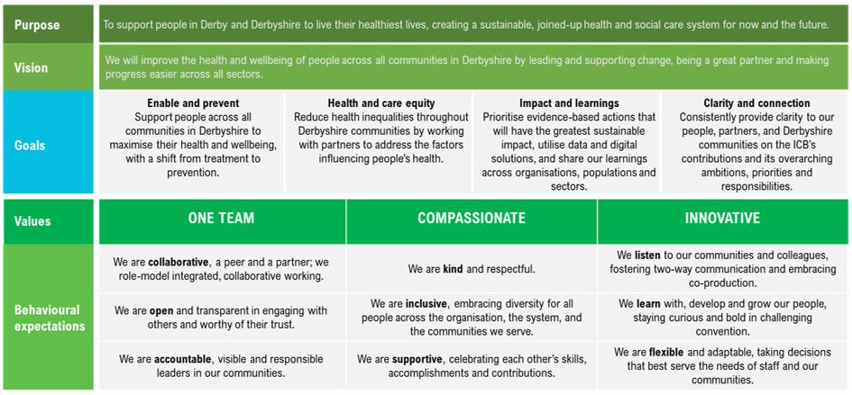
Figure 5 – The Derby and Derbyshire Integrated Care Board's Strategic Framework.

The design and delivery of care at PLACE

Our Places, which are our City and County footprints coterminous with our Local Authority boundaries and within these, our smaller alliance of partnerships at a locality level, have been developing in Derby and Derbyshire for several years. This enables the system to ensure a population focus alongside the traditional service or organisational ways of planning and delivering services and for achieving engagement, planning and delivery at a local community level.

"Empowering people to live a healthy life for as long as possible through joining up health, care and community support for citizens and individual communities".
The vision for PLACE based working in Derby and Derbyshire

This NHS Plan comes at a time where we have moved from informal networks and 'coalitions of the willing' to an operating model for Place with clear structure, purpose, and accountability. This governance will support the ability to identify and act in the areas of population need and service offer where there is most benefit from an integrated approach.

Furthermore, the Integrated Place Executive (IPE) is responsible for the design and delivery of Place development and has identified the fundamental need to model a set of new behaviours to generate the culture that is required to bring true integration about.
Aspirations for 'PLACE behaviour'
- Continue to work on and be brave in challenging each other to embody the attributes and behaviours of distributed leadership.
- Shared, democratic, collaborative decision making.
- Non-hierarchical.
- No idea off the table - not more of the same.
- Clear communication between all parties.
- Empowering all staff to work in partnership.

Provider Collaboration

The JUCD Provider Collaborative provides a single forum for all providers of NHS services to work together and take collective responsibility for the delivery of priorities within the NHS, enabling vertical as well as horizontal integration at scale.

The collaborative includes the following organisations:

- Chesterfield Royal Hospital NHS Foundation Trust
- Derbyshire Community Health services NHS Foundation Trust
- Derbyshire Healthcare NHS Foundation Trust
- DHU Healthcare
- East Midlands Ambulance Service NHS Foundation Trust
- University Hospitals of Derby and Burton NHS Foundation Trust
- GP practices - represented by the GP Provider Board

" Working together as providers to achieve tangible improvements to the way care is delivered ".
The vision for provider collaboration in Derby and Derbyshire

As the Provider Collaborative matures over the period of this NHS Plan, it is anticipated that significant, value adding benefits will arise in the form of:

- Developing and delivering collaborative approaches to specific challenges within providers’ gift to resolve;
- Addressing efficiency, productivity and sustainability through collaborative working, integration, or the consolidation of service delivery or corporate functions;
- Developing partnership relationships, strengthening communication between providers, sharing approaches to challenges and opportunities;
- Reducing inequalities of access and unwarranted variation, where provider collaboration can best achieve this; and
- Taking on some commissioning responsibilities within the ICS where this will align better with operational delivery and transformation, improve decision making and accelerate change.

Our NHS Plan – its positioning and core focus

This NHS Plan has been constructed with clear recognition of the extent to which good healthcare provision contributes to health. As shown in Figure 6, the Plan's scope focuses exclusively on how the NHS in Derby and Derbyshire can 'maximise the 20%', by addressing a series of structural design issues which has hampered our ability to improve.
Indeed, delivering this plan will mean that the NHS will become the best partner it can be, collaborating with other sectors to shift the system towards health opportunities for all communities.

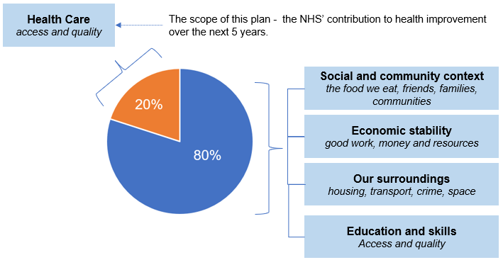
Figure 6. Drivers of health

The NHS Plan within the wider effort to improve population health

The Derby & Derbyshire ICB's definition of Population Health Management (PHM), that the local health economy is coalescing around is:
An approach that identifies communities of people with shared or like characteristics, and then intervenes with socio-economic or healthcare interventions for that community in order to improve health outcomes, reduce service need whilst also improving the sustainability of health and care services.

The local approach to deliver effective Population Health Management brings together:

- A focus on agreed high priority health issues
- The effective reduction in health inequalities, and
- Primary, secondary, and tertiary prevention.
The high priority clinical areas of focus within Derby & Derbyshire are already identified and agreed as:

- Cardiovascular disease (including diabetes);
- Respiratory disease;
- Cancer; and
- The early years of life (pre-school).

There is a recognition that experience of good health in our communities is not equal. There are individuals and communities that experience poorer health outcomes than others, for example individuals within deprived communities, people within minority groups and from specific cultural or ethnic groups and people with other underlying conditions such as severe and enduring mental health concerns.
To address health inequalities and deliver on the prevention agenda, we recognise the need to ensure the better targeting of healthcare resources upon those individuals in greatest need and greatest ability to benefit from those resources. We are now establishing approaches that will deliver both Population Health Management and improved health outcomes, within the communities that we serve.
However, in producing this NHS Plan, it is important to stress that we want to avoid medicalising the population health and health equity agenda. We therefore try to avoid conflating "health" with "healthcare" – fully recognising that healthcare is one of the many factors that contribute to population health.
Furthermore, whilst developing a more comprehensive approach to PHM over the next five-years, we recognise it is not a silver bullet to improving the health of population. This is particularly important when considering the limited effectiveness of PHM interventions relative to large scale structural change that addresses disadvantage, risk and exposures that have accumulated over a lifetime.

The significance of Primary Care in the NHS Plan

A core assumption which underpins this NHS Plan is that Primary Care is the cornerstone of the Derby and Derbyshire NHS' contribution to improving population health. Therefore, over the course of this NHS Plan period, action will be prioritised to strengthen Primary Care, with a programme of work being developed to:
- Integrate primary care and community-based services, including social care, to deliver a model of proactive, preventative, and integrated community care built on integrated neighbourhood teams at PCN level;
- Improve access to urgent and same day care in primary and community settings;
- Reduce inequalities of access, outcomes, and experience associated with care;
- Develop and make best use of JUCD resources - workforce, financial and physical; and
- Support the integration of pharmacy, optometry, and dental primary care services.

A summary of this Programme, which is developed and overseen by the Primary Care and Community Delivery Board, is included under Section 5.

The structure of this document

This NHS Plan is organised into six sections:
- Section 2 – The case for change - discusses a series of key challenges that the NHS in Derby and Derbyshire will face over this five-year period (and beyond) and identifies the critical issues for the NHS to resolve.

- Section 3 – Our guiding policies for action – sets out an approach for dealing with the challenges and critical issues as identified in section 2 – by establishing five guiding policies for action.

- Section 4 – The action that we are taking in 2023/24 – describes the action that we are taking in 2023-24, as the first year of this five-year plan, to carry out these guiding policies.

- Section 5 – Building on this action and going further – sets out a range of works which will be developed and delivered by system partners in future years of this plan, building on the progress that we make in 2023/24.

- Section 6 – Governance – describes the governance arrangements relevant to this Plan and the key strategic risks that need to be considered.

The Case for Change
Summary points:
- There are aspects to the deterioration of the population's health over the last eight years which are of particular concern – specifically avoidable mortality and infant mortality in Derby and the reduction in the wellbeing of the Derbyshire population.

- In addition to the above, improvement works within the NHS must target the conditions which drive the disease burden across the Derby and Derbyshire population - Cancer; Cardiovascular disease, Musculoskeletal disorders; Mental disorders, neurological disorders, and chronic respiratory disease.

- Crucially though, it is the growth in multi-morbidity intersected with older age which is going to require a fundamental shift in how the NHS in Derby and Derbyshire operates.

- Evidence shows that patients feel less in control over the healthcare they receive, despite wanting it. It is imperative that we tackle this particularly given the proven benefits of better clinician relationships, improved adherence to advice and increased satisfaction with the outcome of treatment.

- The growth and expansion of new technology will revolutionise healthcare over the next five years and beyond, presenting both opportunities and challenges for us. The issue that the Derby and Derbyshire healthcare system will need to grapple with isn’t whether we choose to adopt these technologies, rather how best to prepare for the change ahead.

- The recruitment and retention of General Practitioners and Community based nurses is a pre-requisite over the next five year-period.

- The financial, productivity and environment challenge over the next five-year period go hand in hand. There are significant opportunities to reduce waste which must be realised to get the system on a better financial footing.

- Whilst the causes of these challenges are multifactorial and complex, we can positively affect them by reforming: (i) what our clinical workforce does in the future and type of skills we invest in; (ii) the way in which we allocate financial resource within the NHS and (iii) changing the nature of the care that we deliver for patients.

Key challenges for the Derby and Derbyshire Health System

A backdrop of a deterioration in the population's health

The Office for National Statistic’s Health Index provides a single value for health in England and local authorities each year. The index uses a broad definition that aligns with the World Health Organisation’s definition of health, incorporating a range of indicators that relate to health outcomes and health related behaviours in addition to the place where people live, as summarised in Figure 7.
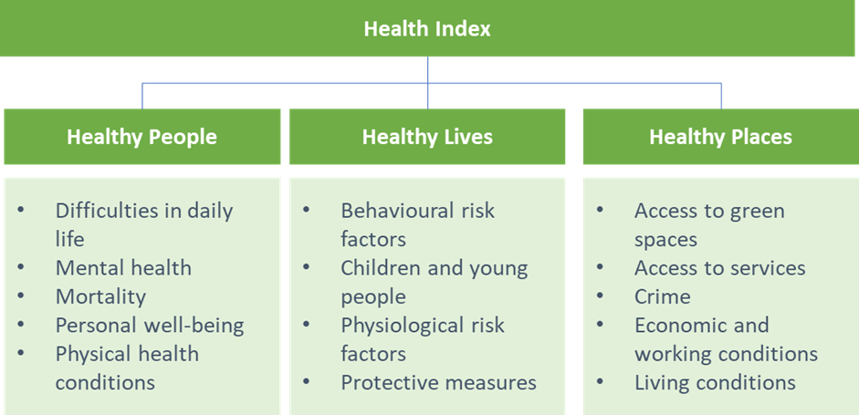
Figure 7. The construct of the Office for National Statistics (ONS) Health Index⁹
All scores are relative to the 2015 baseline, so a higher score indicates improving health, and a lower score indicates deterioration in health.

The health of the Derby and Derbyshire population

At a macro level, the health of Derby population was on average lower in 2021 compared to 2015 (index score of 90.4 in 2021 vs. a score of 92.3 in 2015) and marginally higher for the Derbyshire population at a county level (index score of 108.7 in 2021 vs a score of 108.1 in 2015). However, the 'healthy people' domain score for both local authority areas was significantly lower in 2021 relative to 2015 – as shown in Table 1.

Table 1. Health Index Score with domain breakdown – Derby and Derbyshire

Given that the 'Healthy People' domain draws on indicators that are pertinent to the activities of the NHS, it is a concern that this aspect of health has deteriorated so much in the last eight years.

So, what has caused this deterioration?

The decline in Healthy People has predominantly been seen in the following sub-domains of the measure: 'personal well-being' (a 11.0-point reduction in Derbyshire and 2.6-point reduction in Derby); 'mortality' (a 5.5-point reduction for Derby specifically) and 'difficulties in daily living' (a 2.6- point reduction in Derbyshire and 12.3 reduction in Derby) - as shown in Figure 8.
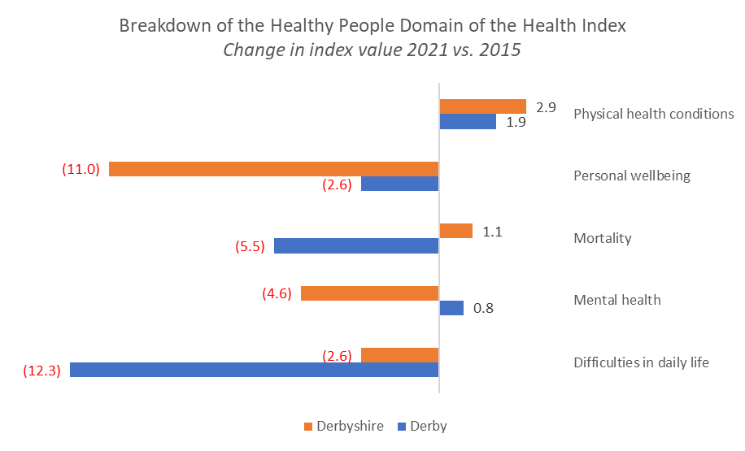
Figure 8. The sub-domain elements of the Healthy People Measure of the Health Index – difference between the 2021 measure and the 2015 baseline index value¹⁴
A full breakdown for each of the elements listed in Figure 8, is detailed in Appendix A for information but the most significant findings are that:
- The adverse change in the mortality index seen across Derby is a concern - with all aspects of this measure – mortality from all causes; life expectancy; infant mortality and avoidable mortality - recording a lower index value in 2021 relative to the 2015 baseline.

- The reduction in the level of personal wellbeing felt by people living in Derbyshire, is driven by people feeling, on average, less satisfied within their life, less happy, more anxious and feeling that activities in life are less worthwhile than in 2015.

- The reduction in the difficulties in daily life score across both Derby and Derbyshire, is due to a greater proportion of working age adults registered as disabled under the Equality Act or work-limiting disabled.

The burden of disease

The latest Global Burden of Disease Study shows that the top six causes of disease burden, as measured through the Disability Adjusted Life Years, across the Derby and Derbyshire population are: Cancer; Cardiovascular disease, Musculoskeletal disorders; Mental disorders, neurological disorders, and chronic respiratory disease – with the burden of mental and neurological disorders increasing over the last three decades, as shown in Figure 9.
Figure 9. Disability Adjusted Life Years (DALYs) per 100,000 population¹³

All these conditions are non-communicable with the main causes of them relating to tobacco use, high fasting glucose levels, high body mass index, dietary risk and high blood pressure and cholesterol, as shown at Figure 10.
Figure 10. Cause of Disability Adjusted Life Years (DALYs) per 100,000 population¹³

Whilst dealing with the impact of these conditions over the next five-year period is going to present a series of complex challenges for the NHS, it is the growth in multi-morbidity intersected with age (see next point) which is going to require a fundamental shift in how the NHS in Derby and Derbyshire operates.
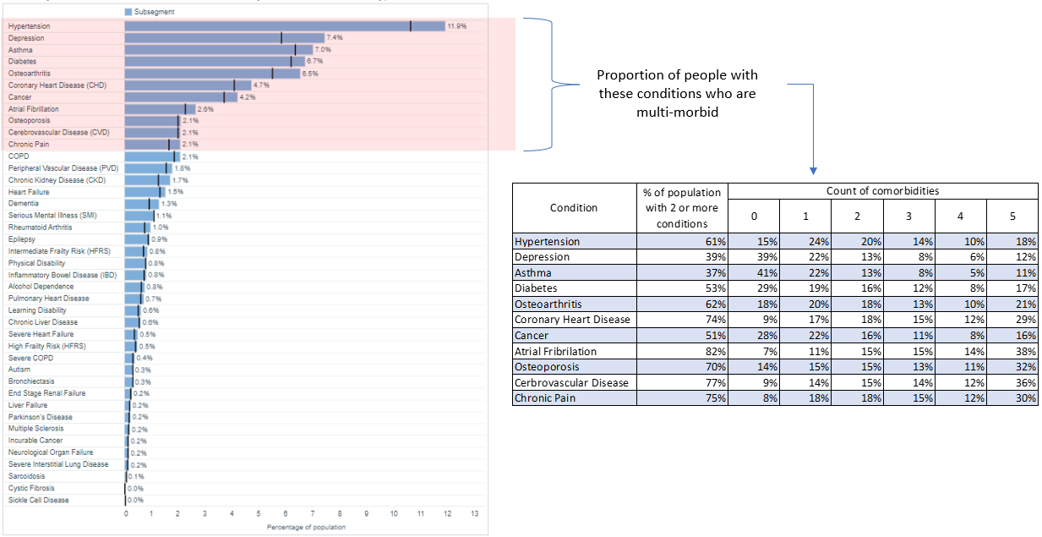
Figure 11. Proportion of the Derby and Derbyshire population with a range of clinical conditions – snapshot as at 30/06/21

Preparing for the change in demography

Whilst over the next five-year period, we expect all age population to be bigger in 2028 relative to 2023 (1% Derby and 3% Derbyshire), the fastest growing sector of the Derby and Derbyshire population is the older adult, those aged over the age of 65. We expect this population to be 10% and 9% larger in 2028, in Derby and Derbyshire respectively.
Furthermore, it is expected that two-thirds of adults aged over 65 will be living with multiple health conditions (multi-morbidity) by 2035 - 17% living with four or more diseases, double the number in 2015 and one-third of these people would have a mental illness like dementia or depression.
Figure 12. Derby and Derbyshire population projections. Office for National Statistics

Public expectations and insights

Public expectations regarding healthcare have evolved over time, with patients and their families seeking more active involvement in decisions regarding their care. However, the evidence shows that patients feel less in control over the healthcare they receive. For example, the latest population survey of General Practice found that 44.6% of patients want more involvement than they currently have in their healthcare decisions – the highest proportion since the question was first asked in 2018. Similar findings arise in other aspects of provision, including community mental health services and acute inpatient services.
In this context, giving patients better control over their care – shared decision making, health literacy and the provision of better information - is a challenge that the Derby and Derbyshire NHS must meet over the next 5 years, particularly given the proven benefits of better clinician relationships, improved adherence to advice and increased satisfaction with the outcome of treatment.
In addition to this, insight gathered from recent engagement exercises relating to development of the DDICS and for 'NHS@75' – summarised in Figure 12, illustrates some of the pressing drivers for change from the public's perspective across the start well, stay well, and age well life course.

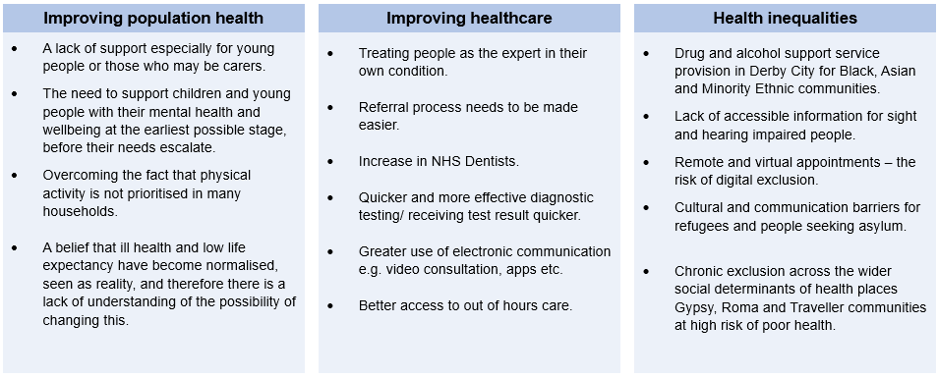
Figure 13: Summary of issues arising from the NHS @75 engagement event.

Advancements in technology

The growth and expansion of new technology will revolutionise healthcare over the next five-years and beyond, presenting both opportunities and challenges for us. Medical breakthroughs, such as genomics, precision medicine and machine learning hold the potential for us to personalise the care we give in a more efficient and effective way.
The issue that the Derby and Derbyshire healthcare system will need to grapple with isn’t whether we choose to adopt these technologies, rather, the issue is one of preparedness – with a range of challenges to work through.

Improving productivity

The recently published report by the Institute of Government examines the issue of why hospital activity has not increased in line with funding and staff. Clearly, the productivity challenge is not only limited to hospital-based care. However, given that significant investment has gone into the sector in the recent past is it reasonable to focus on the challenges of this sector as a priority.
The key area of improvement required over the next five-year period relates to the productivity of elective acute care services, where the level of input (the number of medical Full Time Equivalents FTEs working in surgical specialties) has increased by 20% since 2016, but the level of output (the number of completed RTT admitted and non-admitted pathways) has reduced – as shown in Figure 14.
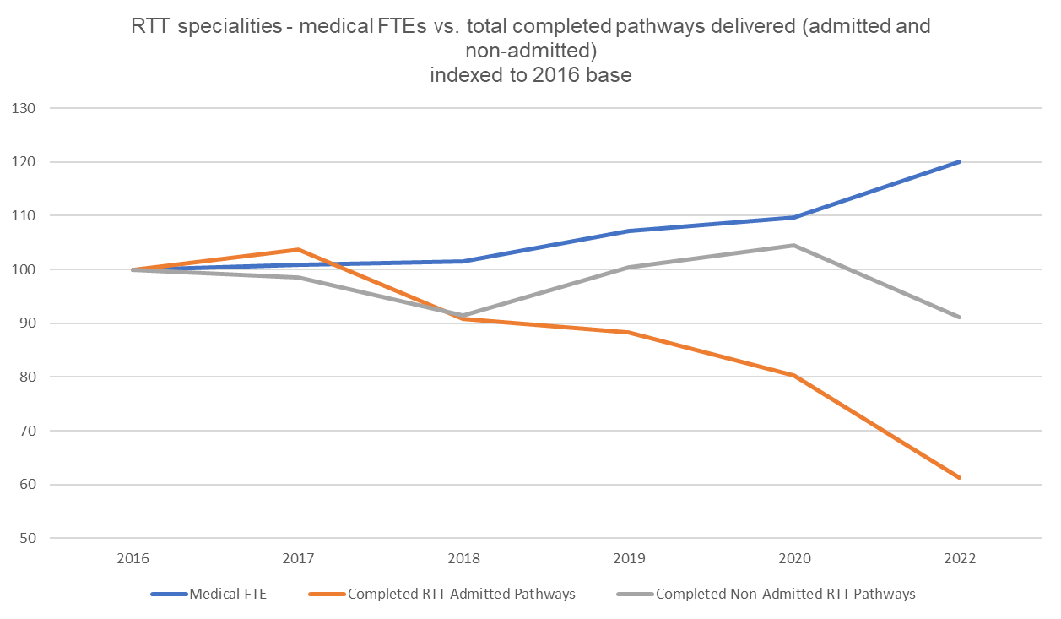
Figure 14: Number of Medical FTEs working in elective care specialities and the total number of RTT admitted and non-admitted pathways – with 2016 as the base year
Whilst the causes for the lag in elective productivity are complex and multifactorial, there are two underlying issues at play, which need to be resolved if we are to improve the situation.
- Reducing general medical acute demand. The use of surgical bed provision to manage medical demand because it can't be safely managed within the medical bed footprint, has become normalised in day-to-day practice.

- The c.200 patients currently who are ready to go home but are in delay. The opportunity cost of delayed discharge is significant, due in part to a lack of suitable capacity outside our acute hospital (c.60% of the problem) in addition to poor internal discharge processes (c.40% of the problem).

The care quality gap

Over this five-year period, there are significant opportunities to improve the quality of healthcare provision as shown in Figure 15. This will not only have a demonstrable positive effect on the health and wellbeing of our population but also enable the Health System to save money.
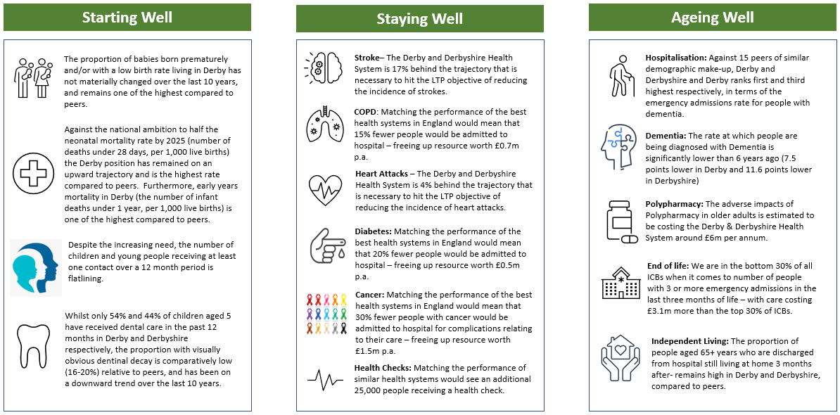
Figure 15: Summary of opportunities to improve specific aspects of healthcare over the next five-years.

The cost of provision

The environmental challenge
NHS England in its 2020 report, delivering a Net Zero National Healthcare Service, sets challenging targets for the NHS to decarbonise healthcare delivery. This includes achieving net zero carbon emissions by 2040 and requires the NHS in Derby and Derbyshire to remove 23,000 tonnes of carbon emissions per year, during this NHS Plan period, from both direct and indirect aspects of healthcare provision.

The financial challenge
In the context of the economic situation, it is highly likely that the next five years will see the NHS in Derby and Derbyshire continue to operate within a constrained financial environment. To clear the underlying deficit over the next 5-year period will require a cumulative reduction in the cost of delivering care of around £363m (assuming a 4.4% reduced level of spend is delivered in 2023/24 and recurrent savings of 2% are delivered in years 2-5). Meeting this challenge will require all parts of the Derby and Derbyshire health system to fundamentally change at significant scale, how NHS care is delivered and have a much greater focus on reducing different aspects of waste from the process of delivering care – as summarised in Figure 16.
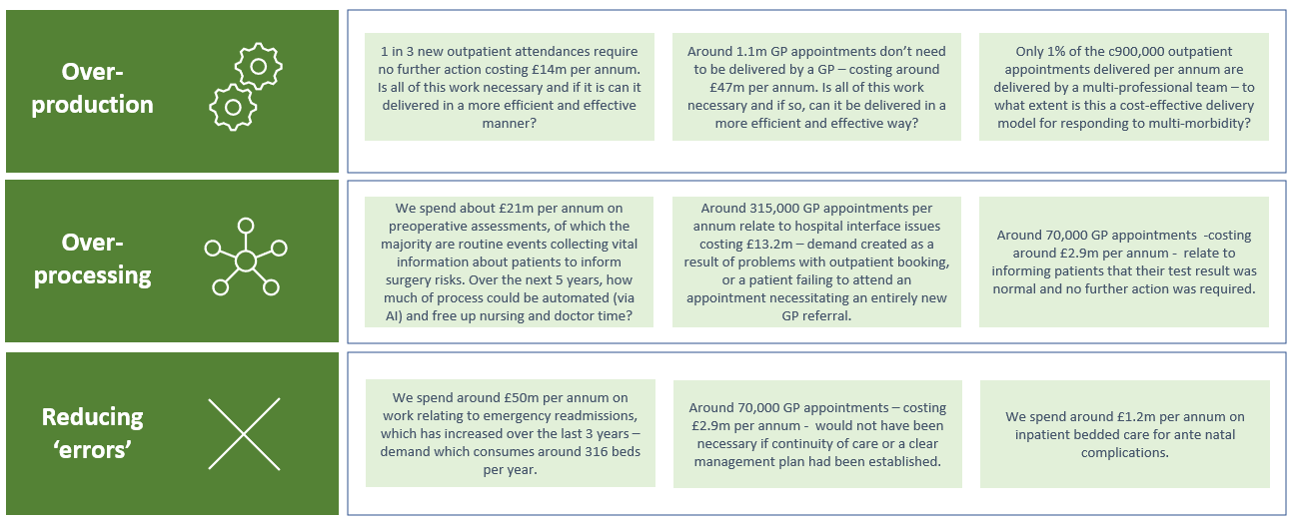
Figure 16. Some examples of waste inherent in the way care is currently delivered

Our estate

Over the next five-years, the Derby and Derbyshire NHS is likely to face several challenges in relation to its estate.

Ageing infrastructure

NHS Provider Trusts operating in Derby and Derbyshire occupy estate that predates the formation of the NHS (22%) or is more than 30 years old (65%).
Figure 17. Age of the Derby and Derbyshire NHS Provider estate

While this is not always a problem, as some older buildings have been upgraded to meet modern standards of care, it is still too often the case that the NHS is operating in inadequate facilities. Unfortunately, no equivalent national data is collected on the maintenance of the primary care estate; however, anecdotal evidence suggests the age and condition of the primary care estate is no better than that owned by NHS provider trusts.
The impact of this can be seen in the levels of backlog maintenance – estimated to be valued at around £43m in 2021/22²⁴.

Sustainability and Climate Change

Achieving net zero by 2040 will require a transformation in how we make our NHS estate more energy efficient using renewable energy sources.

Changing models of care

Transitioning the operating model of the NHS in Derby and Derbyshire to one that is truly community based and integrated, will require a reconfiguration of estate to support the move. In addition, the adoption of new technology and digital systems as a way of transforming the care delivery model over the next five-years (e.g. electronic health records, telemedicine capability and smart infrastructure) will require careful planning and investment.

Adapting to pandemics and health emergencies

The COVID-19 pandemic highlighted the need for flexible, adaptable, and resilient healthcare facilities. It is therefore vital that the preparedness work that we do over the next period examines this important issue, so that we can handle surges in demand and deliver infection control measures effectively.

Delivering improvement with significant workforce constraints

The clinical workforce pressures that the Derby and Derbyshire NHS has experienced over recent years, reflects the challenge that is seen across many parts of the NHS across England. Indeed, whilst the clinical workforce has increased over the recent period, much of the healthcare that has been delivered in recent years has been done with ‘deficit level’ of demand. This is particularly the case for General Practitioners and nurses across NHS Hospital and Community Health Services (HCHS).

The need to recruit
The importance of effective workforce planning for this five-year period cannot be under-estimated and is urgent. Applying the work of The Health Foundation to the Derby and Derbyshire health system poses significant questions about general practice workforce supply for Derby and Derbyshire with a projected ~30% deficit in General Practitioner FTEs by the end of the NHS Plan period (as displayed at Figure 18) which poses a material risk to the sustainability of the section.
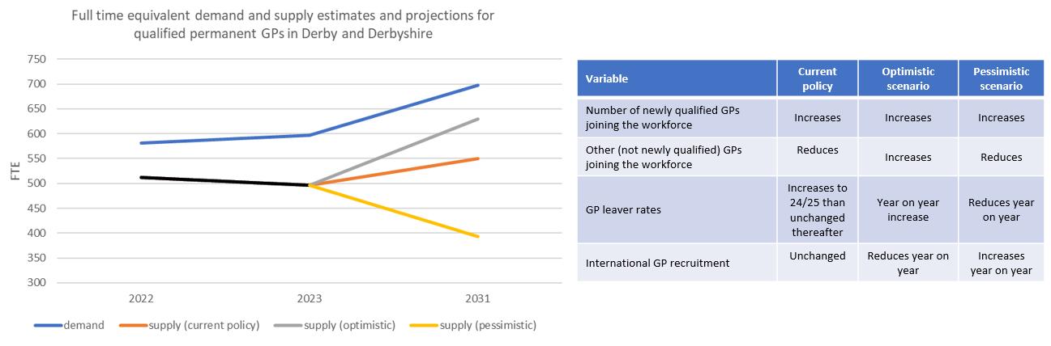
Figure 18. Projection of fully qualified permanent GPs in Derby and Derbyshire needed vs. forecast supply.
Furthermore, HCHS nursing is projected to continue operating at a deficit over the period – equating to a ~8% gap by the end of the NHS Plan period, as displayed in Figure 19.

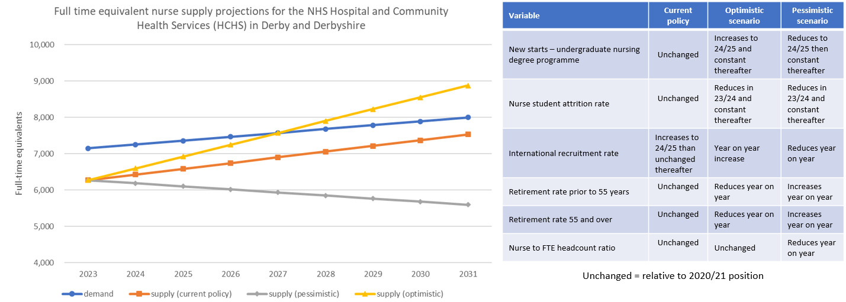
Figure 19. Projection of registered nurses in Derby and Derbyshire needed vs. forecast supply.

The need to retain

Retaining our clinical workforce is of paramount importance, particularly when considering how it mitigates the workforce shortages summarised earlier and is also better for the quality of care provided to patients. Whilst there are issues at an individual service line level within organisations, at a macro level, the current situation across the Derby and Derbyshire Health System is broadly positive - albeit with some clear pressure points.

General Practitioners
During the last financial year (2022-23), England saw more fully qualified General Practitioners leave the workforce relative to the number joining – a net 1.2% reduction. This is a similar position seen across the Derby and Derbyshire patch, with a net 1.5% reduction, as shown at Figure 20. A continuation of this performance into the following years, against a backdrop of a structural deficit of GP supply relative to demand poses a significant set of risks for the Derby and Derbyshire Health System over the five-year period.

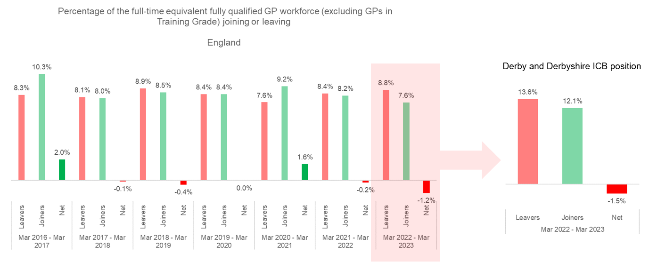
Figure 20: Percentage of the full-time equivalent fully qualified GP workforce (excluding GPs in Training Grade) joining or leaving. Source: NHS Digital, General Practice Workforce, England, GP Joiner and Leaver Tables, March 2023.

Nursing
When benchmarked against other Providers across England, the rate of people leaving the Chesterfield Royal Hospital NHSFT, University Hospitals of Derby & Burton NHSFT and Derbyshire Health NHSFT is in a good position relative to other Trusts. However, the position of Derbyshire Community Healthcare Services NHSFT is of a concern, with a leavers rate higher than the median position across England.

Figure 21: NHS Leavers Rate (Registered Nurses) – 12 month rolling position ending February 2023. Source: NHS Model System.

Midwifery
When benchmarked against other Providers across England, the rate of people leaving the midwifery services of Chesterfield Royal Hospital NHSFT and University Hospitals of Derby & Burton NHSFT and Derbyshire Health NHSFT is in a good position relative to other Trusts.

Figure 22: NHS Leavers Rate (Midwifes) – 12 month rolling position ending February 2023. Source: NHS Model System.

Medical and Dental
The rate of medical and dental professional leaving our Provider organisations is like that of other organisations across England, apart from Derbyshire Community Healthcare Services NHSFT which is high.

Figure 23: NHS Leavers Rate (Medical and Dental) – 12 month rolling position ending February 2023. Source: NHS Model System.

Key issues that the Derby and Derbyshire NHS will seek to resolve

Whilst the causes of the challenges detailed in section 2.1 are multifactorial and complex, there are some fundamental aspects of design – both from the perspective of policy (e.g., finance and workforce) and operations (e.g., how care is delivered) which, if properly addressed, would allow the NHS to meet these challenges in a more effective way.

How we invest financial resource to bring about the change we need

Whilst the evidence on the relationship between financial incentives and quality improvement is mixed, the powerful role in how financial resource is allocated cannot be underestimated.
Over recent years, the desire to direct resource to services which can reach into the most disadvantaged communities, has not been met with any substantive, practical change in how the £3bn worth of revenue expended each year is distributed. Funds have been allocated on an institutional basis and largely based on what has happened retrospectively, reflecting how services have been delivered in the past - rather than what the local population health needs are now and are to be in the future.

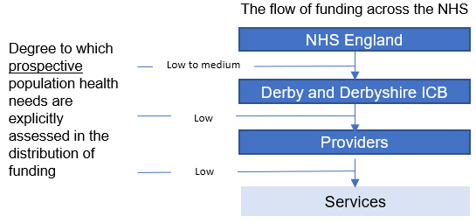

Most financial resource flows in a ‘blocked’ way and is not linked to the delivery of clear and agreed health outcomes. This also means funding can be out of line with changes in patient demand. Pooling financial resource between providers is a critical component for places to design and deliver interventions to improve health and wellbeing of communities. However, the pooling of financial resource between providers of NHS services and NHS services with local authority and voluntary sector provision, is limited and under-developed.
Finally, the way in which service transformation is funded within the Derby and Derbyshire health system needs to be reviewed – with many critical improvements being funded via non-recurrent means, thus impeding our ability to scale interventions quickly.

The type of workforce that we invest in over the next 5 years

The historic way that the NHS has been funded, has incentivised a greater proportion of the monies available to propagate specialist and acute care - rather than primary and community-based physical and mental ill health care.

This has reduced the ability of primary care to deliver effective population health management by preventing, postponing, and lessening disease complications and playing its full potential role in delivering integrated and proactive care, working alongside other parts of the system. This is illustrated in Figure 24, which shows growth in general medical acute doctoring and nursing outstripping the growth in general practice and community-based provision over the last six-year period.

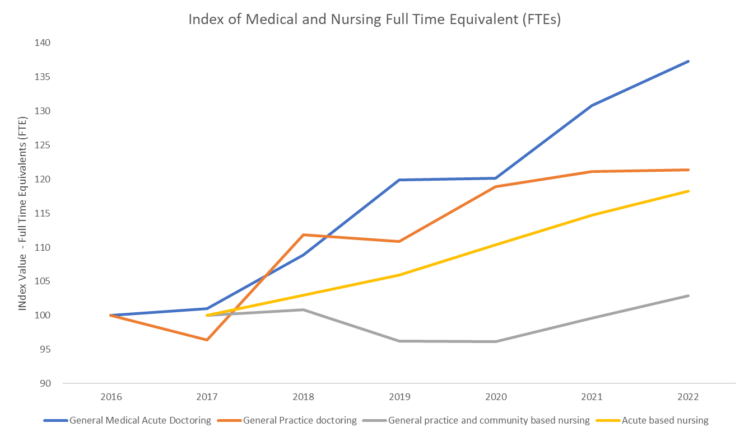

Figure 24: General Medical Acute Doctoring Index vs. General Practice Doctoring Index (2016 as the base year) and General Practice and Community Based Nursing Index vs. Acute Based Nursing Index (2017 as the base year)

Reversing this approach is a fundamental prerequisite to improving the structure and quality of chronic and multimorbidity disease care over the next five-years and beyond and thus reducing the cost of preventable care. Addressing this will also require the NHS to rethink the way that different professional groups are deployed, ensuring that there is enough capacity and the right skills to deliver an integrated, community-based model of care at the scale required.

The nature of the care that we deliver

The adverse health impacts and financial inefficiency as discussed in Section 2.1, are due in part to fragmented and reactive care delivery with restrictive access points, poor continuity and co-ordination across pathways and a fundamental gap between the policy aim of greater personalisation and actual routine clinical practice.
Over the period of this NHS Plan, there are several issues relating to the operating model which therefore need to be resolved, including but not limited to the following:

- In many areas of provision, patients can be made to feel remote from decision-making relating to their care, due in part to fixed arbitrary points where information is exchanged between a patient and the clinician/care team. The opportunity cost of this is that vital information about a patient’s condition and/or general health and wellbeing and opportunities to intervene can be missed.

- Targeting limited clinical resource to those people who are most at risk of their health deteriorating and thus developing a more proactive care offering, can be improved by the further development of risk stratification technologies.

- There has been little progress on restructuring the way that clinicians work across different settings of care, to combine the collective power of the specialist and expertise of the generalist within integrated clinical networks.

- Acute hospitals respond to acute medical and surgical, social, and primary care needs and it is important that people’s needs are met in an integrated and holistic way wherever they present. All too often, the demand for emergency medical care hampers other care pathways. We need to improve alternatives to admission and more rapid discharge of patients and design hospital pathways to protect planned care, diagnostics and surgical provision for the patients requiring them.

- The model of hospital provision needs to be reviewed so that it is fit for the future, harnesses the benefits of new technology and reflects best clinical practice.

Our guiding policies for action

The purpose of this section is to outline an overall approach for the NHS Derby and Derbyshire NHS, for overcoming the obstacles highlighted in Section 2. This approach has been embodied in the creation of five guiding policies to channel the action that is required over this NHS Plan period, to change the way in which the NHS operates.

Figure 25. The five guiding policies of our NHS Plan for the next five years

Allocate greater resource to activities that will prevent, postpone, or lessen disease complications and reduce inequity of provision

During the period covered by this NHS Plan, the Derby and Derbyshire NHS will allocate a greater proportion of its resources – financial, human and estates – to enhance both the scale and quality of its prevention activity. It is fully recognised that there will be short to medium term issues and risks – quality, performance and finance related – that we will need to explicitly trade-off, given that our collective resource is limited. This requires detailed work up, including modelling over the five-year period.
This represents a different approach to what has gone before, and we are choosing it because it is a pre-requisite for putting our local NHS on a more sustainable footing.
Key actions include:
- Strengthening primary care, specifically General Practice – both in terms of financial investment and clinical workforce.

- Re-purpose the focus of acute based general medical provision and how it integrates with general practice chronic care management provision.

- Reallocate primary and community care resource between localities – so that people with the poorest health outcomes have greater access to services.

Delivering this action will allow us to build a more preventative model to how the NHS currently operates across Derby and Derbyshire. However, it is also important that we define what type of preventative activity we want to enhance the scale and quality of.
In every interaction between a clinician and a patient, it is vitally important that interventions designed to prevent disease or injury before it happens, are being utilised by the people who would benefit. As such, the NHS' support role in primary prevention will be strengthened over the five-year period of this plan. However, in full recognition that introducing and scaling impactful primary prevention interventions at a population level is something that goes well beyond the boundaries of the NHS, the health system in Derby and Derbyshire will prioritise providing high quality, evidenced based secondary and tertiary prevention services.

Give the teams working in our localities, the authority to determine the best ways to deliver improvements in health and care delivery for local people

The first guiding policy discussed above focusses the NHS to act on the prioritisation of resource to deliver more and better preventative activity and strengthening how this is delivered between clinical professions. delivering the activity (e.g., general, and general medical specialists). However, this on its own is not enough to have the impact we need.
Therefore, the second guiding policy over this NHS Plan period, will be focussing action to create the infrastructure and incentives that are necessary to bring about a fundamental shift in how preventative activity is delivered – powering the creation of multidisciplinary teams working in localities - consisting of staff from the NHS, wider public and voluntary sector and enabling them to deliver improvement to the health of the populations they serve.
The further development of multi-disciplinary teams of professionals, working in and with local communities over the next five-years, will mean that they will possess greater insight into the specific needs, challenges, and cultural considerations of these communities. This form of 'organisation of professionals' offers significant opportunities for greater innovation and flexibility – quickly adapting to errors and fixing problems.
To harness this collective power, our actions will focus on the following:
- Training and capacity building - developing an achievable workforce plan that focusses on transitioning the current workforce to deliver the requirements described in this Plan.

- Decision making – creating the right conditions for organisations (and their staff) to make decisions together, including the allocation of resource, for the benefit of improving population health, as opposed to being driven by individual organisation's needs and priorities.

- Performance incentives – designing a performance improvement approach that incentivises the right type of work being undertaken in the right way.

- Management support – ensuring an increased focus across our NHS organisations on (i) a high-quality data and analytics service to provide local teams with a clear analysis of local problems and assets; (ii) communication and engagement teams to design and deliver more effective ways of engaging with marginalised and disadvantaged communities; and (iii) high quality project management support to manage change.

Give people more control over their care

Establishing the first two guiding policies sets the direction for action in relation to the type of activity delivered and giving a new mandate for a different 'organisation of professionals' to deliver it. This third guiding policy builds on this by focussing attention on the person receiving the healthcare.
Over this NHS Plan period, it is vital that the NHS in Derby and Derbyshire changes its operating model, so that the exclusion of patients from decision-making in the process of delivering care, as discussed in section two, is overcome. Without it, the opportunity for people to become active participants in their healthcare will not be realised.
Giving people more control over their care is therefore a guiding policy of this NHS Plan, with focussed work required to establish a set of coherent, scalable, evidence-based actions to advance the following aspects, across all areas of provision:
- Promoting health literacy, helping people to understand their conditions and the choices they can make – particularly amongst people living in some of the most disadvantaged communities in Derby and Derbyshire, as a way of improving self-management of conditions.

- Ensuring tailored information and support for individuals ensuring equality, diversity, and inclusivity. For example, information being provided in different languages. Also ensuring that inequity is not created through systems and processes which are not easily accessible for some communities.

- Personalised care and support planning – giving people access to all the information about their health that the NHS holds and supporting patients.

- Shared decision making - embedding this as the default way of working.

- People will be able to source health care provision outside of routinely funded services where this would meet their identified health needs.

Identify and remove activities from the provision of care which result in time and cost being expended but do not materially improve patient outcomes

This fourth guiding policy builds on the first three, by focussing action on the fundamental redesign of the process by which care is delivered, thus guiding action to achieve a more systematic approach to reducing inefficiency from the process.
Developing action to deliver this guiding policy will be complex and complicated, with more immediate focus on:
- Reframing the Derby and Derbyshire NHS efficiency improvement programme – by focusing on identifying waste as an organising principle and reducing waste as a core objective, we will be able to address the issue of 'inefficiency' in a more holistic and scalable way, across different care and service settings.

- Connecting experts on our key change programmes – When it comes to 'improvement' and delivering 'transformation', our experts – the people who support and deliver care – are spread too thinly and are not always focussed on working collectively to address agreed system priorities.

- Re-prioritising projects within our efficiency improvement programme – focusing resource on identifying and redesigning clinical and administrative work that is generalisable to many different care settings and sectors so we can achieve change at a greater scale.

- There are some 'here and now' examples linked to the operational challenges we face including:

  - Enhancing diagnostic capacity so that there is sufficient capacity to support elective recovery, delivered closer to where patients live.
  - Deliver a step change in the effectiveness of discharge provision so that hospital bed capacity is utilised effectively, and patients go home as soon as they are able.
  - Supporting more people with complex mental ill health, learning disabilities and/or autistic people to live happy, safe, and well lives within our local communities and reduce the reliance on hospital-based services.

Prioritise the improvement of the System's Intelligence Function and the capacity and capability of its research programme

The people who work in the Derby and Derbyshire NHS are its most valuable resource. The knowledge, skills, expertise, and experience of our people is vital for the long-term success of the service and contributes significantly to achieving better health for the Derby and Derbyshire population.
However, as discussed in Section 2, the next five-years will see technology fundamentally change how care is delivered, with vast amounts of new data being generated. Health and Care Systems which can effectively collect, analyse, and leverage data to gain insights, make informed decisions and drive innovation will create a competitive edge, in the following ways:
- Enabling predictive and preventative care –by leveraging data strategically, we can develop predictive models to anticipate disease outbreaks, identify individuals at risk of developing chronic conditions, and intervene proactively.

- Supporting research and innovation –building new collaborations and strengthening existing ones with academic, public, voluntary, and private sector stakeholders – advancing knowledge, improving practice, and creating opportunities for new financial revenues to flow into our health system.

- Enhancing operational efficiency – moving away from treating data as a 'by-product' of operational care processes and treating it as a strategic asset will provide us with the means to get better insight into how to optimise these operational processes, identify bottlenecks and improve resource allocation.
To achieve the above, action will be focussed on:
- Developing the skill of our analytical workforce – training in new forms of analytical techniques and methods.

- Developing a strategic approach to system intelligence and evidence which enables all teams involved in the planning of care to have access to a shared data set, with support from skilled analysts where they need it.

- Changing the nature of the work that analysts do - with teams working on a project basis focussed on clear, high impact questions, set in an environment which commits to embracing the outputs in planned decision-making processes.

- Developing the ICS' data model – synthesising a wide range of patient level datasets relating to the interaction of citizens with services and creating joint workspaces for local analysts to use it and collaborate.

- Collaborating with regional and national analytical networks - so that knowledge and evidence can be shared across the NHS.

- Improving data quality (accuracy, completeness, consistency, validity, uniqueness, timeliness) as an enabler to consistent and joined up data capture.

- Ensuring different but related workstreams are joined-up, with identified named leads to enable this. These workstreams need to be connected to ensure maximum value is realised. This may present challenges, for example, because of traditional contractual arrangements between one constituent organisation and a supplier.

The action that we are taking in 2023/24
The 2023/24 financial year represents the first year of this NHS Plan. Over the course of this 12-month period, a series of targeted actions are being taken by the NHS in Derby and Derbyshire, working closely with our partners, to carry out the five guiding policies.

Allocate greater resource to activities that will prevent, postpone, or lessen disease complications and reduce inequity of provision

The prevention agenda features prominently in the Derby and Derbyshire ICB's Operational Plan for 2023/24, with action being taken to focus on all aspects of prevention, with particular emphasis on secondary and tertiary provision.

Primary prevention

In full recognition that scaling impactful primary prevention interventions at a population level is something that goes well beyond the boundaries of the NHS, our focus is on a few select schemes as a contribution to a much wider partnership effort – led by both of our Health and Wellbeing Boards.
The focus of the NHS over the next 12 months is on:
Circulatory diseases, including stroke and diabetes | For those people who are pre-diabetic, increase the take-up of the diabetes prevention programme – with a particular focus on people living in deprived communities, ensuring the approach is adapted for our high-risk health inequality groups who require a tailored offer to support greater engagement and impact.
Smoking | Increasing the number of people who smoke being referred to smoking cessation and treatment services – including a particular focus on people living in deprived communities and people with a severe mental illness, who are four times more likely to smoke.
Obesity | Increasing the number of people with a high BMI referred to weight management services – with a particular focus on people living in deprived communities, people with learning disabilities or Autism (who are more likely to be over or underweight due to sensory processing and associated dietary choices) and people with severe mental illness (who are more likely to have lower levels of income and may not be prioritising their physical healthcare).

Secondary prevention

The first year of this NHS Plan sees the health system focussed on restoring and extending a range of secondary prevention interventions – particularly to population groups that had low uptake before the pandemic.
On the understanding that secondary prevention is evidence based, preventative measures to help stop or delay disease, taken during an interaction between an individual patient and a clinician, the focus of the NHS in Derby and Derbyshire over the next 12 months is on the following areas:

Dementia | We will improve the number of people being seen in memory assessment services to enable more people to be diagnosed early with the signs of dementia. Our aim is to achieve the national diagnosis rate of 67%.
Circulatory diseases, including stroke and diabetes | For those who are pre-diabetic, we will increase the take-up of the diabetes prevention programme.  We will increase the percentage of patients aged between 25 and 84 years with a CVD risk score greater than 20 percent on lipid lowering therapies to 60%.
Mental Health | We will double the number of women accessing specialist perinatal mental health services over the next 12 months.
Cancer | We will ensure that at least 75% of people receive communication of a diagnosis for cancer or ruling out of cancer, or a decision to treat if made before a communication of diagnosis, within 28-days following an urgent referral for suspected cancer.  We will increase uptake of the National Cancer Screening Programmes.
Diagnostics | We will reduce the number of people waiting for a diagnostic test by 30% over the next 12 months and, on average, 85% of people requiring a test will get one within 6 weeks.

Tertiary prevention

Frailty induced falls | - In 2023/24 the Health System is planning to reduce the incidence of frailty related falls by 15%.
Musculoskeletal disorders | - We will reduce the waiting list for community MSK and Physiotherapy Service by 20% (as at the start of April 2023) by March 2024.  - We will reduce the number of people waiting for a hip and knee replacement by 22% over the next 12 months.
Circulatory diseases, including stroke and diabetes | - We will increase the number of people with heart problems who are referred to and uptake a programme of cardiac rehabilitation.  - We will increase the percentage of patients with hypertension treated to NICE guidance to 77% by March 2024.
Mental Health | - We will increase the number of adults with a diagnosed mental illness accessing a mental health service by a third, over the next 12 months.  - We will reduce the number of adults who are autistic, have a learning disability or both, who are in beds commissioned by the ICB and our Provider Collaborative to 23 and 13 respectively, by March 2024.  - We will reduce the number of inappropriate out of area placement beds days by 40% over the next 12 months.  - We will increase the number of children and young people accessing a mental health service by a third, over the next 12 months.
Chronic respiratory | - Over the next 12 months we will increase the number of people with a chronic respiratory condition who are referred to and uptake a programme of pulmonary rehabilitation.
Cancer | - We will reduce the number of people waiting for their first definitive treatment for cancer by 30% over the next 12 months, and no patient will be waiting longer than 62 days for this treatment by the end of March 2024.

Give the teams working in our localities, the authority to determine the best ways to deliver improvements in health and care delivery for local people

The next 12 months sees the 'Team-up' approach to integrating services become core to delivering key service improvements – specifically in relation to:
- Providing an urgent community response (UCR) to older adults with complex health needs, within 2 hours. This intervention sees the augmentation of rapid response nursing and therapy services, falls recovery services, home visiting services and short-term adult social care, into a co-ordinated offering, working at scale across all geographies of Derby and Derbyshire.

- Delivering a holistic health and wellbeing support offering to people with severe mental illness – through the Living Well Derbyshire Programme. This sees us building a new and strengthened model of caring for people with mental illness in the community – combining the collective power of community mental health services, primary care, social care and the voluntary, community and social enterprise sector.

Give people more control over their care

The use of digital technologies

The next 12 months sees the Derby and Derbyshire Health System build on the strong foundations that has been set to extract maximum value from the use of digital technologies in the provision on healthcare, with works focussed on:

Uptake of the NHS App

The roll out of new functionality for the NHS App is a major transformation occurring over the next period. This new functionality will help people take greater control over their health and their interactions with the NHS - including better support to get to the right in-person or digital service more quickly, access to their patient records, improved functionality for prescriptions and improved support for hospital appointments.
In May 2023, just over half of people registered with a GP practice in Derby and Derbyshire are registered with the NHS App which is up 8 points on the position in May 2022. Over the next 12-month period, the NHS in Derby and Derbyshire will seek to get more people registered with the App to give people an easier way into the NHS when it comes to vital information about their healthcare.

Remote healthcare

By the end of March 2024, the Health System will create capacity for a minimum of 255 people whose care is being managed remotely, through the operation of a series of condition specific 'virtual wards'. This innovation is being facilitated by a range of integrated technologies that will give patients and/or the carers the ability to take a range of health readings at home according to clinical need and be able to provide regular updates on a range of symptomatic issues.

Personal health tracking

Over the course of the next 12 months, focused action will be taken to increase access to real-time continuous glucose monitors and insulin pumps to children and young people with diabetes who live in the most deprived communities.

Self-management support

People with common musculoskeletal (MSK) conditions spend 99% of their time self-managing and almost all will benefit from safe and effective self-management to preventing over treatment. During 2023/24, people with a range of MSK conditions will be given access to a digital self-management platform - getUbetter' – which will provide people with support ranging from (a) being able to book treatment; (b) check symptoms and (c) monitor recovery.

Personalised Care

Delivering more personal care is a core part of the Derby and Derbyshire Health Care System's strategy to give people the same choice and control over their mental and physical health that they have come to expect in every other aspect of their life.
We have made good progress over the recent period with:
- around 2,700 people receiving a personal health budget

- around 33,000 people whose care has been discussed as part of a shared decision-making process²⁹

- around 23,000 people having been referred to a social prescribing service since April 2019²⁹
This represents good progress, and the Derby and Derbyshire Health System will continue to take the action that is necessary to increase their uptake and usage.

Choice of Elective Surgery

Our objective to reduce elective waiting lists over the next 12 months and give people more choice over where they receive their care, go hand in hand. To that end, the Derby and Derbyshire Health Care System will continue to ensure that people are given a legitimate and substantive choice about where they receive their care, with either an NHS or Private Provider.

Identify and remove activities from the provision of care which result in time and cost being expended but do not materially improve patient outcomes

Use of acute resource

Improving the use of our acute capacity is a priority for the NHS in Derby and Derbyshire in 2023/24 and beyond and is a prerequisite for delivering the extra treatments that are required, particularly in relation to MSK care.
Areas of focus include:
- Reducing general and acute bed occupancy to 92% on average.

- Fully utilising our theatre capacity. Whilst our overall utilisation benchmarks well across the NHS, with the system ranked in the upper quartile nationally, there are areas for improvement which will enable us to increase output by 15-20%.

- The Derby and Derbyshire Health System's Did Not Attend (DNA) rate is one of the best in the NHS, operating in the upper quartile of all systems nationally. However, we will seek to move to top-decile performance over the next 12 months.

- Increasing the use of Patient Initiated Follow-up (PIFU) as a way of saving patient and clinical time and recycling capacity for new work.

Urgent and Emergency Care triage

Over the next 12 months, the ICB will continue to pilot the Clinical Navigation Hub to support a faster and convenient way to direct more people to the right part of the health and care system in a timely manner. The pilot sees the introduction of a Multi-Disciplinary Team (MDT) made up of professionals including GP's, Advanced Clinical Practitioners, Nurses and EMAS Practitioners, forming a Hub working alongside Social Care to support frontline clinicians by maximising the opportunities to find the right care, first time for patients who have called 111 or 999.

Prioritise the improvement of the System's Intelligence Function and the capacity and capability of its research programme

In 2023/24, all major organisations of the Derby and Derbyshire Health System will work together to develop a new Health Intelligence Platform. This Platform will enable Analysts from across the Health System to collaborate and with access to new datasets enable to the creation of more advanced analytical work – vital to support the population health management agenda in Primary Care and PLACE more generally.

Building on this action and going further

The previous section describes the progress that we are planning to make on a range of fronts in 2023/24. However, we acknowledge that a significant amount of work is still required to change the way in which the NHS in Derby and Derbyshire operates. In this context, this section set out what we plan to do to create the conditions that are necessary for this change to happen and give more insight into some of the areas that we want to improve.
We recognise there is more work to do beyond this initial publication and more time is required to fully reflect on the feedback received from partners and to further iterate our Plan together. We therefore intend to review and update the aims and actions in Quarter 2, working collaboratively with partners and publish an updated version of this Plan ahead of winter 2023. The updated version will help ensure this Plan drives our 2024/25 NHS Operational Planning (year two of the five-year plan).

Creating the conditions for change to happen

Immediate issues that we will focus on – July 2023 to November 2023

Prioritisation
Prioritisation plays a crucial role in what is commissioned and ultimately delivered by the NHS in Derby and Derbyshire. This involves making decisions about which healthcare services and interventions should be funded and provided to meet the needs of the population within tight financial parameters.

Given the challenges and issues discussed in Section 2, it is vital that we have a clear and transparent framework to guide these decisions and ensure that we meet our guiding policies. To advance this, a Strategic Commissioning Prioritisation Policy for the next five-year period will be devised.

This policy will act as a framework to enable the ICB to prioritise (and thus deprioritise) which healthcare interventions are to be commissioned during the JFP period. This policy will be developed with partners in time for it to be used in the 2024/25 Operational Planning process.

Financial
Over the next five-month period, work will also commence on developing with partners a PLACE level financial allocation policy. This will complement the prioritisation framework described above and guide the equitable and efficient distribution of NHS financial resources to PLACEs across the Derby and Derbyshire ICB jurisdiction, relative to need.

Furthermore, over the next five-month period, an economic projection of the future "state" of NHS resources – both from a supply and consumption perspective - will be produced that will aim to model the impact of the changes to the operating model that we want to bring about. This projection will be developed with partners before the start of the 2024/25 Operational Planning Process – vital so that parameters for capacity supply, utilisation, finance, and operational performance can be set to inform the process.

Workforce
The next period will see work accelerate on defining what workforce model is required at each local PLACE to scale the offering that it currently operational. This is vital so that all partners are aware in a more specific sense of what is needed to enhance the integrated community care offering that we all want, and more specific action can be organised to bring it about. At the time of writing this plan, we await the publication of the government's national workforce plan. This will be incorporated into our local workforce planning and next edition of our NHS Plan.

Data
It is vital that the developing integrated care teams receive the intelligence they need to target individuals and / or parts of the community who are at greatest risk of needing resource intensive care. This is vital so that proactive action can be taken to reduce this risk. We are aware that local teams have this information and are acting on it so over the next period we will ensure that all teams are receiving consistent and timely information so they can advance their anticipatory care offering.

Other vital enabler development work

Working with the Voluntary, Community and Social Enterprises Sector (VCSE)

The VCSE sector already makes a significant contribution to health and social care through complementary as well as mainstream provision, often supporting people who are under the radar of statutory services. This was particularly evident during the pandemic. VCSE organisations can also support, engage, and articulate the needs of both communities of place, interest, and condition.

There is now the opportunity for a less transactional relationship with the VCSE sector where it can contribute at all points of the planning cycle; helping to define needs through soft intelligence, helping to design services so that they meet the needs of communities, as well as offering new and cost-effective approaches to service delivery.

Our focus will be on the following issues which have been identified as crucial to resolving:

- Supporting and developing the paid and volunteer workforce.

- Involving such a large and diverse number of VCSE organisations in a defined ICS structure and communicating with them.

- Finding investment, commissioning and support approaches that will make the most of what local VCSE organisations have to offer and develop longer term relationships.

- Stimulating greater VCSE sector engagement and delivery in key system initiatives such as hospital discharge.
- Building the capacity of VCSE organisations.

Estates

With the ICS' Estates Strategy in place and the priorities established, more detailed work will be scoped to set out the actions that are necessary to ensure we have an estate that is fit for purpose, in the right location and appropriately sized.

There are a range of service development proposals currently being considered by the ICS for capital investment. However, it is in Mental Health space where advancements to infrastructure will be made over the next period, with monies secured for the following developments.

- A new 14-bed psychiatric intensive care unit (PICU) at Kingsway Hospital in Derby - Derbyshire does not currently have a PICU and people who need this level of support currently need to travel outside of the county to access an appropriate bed.

- Refurbishment of the Radbourne Unit in Derby to create a dormitory-free acute 34-bed female unit.

- Relocation of the northern Derbyshire older adult's mental health inpatient service from Hartington Unit to Walton Hospital (12-bed relocation).

- Refurbishment of Audrey House at Kingsway Hospital - initially into a 10-bed decant ward, then into an eight-bed mental health 'Enhanced Care Unit' female unit.

Research and innovation

Working as an Integrated Care System provides us with a significant opportunity to co-ordinate and synergise research and innovation works within the NHS and with our partners from the private, public, and academic sector. Over this next period, we will act on the following issues, which have been identified as crucial to resolve:

- Ensuring an appropriate skill mix at board-level and across registered professional leads to promote research and support collaboration.

- Ensuring research across local systems addresses ICB health and care priorities.

- Providing evidence derived from research to decision makers in a more intuitive and useful way.

- Attracting additional research investment into the ICS from external agencies.

Digital and Data

The next period will see work continue to deliver a range of impactful changes to how digital and data are used to achieve our strategic aims as an ICS. The key focus of work is on enhancing our technical infrastructure with three key programmes in play:

- Delivering the Derbyshire Shared Care Record (DSCR) Programme. The deployment of the DSCR will be expanded to include hospices, care homes, community pharmacies and other commissioned health and social care providers.

- Deploying a new Electronic Patient Record (ePR) in our acute hospitals. To enable collaborative working, faster care, pathway redesign and reduced clinical risk.

- Digitising in Social Care (DiSC). This includes the implementation of digital social care records for care homes and domiciliary care providers.

In addition to this, action will be taken to advance other aspects of the ICS' Digital and Data Strategy, including:

- Creating a data architecture to enable population health management to be embedded across the system to inform service planning and delivery. The ambition is to create a holistic view of citizens that incorporates wider determinants of health to improve physical and mental health outcomes.

- Digital and data innovation to support technology enabled care pathways to augment care delivery, efficiency, and citizen/ patient/ staff experience.

- Supporting and developing our citizens and workforce in the use and adoption of digital services.

Workforce and the People Services Collaborative

The Derby and Derbyshire ICS has a clear vision for our workforce:

“Anyone working in health and care within Derby and Derbyshire feels part of one workforce which is focused on enabling our population to have the best start in life, to stay well and age well and die well. Our workforce will feel valued, supported, and encouraged to be the best they can be and to achieve the goals that matter to them wherever they work in the system.”

To achieve this vision, we will act over the coming period to advance the following:

- Creating a single point of access for new recruits, with a “no wrong door” approach to seeing people as a system asset, to be deployed wherever their skills fit best.

- Developing an integrated system rather than organisational approach to assessing workforce supply requirements.

- Unifying our approach to leadership and talent development and organisational development (OD).

- Creating an inclusive talent approach as the driver for recruitment and development.

- Creating a high quality and consistent People Services offering.

- Using technology to enable ease of movement between organisations and reduce non-value adding processes.

- Creating a clearer sense of common purpose and agreement on priorities for where we can work together and share resources.

Furthermore, from a training and development perspective, we will progress work on the following aspects:

- Expand the scope of work, supported with adequate training and development, for people who are Acute Care Practitioners, Physicians Associates, Nursing Associates, and non-medical prescribers.

- Prioritise investment in training and development in prevention, personalisation, and health inequalities.

- Develop the digital skills of our workforce so they can embrace new technologies.

- Expand clinical placement capacity across all professional groups to meet future workforce demand and corresponding development of our educator workforce.

Lastly, the ICB will actively work with Equality, Diversity, and Inclusion (EDI) leads within the system and internally with the ICB Diversity and Inclusion staff network, to develop a workplan to deliver the six high-impact actions identified within National NHS EDI Improvement Plan. The aim of this plan is to address the widely known intersectional impacts of discrimination and bias, improve equality, diversity, and inclusion, and to enhance the sense of belonging for NHS staff to improve their experience.

Our Green Plan

Work will continue to deliver key aspects of the ICS' recently published 'Green Plan' – with specific areas that we are currently focussing on.

Area | What we are currently focussing on:
Medicines | - Using lower carbon inhalers  - Encouraging patients to return old or unwanted inhalers to pharmacies for environmentally safe disposal through reminders and promotions  - Transforming anaesthetic practice - using alternatives to desflurane.
Promoting active transport for both staff and patients | - Bicycle lease schemes in place for staff  - A lift share policy and communication campaign  - Considering ways to expand the installation of electric vehicle charging points.
Data | - Developing our data on carbon emissions to aid our understanding of organisation and service level carbon performance.
Decision making | - A Net Zero/ Green Quality Impact assessment is to be developed to support all business cases and programmes within Derbyshire.

Support broader social and economic development

The two local authorities, local NHS organisations and JUCD, Derby County Community Trust and the University of Derby are signatories to an Anchor Charter, and together with Rolls Royce, are members of Derbyshire’s founding Anchor Partnership.

Over this coming period, the Partnership has agreed to initially focus its combined influence and actions on the following two impact areas:

- Workforce and access to work.
- Social value in procurement.

The Integrated Care System's Improvement Programme

The Integrated Care System's (ICS) improvement programme consists of a variety of works that are aimed at improving the quality and efficiency of health care provision. In addition to this, there are numerous programmes in place that connects the NHS to the wider Integrated Care Partnership.

Hard wiring the objective reducing health inequalities in our improvement work

The Derby and Derbyshire ICS is using the CORE20PLUS5 framework as a strategic guide to its work to reduce health inequalities, with specific action already in play to have a positive effect on the following aspects.

For adults

- Maternity: ensuring continuity of care for 75% of people from Black, Asian and minority ethnic communities and from the most deprived groups.

- Severe mental illness (SMI) and Learning Disabilities: ensuring annual health checks for 60% of those living with SMI or learning disabilities.

- Improving Vaccination uptake: reducing inequalities in uptake of life course, COVID, flu and pneumonia vaccines.

- Early cancer diagnosis: 75% of cases diagnosed at stage 1 or 2 by 2028.

- Hypertension case-finding: to allow for interventions to optimise blood pressure and minimise the risk of myocardial infarction and stroke.
For children and young people

- Asthma: addressing over reliance on reliever medications and reducing the number of asthma attacks.

- Diabetes: Increasing access to real-time continuous glucose monitoring and insulin pumps for people living in the most deprived communities.

- Epilepsy: Increasing access to epilepsy specialist nurses and ensure access in the first year of care for those with a learning disability or autism.

- Oral health: Reducing tooth extractions due to decay.

- Mental Health: Improving access rates to children and young people's mental health services.

Summary of improvement works

Urgent, Emergency and Critical Care Delivery Board

What improvement do we want to bring about? | Change programme/ initiative
Reducing emergency department attendances/ (Improving access to right care) | - Increasing the use of Urgent Treatment Centres  - Introducing a Clinical Navigation Hub
Reducing emergency admissions and readmissions | - Increasing Virtual Ward capacity  - Expanding the use of same day emergency care  - Full review of front door model, streaming and re-direction and flow (to include Co-located Type 3)
Reducing hospital length of stay and improving flow | - Increase Virtual Ward capacity  - Acute flow improvements  - Review of front door model
Improving ambulance response times | - Ambulance handover improvement  - Expand the use of Hear and Treat and See and Treat  - Clinical Navigation Hub

Planned Care Delivery Board

What improvement do we want to bring about? | Change programme/ initiative
RTT wating list reduction | - Theatre utilisation  - Outpatient Transformation  - Referral optimisation  - Integrated MSK Community offering  - Ophthalmology
Cancer access - diagnosis and treatment, quality improvements | - Earlier and Faster Diagnosis  - Treatment and Care: Treatment variation  - Personalised care and Patient Experience  - Core20PLUS5 Health Inequalities
Diagnostics –increasing capacity and reducing the waiting list | - Roll-out of Community Diagnostic Centres  - Workforce and recruitment - endoscopy

Mental Health (MH), Learning Disabilities and Autism Delivery Board

What improvement do we want to bring about? | Aim
MH Urgent Care and Acute Services | - Improved responsiveness for people in Mental Health crisis
Community Mental health Services | - Improved responsiveness for people with diagnosed mental illness to enable condition management, improve wellbeing and reduce risk of deterioration/escalation of needs.
Talking Therapies Services | - Improved support for in relation to understanding and personal management strategies, for MH.
Neurodevelopmental Services | - Improved service responsive for people with diagnosed Learning Disability or Autism.
Dementia and Delirium Services | - Improved access to diagnosis and support services.
Children and Young People MH Services | - Improved support for C&YP in relation to MH understanding and personal management strategies, improved responsiveness for people in mental health crisis
Suicide Prevention, Reduction and Bereavement | - Reduction in total number of deaths by suicide.

Primary and Community Care Delivery Board

Priority/what are we trying to achieve? | Change programme/ initiative
Supporting the development of Primary Care Networks (PCNs) and neighbourhood teams | - PCN development programme  - Integrated neighbourhood team development incl. place operational leadership  - Integration of pharmacy, optometry and dental
Improved access to integrated urgent care in primary and community settings | - Same day GP access plan (23/24)  - GP Access hubs (24/25 - TBC)  - Integration with Team Up/ Urgent Care Response
Sustainability of primary care | - Response to Fuller Report  - Embed GP Provider Board  - Estates strategy and improvements  - Workforce – GP HR Director, Additional Roles Reimbursement Scheme (ARRS) roles

Community Transformation Programme

Priority/what are we trying to achieve? | Change programme/ initiative
Transformation of integrated community services- Team up  (Ageing Well) | - Continued expansion of integrated urgent community response  - PCN home visiting  - Anticipatory Care: case finding, proactive & preventative multi-disciplinary care for complex patients  - Enhanced Care in Care Homes
End of Life (EoL) | - Compassionate communities, people driving change  - Informed workforce, training, and education programme  - sustainable commissioning, develop outcome framework  - EoL shared-care record  - Continue to shape the EoL Board and deliver the EoL Strategy  - EoL dashboard and demand and capacity modelling  - Develop the system EoL Operational Delivery Group
Falls | - Pilot enhancements to falls recovery services  - Recommissioning informed by pilot outcomes (year 2)  - Development of forward plan  - Falls prevention (longer term year 2 focus)
Discharge | - Deliver Pathway 1 strategy: improve processes and capacity  - Strengths based approaches  - Single discharge capacity/flow database  - VCSE support offer  - Redesign Pathway 2 bed model/capacity

Children and Young People Delivery Board

Priority/what are we trying to achieve? | CYP Change programme/ initiative
Transform children’s mental health services, reducing waiting times and improving access to prevent crisis care | - Mental Health Community  - Mental Health Crisis  - Mental Health Eating Disorders
Transform children’s neurodevelopment services | - Neurodevelopment
Prevention and redesigned clinical pathways | - Long Term conditions – asthma, obesity, diabetes, and epilepsy  - Oral health (oversight only)  - Cancer/EOL

In addition to this programme, there are a range of improvement works currently in play which connects the NHS with the wider Integrated Care Partnership – overseen by the Integrated PLACE Executive.

Early Years (Start Well)

Initial works have commenced on drawing together a programme which incorporates the role of all key stakeholders in bringing about an improvement to the health, social, emotional, and physical development of children in their early years.

To date an outcomes framework has been developed which relate to:

- School readiness.
- Family factors relevant to school readiness.
- Factors relating to the child – more physical health related; and
- Factors relating to the wider public health system.

This will inform the next stage of works to determine what action needs to be taken to improve.

Circulatory Disease (Stay Well)

Based upon national modelling there are least 76,000 people in Derby and Derbyshire who have hypertension, but they are not aware they have the condition, and neither is the NHS. Furthermore, the NHS estimates there are approximately 5,000 people in Derby and Derbyshire with atrial fibrillation (AF) and have this recorded in their patient record but have no active treatment plan in place.

In this context, the key areas of focus in our response to this challenge includes:

- Undertaking a quality assurance process to understand why people with AF are not under active treatment.

- Ensuring primary prevention opportunities are maximised at every point of contact between the NHS and a patient e.g., tobacco dependency programme.

- Increasing early detection and management of common risk factors, for example:

- Increase diagnosis of and ensure optimum treatment of hypertension;
- Improve detection and management of raised cholesterol;
- Improve detection of and optimise anticoagulation of those with AF; and
- Improve detection of type 2 diabetes, including in children and young people, increase uptake of Diabetes Prevention Programme (DPP), improve coverage of care processes

- Reviewing ‘post event’ interventions e.g., Cardiac Rehab post Percutaneous Coronary Intervention / Myocardial Infarction (PCI/MI), to reduce inequalities in uptake and maximise impact.

7. Governance and Delivery

7.1 Oversight
The development of the Derby and Derbyshire NHS' Five Year Plan will be overseen by the Derby and Derbyshire Integrated Care Board, drawing on the input of partners from across the NHS (via the Provider Collaborative) and the wider Integrated Care Partnership (via the Integrated PLACE Executive).

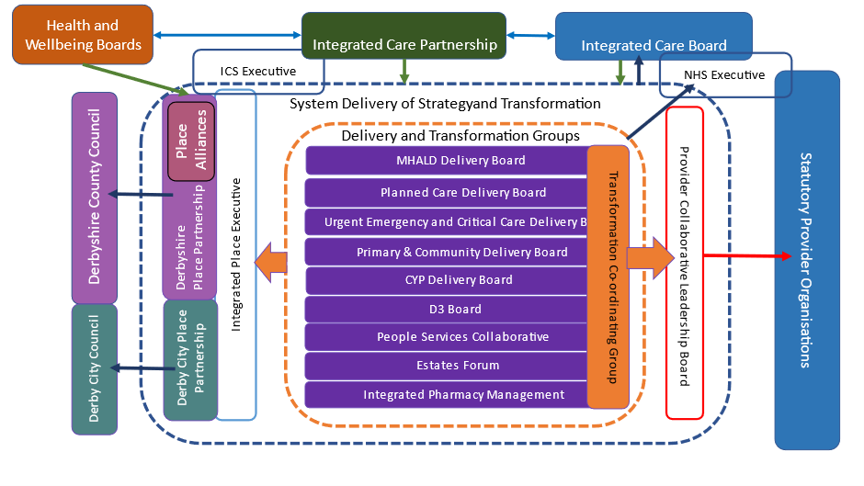

7.2 System Roles
The following diagram is helpful in stating system roles across the ICP, the ICB, Place and the Provider Collaborative, in relation to accountabilities and responsibilities that relate to the Plan.

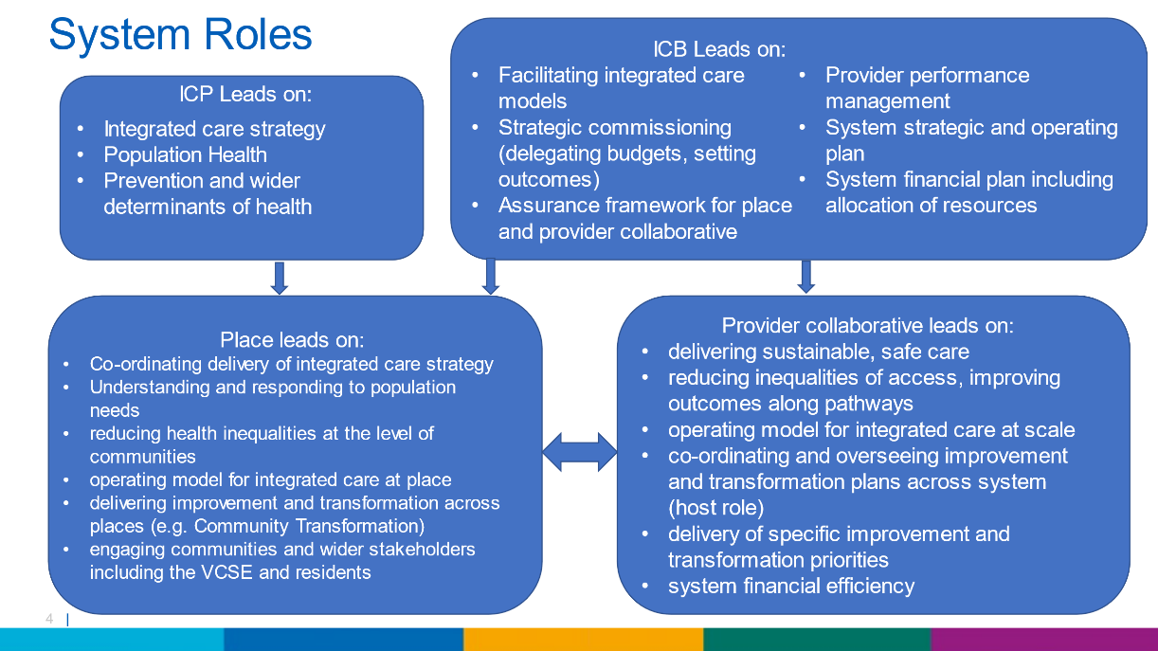

7.3 Improvement and change management methodologies

Improvement science and quality improvement methodologies need to play a key role in facilitating the move from agreed aims to delivering improved outcomes, and the use of the significant QSIR (Quality, service improvement and redesign) capability within the JUCD NHS system will be key in ensuring good quality application of improvement science.

Leaders will therefore need to consider the right balance between the use of ‘planned’ and ‘emergent’ change management approaches and focus on how partners work together, linked to culture and behaviours. This means a ‘one-size fits all’ change management approach will not work, and leaders will have a key role to play in supporting and facilitating the right conditions for emergent change to flourish.

7.4 Tracking delivery

Where it is not the case already, all improvement aims will need to be converted into tangible actions with a clear process for tracking, reporting and governing progress, this will include establishing clarity on the following:
- Key enabling actions
- Portfolio of improvement activities and programmes/ projects
- Objectives and expected outputs – covering each year of the Plan
- Outcomes
- Reporting arrangements
- Governance – including the accountable and responsible officers and forums

The JUCD “e-PMO,” the system level programme management office, will oversee the approach to reporting on the Plan, and in bringing together the outputs from the responsible bodies listed in the table above.

7.5 Risks

At this stage of development. we are conversant of the following strategic risks that we will seek to understand, appraise, and ultimately mitigate via the formation of our operational plans over the coming period.
Workforce
People are our single most important resource, and we will not be able to deliver on our Plan unless we can develop, attract, and retain staff. Staffing shortages in several sectors, including nursing and the medical workforce have been the biggest challenge facing local trusts and providers and this poses the biggest threats to fulfilling the aims and objectives set out in our Plan.
Financial
Immediate pressures and operational requirements (NHS annual planning targets) have the potential to drive us into allocating resources based on short / medium term priorities and preventing us from investing in the long terms activities that will help us deliver the outcomes we aim to achieve and ultimately limiting our ability to realise the efficiency or operational returns that are expected.
Our workforce and financial plan therefore need to be driven by the type of outcomes and activities we desire to achieve. Going forward we will need to ensure our activity, workforce and financial plans are developed in an integrated manner both within the NHS 'family' and across our broader partnerships.
The rising demand for NHS services
It is accepted that the ageing population has significant rising demand for NHS services across Derbyshire. However, there are other factors that contribute to rising demand which are not yet fully understood for example, wider socio-economic factors such as housing, employment, and changes to benefits and universal credit. We therefore need to ensure we design and develop a true, evidence-based programme of transformation which complements operational improvement and delivery plans and supports the quality, safety and economic commitments made by the system partners.
Ways of working
The current financial pressures in both the NHS and local government poses a significant risk and will make partnership working that bit more challenging. We will need to ensure we have appropriate governance arrangements and support partner organisations and their staff to adapt to the new ways of working.

Conclusion

This five-year plan represents a significant milestone in the ongoing commitment to providing high-quality healthcare services to the people living and working in Derby and Derbyshire. At the end of this five-year period, the NHS in Derby and Derbyshire will operate differently to how it does now, to the benefit of our citizens, patients, and staff.
There are three aspects of this plan to emphasise:
- The importance of patient-centred care, focusing on prevention, early intervention, and personalised treatment options. By placing patients at the centre of decision-making processes, this NHS Plan ensures that services are tailored to individual needs, promoting better health outcomes and overall satisfaction.

- Enhancing patient outcomes, improving access to care, and promoting efficiency in service delivery are key. By pooling resources, expertise and knowledge, healthcare providers can work together to streamline processes, reduce duplication, and optimize the use of available resources.

- The significance of engaging and involving stakeholders, including patients, healthcare professionals, our VCSE sector and our local authority partners. By fostering collaboration and partnership, the plan aims to build a stronger healthcare system that is responsive to the diverse needs and aspirations of the community it serves.
Finally, this Plan reflects our NHS commitment to continuous improvement and innovation in healthcare delivery. By working together, we will create a more integrated and efficient system that meets the challenges of today while ensuring a sustainable tomorrow. The plan sets a clear pathway towards a healthier and thriving community, where individuals receive the care and support they need, when they need it.

Appendix A – Derby and Derbyshire Health Index

The figure below shows a breakdown of the Health Index for the Derby and Derbyshire PLACEs, with the England position also shown.
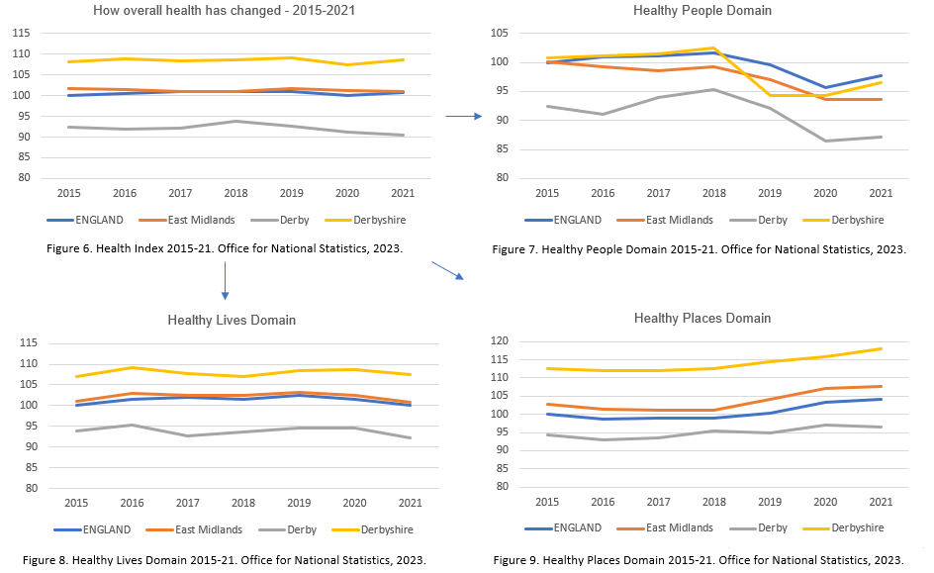

The constituent elements of each sub-domain within the Healthy People Domain of the Health Index – difference between the 2021 measure and the 2015 baseline index value

NHS England – Guidance on developing the joint forward plan. B1940-guidance-on-developing-the-joint-forward-plan-december-2022.pdf (england.nhs.uk).
NHS England. NHS Long Term Plan, 2019.
Joined Up Care Derbyshire – Integrated Care Partnership. Derby and Derbyshire Integrated Care Strategy, 2023.
Office for Health Improvement & Disparities – Fingertips – Public Health Profile. Life expectancy at birth is a measure of the average number of years a person would expect to live. Healthy life expectancy at birth is a measure of the average number of years a person would expect to live in good health. Inequality in life/healthy life expectancy at birth is a measure that shows how much life/healthy life expectancy varies with deprivation.
NHS England, May 2022.
Department for Health and Social Care. Major Conditions Strategy: Call for evidence, 2023.
Department for Health and Social Care. The government's 2023 mandate to NHS England, 2023.
Alberti PM, Pierce H. A population health impact pyramid for medicine. Millbank Quarterly, 2023.
Health Foundation, 2019.
Blumberg et al., 2021.
Lantz PM. The medicalisation of population health: who will stay upstream? Millbank Quarterly, 2019.
Office for National Statistics (ONS), release date 09 November 2022, ONS website, methodology article, Title: Health Index contents and definitions.
Constitution of the World Health Organisation.
Office for National Statistics (ONS) released 16 June 2023, ONS website, Methodology, Health Index methods and development: 2015 to 2021.
Global Burden of Disease, 2019. Institute for Health Metrics and Evaluation – University of Washington, 2023. https://vizhub.healthdata.org/gbd-compare/ accessed 7 June 2023.
Disability Adjusted Life Years – DALYs: the total number of years of ‘healthy life’ lost due to illness and/or death
NHS England. Population and Person Insights Dashboard. Accessed 7 June 2023.
Office for National Statistics (ONS), National population projections: 2018-based, October 2019.
Personalised Care Institute https://www.personalisedcareinstitute.org.uk/2022/09/06/new-data-shows-patients-want-more-involvement-in-healthcare-decisions
The Nuffield Trust. Patient experience: do patients feel involved in decisions about their care? https://www.nuffieldtrust.org.uk/resource/do-patients-feel-involved-in-decisions-about-their-care#:~:text='%2038%25%20said%20they%20were%20involved,2020%20to%2026%25%20in%202021.
Freedman S, Wolf R. The NHS productivity puzzle: Why has hospital activity not increased in line with funding and staffing? Institute for Government, 2023.
Medical FTEs relating to: Cardiology, Dermatology, Gastroenterology, General Surgery, Neurology, Gynaecology, Ophthalmology, Oral and MaxFacs, Orthodontics, Otolaryngology, Rheumatology, Trauma and orthopaedic surgery, Urology, Vascular Surgery. RTT service relate to: Cardiology, Dermatology, Ear Nose and Throat, Gastroenterology, General Surgery, Gynaecology, Neurology, Ophthalmology, Oral Surgery, Plastic Surgery, Rheumatology, Trauma and Orthopaedic, Urology.
NHS England. Estates Returns Information Collection (ERIC) 2021/22 - October 2022.
Naylor, R. NHS Property and Estates – Why the estate matters for patients. March 2017.
Shemavnekar N, et al. NHS workforce projections 2022. The Health Foundation, 2022.
Financial incentives, healthcare providers and quality improvements – a review of the evidence. Christianson et al. The Health Foundation (2007)
Whitty C et al. Restoring and extending secondary prevention. British Medical Journal, 2023.
NHS England – NHS App Reporting Dashboard.
NHS England – Personal Care Group Dashboard.
ICS Estate Strategy – main priorities: (1) Transform places and services - prioritise & maximise the use of the best quality estate, which is modern, agile, and fit for purpose to support patient care (2) A smaller better, greener public estate - Create an estate which is more efficient, effective and sustainable through optimisation; and (3) Partnership approach - Work with our partners to strengthen collaboration and benefit from multi agency working

