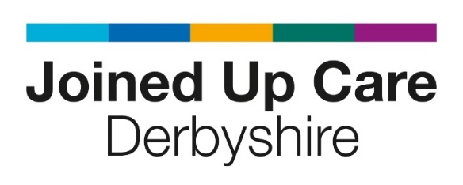

One to one guidance – Patient and Public Partners (PPP)
(This guidance has been put together following development work with PPPs and is only a template please feel free to adapt)
Name: Date
How are you finding your current role?

Is it currently meeting your expectation? What impact/influence do you feel the role has had?

Do you have any concerns?

Is there any further support or training you think would be useful?

Any thing else you would like to talk about?

Feedback from lead

