**Patient and Public Involvement (PPI) Form Guidance**

**What is the PPI Form?**

The PPI Form is a tool used to record that commissioners of health services have fully assessed whether the legal duty to inform, involve or consult individuals to whom the services are being or may be provided, and their carers and representatives, has been considered.

The most up to date PPI form can always be found [here](https://joinedupcarederbyshire.co.uk/download/patient-and-public-involvement-assessment-and-planning-form/).

**Legal Duty**

NHS commissioning organisations have a legal duty to ‘make arrangements’ to secure that individuals to whom services are being or may be provided **and their carers/representatives** are involved when commissioning services for NHS patients.

The main duties on NHS bodies to make arrangements to involve the public are all set out in the National Health Services Act 2006, as amended by the Health and Care Act 2022.

You can find the relevant sections of the legislation below:

* [section 13Q for NHS England](https://www.legislation.gov.uk/ukpga/2006/41/section/13Q)
* [section 14Z45 for Integrated Care Boards](https://www.legislation.gov.uk/ukpga/2022/31/section/25/enacted) (ICBs)
* [section 242(1B) for NHS trusts and NHS foundation trusts](https://www.legislation.gov.uk/ukpga/2006/41/section/242)

To fulfil the public involvement duty, the arrangements must provide for the public to be involved in:

(a) the planning of services

(b) the development and consideration of proposals for changes which, if implemented, would have an impact on the manner or range of services, and

(c) decisions which, when implemented, would have such an impact.

More information about the specific legal duties in relation to working in partnership with people and communities can be found in [Working in partnership with people and communities: Statutory guidance](https://www.england.nhs.uk/long-read/working-in-partnership-with-people-and-communities-statutory-guidance/#b1-public-involvement-legal-duties).

Key requirements of NHS England, ICBs, NHS Trusts and NHS Foundation Trusts include that they:

* Assess the need for public involvement and plan and conduct involvement activity – this is done via the PPI Form
* Clearly document at all stages how involvement activity has informed decision-making and the rationale for decisions
* Have systems to assure themselves that they are meeting their legal duty to involve – these systems need to be reported on in annual reports.

**Each organisation, i.e., NHS England, ICBs, NHS Trusts and NHS Foundation Trusts are accountable and liable for compliance with their public involvement obligations.**

However, that does not mean that each organisation should conduct its public involvement activities in isolation from others within the ICS and beyond. Plans, proposals, or decisions will often involve more than one organisation, particularly in respect of integration and service reconfiguration, in which case it is usually desirable to carry this out in an joined up and coordinated way, reducing the burden on both the public and the organisations themselves.

The legal duties require arrangements to secure that people are ‘involved’:

* This can be achieved by consulting people, providing people with information, or in other ways. This gives organisations a considerable degree of discretion as to how people are involved, subject to the below requirements.
* Neither the legal duties, nor this statutory guidance, seek to prescribe exactly how to involve people in any given case.  What is necessary will always depend upon the circumstances.
* Public bodies are required to act rationally, and this applies to the arrangements they make to involve people. Public bodies can demonstrate that they are acting rationally by keeping good records of decisions taken about when and how to involve the public.
* Statutory duties, such as the involvement duties set out above, are not the only circumstances in which a duty to consult may arise. Under common law, a duty to consult *may* also arise where there has been a promise to consult, where there has been an established practice of consultation, or, in exceptional cases, it would be conspicuously unfair not to consult. There will also be circumstances in which working with people and communities would be beneficial even if doing so is not legal requirement. Therefore, whether or not the involvement duties apply is not the only consideration when deciding whether and how to work with people and communities.

**Individuals, carers and representatives**

These public involvement duties have applied to commissioners and providers for many years and are largely unchanged. However, a significant change introduced by the Health and Care Act 2022 is that, in respect of NHS England and ICBs, the description of people they must make arrangements to involve has been extended from ‘individuals to whom the services are being or may be provided’ to also include ‘their carers and representatives (if any)’. While it is already common practice to involve carers and their representatives – and to do so is in line with previous statutory guidance on the public involvement duties – this change makes it a legal requirement for arrangements for public involvement to secure the involvement of carers and representatives (if any), as well as service users themselves.

Relevant carers and representatives could include young carers, individual patients’ advocates or family members who help organise their care, as well as councillors and community leaders, VCSE sector organisations, local Healthwatch and other organisations able to represent the interests of the individuals who use, or may use, the services in question. A stakeholder analysis can help determine which groups are relevant representatives depending on the context. More than one of these representative groups may need to be involved alongside people with lived experience to ensure that the full range of views can be considered.

**A process for assessing whether the legal duty to involve applies**

We have developed a process for assessing whether the legal duty applies. This should be documented in the PPI Form.

[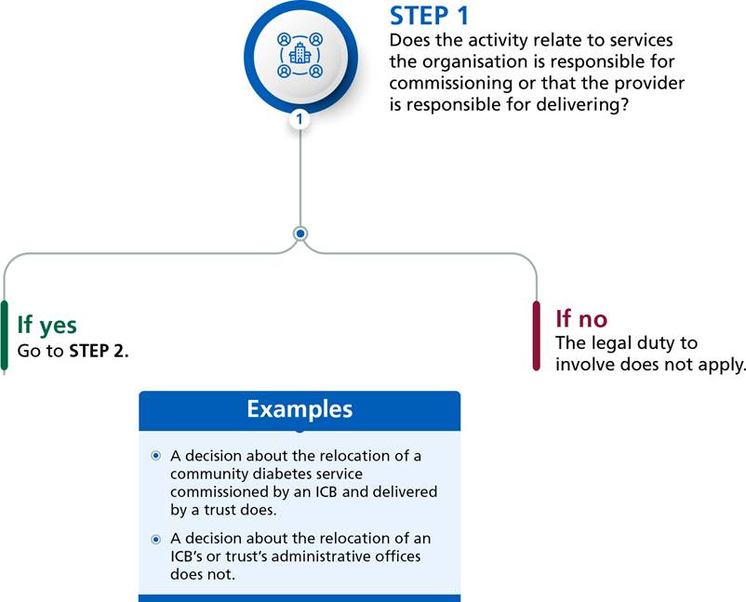](https://www.england.nhs.uk/wp-content/uploads/2022/09/step-1.jpg)

[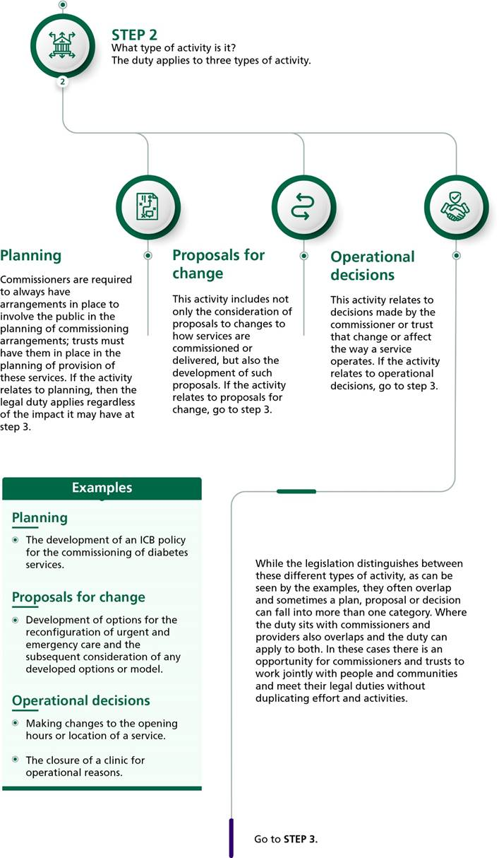](https://www.england.nhs.uk/wp-content/uploads/2022/09/step-2.jpg)

[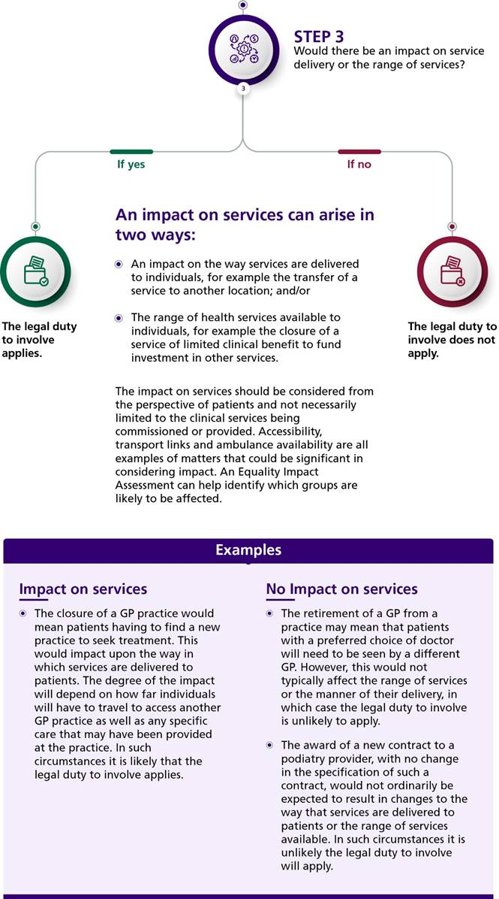](https://www.england.nhs.uk/wp-content/uploads/2022/09/step-3.jpg)

**Impact is the main consideration – what is the impact on the patient, member of public, and their carers?**

* The bigger the change/impact the bigger the consultation/engagement needs to be.
* The numbers of people impacted is important.
* The impact on services should be considered from the perspective of patients and not necessarily limited to the clinical services being commissioned or provided. Accessibility, transport links and ambulance availability are all examples of matters that could be significant in considering impact.
* An Equality Impact Assessment (EIA) can help identify which groups are likely to be affected. Information about completing the EIA can be found on page 16 of our [Guide to working with People and Communities](https://joinedupcarederbyshire.co.uk/involving-people-communities/guide-to-working-with-people-communities/), and is included in the Quality and Equality Impact Assessment Tool, found [here](https://joinedupcarederbyshire.co.uk/download/derbyshire-wide-qia-and-eia-tool/).

**Support with completing an assessment of the legal duties can be provided by the ICB Engagement Team**.

The Engagement Team should see all assessments related to:

* Planning, proposals for change, or operational decisions where the business decision originated in the system, or ICB space, or where the service is jointly commissioned with the ICB.
* Where the business decision originates in a specific NHS Trust or Foundation Trust, and relates only to that Trust, then the assessment can be conducted through internal processes. It is recommended that the same process is followed as stipulated in this guidance, and that the offer of support from the ICB Engagement Team with assessments is communicated – **due to the points below.**
* The ICB Engagement Team should be sighted on decisions that originate in a specific NHS Trust or Foundation Trust **which may lead to a significant/substantial change to services**, as consultation with the Health Overview and Scrutiny Committee (HOSC) (see separate guidance around the role of the HOSC which can be found [here](https://joinedupcarederbyshire.co.uk/download/health-overview-and-scrutiny-committee-hosc-guidance/)) is likely in this scenario, as well as the duty for commissioners to notify the Secretary of State (SoS) of substantial reconfigurations, this HOSC relationship and SoS notification process is facilitated by the ICB. Moreover, any significant or substantial service change may lead to the requirement for **consultation** which should be overseen by the ICB.

Process for assessment of PPI Forms by ICB Engagement Team:

* The PPI form should be completed by the project lead and sent to the ICB Engagement Team via email: [ddicb.engagement@nhs.net](mailto:ddicb.engagement@nhs.net)
* PPI forms received into the team will be assigned by the Engagement Officer to the first available PPI Form Assessment Meeting.
* Assessment of PPI Forms may take 2-3 weeks, as further information may be required in order for the team to make a confident assessment.
* All PPI form assessments made by the Engagement Team are reviewed by Sean Thornton, Deputy Director of ICB Communications and Engagement.
* Once the form has been assessed, the project lead will then be notified of the decision, and next steps.
  + If the decision is to 'inform only' the form will be passed to the ICB Communications Team for appropriate advice or action.

* + If the decision is to engage, or consult, then the team member will discuss next steps with the project lead. This will trigger other governance related processes outlined on pages 13-17 of the [ICS Guide to Involving People and Communities](https://joinedupcarederbyshire.co.uk/involving-people-communities/guide-to-working-with-people-communities/), such as the Quality and Equality Impact Assessment (QEIA), consultation with the Health Overview and Scrutiny Committee (HOSC), assurance from the Public Partnership Committee (PPC) and SoS notification process.