Post (Long) Covid Service
Case for Change
FINAL v1.5

September 2025

Contents
Section 1: Executive Summary 3
Section 2: Context 3
2.1 Definition 3
2.2 Post (Long) COVID Symptoms 4
2.3 Overview of Service Implementation 4
2.4 2023/24 service review 5
2.5 2024/25 service model 6
2.6 Children and Young People (CYP) 8
2.7 Providers of the service 9
2.8 Finances 9
2.9 Service Performance Data 9
2.10 Patient Experience 11
Section 3: Needs of the Population 12
3.1 Prevalence of ongoing symptoms following COVID-19 infection in the UK 12
3.2 Health Inequalities 13
Section 4: Key Challenges 16
4.1 Reduction in referrals & demand 16
4.2 Workforce recruitment and retention 17
4.3 Caseload 18
4.4 Revised pathway not in line with NHSE guidelines 18
Section 5: Opportunities for Change 18
5.1 Service Opportunities 18
5.2 Patient and Public Engagement 18
5.3 Quality Equality Impact Assessments 20
5.4 Commissioning Guidance for Post (Long) COVID services, for adults, children and young people 20
Section 6: Vision and Next Steps 21
6.1 The Vision 21
6.2 Next steps 22

Section 1: Executive Summary

The Derbyshire Post (Long) COVID Syndrome Assessment Clinic was launched in December 2020 to provide physical, cognitive, and psychological assessments to patients experiencing complex Post (Long) COVID syndrome symptoms. In April 2022 the service was expanded to include rehabilitation hubs in the north and south of the county to manage patient symptoms. The rehabilitation offer included support for Breathlessness, Chronic Fatigue, Occupational Health, Vocational Support and Health Psychology.

In 2023/24 the Derby and Derbyshire Integrated Care Board (DDICB) led a service review in response to the national downward trend in referrals, workforce retention issues, and financial sustainability issues caused by the uncertainty of future funding arrangements. The review recommended that the existing service model was to continue for 2024/25 but with reduced resource (staffing and funding) aligned to current demand. The service transitioned to a one provider model in July 2024, led by Derbyshire Community Health Services (DCHS) on an annual rolling contract.
The responsibility of commissioning services transitioned from the national programme to DDICB in April 2024 and funding was confirmed as recurrent within the ICB baseline.
DCHS are the sole provider of the Post (Long) COVID service within Derby and Derbyshire. In January 2025 DCHS raised concerns regarding the fragility of the service, linked to workforce retention and contract arrangements. Following negotiations a revised, temporary service model for 2025/26 was agreed on the understanding that a new, sustainable model would be developed and would be commissioned on an ongoing basis from April 2026.
The key drivers for the case for change is the reduction in referral activity and concerns regarding the sustainability of the service:
- In line with national trends, since December 2022 referrals continue to decrease annually. Between April 2025 and August 2025 there were 87 referrals into the service, averaging four per week.
- Service is commissioned non recurrently on a one-year rolling basis leading to recruitment and retention concerns. In March 2025 42% of staff were called back from secondment, leading to service fragility
To address workforce retention concerns it has been agreed that a sustainable service will be redesigned, in line with expected activity levels, and that this will be commissioned, recurrently from April 2026.

Section 2: Context

2.1 Definition

Most people with COVID-19 feel better within a few days or weeks of their first symptoms and make a full recovery within 12 weeks. For some people, symptoms can last longer.
This is called long COVID or post COVID-19 syndrome, for consistency this will be referred to as Post (Long) COVID throughout this document. Post (Long) COVID is a relatively new condition which is still being studied.
The 2020 NICE "Guidelines for managing the long-term effects of COVID-19" contains the following definitions:
Ongoing symptomatic COVID-19: signs and symptoms of COVID-19 lasting from four to twelve weeks.
Post (Long) COVID syndrome: signs and symptoms that develop during or after an infection consistent with COVID-19, continue for more than twelve weeks and are not explained by an alternative diagnosis. It usually presents with clusters of symptoms, often overlapping, which can fluctuate and change over time and can affect any system in the body. Post (Long) COVID syndrome may be considered before twelve weeks while the possibility of an alternative underlying disease is also being assessed.

2.2 Post (Long) COVID Symptoms

Symptoms after acute COVID-19 are highly variable and wide ranging. The most commonly reported symptoms include (but are not limited to) the following:
Respiratory Symptoms  - Breathlessness  - Cough | Cardiovascular Symptoms  - Chest tightness  - Chest Pain  - Palpitations | Generalised Symptoms  - Fatigue  - Fever  - Pain
Neurological Symptoms  - Cognitive impairment ('brain fog')  - Headache  - Sleep disturbance  - Peripheral neuropathy symptoms  - Dizziness  - Delirium  - Mobility impairment  - Visual disturbance | Psychological / psychiatric symptoms  - Symptoms of depression  - Symptoms of anxiety  - Symptoms of post-traumatic stress disorder | Ear, nose and throat symptoms  - Tinnitus  - Earache  - Sore throat  - Dizziness  - Loss of taste and / or smell  - Nasal congestion
Musculoskeletal symptoms  - Joint pain  - Muscle pain | Dermatological symptoms  - Skin rashes  - Hair loss | Gastrointestinal Symptoms  - Abdominal pain  - Nausea and vomiting  - Diarrhoea  - Weight loss and reduced appetite

2.3 Overview of Service Implementation

In October 2020 NHS England and NHS Improvement (NHSE/I) announced nationwide investment to implement Post (Long) COVID Syndrome Assessment Clinics across what was previously the Sustainability and transformation (STP) footprints but we now present as Derby and Derbyshire Integrated Care Board.
Aligned to the NHSE/I guidance the Derbyshire Post (Long) COVID Syndrome Assessment Clinic was launched in December 2020. The lead provider was Derbyshire Community Health Services (DCHS).
The service offered physical, cognitive, and psychological assessments for patients with suspected Post (Long) COVID, providing centralised advice and referrals to rehabilitation, psychological support, or specialised investigations as needed.
Only patients with complex Post (Long) COVID symptoms were to be referred to the assessment clinic, with referrals into the service via primary care and secondary care.
NHSE guidance was published in June 2021 to support the further development of the end-to-end Post (Long) Covid pathway. It specifically focussed on the rehabilitation needs, spanning across several areas, to aid the recovery of a proportion of patients who, following initial assessment, were identified as requiring a form of rehabilitation. In most cases the rehabilitation needs spanned across Chronic Fatigue, Breathlessness, Vocational and Psychological support.
Work commenced to devise and develop a suitable rehabilitation offer for the Post (Long) Covid service, taking learning from the assessment service and collaborating with clinical specialists and operational leads across the system. A workforce plan and pathway were developed and agreed early in 2022. These services were provided by DCHS, Chesterfield Royal Hospital (CRH) and University Hospitals Derby and Burton (UHDB)

2.4 2023/24 service review

In 2023 a comprehensive service review was carried out.
The drivers for the review were:
- Declining Referrals: Weekly referrals had dropped since December 2022 from 20 to 12, aligning with national trends.
- Funding Uncertainty: NHS England initially indicated a funding reduction for 2024/25, creating concerns about financial sustainability.
- Workforce Stability: Concerns about staff retention due to uncertainty over the service’s future.
- High Caseload: 966 patients were on the rehabilitation caseload in October 2023, risking inefficiencies in future service delivery.
As part of the review an options appraisal was carried out and four potential service models were developed.
The four options considered were:
  - Decommission the service and signpost to online resources.
  - Decommission and enhance existing services to absorb Post (Long) COVID patients.
  - Continue the current model with reduced resources.
  - Expand the service to include early rehabilitation for post-viral symptoms.
During this service review, extensive patient engagement was carried out, consisting of workshops and surveys, which showed considerable support for maintaining or expanding the service. (This is summarised within section 5.2).
An evaluation panel was held in December 2023, which reviewed all options based on deliverability, clinical effectiveness, accessibility, affordability, workforce, and health inequalities. This panel consisted of clinicians, commissioners, providers, patients and finance representatives. The panel received information packs for all four options, consisting of case of change, pre-engagement report, Quality and Equality Impact Assessments, SWOT analysis, patient pathways, service costs and staffing models.
  - Option 4 was preferred by 69% of panel members for its holistic, equitable, and innovative approach.
  - Option 3 was supported by 31% for being cost-effective and aligned with current demand.
Clinical and Professional Leadership Group (January 2024) supported both Options 3 and 4 and rejected Options 1 and 2 as clinically ineffective.
The recommendation to approve option 3 was agreed through ICB governance processes during February and March 2024, meaning that the Post (Long) COVID service was to continue in 2024/25 with reduced staffing and funding, aligned to current demand.
The decision was communicated to stakeholders and published on the Joined-Up Care Derbyshire platform.

2.5 2024/25 service model

Following extensive engagement and options appraisals in 2023, the service moved to a sole provider model from April 2024, delivered by DCHS. The service merges assessment and rehabilitation into a single, streamlined pathway.
Initial assessment confirms diagnosis, identifies medical need and sets rehabilitation goals. A tiered rehabilitation approach is taken, structuring the service into three tiers, based on patient complexity and need:
Tier 1 | Patients will have access from the Multi-Disciplinary Team (MDT) to virtual education programmes in the first instance and will include a watch at home video for family and carers.
Tier 2 | Will offer group and/or individual sessions which may be virtual or face-to-face, for the patient who has not met all their needs in the virtual group work and require additional input for their rehabilitation.
Tier 3 | This will be individualised sessions for the more complex patients who present within the Post (Long) Covid Service and require more in-depth work to help them rehabilitate to the best they possibly can, this will be offered virtual or face-to-face.

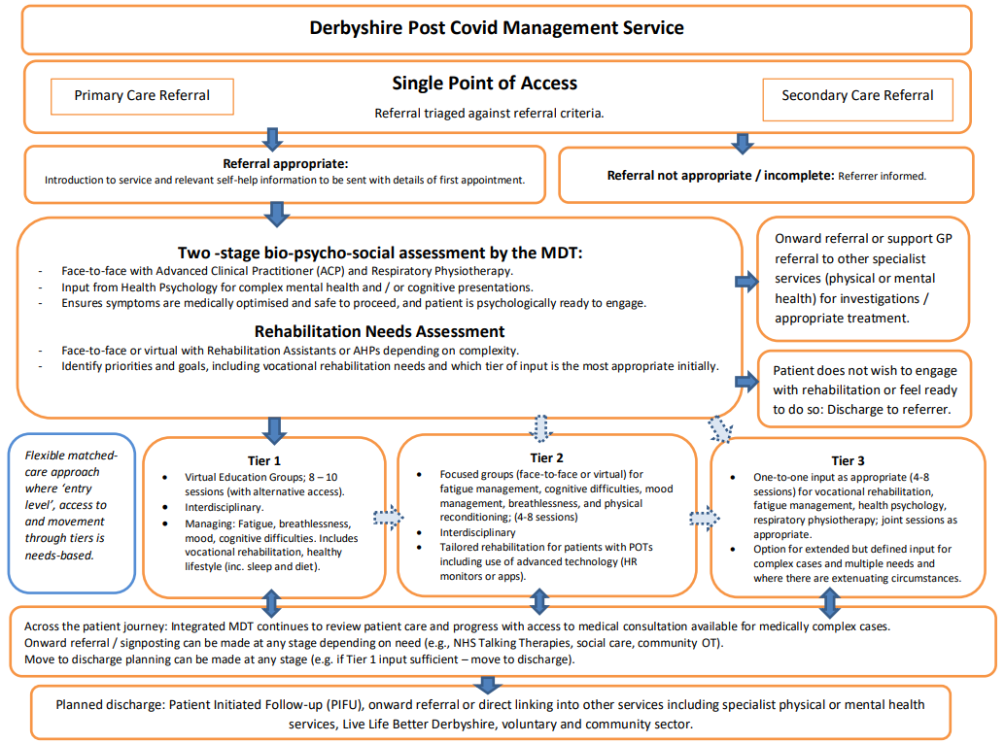

2.6 Children and Young People (CYP)

East Midlands Post (Long) COVID Regional Referral Pathway for Children & Young People
All referrals for Post (Long) COVID Service across Derby and Derbyshire come through the Assessment Service and if required on onward referred to the Paediatric Team. The Post (Long) COVID Service is a single point of access in the County. Between June 2024 and June 2025 there were eight referrals to the Post (Long) COVID service for under 18s.

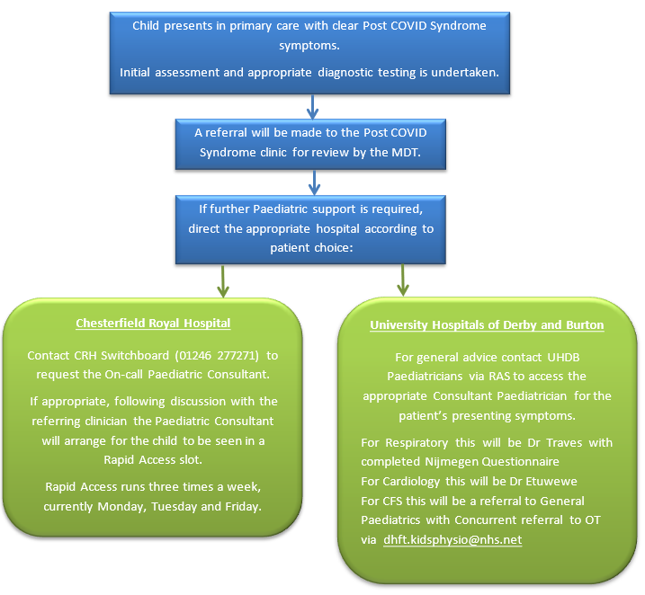

Prior to 31st March 2025 there were specialist hubs across England to coordinate specialist assessment services or remote support to local paediatricians and Post (Long) COVID clinics.
Within Derby and Derbyshire there was access to a Children and Young Persons hub virtual MDT for local paediatricians within Derby and Derbyshire, who required additional support regarding patients who were believed to have Post (Long) COVID syndrome. This contract ended on 31st March 2025, with ICBs now being responsible for commissioning adult and children's services. Currently DCHS sub-contract to University Hospitals of Derby and Burton (UHDB) to provide this service. As part of this review, the current arrangement will be evaluated, and, if deemed appropriate, a more formal agreement will be implemented to ensure that children and young people affected by Post (Long) COVID continue to receive these services.

2.7 Providers of the service

NHS Derby and Derbyshire ICB commissions services from providers within the system, ensuring that service design aligns with national guidelines and standards.
Derbyshire Community Health Services (DCHS) have been contracted to deliver the service for 2025/26. In addition, a service development and improvement plan (SDIP) has been included in the contract, to support the development of a recurrent service model for 2026/27 onwards.

2.8 Finances

The Post (Long) COVID Service was originally funded by non-recurrent funds provided by NHSE.
NHSE confirmed in January 2024 that funding for the adult post COVID services would be included in ICB baseline funding as recurrent, at the same levels as 2023/24, with responsibility for commissioning the programme moving to ICBs from April 2024. Updated guidance was issued, and intended to be used as a blueprint for best practice and designed to be adapted to local needs (NHS England » Commissioning guidance for post-COVID services for adults, children and young people).
In 2023/24 a service review was undertaken and from 2024/25 a decision was made to reduce resource to the service to reflect the decrease in activity.

2.9 Service Performance Data

Referral Data – Federated Data Platform Post COVID assessment

This data shows a decrease in the referral rate by 100,000 population from 4.22 referrals per 100,000 people in July 2024 to 0.22 referrals per 100,000 people in June 2025.
Please note that the data provided by NHS England does not account for the increase in referrals observed in June and July 2025. This recent rise will be assessed as part of the forthcoming service review.

Initial Assessments and Follow Up Assessments

Data submitted to NHS England shows that between July 2024 and April 2025, 200 initial assessments were carried out. The average number of initial appointments over this time period was therefore 20 per month, with the rates ranging from 10 in July 2024 and 29 in January 2025.

In this same time period there were 433 follow up appointments. The average per month was 43, with the rates ranging from 69 in August 2024 to 23 in November 2024.

The frequency of follow-up assessments has demonstrated a steady downward trend, with six of the past seven months recording rates below the average. It must be noted that this data does not reflect the perceived level of follow up activity at DCHS but is the only data currently available.
Waiting List Data

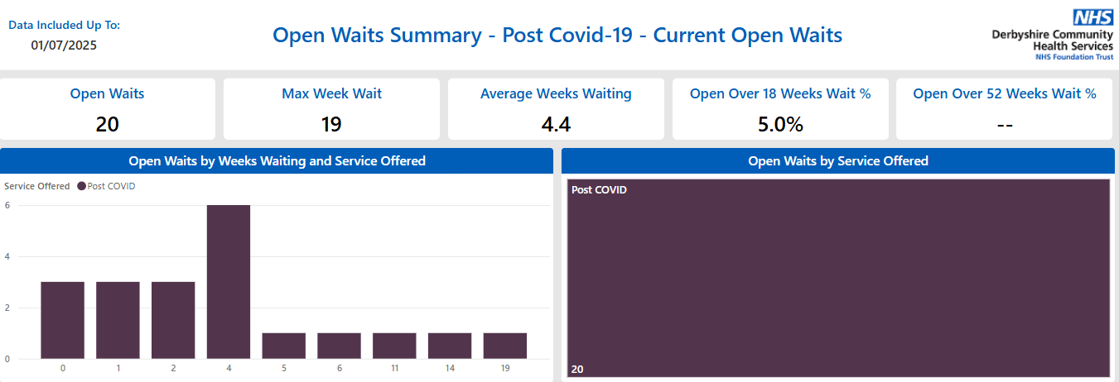

NB: Wait times exceeding four weeks are due to patient choice.

Caseload Information

The caseload at the beginning of August 2025 was 506 patients (a reduction from 540 in June 2025). Of these 506 patients almost 20% were under Patient Initiated Follow Up (PIFU), meaning they were due to be discharged within the next three months, unless they contacted the service for review.

2.10 Patient Experience

Patient Feedback
Recent patient feedback provided to DCHS regarding the service has been overwhelmingly positive. According to the Friends and Family survey results from July to September 2025, 30 out of 33 respondents rated the service as "very good," 3 rated it "good," and 1 indicated "very poor."
Below is a table detailing the common themes from the feedback received over this time period:
Theme | Example Feedback
Feeling listened to | “I felt listened to and supported to work out a plan together.”
Clear communication | “Explained everything well… practical and helpful guidance.”
Compassionate approach | “Gentle and kind approach… helped me explore the impact of long covid.”
Positive impact | “You’ve helped change my life.”
Group work | “Group was starting to gel… opening up especially in smaller groups.”
Responsiveness | “Phone calls were on time… informed in plenty of time.”
More follow up needed | “Need more follow-ups… seems to take months for each step.”
Appreciation | “Thank you for all your help throughout my care program.”
Areas for improvement | “A clearer description of the service from entry to discharge criteria would be good.”

All existing sources of feedback were considered, and a range of stakeholders were contacted to gather any relevant information with regards to the Post (Long) Covid Service across Derby and Derbyshire.
The following sources below were all contacted, and any relevant feedback has been collated below.
- Integrated Care Board (ICB) – Patient Experience Team.
- Joined Up Care Derbyshire (JUCD) Patient and Public Insight Library.
- Healthwatch Derby and Derbyshire.
- Any previous engagement/consultations (See section 5.2).

Healthwatch Derbyshire
"The commentator praised the Post-COVID Syndrome Assessment Clinic, highlighting how the hour-long initial consultation made their partner feel heard and holistically assessed. They expressed a wish that GPs would adopt a similar whole-person approach.
Their only criticism was the lack of support for carers. While their partner received excellent care and access to workshops and groups, they felt carers were left without guidance on managing complex needs or coping with grief for life before Covid. They now attend a Derbyshire Carers Association support group but would have appreciated earlier signposting from the clinic."

Section 3: Needs of the Population

3.1 Prevalence of ongoing symptoms following COVID-19 infection in the UK

The Office of National Statistics (ONS) collected data on self-reported Post (Long) COVID and associated activity limitation until March 2023. At that point an estimated 2.0 million people living in private households in the UK (3.1% of the population) were experiencing self-reported Post (Long) COVID.

Post (Long) COVID symptoms impacted the daily activities of 1.5 million individuals, representing 77% of those who self-reported Post (Long) COVID. Among them, 381,000 people (19%) indicated that their ability to carry out everyday tasks was “limited a lot.”

Fatigue was the most common Post (Long) COVID symptom (71%), followed by difficulty concentrating (52%), shortness of breath (48%), and muscle ache (47%).

According to the data, self-reported Post (Long) COVID was most commonly observed among individuals aged 35 to 69 years, females, residents of more deprived areas, people employed in social care, those aged 16 and over who were neither working nor seeking employment, and individuals with other activity-limiting health conditions or disabilities.
While publicly available UK-specific data after March 2023 remains limited, both anecdotal evidence and clinical observations indicate a decline in the number of new Post (Long) COVID cases. This trend is likely attributable to several factors:
- Widespread immunity (from vaccination and prior infection)
- Milder variants (e.g. Omicron and its subvariants)
- Improved treatment and awareness

From 1st April 2022 free mass symptomatic and asymptomatic testing for the public ended.
People with COVID symptoms were asked to exercise personal responsibility when deciding whether to stay at home. This change in guidance restricts the ability to measure prevalence.

3.2 Health Inequalities

NHSE requested a plan from every Post (Long) COVID Service across the country to demonstrate innovative ways of addressing health inequalities that are linked to service access and outcomes.
In 2022/23 NHSE allocated a ringfenced amount for the ICB to develop innovative and new ways of addressing health inequalities linked to service access and outcomes. The funding was used to strengthen the work of Covid Community Champions Networks and to extend the contract of the DCHS Research & Implementation Officer to address health inequalities linked to service access and outcomes.

The work the Research and Implementation Officer completed links with existing ICB workstreams to address Health Inequalities and will continue to work with varying programmes already in place and below are some of the workstreams already in place:
- Tackling Neighbourhood Inequalities Primary Care Network (PCN) Direct Enhanced Service (DES)
- Core20+5 Work Programme – Derby City (Derby Health Inequalities Partnership which is public health and Community Action Derby - for connectors to reach into communities)
- Cancer Inequalities Work Programme
- Equality, Diversity, and Inclusion (EDI) collaborative
- Population Health Management Programme
- Plus, other forums / programmes across the system linked to Health Inequalities programmes of work

The report found that there was an underrepresentation of patients from IMD quintile areas 1 and 2, making up fewer than one in five referrals, despite national data showing higher self-reported Post (Long) COVID rates among people in deprived areas. Several possible barriers were identified, including reduced health literacy in certain regions impacting knowledge and comprehension of Post (Long) COVID, limited trust in healthcare, and the need for referrals to go through general practitioners. There is also symptom overlap, with Post (Long) COVID sometimes being confused with other conditions, particularly among individuals with learning disabilities.

The full report is included in Appendix A.

Below is a summary of the work that was carried out in response to this.

1. Community Engagement and Outreach
- Distributed translated Post (Long) COVID leaflets at:
  - Health & Wellbeing events (e.g. Sports Direct, Shirebrook)
  - Derby City Refugee Week
  - Vaccination sites, BME forums, and local councils
- Engaged with community groups like the African Institute in Derby to deliver rehab programmes and raise awareness.
- Participated in Derbyshire Dialogue events to gather public feedback and raise service awareness.
2. Targeted Interventions
- Focused outreach in areas with low referral rates (e.g. North East Derbyshire, Derbyshire Dales, High Peak).
- Promoted Post (Long) COVID syndrome awareness through Football Community Trusts to reach working-age men.
- Developed gender-based clinics to support women from ethnic minority backgrounds.
3. Health Literacy and Communication
- Co-produced easy-read and illustrative leaflets to support people with learning disabilities and language barriers.
- Developed a patient journey video (with translations and sign language) to improve understanding of the service.
4. Research & Implementation Officer (RIO)
- Conducted qualitative research with underrepresented communities.
- Reviewed best practices and literature to inform interventions.
- Led co-production of interventions with patients, staff, and community leaders.
- Supported implementation and evaluation of interventions to improve access and outcomes.
6. Covid Community Champions Networks
- Strengthened and funded local champions to:
  - Disseminate information.
  - Capture community intelligence.
  - Support outreach and engagement.
7. Monitoring and Evaluation
- Developed a Health Inequalities Action Plan with Key Performance Indicators.
- Monitored increased referrals from underrepresented groups.
- Embedded outcome measurement tools into Post (Long) COVID service.
- Evaluated return on investment impact through supervision and appraisal.

DCHS monitor the demographic breakdown of the patients who are referred to the service. Below is a summary of the 51 referrals received between April and July 2025.

Gender

Age

Ethnicity

Deprivation

The data above indicates that 67% of patients referred to Post (Long) COVID services between April and July 2025 were female.
Approximately two thirds of referrals were for individuals aged between 40 and 70, with fewer referrals observed among young adults.
Ethnicity data is incomplete, with one quarter recorded as unknown. For those whose ethnicity is recorded, 87% are identified as White British, compared to 80% across Derby and Derbyshire (source: RAIDR).
32% of referrals are from the most deprived deciles (1-4), whereas these groups comprise 39% of the population according to RAIDR.
ONS data shows women are more likely than men to report Post (Long) COVID, with the highest prevalence in the 35 to 69 age range. Findings related to ethnicity vary but indicate similar or higher levels of Post (Long) COVID among minority ethnic groups, potentially due to increased infection rates and underlying health disparities. Individuals living in the most deprived areas also appear more likely to report Post (Long) COVID symptoms.
The referral data, therefore, reflects trends comparable to national patterns regarding age and gender; however, it potentially indicates disproportionately low rates among individuals from minority ethnic groups and those residing in more deprived areas.

Section 4: Key Challenges

4.1 Reduction in referrals & demand

Regionally and nationally, referral rates steadily decreased, until the data stopped being collated in February 2024.

Referrals to Derby and Derbyshire Long (Post) Covid services peaked at 120 during the first two weeks of June 2022. From December 22 to February 23 there was a downward trend in fortnightly referrals to 25 (12 a week). These now stand at approximately 4 per week. This is in line with national trends.

4.2 Workforce recruitment and retention

The number of staff working within the service reduced by 42% in March 2025, when seconded staff returned to their substantive position, an issue largely driven by the non-recurrent nature of the service's funding.

Due to concerns regarding the fragility of the service the ICB committed to maintaining a smaller service while a further review was undertaken to inform the development of a sustainable delivery model from April 2026 onwards.

In the revised model, therapy and psychology staffing will be provided from core DCHS services, to support delivery of rehabilitation by a broader range of staff, reducing the challenges and risks associated with operating a small standalone service. Referrals for children and young people will continue to be passed through DCHS and onto the UHDB paediatric occupational therapy team.

It is hoped that the commitment to commissioning a recurrent service will help to mitigate against this risk of service staff seeking alternative employment, destabilising the service in-year.

4.3 Caseload

At the beginning of August 2025 the caseload for the service stood at 506 patients. Due to the challenge of managing a high caseload with reduced staffing, DCHS were aiming to clear a substantial amount of this caseload, before there are further staffing reductions in October 2025.

4.4 Revised pathway not in line with NHSE guidelines

The service model that has been agreed for 2025/2026 is not fully aligned with the NHSE commissioning guidelines for Post (Long) COVID services. The main difference is that the service will no longer be led by a medical lead, but will be led by an experienced, advanced clinical practitioner, with access to clinical guidance, from different specialities, through advice and guidance pathways. However, this guidance was intended to be used as a blueprint for best practice and designed to be adapted to local needs.

Section 5: Opportunities for Change

5.1 Service Opportunities

The ICB has agreed a revised pathway for the Post (Long) COVID service that is being delivered by DCHS. As detailed above the revised pathway deviates from NHS England guidelines, as the referrals are triaged by an advanced clinical practitioner (ACP), rather than a dedicated medical lead, as this is no longer feasible. Additional medical oversight will be available from the wider DCHS infrastructure and through advice and guidance systems.

A task and finish group will be established to include (at a minimum) representatives from the provider (clinical and managerial), Derby and Derbyshire Integrated Care Board representation and patient and public partners. The revised model will be evaluated over the coming months and with involvement from these key stakeholders, a model for 2026/27 onwards will be agreed and commissioned.

5.2 Patient and Public Engagement

The ICB and providers are always keen to listen and gain feedback from patients and the public regarding the current service and future service opportunities. (e.g., access, quality of care).
During the previous service review a thorough patient engagement exercise was conducted. This consisted of a survey and five workshops (two were virtual, at different times of the day, and three were face to face across the north and south of the county). 221 people fed directly into these. Additionally, other sources of feedback were collated, such as emailed experiences and social media feedback.
Below is a summary of the findings of this feedback.
- Access to Specialised, Holistic Care

- Patients want access to specialist treatment, diagnostics, and therapies tailored to Post (Long) COVID symptoms.
- A multi-disciplinary team (MDT) or hub model is preferred, offering joined-up, holistic care in one place.
- Continuity of care and access to expert clinicians who understand the condition is highly valued.

- Service Availability and Accessibility
- People want the service to remain available and easily accessible, with options for face-to-face, phone, and online appointments.
- Shorter waiting times and clearer referral pathways are important.
- Suggestions included drop-in clinics, local outreach hubs, and better access for rural or deprived areas.

- Ongoing Support and Follow-up
- Patients want long-term support, not just one-off interventions.
- This includes psychological support, peer support groups, and help with employment or benefits.
- Many expressed a need for post-discharge contact, fast-track re-entry if symptoms worsen, and patient-initiated follow-up.

- Clear Communication and Information
- Patients want better communication about:
  - What the service offers.
  - What to expect during the care journey.
  - Who to contact and how.
- Personalised communication is important, especially for those with brain fog or memory issues.
- Self-help resources, updates on new treatments, and clear care plans were also requested.

- Empathy, Understanding, and Being Believed
- Feeling listened to, believed, and treated with empathy was a recurring theme.
- Patients want to avoid being dismissed or “gaslighted” by professionals unfamiliar with Post (Long) COVID.

- Education and Awareness
- Patients want:
  - More public awareness of Post (Long) COVID and the service.
  - Better GP education on symptoms and referral pathways.
  - Reduced stigma and increased understanding in workplaces and communities.

- Research and Innovation
- There’s strong interest in:
  - Access to up-to-date research.
  - Participation in clinical trials.
  - Services that evolve with the science.

For the purposes of this service review, as well as incorporating this previous learning, the ICB will recruit three patient and public partners, who will be invited to attend the Task and Finish Group. They will be invited to contribute to the service review and will help to shape the future Post (Long) COVID service model.
The ICB will also monitor patient experiences, friends and family tests and complaints, with regard to the amended 2025/26 model, and ensure that this feedback is considered in the design of the 2026/27 model.

5.3 Quality Equality Impact Assessments

The ICB is committed to ensuring that commissioning decisions and business cases are appropriately evaluated for any potential impact on quality and equality.
Quality and Equality Impact Assessments (QEIA) is a continuous process that ensures that business plans/decisions are assessed. All potential consequences on quality or protected characteristic groups are considered and any necessary mitigating actions are outlined in a uniformed way.
A QEIA has been conducted for the updated service model for 2024/25. An additional QEIA will be undertaken once the future service model is finalised.

5.4 Commissioning Guidance for Post (Long) COVID services, for adults, children and young people

NHSE released guidance on the commissioning of Post (Long) COVID services by ICBs, ahead of the transition of responsibility from the Post (Long) COVID national programme to ICBs in March 2024. The recommendations are as follows:
Governance and Leadership
- Establishment of an ICS-based Post (Long) COVID steering function accountable to the ICB, with a named ICB lead to oversee delivery of Post (Long) COVID services and ensure appropriate reporting, escalation, and assurance mechanisms.
- Provision of strategic clinical leadership and guidance with clinicians involved in the planning, delivery, and transformation of services.
Finance and Contracting
- Commissioning of Post (Long) COVID services transitioned to ICBs in March 2024. NHSE confirmed in January 2024 that funding for the adult Post (Long) COVID services would be included in ICB baseline funding as recurrent, at the same levels as 2023/24.
Population Health Management
- Alignment of ICB governance for Post (Long) COVID services with population health management for people with multi-system Long Term Conditions and the consideration of opportunities for care provision for people with similar patient needs.
Data and Coding
- Data capture is required to ensure the totality of the interventions is understood and bottlenecks identified. Continue to report data as per National, Regional and ICB expectations through agreed platforms.
- Continued collection and analysis of outcome measures is recommended in order to assess the effectiveness of pathways and better understand the condition, including how interventions or management influence patient progress and recovery.
Maintaining Quality and Clinical Standards
- Guidance recommends that access to multidisciplinary services is provided for assessing physical and mental health symptoms and carrying out further tests and investigations.
- These should be led by a doctor with relevant skills and experience, and appropriate specialist support, considering the variety of presenting symptoms.
- Post (Long) COVID services should comprise an integrated pathway of assessment, medical treatment and multifaceted rehabilitation, including psychology with direct access to required diagnostics.
- Multidisciplinary teams (MDTs) to bring specialist medical, nursing, and allied health professional (AHP) input to community-based case management without multiple separate referrals.
- Delivery of needs/symptom-based rehabilitation by a broad multi-professional team, to include management of breathlessness and fatigue, physical rehabilitation, management of dysautonomia symptoms, management of pain, educational support and vocational rehabilitation.
- Referral pathways into and from specialist services such as secondary care, mental health services, the VCSE sector as needed.
- Provision of a self-management plan on discharge. Options for in-person and virtual support as per clinical need and patient preference.
Outcomes
- Adult and CYP services in primary care, secondary care and specialist services should collect and analyse patient-reported outcome measures, clinical measurements and patient reported experience measures to help monitor patient progress, facilitate communication between professionals and improve the quality of services.
- Data also contributes to the evidence base on the management of Post (Long) COVID efforts to reduce unwarranted variation in Post (Long) COVID services.

Section 6: Vision and Next Steps

6.1 The Vision

The case for change is driven by a need to balance clinical effectiveness, financial sustainability, and equity of access. The current model is a pragmatic response to reduced demand and funding, but a long-term solution is to be sought.
To ensure the future viability of the service, the ICB must:
• Continue to monitor performance and patient outcomes.
• Secure a recurrent, multi-year commissioning model to stabilise the workforce.
• Co-design the 2026/27 model with patients, clinicians, and system partners.
The service remains essential for those affected by Post (Long) COVID, and its evolution must reflect both the changing epidemiology and the lived experiences of patients.

6.2 Next steps

Performance Monitoring
- Continue to monitor service performance, referral trends, and patient outcomes.
- Use this data to inform future service design and commissioning decisions.
Commissioning a Sustainable Model
- Develop and commission a recurrent, multi-year service model from April 2026.
- This model should reflect expected activity levels and address workforce stability.

Patient and Public Involvement
Recruit three patient and public partners to join the Post-COVID Review Task and Finish Group.
Continue to gather and incorporate patient feedback, including:
- Friends and Family Test.
- Complaints.
Task and Finish Group

Establish a monthly meeting chaired by the ICB.
This group will:
- Support service delivery.
- Embed NHSE guidance.
- Review performance.
- Oversee the development of the future model.

Quality and Equality Impact Assessments (QEIA)
Complete a new QEIAs for the 2026/27 future services options to ensure equity and quality are embedded in decision-making.
Governance Procedures
Ensure the completion of all necessary documentation and adherence to governance procedures to support the commissioning of the agreed future service model. Sufficient time should be allocated to enable DCHS to implement any required changes effectively.
In summary, these measures will ensure robust oversight, transparency, and quality assurance throughout the commissioning process, supporting the successful delivery of future services.

Appendix A

Hedberg P, van der Werff SD, Nauclér P. The effect of COVID-19 vaccination on the risk of persistent post COVID-19 condition: cohort study. J Infect Dis. Published online March 12, 2025. doi:10.1093/infdis/jiaf133
Xie, Y., Choi, T., & Al-Aly, Z. (2024). Postacute Sequelae of SARS-CoV-2 Infection in the Pre-Delta, Delta, and Omicron Eras. New England Journal of Medicine, 391(6), 515-525. doi:10.1056/NEJMoa2403211

