**Assessing the need for Public Involvement when making changes in Primary Care Networks (PCNs) and contractual changes in General Practice**

**Background**

This guidance is to summarise the work that has taken place with the Primary Care Team to establish a process for applying the Patient and Public Involvement (PPI) Legal duty in General Practice.

**The Public Involvement Legal Duty**

The public involvement duty set out in the National Health Services Act 2006, as amended by the Health and Care Act 2022, states that patients and the public must be involved in:

(a) the planning of services

(b) the development and consideration of proposals for changes which, if implemented, would have an impact on the manner or range of services, and

(c) decisions which, when implemented, would have such an impact, i.e., decisions that change or affect the way a service operates.

Section 242 of the NHS Act 2006 applies to NHS Trusts and NHS Foundation Trusts, and Section 14Z45 of the Health and Care Act 2022 applies to Integrated Care Boards.

Whether the legal duty applies mainly comes down to whether there is:

**An impact on the way a service is delivered** to patients, e.g., the transfer of a service from one location to another or changing from offering face to face appointments to virtual appointments.

**An impact on the range of services delivered** to patients, e.g., the closure of a service of little clinical value to fund investment in other services.

The duty can lead to a requirement to either **inform**, **involve**, or **consult** with patients and members of the public. The bigger the change/impact the bigger the consultation/engagement needs to be. The numbers of people impacted is also an important consideration.

**How does this apply to General Practice?**

With regards to General Practice, the legal duty mainly comes into play when there are contractual changes overseen by our commissioning colleagues and governed by the Primary Care Subgroup.

These contractual changes fall into the following categories:

* Practice boundary changes
* Mergers and Branch Closures
* Close Lists
* Procurement of a GP practice

In order to assess if the legal duty applies, we ask that a [PPI Form](https://joinedupcarederbyshire.co.uk/download/patient-and-public-involvement-assessment-and-planning-form/) is completed, to ensure we have the information needed to make a decision.

**What about temporary changes?**

Where there is an imminent risk to patient safety or the welfare of patients or staff, e.g**.,** the closure of a branch surgery due to the building being damaged and may take many months to fix, it is possible to make a change to a service without allowing time for patient and public involvement. However, it is not acceptable for NHS bodies to delay addressing fragile service situations that might lead to such a risk occurring until they are so urgent that an imminent risk exists.

In these cases, NHS bodies should:

* Keep good records of the factors they considered in making these decisions
* Communicate the changes to affected people
* Inform the local authority HOSC about the changes and reasons for not consulting them under the regulations

**What about the procurement of a new GP practice?**

The procurement of a new GP practice is not considered to be a change to services, but does still trigger the legal duties under the need to involve patients and members of the public in the 'planning of services'; therefore, it is still important to consider how the legal duty can be met. We have developed a process that can be adapted to meet the needs of each individual procurement process, which we know can vary. 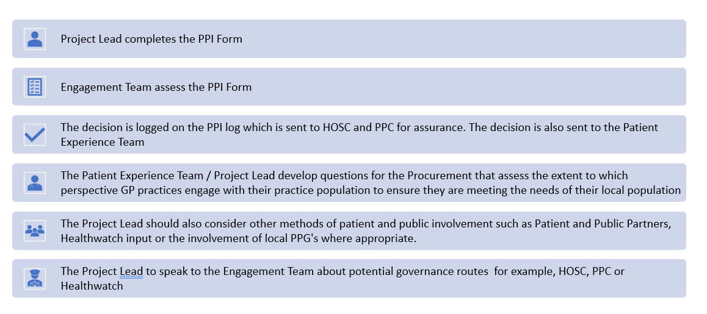

**What about changes to services agreed and implemented by Primary Care Networks?**

[Section 5.5 in the 24/25 version of the DES specification - PCN requirements and entitlements](https://www.england.nhs.uk/wp-content/uploads/2024/03/PRN01035-ii-pcn-des-contract-specification-2024-25-pcn-requirements-and-entitlements-April-2024-version-2.pdf) states the following:

5.5 Patient engagement

5.5.1. A PCN must act in accordance with the requirements relating to patient engagement under the PCNs Core Network Practice’s primary medical services contracts by:

* Engaging, liaising and communicating with the PCN’s Patients in the most appropriate way;
* Informing and/or involving them in developing new services and changes related to service delivery; and
* Engaging with a range of communities, including ‘seldom heard’ groups.

5.5.2. A PCN must provide reasonable support and assistance to the commissioner in the performance of its duties (Sections 14Z36 and 14Z45 of the NHS Act 2006) to engage patients in the provision of and/or reconfiguration of services where applicable to the PCNs Patients.

Therefore, it is the responsibility of the membership of a PCN to ensure that this requirement has been considered and actioned in the most appropriate way.

The ICB Engagement Team can offer support and guidance around good practice in Patient and Public Involvement, relating to changes to the design and delivery of services. The team can be contacted at [ddicb.engagement@nhs.net](mailto:ddicb.engagement@nhs.net).

**Assessing whether the legal duty applies/and to manage our responsibilities to keep the Health Overview and Scrutiny Committee (HOSC) informed**

In order to assess if the legal duty applies, we ask that a [PPI Form](https://joinedupcarederbyshire.co.uk/download/patient-and-public-involvement-assessment-and-planning-form/) is completed, to ensure we have the information needed to make a decision. The [PPI Form](https://joinedupcarederbyshire.co.uk/download/patient-and-public-involvement-assessment-and-planning-form/) is a tool used to record that we have fully assessed whether the legal duty to inform, involve or consult individuals to whom the services are being or may be provided, and their carers and representatives, has been considered. This form also needs to be completed when a temporary service change is put in place. This allows the team to support and give advice on any immediate engagement, communications, or governance needed and monitor the length of any temporary change. Temporary changes cannot be made permanent without the appropriate level of involvement taking place.

Forms should be sent to the ICB Engagement Team via email: [ddicb.engagement@nhs.net](mailto:ddicb.engagement@nhs.net). Assistance can be provided with the completion of forms. The table below shows a clear breakdown of where decisions are made and at what stage a [PPI Form](https://joinedupcarederbyshire.co.uk/download/patient-and-public-involvement-assessment-and-planning-form/) needs to be completed.

**Overview of when and which PPI form needs completing for Primary Care Contractual Changes**

|  |  |  |  |
| --- | --- | --- | --- |
| **Contractual changes area** | **Decision making process** | **Action by: primary care team** | **When** |
| **Practice boundary changes** | Decision is made at PCSG | To be completed by Primary Care Team | As part of the submission pack to PCSG.  Completed [PPI Form](https://joinedupcarederbyshire.co.uk/download/patient-and-public-involvement-assessment-and-planning-form/) to be fed into decision making process at PCSG. |
| * **Merger of branches** * **Branch Closures** * **New branch** * **Relocation of a branch** | Decision are made in a 2 step process:   * Stage 1 – agreed in principle (pending engagement) * Stage 2 – final decision following engagement | To be completed by Primary Care Team | Once "Agreed in Principle" at PCSG |
| **Close Lists** | Decisions are made on safety reasons on a temporary basis only:   * Stage 1: 0-3 monthly closure decided by the Assistant Director of Primary Care * Stage 2: 4-12 month closure at the PCSG | To be completed by Primary Care Team | A temporary form completed at stage 2 as part of submission paperwork for at PSCG.  Updated and tracked by Engagement Team |
| **Procurement of a GP practice** | Decisions are made at the PSCG  Decisions are made in a 2 step process:   * Stage 1 – agreed in principle (pending engagement) * Stage 2 – final decision following engagement | To be completed by Primary Care Team | **For new practice sites:**  Once "Agreed in Principle" at PCSG and before EOI. |

**Governance relating to Patient and Public Involvement**

* **Public Partnership Committee (PPC)**

The Public Partnership Committee is one of five formal sub-committees of the ICB Board and reflects the significance the Board places on seeking to hear the views and voices of local people to help influence the work of the ICB. Membership of the group is made up of Lay Representatives, Foundation Trust Governors, VCSE colleagues, and officers. Some key responsibilities are:

* Seek assurance that the JUCD Engagement Strategy is being fully implemented
* Support the development of policy around legislation governing patient and public involvement and evaluate compliance with those legal duties
* Articulate and seek assurance of mitigation against risks which exist in seeking to achieve the objectives and ambitions set out in our policy and strategy
* Manage performance against the principles outlined in JUCD Engagement strategy

The PPC receives a spreadsheet outlining all PPI Forms received and assessed, once every 2 months, and can request further information on any of these service changes or ask that a service change be put on the agenda of the next meeting. The Engagement Team also identify appropriate projects to make the committee aware of; these are usually service changes of a significant, or sensitive nature.

* **Health Overview and Scrutiny Committee (HOSC)**

Guidance on the role of the Health Overview and Scrutiny Committee (HOSC) can be found [here](https://joinedupcarederbyshire.co.uk/download/health-overview-and-scrutiny-committee-hosc-guidance/).