Detailed role information:
Turn your patient experience into patient expertise:
Patient and Public Partners – Role Description

Name of Board, Committee, Workstream or group |  | Developing Psychology support for people living with Cancer in North Derbyshire  The DCHS Health Psychology Service, Dr Kim Campbell
How many opportunities are available? |  | Up to 6
Who can apply for this role? |  | This role is open to all residents, previous or existing patients, carers or parents who have received or cared for those who have received services in Derby or Derbyshire
Description of Board, Committee or Workstream

The DCHS Health Psychology service is dedicated to providing psychological support for individuals living with cancer and their caregivers in North Derbyshire. With funding from Macmillan and the East Midlands Cancer Alliance, we are developing a two-year pilot program to expand psychology provision. To ensure our service address the specific needs of local people, we want to talk to people whose life has been touched by cancer to help shape and deliver our service.
We are looking for people who like to either volunteer to join a list of people who are happy to take part in future discussions about the service and / or who are happy to complete an anonymous questionnaire.

What will the role involve?
The role will involve:
- Mostly attending online meetings
- On occasion activities may be in-person and others may be through email contact.

Key requirements of the role: [Please check that you are happy with the below which are standard statements we use for the Patient and Public Partner role].

- Using your experience of healthcare services and what you thought of them, to help shape and improve health services.
- To be focused on finding positive solutions which benefits all patients and users of services.
- Understand that health and wellbeing is affected by many things (such as housing, employment, education, ethnicity) and so people’s experience of health and wellbeing is not equal, and be committed to addressing any avoidable differences.
- To understand and commit to maintaining and respecting confidentiality.
- You should have good communication skills, feel comfortable sharing your views, and constructively contribute to discussions.
- To be able to listen to others and be open to, and respectful of other people’s points of view.

Time commitment |  | Short questionnaires
Where do meetings take place? |  | On-line (MS teams)  In-person (to be agreed as and when)
Additional information:
- You will be provided with a named person to help you with any questions and provide you with support.
How do I apply?
Becoming part of our patient group.
If you would also like to become part of a list of patients we can call upon to talk to directly, please contact Kim Campbell - k.campbell17@gmail.com
If you would like to complete the Questionnaire, please use the link below or scan the QR code. All replies are anonymous.
Living with Cancer
https://forms.office.com/e/jzU9aS9sqw
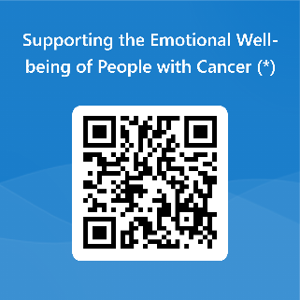
There is also a separate Questionnaire for people who care for someone who has or has had cancer I have include the link in case you have a family member or partner who would like to share their views with us.
Caring for Someone with cancer
https://forms.office.com/e/VMtnvnybbz

Equal opportunities
We aim to offer equal opportunities and we are determined to ensure that no one receives less favourable treatment on the grounds of gender, age, disability, religion, belief, sexual orientation, marital status, or race, or is disadvantaged by conditions or requirements which cannot be shown to be justifiable.
Closing date: | Ongoing

