Would you like to know how to have conversations that lead to real change?

Quality Conversation training will give you the skills.
This free training is for all staff and volunteers working in health and social care and the voluntary sector across Derby and Derbyshire.
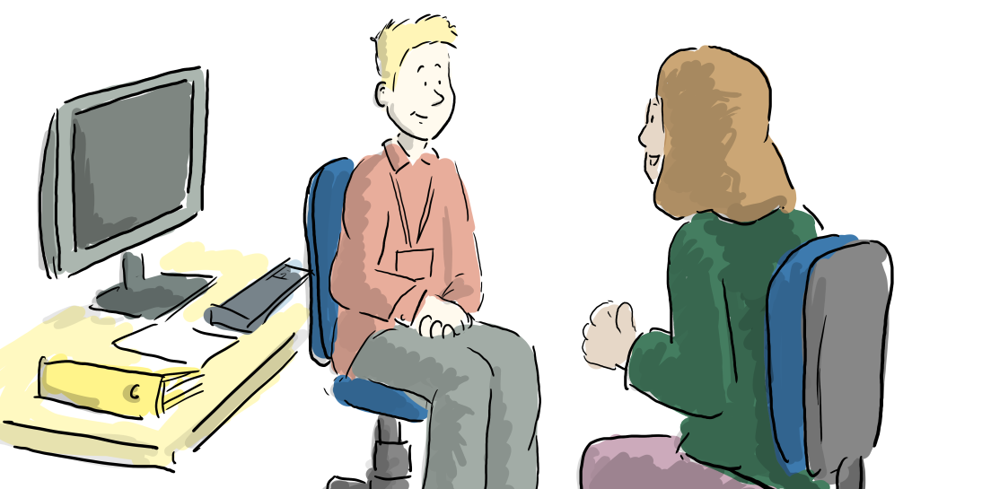

Core Skills Training
You will learn about the impact of health inequalities, and develop listening skills, communications skills, and health coaching approaches. You will gain expert tips and advice tailored to your needs and a chance to practice in small friendly groups.

Spotlight Sessions
Once you have this foundation of knowledge and skills, you can look and learn in more detail about specific areas and tailor your learning, with our new Spotlight sessions. These sessions will cover:
- Supporting people to support themselves.
- Quality Conversations for Leaders.
- How to have better conversations around mental health.
- Having behaviour change conversations.

What’s the training like?
The training is virtual over MS Teams. All sessions are 3 hours 15 minutes long. You need access to a computer with a camera and microphone. Groups are small with time and space to practice your new skills in virtual break out rooms.
How do I book?
Check the dates and times for the training you want to attend and click on the booking link to book you place. You will get an email to confirm your booking and a calendar invite will be sent within 5 working days.

Core Quality Conversations Skills
- You will learn about the impact of health inequalities,
- Develop listening skills,
- Develop communications skills, and health coaching approaches.

Day | Date | Start | Finish | Booking link
April 2024
Tuesday | 16/04/24 | 13:15 | 16:30 | CLICK HERE FULL
Thursday | 18/04/24 | 13:15 | 16:30 | CLICK HERE FULL
Thursday | 25/04/24 | 13:15 | 16:30 | CLICK HERE FULL
May 2024
Tuesday | 14/05/24 | 13:15 | 16:30 | CLICK HERE
Thursday | 23/05/23 | 09:15 | 12:30 | CLICK HERE
June 2024
Thursday | 13/06/24 | 09:15 | 12:30 | CLICK HERE
Wednesday | 26/06/24 | 09:15 | 12:30 | CLICK HERE

Spotlight Sessions
NEW
Having behaviour change conversations

Why is it that most people know what they ‘should’ do, but it doesn’t change their behaviour?

- What is behaviour?
- Health Inequalities and their impact on behaviour.
- How to introduce conversations about behaviour change.
- Exploring barriers and enablers to behaviour change.
- Learn skills to support people to change their behaviour.

Day | Date | Start | Finish | Booking link
June 2024
Thursday | 06/06/24 | 13:15 | 16:30 | CLICK HERE

Quality Conversations for Leaders
- Focus on how to support the workforce more effectively and compassionately.
- Learn how to apply coaching in conversations as a leader.
- Develop skills to improve engagement, well-being, and compassion at work.

Day | Date | Start | Finish | Booking link
April 2024
Tuesday | 16/04/24 | 09:15 | 12:30 | CLICK HERE
Thursday | 24/04/24 | 09:15 | 12:30 | CLICK HERE FULL
May 2024
Tuesday | 21/05/24 | 13:15 | 16:30 | CLICK HERE
June 2024
Tuesday | 18/06/24 | 13:15 | 16:30 | CLICK HERE

Supporting People to Support Themselves
- Understand what this means.
- Develop skills to introduce and promote self-management.
- Understand how to support people to manage their own care.

May 2024
Thursday | 02/05/24 | 09:15 | 12:30 | CLICK HERE
June 2024
Tuesday | 04/06/24 | 09:15 | 12:30 | CLICK HERE

Quality conversations for Mental Health
Would you like to have better conversations with people about their mental health?
- In this short course, you’ll learn how to start conversations about wellbeing, mental health, and helpful ways to respond.
- The course is specifically designed for non-mental health professionals, to help you develop more confidence in everyday interactions around people’s wellbeing.
- You’ll learn mental health conversation skills for your working life – and life away from work.

Day | Date | Start | Finish | Booking link
May 2024
Wednesday | 08/05/24 | 13:15 | 16:30 | CLICK HERE
Wednesday | 15/05/24 | 09:15 | 12:30 | CLICK HERE
June 2024
Tuesday | 18/06/24 | 09:15 | 12:30 | CLICK HERE

