NHS Derby and Derbyshire Integrated Care Board

Safeguarding Children Strategy

KEY POLICY MESSAGES
- The ICB has a statutory duty to ensure that it makes arrangements to safeguard and promote the welfare of children and young people
- The safety and the quality of the care that children and young people and their families receive is of paramount importance to the ICB
- The ICB is responsible for gaining assurance that the organisations from which they commission services from have effective safeguarding arrangements in place.

VERSION CONTROL

Title: | NHS Derby and Derbyshire Integrated Care Board Safeguarding Children Strategy
Supersedes: | NHS Derby and Derbyshire CCG's Safeguarding Children Strategy
Description of Amendment(s): | Versions 0.1 to 0.4 – initial draft  Version 1.0 – final (approved)
Financial Implications: | N/A
Policy Area: | Nursing & Quality – Safeguarding
Version No: | Version 1.0
Author: | Assistant Director for Safeguarding Children/ Lead Designated Nurse for Safeguarding Children  Corporate Governance Manager
Approved by: | Safeguarding Children, Looked After Children and Safeguarding Adults Collaboration Meeting, 20 September 2022  System Quality Group, 1 November 2022
Effective Date: | November 2022
Review Date: | October 2024
List of Referenced Policies: | Raising Concerns at Work (Whistleblowing)  Recruitment and Selection
Key Words section (metadata for search facility online): | Safeguarding Children  Looked After Children
Reference Number: | NQ10
Target Audience: | ICB approved policies apply to all employees, contractors, volunteers, and others working with the ICB in any capacity. Compliance with ICB policy is a formal contractual requirement and failure to comply with the policy, including any arrangements which are put in place under it, will be investigated and may lead to disciplinary action being taken.

CONTENTS
1. Foreword 4
2. Introduction 5
3. Background 5
4. Aims of the Safeguarding Children and Looked after Children Strategy 7
5. Providing Safeguarding Children and Looked after Children assurance to the ICB 9
6. Reporting Framework to the ICB via the Designated Professionals 10
7. ICB Safeguarding Children and Looked after Children Team strategic priorities 10
8. Monitoring the Strategy 11
9. Equality Statement 12
10. Due Regard 12
11. References 12
Appendix 1: ICB Safeguarding Children, Looked after Children and CDOP – Designated Nurses Structure 13
Appendix 2: ICB Safeguarding Children, Looked after Children and CDOP – Doctors Structure 14

- Foreword
  - The safety and the quality of the care that children and young people and their families receive is of paramount importance to the work of NHS Derby and Derbyshire Integrated Care Board (the "ICB").
  - Whatever role or responsibilities staff have within the ICB the clear message is that 'Safeguarding Children is Everyone's Business'. It remains the responsibility of every NHS funded Organisation and each individual healthcare professional working in the NHS to ensure that the principles and duties of safeguarding are holistically, consistently and conscientiously applied with the needs of the child /young person at risk being at the heart of all that we do.
  - The ICB is highly committed in taking all reasonable steps to promote safe practice and to protect children, young people and their families at risk from abuse and neglect in order to reduce risk and improve health outcomes.
  - The ICB fulfils its responsibility to Looked after Children and endeavours that this cohort of children (following entrance into Local Authority care), are not disadvantaged in relation to their health needs being met and their health outcomes are in line with their peers (or improved).
  - The ICB will:
    - have a clear line of accountability for safeguarding properly reflected in the ICB governance arrangements, i.e. a named executive lead to take overall leadership responsibility for the organisations safeguarding arrangements;
    - have clear policies setting out their commitment, and approach, to safeguarding, including safe recruitment practices and arrangements for dealing with allegations against people who work with children and adults, as appropriate;
    - have a safeguarding training programme in order to be able to train staff in recognising and reporting safeguarding issues, appropriate supervision, and ensuring that their staff are competent to carry out their responsibilities for safeguarding;
    - ensure that staff working within the field of Safeguarding Children and/or Looked after Children are competent to the skills and knowledge levels outlined within the relevant Intercollegiate Guidance;
Safeguarding Children and Young People: Roles and Competencies for Healthcare Staff (Fourth Edition: January 2019)
Looked after children: Knowledge, skills and competences of health care staff (2020)
    - have collaborative relationships with the Health Providers, Local Authority and Partner agencies in Safeguarding Children and Looked after Children;
    - promote a positive and proactive attitude on safeguarding arrangements across the Health economy;
    - ensure Safeguarding arrangements are in place in order to discharge its statutory duties in terms of Safeguarding Children and Looked after Children;
    - have equal system leadership between LA children's services, the Police and the ICB as specified in Working Together to Safeguard Children Statutory Guidance (2018);
    - have effective inter-agency working with LAs, the Police and third sector organisations, including appropriate arrangements to co-operate with LAs in the operation of safeguarding children's partnerships, Corporate Parenting Boards, SABs and Health and Wellbeing Boards;
    - have effective arrangements for information sharing;
    - have the expertise of Designated Professionals for Safeguarding Children, Looked after Children and a Designated Paediatrician for Child Death Review Process.
- Introduction
  - The ICB has a statutory duty to ensure that it makes arrangements to safeguard and promote the welfare of children and young people in accordance to the Children Act (1989 and 2004) and Working Together to Safeguard Children (2018) and Promoting the Health and Wellbeing of Looked after Children (2015).
  - Safeguarding children is embedded within the infrastructure of the ICB, including within its governance arrangements, quality assurance and performance processes. The Organisation is able to fulfil its obligations with the support of an experienced Safeguarding team. Please see Appendix 1 and 2: ICB Designated Nurses structure for Safeguarding Children, Looked after Children and CDOP and ICB Designated Drs structure for Safeguarding Children, LAC and CDOP (page 13 & 14).
  - The Safeguarding Children and Looked after Children strategy should be read in conjunction with the ICB Safeguarding Polices, Safeguarding Children and Looked after Children annual reports, and Derby and Derbyshire Safeguarding Children Procedures, and other relevant ICB polices such as the Raising Concerns at Work (Whistleblowing) Policy and Recruitment and Selection Policy.
  - It is not the purpose of this strategy to detail procedure and operational policies required for the management of Safeguarding Children and Looked after Children. The Safeguarding Children Partnership Procedures are available for all to access on the Derby and Derbyshire Safeguarding Children Partnership website and the ICB website [here].
- Background
  - All ICB's have a duty under Section 10 of the Children Act (2004) to cooperate to improve wellbeing and under Section 11 of the Children Act (2004) to ensure that their functions are discharged with regard to the need to safeguard children and promote the welfare of children. All ICB's also have statutory responsibilities outlines within 'Promoting the Health and Wellbeing of Looked after Children (2015). A whole organisational approach to safeguarding and promoting the welfare of all children is required. The scope of child safeguarding and ensuring the safety and wellbeing of Looked after Children is much wider than child protection and involves all Commissioners and Providers of healthcare.
  - Safeguarding children is defined for the purposes of this strategy as:
    - protecting children from maltreatment;
    - preventing impairment of children's health or development;
    - ensuring that children are growing up in circumstances consistent with the provision of safe and effective care;
    - taking action to enable all children to have the best outcomes.
Ref: Working Together to Safeguard Children (2018)
  - Looked after Children are defined for the purposes of this strategy as being 'looked after' by the local authority if the child or young person is in their care for a continuous period of more than 24 hours by the authority. There are four main groups:
    - section 20 children who are accommodated under a voluntary agreement with their parents (or aged 16 years+ and make that choice themselves);
    - sections 31 and 38 children who are subject to an interim care order or care order;
    - sections 44 and 46 children are subject to emergency orders;
    - section 21 children who are compulsory accommodated including children remanded to the care of the local authority or subject to criminal justice supervision with a residence requirement.
Ref: Promoting the Health and Wellbeing of Looked after Children (HM Government 2015)
  - The Safeguarding Children, Young People and Adults at Risk in the NHS: Safeguarding Accountability and Assurance Framework (NHS England, 2019) sets out the safeguarding roles, duties and responsibilities of all organisations commissioning NHS Health and Social Care. As a statutory body the ICB have a range of statutory duties including safeguarding children and adults.
  - As commissioners of local health services, the ICB is responsible for gaining assurance that the organisations which they commission services from have effective safeguarding arrangements in place. As a commissioning organisation the ICB is required to ensure that all Health Providers it commissions have comprehensive single and multiagency policies and procedures in place to safeguard and promote the welfare of children and young people (including those Looked after). The ICB also need to gain assurance that the Health Providers are linked to the Derby and Derbyshire Safeguarding Children Partnership procedures and that the Health Providers actively contribute to the Safeguarding Children Partnership and its subgroups.
  - Safeguarding and looked after also forms part of the NHS Contract and the ICB needs to agree with the Providers that it commissions, that the contract monitoring and quality assurance processes are implemented to demonstrate compliance with safeguarding duties. When the ICB is not assured about the quality of any of the services it commissions, or detects any early warning signs of decline in quality the ICB is responsible to intervene, provide support, advice and guidance.
  - The Designated Safeguarding Children and Looked after Children Professionals must have a key function across the commissioning cycle from procurement to quality assurance, to support the ICB in assuring effective safeguarding arrangements that support the delivery of improved outcomes and life chances for the most vulnerable in all ICB commissioned services (including those Looked after).
  - The ICB is also required to demonstrate that it has appropriate systems in place for discharging its statutory duties in terms of safeguarding and for those Looked after.
- Aims of the Safeguarding Children and Looked after Children Strategy
  - The Safeguarding Children and Looked after Children Strategy aims to set out the ICB's approach to commissioning services that safeguard and protect our local population and in doing so strengthen the safeguarding arrangements for children, young people and families. The Strategy will also set out the ICB approach to fulfilling its statutory duty to Looked after Children (including those originating from Derby and those from elsewhere).
  - The ICB will:
commission services that aim to keep children and young people who are at risk of abuse and neglect safe;
commission services that meet their statutory safeguarding functions;
commission services that meet their statutory looked after children functions;
encourage, embed and maintain the best safeguarding practice across Derby and Derbyshire;
ensure continuous improvement and compliance with national and local safeguarding and Looked after Children policies, guidance and legislation;
continue to develop and implement quality assurance processes that are robust, auditable and effective;
raise awareness about safeguarding and to promote any new initiatives which may help to support vulnerable children and young people;
actively contribute to multiagency approaches such as Channel and MAPPA;
ensure partnership working and contribution to the work of the Derby and Derbyshire Safeguarding Children Partnership;
work in alongside other Neighbouring ICBs and Health Providers;
ensure that the message that safeguarding children is everyone’s business and any national and local key messages are disseminated to Commissioners, Health Providers and the community that we service;
to learn the lessons and disseminate the learning from serious case reviews, child practice reviews or other types of reviews undertaken locally and nationally.

- Providing Safeguarding Children and Looked after Children assurance to the ICB
  - The Designated Professionals obtain Safeguarding Children and Looked after Children assurance using a number of processes that are highlighted in table 2:

Safeguarding children reports from Provider Services
Sharing the learning from rapid reviews, child practice and domestic homicides reviews & monitoring of agreed action plans
Assurance process

Section 11, Markers of Good Practice (LAC) and Joint Safeguarding Children and Adult Assessment frameworks (JSAF)
Designated Professionals reports to ICB Quality & Performance Committees and ICB Board
Outcomes of Single and Multiagency audits

Reporting to NHS England and Improvement Safeguarding team
Designated Professionals attendance an ICB Quality and Performance Committee and Health Providers Safeguarding Committee
Serious incident reporting and investigations

Safeguarding Children and Looked after Children quality visits to Providers

Contribution to the renewal process of Provider contracts

Table 2: Assurance Process

- Reporting Framework to the ICB via the Designated Professionals
  - There are clear lines of communication to ICB Board that the Designated Professionals are able to inform Board members and Executive leads of any risks and priorities pertaining to safeguarding children.

ICB Board

ICB Quality & Performance Committee

ICB Safeguarding Children and Adult Committee

  - The Designated Professionals also attend a number of forums, highlighted below with our Health Providers and Partner agencies that enable the Designated Professionals to have a good understanding and awareness of the local and national issues, challenges and priorities:
    - Derby and Derbyshire Safeguarding Children Partnership and its subgroups;
    - Designated Nurse attendance at Derby and Derbyshire Child Death Overview Panel;
    - Named and Designated Professionals Meeting;
    - attendance at Health Provider Safeguarding Assurance Committee;
    - attendance at NHS England and Improvement Meetings/ forums and conferences;
    - Designated Professionals for Looked after Children attendance at Local Authority Commissioning meetings and Corporate Parenting Committee.
- ICB Safeguarding Children and Looked after Children tEAM strategic priorities
The Safeguarding Children and Looked after Children Team strategic priorities are to:
  - continue to meet the statutory safeguarding responsibilities as a key partner of the new Derby and Derbyshire Safeguarding Children Partnership arrangements;
  - ensure that the ICB meets and adhere to the new Child Death Review statutory arrangements;
  - continue to provide regular reports to the ICB Quality and Performance Committee and Senior Management Team, highlighting any areas of concern or risk;
  - continue to advise the ICB that safeguarding children requirements are added to any new Provider contracts;
  - continue to develop and embed robust safeguarding children assurance processes with our Health Providers and GP Practices;
  - continue to develop and embed robust quality assurance processes with our Looked after Children Services commissioned by the ICB;
  - continue to provide advice and support to health staff and also offer expert advice to partner agencies when required;
  - continue to offer safeguarding supervision to our Health Provider Safeguarding Children Leads/Named Professionals;
  - continue to develop, deliver, and evaluate the safeguarding children training to all staff within the ICB and across Independent Contractor settings such as GP Practices;
  - continue to develop, deliver and evaluate any Looked after Children training in partnership with Local Authority and Derby and Derbyshire Safeguarding Children Partnership;
  - update the ICB's Safeguarding Children policies so that they are in line with Working Together to Safeguard Children (2018) statutory guidance and that they are easily accessible ;
  - continue to have a presence on all Provider Trust’s Safeguarding Committees and provide strategic direction and leadership for health in relation to safeguarding children;
  - continue to take an active role in Rapid Reviews, Serious Case Reviews (SCRs), Child Safeguarding Practice Reviews, monitor the progress of action plans and gain assurance that that learning has been embedded into clinical practice;
  - work in partnership with key agencies in being inspection ready; and
  - continue to raise awareness regarding key priority areas such as Children at risk of Exploitation, Contextual Safeguarding, Improving the Emotional health & wellbeing of children and young people and domestic abuse.
- Monitoring the Strategy
  - Monitoring the strategy and priorities will be through the production of Safeguarding Children and looked after Children annual reports submitted to the ICB's Quality and Performance Committee and ICB Board.
  - A programme of safeguarding and Looked after Children quality assurance visits will take place to Commissioned Health Provider Services.
  - The strategy will be reviewed in May 2022 or in response to any significant changes to statutory requirements for either Safeguarding Children or Looked after Children.
- Equality Statement
  - The ICB aims to design and implement policy documents that meet the diverse needs of our services, population and workforce, ensuring that none are placed at a disadvantage over others. It takes into account current UK legislative requirements, including the Equality Act 2010 and the Human Rights Act 1998, and promotes equal opportunities for all. This document has been designed to ensure that no one receives less favourable treatment due to their protected characteristics of their age, disability, sex (gender), gender reassignment, sexual orientation, marriage and civil partnership, race, religion or belief, pregnancy and maternity. Appropriate consideration has also been given to gender identity, socio-economic status, immigration status and the principles of the Human Rights Act.
  - In carrying out its function, the ICB must have due regard to the Public Sector Equality Duty (PSED). This applies to all activities for which the ICB is responsible, including policy development, review and implementation.
- Due Regard
This policy has been reviewed in relation to having due regard to the PSED of the Equality Act 2010 to eliminate discrimination; harassment; victimisation; to advance equality of opportunity; and foster good relations between the protected groups.
- References
- Safeguarding Children, Young People and Adults at Risk in the NHS: Safeguarding Accountability and Assurance Framework (NHS England 2019)
- Working Together to Safeguard Children (HM Government 2018)
- Children Act (HM Government 1989 and 2004)
- Promoting the Health and Wellbeing of Looked after Children (HM Government 2015)
- Looked after Children: Knowledge, Skills and Competence of Healthcare Staff Intercollegiate Role Framework (2020)
- Safeguarding Children and Young People: Roles and Competence for Healthcare Staff (2019)

Appendix 1: ICB Safeguarding Children, Looked after Children and CDOP – Designated Nurses Structure

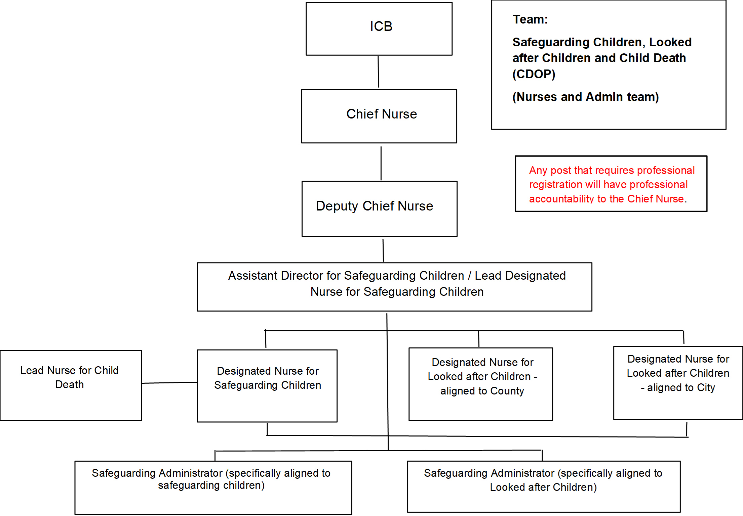
Appendix 2: ICB Safeguarding Children, Looked after Children and CDOP – Doctors Structure
