A review of Derby and Derbyshire Stroke Rehabilitation Services: The Case for Change

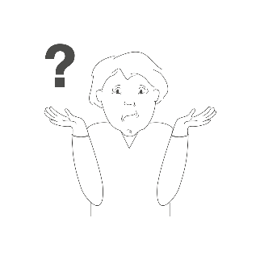
What is happening?

We are reviewing Stroke Rehabilitation services.
We want to improve them and make them fair for everyone.

Why are we doing this?

Community stroke services are very busy because many people need their help.
Services are different depending on where you live; this is not fair.
We want to improve care for all stroke patients.

What is a stroke?
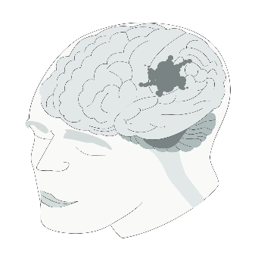
A stroke happens when blood can’t reach part of the brain, which hurts brain cells. This can change how someone’s body works, and how they think and feel. Strokes can happen to anyone and can make life very different. Quick help and therapy can make things better for stroke survivors.
Around 100,000 people have a stroke each year.
There are over one million stroke survivors in the UK.
Most survivors leave the hospital with some disability.
One in six people will have a stroke in their lifetime.
The rate of strokes in Derbyshire is 2.2%. This is higher than the England average of 1.8%.

What are Stroke Rehabilitation services?
Rehabilitation can help people recover after a stroke.
Therapy can help people live better lives after a stroke.
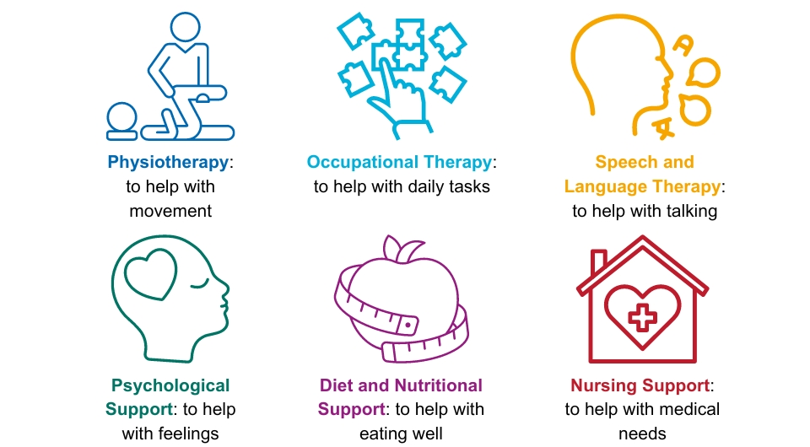
It can include:

Quick and organised care after a stroke can help stop more strokes.
Recovery can take many years, so long-term care is important.

The Stroke Rehabilitation services in Derbyshire are complicated.
There are four possible pathways:
- Early Supported Stroke Discharge (ESSD): This can help those people with mild to moderate disabilities. It lasts about 6 weeks. It aims to provide care at home, improve independence and reduce the length of time people are in hospital. It is not available everywhere.

- Community rehabilitation services: This is for people with more severe strokes, or for those people who need longer support.

- Hospital out-patient services: This is for appointments in a hospital.

- No further rehabilitation needed: This is for people who don’t need more help after their stroke.

People who live in Glossop may go to hospitals outside of Derbyshire.
They access different rehabilitation services. We want to make sure this is fair too.

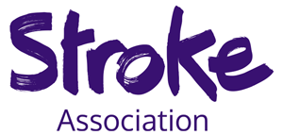

Stroke Association support services
The Stroke Association is a charity which helps stroke patients in Derbyshire.
There are 3 ways they provide support:
- North Derbyshire Stroke Recovery Service:: This is for personalised stroke support in North Derbyshire.

- Communication Support Service: This helps people to improve their communication. It is only in South Derbyshire and Derby City.

- Glossopdale Stroke Recovery Service – This provides personalised support for residents of Glossopdale only.

What do we know already?
People have told us that the following are important:
- Personalised care
- Communication
- Fair access to services
- Support for patients and their families
- The need for a community stroke service
- Addressing health inequalities
- Engaging with GPs
- More mental health support
- Quicker community therapy after hospital discharge
- Lifestyle programmes for health improvement.
We know there are gaps in ongoing support and rehabilitation services for stroke survivors.

We want to find out more from you, we need your help!

We want to hear from people across Derby and Derbyshire especially stroke survivors, friends, family and carers.
Tell us about your experience and what you think is important.
You can get involved by:
- Completing our survey
- Signing up for your nearest face to face or online workshops
You can do this by looking at our website: Derbyshireinvolvement.co.uk/strokerehabservices
There will be someone at the events to help you to join in.
Please contact us if:
- You would like a printer copy of the survey
- Need help filling out the survey
- Need help signing up to the workshops
- Have any other accessibility needs
Our email address is: ddicb.enquiries@nhs.net
Or leave us a voicemail on: 01332 981601.

Thank you. We look forward to hearing from you!

