A **review** of Derby and Derbyshire **Stroke Rehabilitation** Services: **The Case for Change**

**What is happening?**

We are **reviewing Stroke Rehabilitation** services.

We want to **improve them** and **make them fair** for everyone.

## **Why are we doing this?**

Community **stroke services** are very **busy** because **many people need their help**.

**Services are different** depending on where you live; this is **not fair**.

We want to **improve care** for all stroke patients.

## **What is a stroke?**

A **stroke** happens when blood can’t reach part of **the brain**, which hurts brain cells. This can **change** how someone’s **body** works, and how they **think** and **feel**. Strokes can happen to **anyone** and can make **life** very **different**. Quick **help and therapy** can make things **better** for stroke survivors.

Around **100,000 people have a stroke each year**.

There are over **one million stroke survivors in the UK**.

Most survivors leave the hospital with some **disability**.

**One in six** people will have a stroke in their lifetime.

The rate of strokes in **Derbyshire is 2.2%**. This is higher than the **England average of 1.8%.**

**What are Stroke Rehabilitation services?**

**Rehabilitation** can help people **recover** after a stroke.

**Therapy** can help people **live better lives** after a stroke.

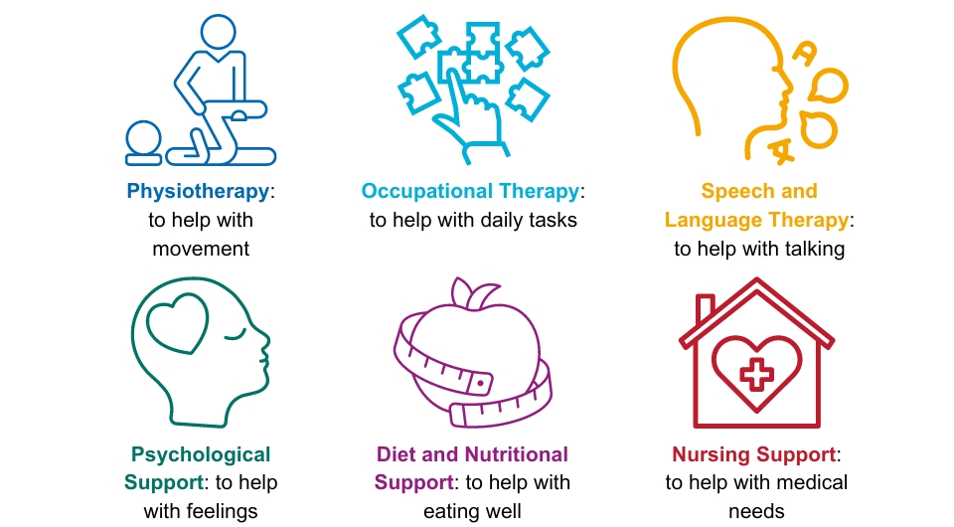It can **include:**

**Quick** and **organised care** after a stroke can help **stop more strokes**.

**Recovery** can take **many years**, so **long-term care is important**.

The **Stroke Rehabilitation services** in **Derbyshire** are **complicated.**

There are **four possible pathways**:

1. **Early Supported Stroke Discharge (ESSD):** This can help those people with **mild to moderate** disabilities. It lasts about **6 weeks**. It aims to provide **care at home, improve independence** and **reduce the length of time** people are in **hospital.** It is **not** available **everywhere**.
2. **Community rehabilitation services: This is for people with more severe strokes, or for those people who need longer support.**
3. **Hospital out-patient services**: This is for **appointments** in a **hospital.**
4. **No further rehabilitation needed**: This is for people who **don’t need more** **help** after their stroke.

People who live in **Glossop** may go to hospitals **outside of Derbyshire**.

They access **different** rehabilitation services. We want to make sure this is **fair** too.

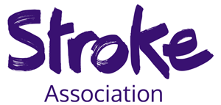

## **Stroke Association support services**

The Stroke Association is a **charity** which helps stroke patients in Derbyshire.

There are **3 ways** they provide support:

1. **North Derbyshire Stroke Recovery Service:**: This is for **personalised stroke support** in North Derbyshire.
2. **Communication Support Service**: This helps people to **improve** their **communication.** It is **only** in **South Derbyshire and Derby City**.
3. **Glossopdale Stroke Recovery Service** – This provides **personalised support** for residents of **Glossopdale** only.

## **What do we know already?**

People have **told us** that the following are **important:**

* **Personalised** care
* **Communication**
* **Fair** access to services
* **Support** for patients and their families
* The need for a **community stroke service**
* Addressing health **inequalities**
* Engaging with **GPs**
* More **mental health support**
* **Quicker** community therapy after hospital discharge
* **Lifestyle programmes** for health improvement.

We know there are **gaps** in ongoing **support and rehabilitation services** for stroke survivors.

## **We want to find out more from you, we need your help!**

We want to **hear from people** across Derby and Derbyshire especially **stroke survivors, friends, family and carers.**

**Tell us** about your **experience** and what you think is **important.**

You can get involved by:

* **Completing our survey**
* **Signing up for your nearest face to face or online workshops**

You can do this by **looking at our website**: [Derbyshireinvolvement.co.uk/strokerehabservices](https://derbyshireinvolvement.co.uk/strokerehabservices)

There will be **someone** at the events to **help** you to **join in**.

Please contact us if:

* You would like a printer copy of the survey
* Need help filling out the survey
* Need help signing up to the workshops
* Have any other accessibility needs

Our **email address is**: [ddicb.enquiries@nhs.net](mailto:ddicb.enquiries@nhs.net)

Or **leave us a voicemail** on: 01332 981601.

**Thank you. We look forward to hearing from you!**