 | 

Task Allocation within Clinical Systems and Improving Communication Flow between System Partners
Standard Operating Procedure

FINAL
Version 8

Version | Circulated To | Date
V1 | Dr Neil Fray, (GP Lead) for comments | January 2022
V2 | Task & Communication Working Group for comments | March 2022
V2.4 | Dr Neil Fray, (GP Lead) for review | July 2022
V2.6 | DCHS, RN & NF for approval | Aug 2022
V2.8 | Final Version – all GP Practices, CGLs & PCNs | Sept 2022
V3 | FINAL VERSION – available on JUCD website/intranet | Oct 2022
V4 | Incorrect details (Pg22) – contacts details updated | May 2023
V5 | Removed DCHS School immunisation service | Jan 2024
V6 | Migration from EMIS to S1 | Feb 2024
V7 | Clarifying how electronic letters are saved and the need to notify GP practices | May 2024
V7.1 | DRAFT – removal for Dr Fray details / clarifying discharge letters process | May 2026
V8 | FINAL VERSION – circulated to users | June 2026

Revision Number | Revision Date | Description of Amendments | By whom
Draft, V1 | 11.01.2022 | Version 1 Created, circulated to Dr Neil Fray for comments | Lisa Roberts
Draft V1.1 | 14.01.2022 | sent to Ross Naylor & Liz Middleton to add S1 task guide (Guidance included 21.01.22) | Lisa Roberts
Draft V1.2 | 25.01.2022 | Checking with EMIS practices | Lisa Roberts
Draft V1.2 | 26.01.2022 | Sent to Scott Goodwin & Lindsay Weatherill to add DCHS sending tasks (Included 22.02.22) | Lisa Roberts
Draft V1.3 | 04.02.2022 | Sent to the T & C working group for Comments | Lisa Roberts
Draft V1.3 | 04.02.2022 & 16.02.22 | Email sent to DCHS Community Managers for comments/information – group discussion Lisa Roberts As at 24.02.22 (no comments received) | Lisa Roberts
Draft V1.5 | 22.02.2022 | Changes to the structure of the SOP before issuing final version sent to the T&C working group for approval/comments (included 02.03.22) | Lisa Roberts
Draft V1.6 | 02.03.2022 | Updated from the T&C Working Group review | Lisa Roberts
Draft V1.7 | 03.03.2022 | Changes to the structure of the SOP – detailing a system partner version to Dr Neil Fray and Dr Niall McKay for approval/comments | Lisa Roberts
Draft V1.7 | 22.03.2022 | Presented to the Primary Care Quality & Performance Sub Committee Review for information | Lisa Roberts
Draft V2 | 28.03.2022 | For final approval – (Still needs to include pathfinder approval & DCHS contact information) | Lisa Roberts
Draft V2 | 30.03.2022 | Sent to the LMC for Committee Approval – April Committee Meeting | Lisa Roberts
Draft V2 | 30.03.2022 | Sent to General Practice Information Governance Assurance Forum (GPIGAF) for review and approval – April Committee | Lisa Roberts
Draft V2.4 | 19.07.2022 | Review Lisa Roberts & Dr Neil Fray | Lisa Roberts
Draft V2.5 | 26.07.2022 | Review and updated Lisa Roberts & Dr Neil Fray | Lisa Roberts
Draft V2.6 | Aug 22 | Updating DCHS Information | Lindsay Weatherill
Draft V2.7 | Aug 22 | Telephone Contact update – DCHS Therapy | Lisa Roberts
Final V2.8 | Sept 22 | EMIS emails updated | Lisa Roberts
Final V3 | Mar 23 | Removed bullet point 8 (page 4) tasking group message | Lisa Roberts
Final V4 | Jun 23 | Clinical Systems changes EMIS (3 practices migrating to S1)/ updating DCHS School Nurses and Health Visitors | Lisa Roberts
V5 | Jan 2024 | Removed DCHS School immunisation service | Lisa Roberts
V6 | Feb 2024 | Migration from EMIS to S1 practices / JUCD website updated | Lisa Roberts
V7 | Apr 2024 | Updated Post COVID contact details (pg7) / Updated Cottage Lane Surgery email | Lisa Roberts
V7.1 | May 2026 | Removal of Dr Fray details (Aug 2025) / Discharge Letters Process | Lisa Roberts

Task & Communications Working Group Members
Active Members
Lisa Roberts (ICB Project Lead) | Clinical Quality Manager (ICB Project Lead)  NHS Derby and Derbyshire Integrated Care Board
Non-Active Members
Dr Neil Fray Non-Active since August 2025 | GP Lead - project
Joanne Roach Non-Active member since Sept 22 | Integrated Community Manager - DCHS
Ross Naylor Non-Active member since Sept 22 | Clinical Systems Specialist, NECS
Hayley Scott Non-Active member since Sept 22 | Practice Liaison Officer, Derby and Derbyshire Local Medical Council
Jonathan Sanderson Non-Active member since Sept 22 | General Manager, HP Community & Derbyshire Dales Community - DCHS
Lindsay Weatherall Non-Active member since Sept 22 | Integrated Community Services Systm1 Lead - DCHS
Christy Herbert Non-Active member since Sept 22 | Administrative support, NHS Derby and Derbyshire Integrated Care Board
Jackie Jones Non-Active member since Sept 22 | General Manager, Derby City - DCHS
Dr Niall Mckay Non-Active member since Apr 22 | GP, Derby City PCN
Dominic Fackler Non-Active member since Apr 22 | General Manager, Derby City – DCHS
Marie Scouse Non-Active member since Dec 21 | Assistant Director of Nursing and Quality: Primary Care (CCG)
Fran Higton Non-Active member since Dec 21 | District Nurse – DCHS
Scott Goodwin Non-Active member since Nov 21 | Risk Manager, DCHS
Dr Kath Markus Non-Active member since Nov 21 | LMC
David Hill Non-Active member since Nov 21 | IT Service Delivery Manager, CCG

CONTENTS
PAGE
SECTION 1: Task Allocation within Clinical Systems and Improving Communication Flow between System Partners  - Introduction  - General Principles of Communicating Tasks across ALL Derbyshire System Partners | 4
SECTION 2: Situation, Background, Assessment, Recommendation and Contact Details (SBARC) Communication Tool:  - How Does SBARC work?  - SBARC Communication Tool  - Why use SBARC | 5
SECTION 3: General principles of Sending task across ALL Derbyshire System Partners  - Tips for System Partners Sending Tasks  - Tips for GP Practices | 6
SECTION 4: Method of contacting System Partner professionals, if applicable  - Derbyshire Community Healthcare Services | 7
Appendices:  Appendix A – System Partners & GP Practice Communication Pathway  Appendix B – List of EMIS Generic Email Addresses  Appendix C – Checklist and Guides in Creating/Monitoring the Universal Task Box  Applies to General Practices: GP Practice Implementation Checklist  Applies to General Practices: S1 Guide – Creating the Universal Task Box (called: External Task to GP Practice)  Applies to General Practices: Setting up Practice Rules (Option 1 or Option 2)  Optional for General Practices/Applies to System Partners: Creating a SBARC Template  Appendix D – Additional Information and System Partners Contact Directory | 9  10  11  11  12 – 13  14  18 – 20  21 - 23

SECTION 1: Task Allocation within Clinical Systems and Improving
Communication Flow between System Partners

INTRODUCTION

A Task and Communication Working Group has been established to look at improving the communication channels with system partners. Several significant events have been raised during discussions with various stakeholders and from these discussions the group was tasked to work together to find a solution to address these concerns and reduce the barrier to safe effective communication across different disciplines and levels of staff. This procedure standardises the sending of task/electronic communication to allow the good communication between system partners that is critical in providing safe and effective patient care in a timely manner. Failure to follow these task principles will mean that messages are missed and will present clinical risk, such as patient safety concerns, delayed or missed patient care, staff safety and well-being. This procedure does not make recommendations for how messages are processed within individual practice/unit but only when tasking between system partners. Appendix A (Page 9) details the System Partner and GP Practice Communication Pathway Flowchart 2022.

It would be helpful if you can provide any feedback/questions/comments back to the Primary Care Quality Team to enable us to refine/improve this process as appropriate via the Quality Team inbox, ddicb.primarycarequalityteam@nhs.net

GENERAL PRINCIPLES OF COMMUNICATING TASKS ACROSS ALL DERBYSHIRE SYSTEM PARTNERS

COMMUNICATING TASKS:
- All written/verbal communications should use the Situation-Background-Assessment-Recommendation-Contact Details (SBARC) Principles/Template for clarity (SBARC principles detailed on page 5).
- Urgent communication must be telephoned and discussed with the duty clinician. NB: Practices have allocated monthly training sessions on varying days and their number may not connect to the out of hours service during these times. It is not acceptable to Task ^{(S1)} /Email ^{(EMIS)} in this situation. You must call the out of hours service.
- All telephone calls must be followed up with a Task ^{(S1)} / Email ^{(EMIS)} and be prefaced 'as per the phone call with the clinician X' to avoid confusion or concerns over a new task arriving that has already been discussed.
- Never task individuals based at a GP Practice, either use task type "EXTERNAL TASK TO GP PRACTICE" for S1 practices or GENERIC ADMIN EMAIL BOX for EMIS practices
- Tasks should not duplicate existing communication routes (e.g. clinical/discharge letters). A task should only be used where there is a clear action, escalation, or patient safety requirement.
- GP practices are not automatically aware of documentation added to the clinical system; therefore, all clinical correspondence must be sent via standard document workflows in a way that ensures it is visible within GP practice processes and can be safely received, processed and coded.
- All written Tasks ^{(S1)} /Emails ^{(EMIS)} must include contact details of individual sender and alternative contact in case clarification required
- SystmOne (S1) Task Exchange – S1 users need to be made aware that you must select the recipient of the task if you want reply to a task for it to connect with the correct recipient. If nothing is selected, then the task will stay with the originator ie it is possible to task yourself if you are not careful.
- Tasks generated in patient records should only be used for specific information about that patient.
- Tasks and emails should predominantly be a way of communicating with practices rather than to displace a unit's responsibility or activity into a practice.
- Clinical conversations are encouraged and can be arranged by using contact information detailed in the Task ^{(S1)} / Email ^{(EMIS)}.

SECTION 2: Situation, Background, Assessment, Recommendation and Contact Details (SBARC) Communication Tool

How does SBARC work?
SBARC allows staff to communicate assertively and effectively, reducing vagueness and the need for repetition. The SBARC process consists of five standardised stages or 'prompts' that help staff to anticipate the information needed by colleagues and formulate important communications with the right level of detail.

Recommended uses and settings for SBARC:

- Urgent or Non-Urgent Communications
- Verbal or Written exchanges
- Escalation and Handover
- Reducing incidence of missed communications
- Promotion of patient Safety and ultimately improving Patient Care

SBARC Communication Tool – Below are suggestions of what a clinician might include if relevant and are not prescriptive

Situation | - Identify yourself  - Identify your patient, current location  - Identify reason for this communication  - Describe main concerns or situation  - Observations undertaken  - Respect
Background | - Patient current status  - Significant medical history  - Current medication if applicable  - Significant social history  - Allergies
Assessment | - Vital signs/NEWS2  - Clinical concerns  - Consideration of underlying reason for current condition  - Investigations undertaken: Venepuncture, swab and urinalysis  - Risk assessments completed
Recommendation | - Be specific-explain what you want  - Request a time frame  - Red flag if appropriate  - Make suggestions  - Clarify your expectations  - Advocate your concerns  - Escalate?
Contact Details | - Sender's Contact Name  - Urgent Contact Telephone Number & Times available  - Generic Task Box ^{(S1)} / Email ^{(EMIS)}  - Non-Urgent Team Contact Telephone/Email

Why use SBARC

- To reduce the barriers to effective communication across different disciplines and levels of staff
- SBARC creates a shared mental model around all patient information (handoffs) and situations requiring escalation, or urgent critical exchange of information (handovers from a clinician to clinician)
- SBARC is memory prompt: easy to remember and encourage prior preparation for communication
- SBARC reduces the incidence of missed communication

SECTION 3: General Principles of Sending Tasks across ALL Derbyshire System Partners

TIPS FOR SYSTEM PARTNERS SENDING TASKS:

- NEVER task individuals at GP Practice

- Routine S1 Message to be sent to task box marked "EXTERNAL TASK TO GP PRACTICE" following the SBARC principles. Be certain the destination task box has been selected (there have been some incidents of the task sender tasking themselves)

- Routine EMIS referral request to be sent to GENERIC ADMIN EMAIL BOX following the SBARC principles. List of EMIS practice generic emails detailed in Appendix B (Page 10)

- Urgent Communication to be made by telephoning the GP practice (format of message to be made similarly using the SBARC principles). If a call has been made, Task ^{(S1)} / Email ^{(EMIS)} must be prefaced 'as per the phone call with Clinician X' to avoid confusion or concerns over a new task or email arriving that has already been discussed.

- Discharge Communications: Discharge summaries or clinical letters sent through standard document workflows should not be accompanied by a separate task, as this duplicates existing communication routes. A task should only be used where there is a clear action, escalation, or patient safety requirement. System partners must ensure correspondence is sent via standard document workflows in a way that makes it visible within GP practice processes, as GP practices are not automatically aware of documentation added to the system.

- All written Task ^{(S1)} / Email ^{(EMIS)} must include contact details of individual sender and alternative contact in case clarification required.

- Tasks generated in patient records should only be used for specific information about that patient.

- Tasks and emails should predominantly be a way of communicating with practices rather than to displace a unit's responsibility or activity into a practice.

- If the practice is closed contact must be via the DHU service. DO NOT send an urgent task if you have not been able to have a clinical conversation. The practice may be closed, and your message may not be received.

TIPS FOR GP PRACTICES

- The S1 task box will need to be setup by the practice. GP Practices need to ensure they have a mechanism in place to ensure tasks to the new task box are allocated according to their workflow rules BEFORE creating the new task box, so that everyone is clear how to process any new message arriving in the new task box. A practice guide and technical advice on how to setup a task box is detailed in Appendix C (Page 11). If support and advice is required, please contact the NECS helpdesk Clinical Systems Team, Email: necs.servicedesk@nhs.net / Telephone Number: 0300 5550340 (available Monday to Friday)

- All S1 practices (Pathfinder and non-Pathfinder), will need to action the Appendix C (Page 18 - 20) 'Creating the task template' for the SBARC template to appear in the 'Task Templates' list. The Pathfinder team can add the SBARC template as a 'quick action' (a button) to Pathfinder templates (pages) when advised but it will not appear in the default list of task templates for the practice without actioning Appendix C locally. Please contact the NECS helpdesk Clinical Systems Team, Email: necs.servicedesk@nhs.net / Telephone Number: 0300 5550340 (available Monday to Friday). This will not apply to EMIS practices.

- Clinical conversations are encouraged and can be arranged by using contact information detailed in the Task ^{(S1)} / Email ^{(EMIS)}. Appendix D includes system partners' backup contact arrangements if they are not clearly detailed in the sender referral task/email.

SECTION 4: Method of Contacting/Replying to System Partner Professionals:

All written tasks must follow SBARC principles and include contact details of sender’s team (in and out of hours) in case clarification required. Appendix D includes additional Information and Contact Directories from System Partners.

- Replies to Derbyshire Community Health Services NHS Foundation Trust (DCHS) (NB: This is for replies, not for new referrals):

Replying to DCHS Integrated Community Services
Community Nursing & Therapy Team request:
- Replying to DCHS teams should be via the contact details in the SBARC task template ('C' for Contact Details) sent by DCHS clinicians or via the DCHS team task boxes on the appropriate DCHS TPP unit, e.g., Belper DN team. Tasking should always be done via a patient record if it involves direct patient care. This allows it to be stored within the patient record for audit purposes. A new task should be opened, and the contents of the original task should be copied and pasted into the new task. If the original task came from an appropriate sender, i.e., a DCHS team task group, then the reply to functionality may be used.
- DCHS task boxes are managed by multiple users. This ensures that tasks are responded to/actioned in a timely manner and does not rely on an individual staff member being available.
- If Urgent Telephone clarification is required, this is via the Local Triage Point detailed in the Sender Referral Task ^{(S1)} / Email ^{(EMIS)} (Telephone numbers also in Appendix D if required). This service is available between 8am and 6.30pm, 7 days a week.
- Routine replies can be also made to the contact detailed in the Task (S1) / Email (EMIS) however depending on that person’s working pattern there may be a delay in response.

Replying to DCHS Planned, Care & Specialists Services
The following care specialities request that contact is made to the individual clinician/team who will have been identified on initial Sender Referral Task ^{(S1)} / Email ^{(EMIS)}. This would usually be by task unless specified below for S1 practice and email for EMIS practices.
- Walton Older People Mental Health Inpatient ward: generic e-mail address dchst.thewaltonunit@nhs.net
- Older People Mental Health Day Service - individual clinician identified on initial Sender Referral task
- Learning Disability Community Teams – individual clinician identified on initial Sender Referral task
- Hillside Learning Disability Assessment & Treatment Unit – individual clinician identified on initial Sender Referral task
- Diabetes Specialist Nurses (North): generic e-mail address dchst.communitydiabetesnurses@nhs.net
- Heart Failure Specialist Nurses (North): generic e-mail address DCHST.heartfailurenorth@nhs.net
- Heart Failure Specialist Nurses (South) – individual clinician identified on initial Sender Referral task or generic e-mail address dhft.derbyhfteam@nhs.net
- Cardiac Rehabilitation (North) – generic e-mail address DCHST.communitycardiacteam@nhs.net
- Community Respiratory Team (North) – generic e-mail address DCHST.Respiratory@nhs.net
- Babington Day Service – individual clinician identified on initial Sender Referral task or generic e-mail address dchst.avrehabunit@nhs.net
- Post Covid Syndrome Assessment & MDT Service – individual clinician identified on initial Sender Referral task or generic e-mail address dchst.postcovidspa@nhs.net
- Urgent Treatment Centre – individual clinician identified on initial Sender Referral task
- Dementia Palliative Care Team - individual clinician identified on initial Sender Referral task

Replying to DCHS Health, Wellbeing & Inclusion Services

Diabetes Education Team Request:
- Urgent enquiries must be by phone to our central admin on 01773 525029. This service is covered between 9.30am and 5.30pm, Mon - Thurs and 10.00am - 3.00pm Fridays.
- For routine enquiries, practices must email our generic admin email, dchst.diabetesT2education@nhs.net, please do not email individual staff members

DCHS Continued………

DCHS Continued………

Replying to DCHS Health Visiting
- GP practices must always task health visitor teams in the first instance – NEVER individuals
- Replying to DCHS teams should be via the contact details in the SBARC task template ('C' for Contact Details) sent by DCHS clinicians or via the DCHS team task boxes on the appropriate DCHS TPP unit, e.g., Belper HV team. Tasking should always be done via a patient record if it involves direct patient care. This allows it to be stored within the patient record for audit purposes. A new task should be opened, and the contents of the original task should be copied and pasted into the task response. If the original task came from an appropriate sender, i.e., a DCHS team task group, then the reply to functionality may be used.
- DCHS task boxes are managed by multiple users. This ensures that tasks are responded to/actioned in a timely manner and does not rely on an individual staff member being available.
- If Urgent Telephone clarification is required, please contact via the Single Point of Access 01246 515100. This service is available between 9am and 4.30pm, Monday – Friday (excluding bank holidays). This is the contact point for the service and admin will initially respond to your query, if you need to speak to a clinician in SPA there may be a delay as they manage call backs via a waiting list.

Replying to DCHS School Nursing
- For referrals into the service GP practices must access the referral form via the service website School Nursing referral form
- To share information or request an update always task the school nurse teams in the first instance – NEVER individuals
- If Urgent Telephone clarification is required via the Single Point of Access 01246 515100. This service is available between 9am and 4.30pm, Monday – Friday (excluding bank holidays) Routine replies can be made to the contact as detailed in the Task, however there may be a delay in a response.

Appendix A
System Partners & GP Practice Communication Pathway
All written/verbal communications must use the SBARC Principles/Template
(Situation-Background-Assessment-Recommendation-Contact Details)
All written tasks must include contact details in case clarification required
SBARC principles as detailed on page 5.

This pathway standardises the flow of allocating tasks to allow good communication between system partners that is critical in providing safe and effective patient care in a timely manner. Failure to follow these task principles will mean that tasks are missed and will present a patient safety risk
System
Partners
NON-URGENT (Routine Referral) Request
URGENT Telephone Referral Request

*Urgent referral request to be made by telephoning the GP practice following the SBARC principles

(*Urgent definition: Any deteriorating clinical situation. This applies to tasks expecting a response by end of the next working day Monday to Friday (for weekends or bank holidays please aim to receive a response prior to the practice closing), this excludes as follows:
- emergency medical attention immediately required
- any prescriptions which should go through the normal channels

One Wednesday afternoon a month the GP practice may be closed for training - If the GP practice is closed contact must be via the DHU service

SystmOne
GP Practice

EMIS
GP Practice

Routine referral request to be sent to Generic Admin Email box as detailed in Appendix B (Page 10)

All written tasks must follow SBARC principles and include contact details of sender’s team (in and out of hours) in case clarification required

Routine referral request to be sent to EXTERNAL TASK TO GP PRACTICE)

All written tasks must follow SBARC principles and include contact details of sender’s team (in and out of hours) in case clarification required

GP Practice
(GP Practices need to ensure they have a mechanism in place to ensure tasks to the new task box are allocated according to their workflow rules BEFORE creating the new task box, so that everyone is clear how to process any new message arriving in the new task box.

NON-URGENT Routine response
URGENT telephone response
If clarification / response required …

GP Practice to contact the System Partner via the sender's preferred contact details as detailed in the Sender Referral Task ^{(S1)} / Email ^{(EMIS)}

(Section 4 includes system partners backup contact arrangements if it's not clearly detailed in the sender referral task/email).

All Communications must follow SBARC principles

If urgent response required: GP Practice to contact the System Partner by telephone using the sender's preferred contact details as detailed in the Sender Referral Task (S1) / Email (EMIS) and follow up with a written communication

(Section 4 includes system partners backup contact arrangements if it's not clearly detailed in the sender referral task/email).

All Communications must follow SBARC principles

Appendix B – List of EMIS Generic Email Addresses

 | Practice Code | Name of Practice | Generic E-Mail
1 | C81003 | Sett Valley Medical Centre | adminsettvalleymedicalcentre@nhs.net
2 | C81004 | Ivy Grove Surgery | ddicb.admin.ivygrove@nhs.net
3 | C81025 | Dronfield Medical Practice | ddicb.dmp@nhs.net
4 | C81034 | Stewart Medical Centre | admin.stewartmedical@nhs.net
5 | C81039 | Eyam Surgery | ddicbadmineyam@nhs.net
6 | C81063 | Thornbrook Surgery | ddicb.admin.thornbrook@nhs.net
7 | C81065 | Buxton Medical Practice | ddicb.bmp.admin@nhs.net
8 | C81080 | Goyt Valley Medical Practice | ddicb.reception.gvmdp@nhs.net
9 | C81082 | Hartington Surgery | ddicb.admin.hartingtonsurgery@nhs.net
10 | C81092 | Evelyn Medical Centre | ddcib.admin.emc@nhs.net
11 | C81634 | Arden House Medical Practice | If you are trying to send us a general enquiry including a request for information or repeat medication, please fwd your email to ddicb.surgery.ardenhouse@nhs.net  If you are trying to send patient information/requests from a hospital or other clinic in the form of a document for patient records or GP action please fwd your email on to ddicb.documents.AHMP@nhs.net
12 | C81106 | Lambgates Health Centre (Hadfield Glossop) Practice | ddicb.c81106@nhs.net
13 | C81640 | Simmondley Medical Practice | ddicb.simmondleymedicalpractice@nhs.net
14 | C81081 | Manor House Surgery | ddicb.manorhousesurgery@nhs.net
15 | C81615 | Cottage Lane Surgery | ddicb.cottagelanesurgery@nhs.net

Appendix C – GP Practice Implementation Checklist, S1 Guide and Technical Advice
To help with the flow of tasks and communications within a practice setting please refer to this Checklist and Guide to assist you in creating and monitoring the Universal Task Box.

Index:
- GP Practice Implementation Checklist – Page 11
- S1 Guide – Page 12 to 13
- Technical Advice (Setting up rules) – Page 14

GP Practice Implementation Checklist
Creating the Universally Named Task Box in S1

Read the SOP and refer to the appendices

Decide which team will be monitoring the Task the box (eg Reception or Admin)

Create the universal task box named in the SOP (refer to the set-up instructions as detailed in Appendix C)

Below are optional settings to improve the message flow in your practice by creating RULES in S1

It is possible that if you do not set new rules up correctly that it will alter your current workflow (eg a new rule may direct letters to your new task box, away from any previously designated box).

OPTION 1 'Catch All' Rule' - Create a rule as a “catch – all” to direct all tasks from external organisations to the “External Task to GP Practice” task box. Refer to Appendix C Technical Advice. DO NOT SELECT “Do not process further rules”, or else any pre-existing rules relating to “Type of task will not be actioned.
NOTE- this may direct a large volume of new traffic to the task box, but no external task will get missed.

OPTION 2 – 'Redirection Rule' - Create a rule to direct external messages that have been sent to the “External Task to GP Practice” task box, to the box of the internal group you have decided who will be monitoring this universal box (eg Reception / Admin). Refer to Appendix C Technical Advice section for advice. DO NOT SELECT “Do not process further rules”, or else any pre-existing rules relating to a “Type” of task will not be actioned.

If you are not sure about how to proceed, please contact NECS helpdesk Clinical Systems Team for assistance either via email: necs.servicedesk@nhs.net or telephone 0300 5550340 (available Monday to Friday).

Action for EMIS and SI Practices:

Familiarise all staff with SBARC principles for messages (refer to the SOP)

S1 Task Box - Please notify the ICB Clinical Quality Team (ddicb.primarycarequalityteam@nhs.net) (FAO: Lisa Roberts) once you have set up your S1 task box. This will allow the Quality Team to notify relevant System Partners that the task box has been created and will be monitored accordingly.

S1 Guide – Creating the Universal Task Box (applies to General Practices)

Groups - GP practices on SystmOne will all have a task group set up called ‘External Task to GP Practice' (drop down list) – this will be the default recipient of all community external tasks once the aforementioned rule has been set*. It is the responsibility of the practice to setup their staff task groups to ensure these tasks are managed and distributed appropriately to relevant staff members.

1. Creating the Task Group

- Go to Setup -> Users and Policy -> Organisation Preferences

- Select User Groups

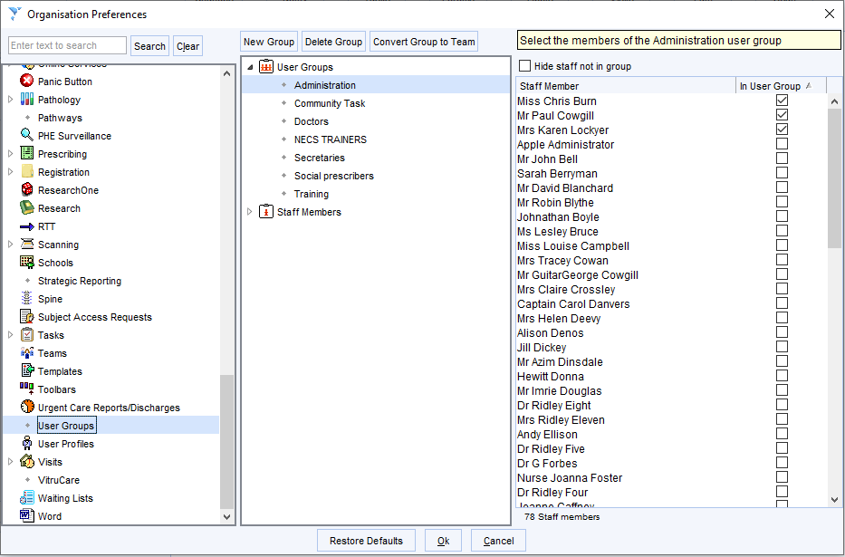

Select New Group

Name the group External Task to GP Practice

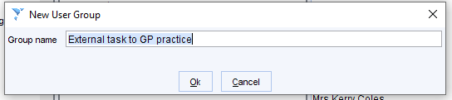

2. Assigning Users to the Task Group

- Decide who you want to be able to action external tasks to the practice (eg admin staff, reception staff)

- Go to Setup -> Users and Policy -> Organisation Preferences

- Select User Groups

Select the "External Task to GP Practice"

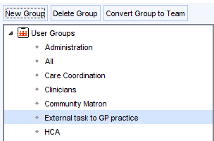

Select the staff you have chosen to action external tasks in the right-hand column to assign them to the group

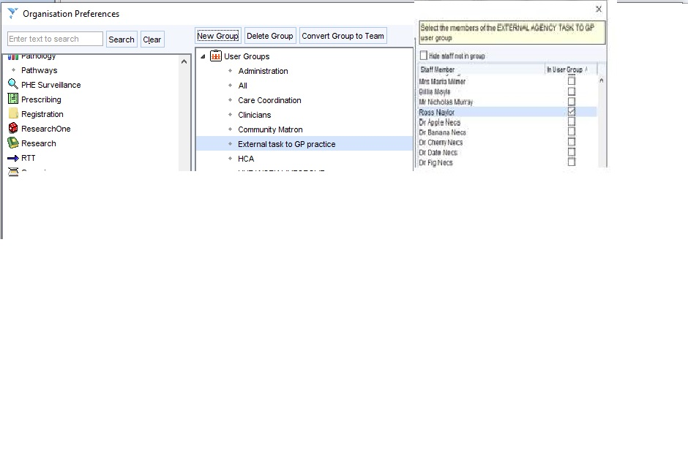

Technical Advice: Rules - Option 1 'Catch All' Rule' / Option 2 'Redirection Rule' – both rules can be applied

BELOW ARE OPTIONAL ACTIVITIES TO IMPROVE THE MESSAGE FLOW IN YOUR PRACTICE BY SETTING UP RULES IN S1

It is possible that if you do not set new rules up correctly that the new rules will alter your current workflow (eg a new rule may direct letters to your new task box, away from the previously designated box). If you are not sure about how to proceed, please contact NECS helpdesk Clinical Systems Team for assistance either via email: necs.servicedesk@nhs.net or telephone 0300 5550340 (available Monday to Friday).

Rules – SystmOne units can create Task Rules to govern how the system distributes messages received by the unit and / or the named User Group.

1. 'Catch All' Rule – This rule is designed to capture messages intended for but not sent to the named Task Group

- Go to Setup -> Users and Policy -> Organisation Preferences

- Expand Tasks and select Rules

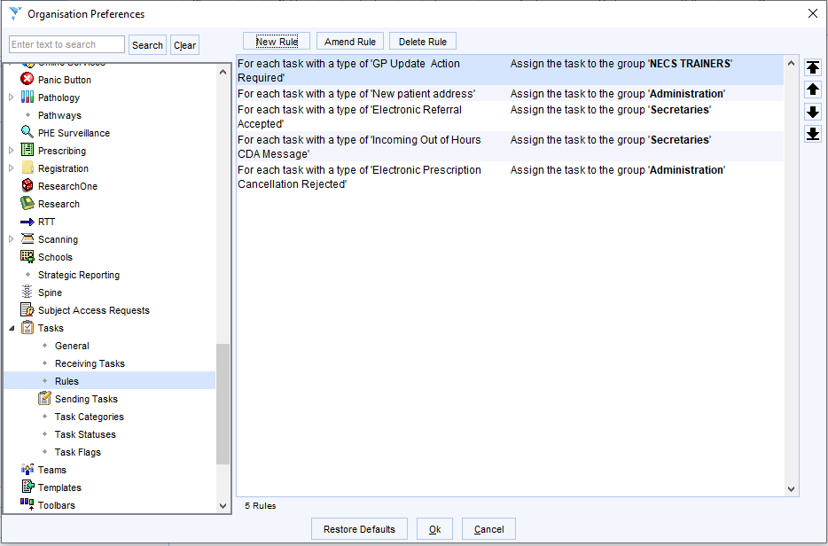

- Select New Rule

- Set as below – this will direct new tasks from outside of this SystmOne unit to the previously created 'External task to GP practice' user group. Do not select 'Do not process any further rules'

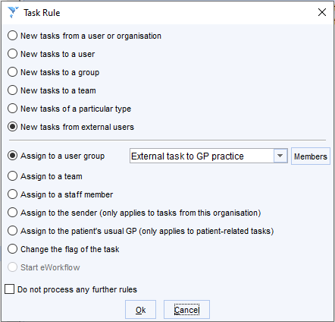

- Use the arrows to the right of the existing rules to move the new rule to the top of the list.

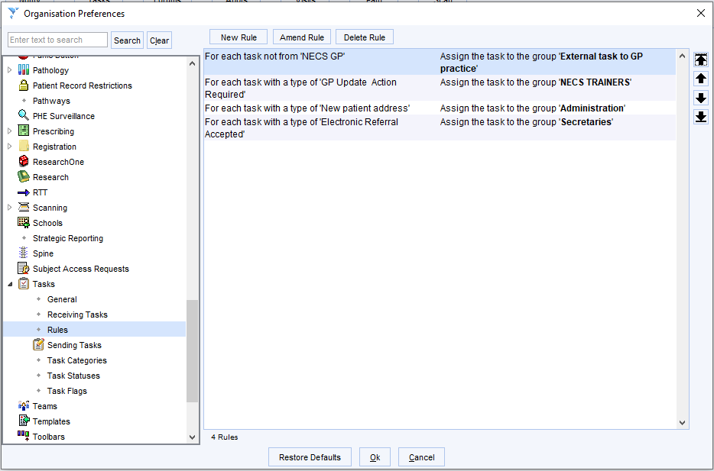

SystmOne will test this rule first, so if a task of a new type is sent from outside the unit, it will be sent to the 'External task to GP practice' group unless a subsequent rule redirects it further (i.e. in the example above, an 'Electronic Referral Accepted' task would be directed to the group 'Secretaries' as that rule follows the rule assigning all external tasks, which was not told to stop processing rules).

2. Redirection Rule - This rule is designed to redirect messages sent to the named Task Group to a more appropriate internal group

- Decide who is to triage / action external tasks to the practice (eg admin staff, reception staff)

- Go to Setup -> Users and Policy -> Organisation Preferences

- Expand Tasks and select Rules

- Select New Rule

- Set as below (selecting the appropriate user group for your practice in the highlighted drop down) – this will direct new tasks sent to the previously created 'External task to GP practice' user group to an appropriate internal team

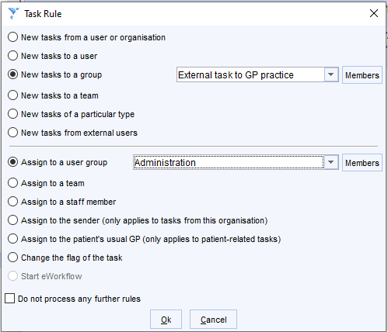

- Use the arrows to the right of the existing rules to move the new rule to the bottom of the list.

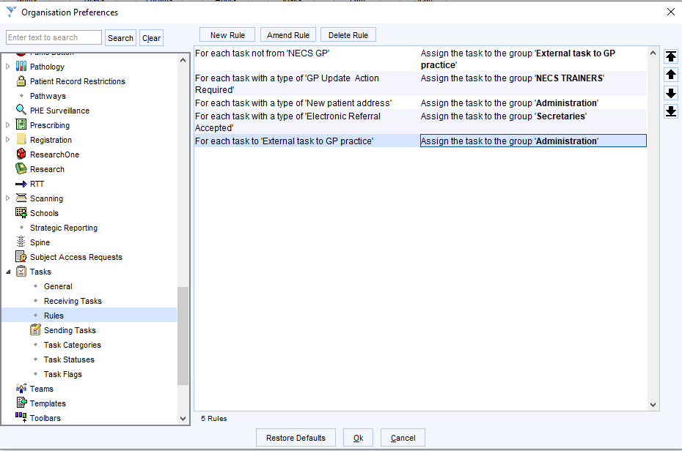

SystmOne will test this rule last, so if a task of a new type is sent to the 'External task to GP practice' group, it will be redirected to the chosen group unless a previous rule redirects it with the 'Do not process any further rules' option selected

Optional for General Practices/Applies to System Partners: SBARC Task Template – Creating the Task Category
Creating the Task Category (System Administrator)

- Go to Setup -> Users and Policy -> Organisation Preferences

- Go to Tasks -> Task Categories
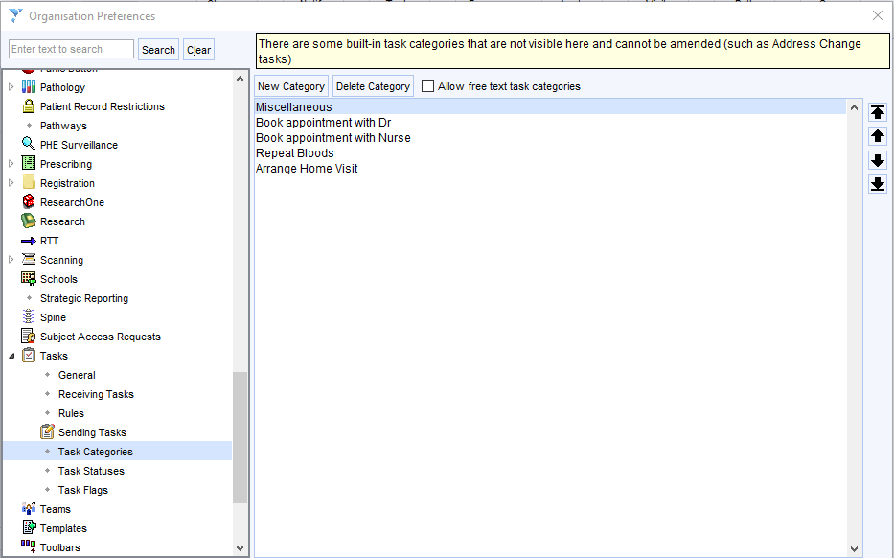
- Select New Category

- Name the new category SBARC and click OK
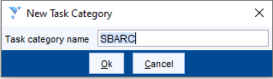

Creating the Task Template (System Administrator)

- Go to Setup -> Data Entry -> Task Templates

- Select New Template
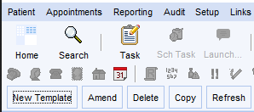

- Name the task SBARC, select an icon and set description as appropriate

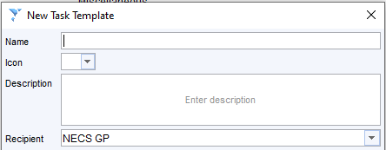

- The recipient will default to the unit in which the task is created. This will need to be set manually at the point of sending as it is not possible to default to either a particular external unit, nor user group at an external unit. Therefore the default recipient should be left as 'Unassigned'
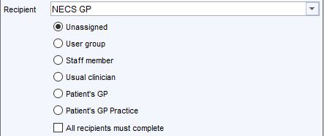

- The SBARC criteria can be pasted into the task body. This content will be amendable / fillable by the end user.

*Do not send this task if this is an urgent matter - Ring the appropriate surgery and discuss with the duty clinician*
If this task is not urgent check that you have selected the correct task box for the appropriate surgery.
SBARC
Situation:
Background:
Assessment:
Request/Recommendation:
Contact:
Please do not amend the Task Category field, this should remain as SBARC. If you are asked to create a new task to a different user or team, please select the SBARC Task Template.
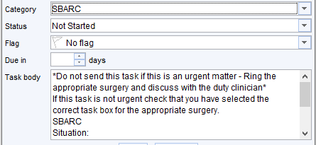

Applying the Task Template (End User)
- Create a New Task from within the patient record
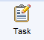

- Select Apply Template
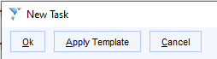

- Select the previously created Task Template

- Select the appropriate receiving unit and user group
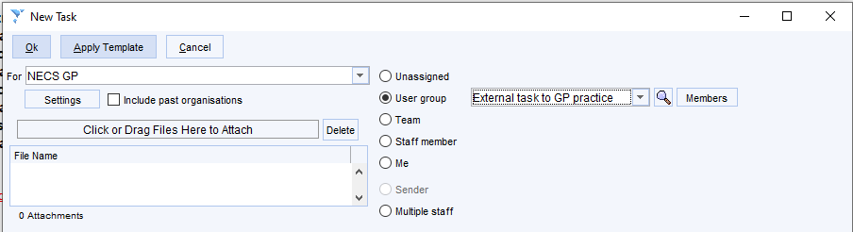
- Add the required information to the pre-populated prompts
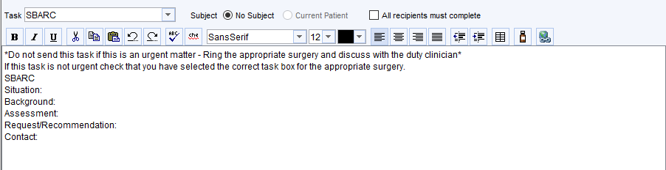

Appendix D – Additional Information and Contact Directory from System Partners

- Derbyshire Community Health Services NHS Foundation Trust (DCHS):

DCHS Integrated Community Services: Replying to a Community Nursing & Therapy Team request:

URGENT REPLY REQUIRED
- If Urgent Telephone clarification is required, this is via the Local Triage Point detailed in the Sender Referral Task ^{(S1)} / Email ^{(EMIS)}
- This service is available between 8am and 6.30pm, 7 days a week.

ROUTINE REPLY
Routine replies can be made to
- the contact as detailed in the Task ^{(S1)} / Email ^{(EMIS)}, however there may be a delay in a response
- If it is not appropriate to reply to the individual who sent the Task ^{(S1)} / Email ^{(EMIS)}, in the first instance, contact via the Local Triage Point and someone in the team will respond or the individual named.

S1: A new task should be opened, and the contents of the original task should be copied and pasted into the new task addressed to the Generic S1 Task box of your local triage hub

DO NOT task individuals at the hub - DCHS task boxes are managed by multiple users. This ensures that tasks are responded to/actioned in a timely manner and does not rely on an individual staff member being available. Tasking related to patient care should always be done via a patient record for it to be stored within the patient record for audit purposes.

EMIS: Email FTOA of your local hub to dchst.communityaccesspoint@nhs.net (Enter your contact details and a request for a clinical conversation/call back in your e-mail)

Local Triage Hub | Telephone Number | Generic S1 Task Box
High Peak Triage Hub | 01298 212865 | HP and DD Nursing Triage  HP and DD Therapy Triage
Derbyshire Dales Triage Hub | 01629 593051 | HP and DD Nursing Triage  HP and DD Therapy Triage
Chesterfield and North East Derbyshire Triage Hub | 01246 252914 | CHES/NED nursing Triage  CHES/NED therapy triage
Amber Valley Triage Hub | 07920 701875 (Nursing)  07747 756693 (Therapy) | AV and Erewash Nursing Triage  AV and Erewash Therapy Triage
Erewash Triage Hub | 07770 973111 (Nursing)  07870 829392 (Therapy) | AV and Erewash Nursing Triage  AV and Erewash Therapy Triage
Derby City Triage Hub | 01332 564889 (Nursing)  01332 786204 (Therapy) | Derby City Nursing Triage  Derby City Therapy Triage
South Derbyshire Triage Hub | 07786 854638 (Nursing)  07768 463909 (Therapy) | South Derbys Nursing Triage  South Derbys Therapy Triage

NEW REQUEST
New referral requests should go to the DCHS Community Access Point (CAP):
This service is available between 8am and 6.30pm, 7 days a week. Tel: 01332 564900

New Referral Requests: All new referrals for nursing/therapy should be directed through the CAP. This service is covered between 8am and 6.30pm, 7 days a week. Tel: 01332 564900

- e-referral (S1 practices) – select:
  - DCHS Community Access Point on the "Electronic Referral Recipient Box" Click OK
  - Then under Task recipient select CAP Call Handlers
- email (EMIS practices) dchst.communityaccesspoint@nhs.net
(Enter your contact details and a request for a clinical conversation/call back in your e-referral/e-mail)

Replying to Adult Continence Service email: Continence.advisoryservice@nhs.net Tel. No: 01773 546868
Referrals can be found under DCHS Continence Advisory Service
DCHS Continued……

DCHS Continued…..
DCHS Community Health Visiting and School Nursing Teams
Replying to a Health Visiting request/message:
URGENT REPLY REQUIRED
- If Urgent Telephone clarification is required, please contact via the Single Point of Access 01246 515100. This service is available between 9am and 4.30pm, Monday – Friday (excluding bank holidays). This is the contact point for the service and admin will initially respond to your query, if you need to speak to a clinician in SPA there may be a delay as they manage call backs via a waiting list.

ROUTINE REPLY
Routine replies can be made to
- the contact as detailed in the Task ^{(S1)} / Email ^{(EMIS)}, however there may be a delay in a response
- If it is not appropriate to reply to the individual who sent the Task ^{(S1)} / Email ^{(EMIS)}, contact the team named in the contact details in the SBARC task template ('C' for Contact Details), or via the DCHS team task boxes on the appropriate DCHS TPP unit, e.g., Belper HV team.
- Tasking should always be done via a patient record for it to be stored within the patient record for audit purposes.

S1: A new task should be opened, and the contents of the original task should be copied and pasted into the new task addressed to the Generic S1 Task box of the appropriate DCHS team

NEW REFERRALS
If urgent – telephone via the Single Point of Access 01246 515100 selecting Option 2 for the Derbyshire family helpline, and follow up with task or email
(Note that S1 Task may not be possible if the patient is not open to the HV service)

If routine, contact your Health Visitor or School Nurse by task– See table below for localities and email addresses, all tasks should be sent unassigned into the correct SystmOne unit. Admin will allocate these to the correct clinical team upon receipt

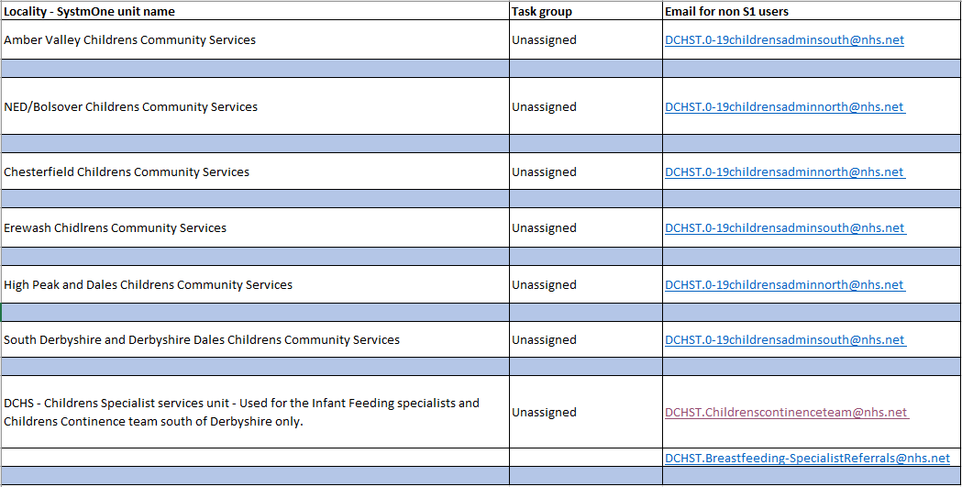

DCHS Continued……

DCHS Continued…..
DCHS School Nursing

URGENT REPLY REQUIRED: Please contact via the Single Point of Access 01246 515100. This service is available between 9am and 4.30pm, Monday – Friday (excluding bank holidays). This is the contact point for the service and admin will initially respond to your query, if you need to speak to a clinician in SPA there may be a delay as they manage call backs via a waiting list.

ROUTINE REPLY
Routine replies can be made to
- the contact as detailed in the Task ^{(S1)} / Email ^{(EMIS)}, however there may be a delay in a response
- If it is not appropriate to reply to the individual who sent the Task ^{(S1)} / Email ^{(EMIS)}, contact the team named in the contact details in the SBARC task template ('C' for Contact Details), or via the DCHS team task boxes on the appropriate DCHS TPP unit, e.g., Belper HV team.
- Tasking should always be done via a patient record for it to be stored within the patient record for audit purposes.

S1: A new task should be opened, and the contents of the original task should be copied and pasted into the new task addressed to the Generic S1 Task box of the appropriate DCHS team. See table below detailing School Nurse Bases, email addresses and task groups

NEW REFERRALS: FOR NEW REFERRALS into the service, GP practices must use the referral form via the service website School Nursing referral form :: Derbyshire Family Health Service www.derbyshirefamilyhealthservice.nhs.uk/contact-us/school-nursing-referral-form

To share information or request an update always task/email the school nurse teams If routine, contact the School Nursing team by task– See table below for localities and email addresses, all tasks should be sent unassigned into the correct S1 unit. Admin will allocate these to the correct clinical team upon receipt.

Children Services have the following S1 units. Information shown below.

DCHS Health, Wellbeing & Inclusion Services
Diabetes Education Team - New Referral Requests:
- Referrals to Diabetes Education from S1 practices should be by e-referral through Pathfinder. Go to Pathfinder, Specialities Section, Diabetes, Diabetes Structured Education
- Referrals to Diabetes Education from EMIS practices should be by email to: dchst.diabetesT2education@nhs.net

****This is the end for DCHS Divisions****

Urgent definition: Any deteriorating clinical situation. This applies to tasks expecting a response by end of the next working day Monday to Friday (for weekends or bank holidays please aim to receive a response prior to the practice closing), this excludes as follows: emergency medical attention immediately required (999) / any prescription which should go through the normal channels.
2 This task type will need to be setup by the practice. Support and advice can be provided by NECS helpdesk Clinical Systems Team, Email: necs.servicedesk@nhs.net / Telephone Number: 0300 5550340 (available Monday to Friday)

