


December 2022 bulletin of Team Up Derbyshire,
incorporating updates from the Ageing Well Steering Group



This latest bulletin from Team Up Derbyshire brings together news from the programme and updates from the Ageing Well Steering Group. Team Up Derbyshire is an ambitious programme in Derby and Derbyshire that is creating one team across health and social care who see all the people in a neighbourhood who are currently unable to leave home without support. For more information, visit the Joined Up Care Derbyshire website.

Home visiting services set to expand across Derbyshire

Funding has been approved for two new home visiting services in the county – in North Hardwick and Bolsover and in the High Peak.

An established process is in place for approving such plans from the local primary care networks (PCNs) – with review panels finding both plans to be of a good standard while being able to feedback suggestions for improvement. The plans have previously been subject to review by finance representatives and the Team Up Learning in Practice (TULiP) group.

Moves to boost falls recovery services

As highlighted previously, enhanced falls recovery service pilots have been planned for Derby City and Chesterfield.

The NHS England ‘going further for winter’ letter outlined a need to have the service responding to level 1 and 2 falls across all of the Integrated Care System footprint. Existing falls recovery providers are not able to deliver this enhanced offer in every part of the county, so modelling has been carried out to determine how other established healthcare providers may be able to support.

Discussions are currently taking place with the Integrated Place Executive with a view to try to secure provision from a number of providers to support an expanded service.

Contracting arrangements

Following coverage of the proposed Integrated Care Board and Team Up contracting arrangements in November’s bulletin, a letter is being sent this month to GP practices, primary care networks, Place leads and Team Up leads with an update on proposals and relevant contracting documentation. The letter is being supported by a briefing and a follow-up webinar to help with any questions and actions about the process.

Stable trend for ED attendance

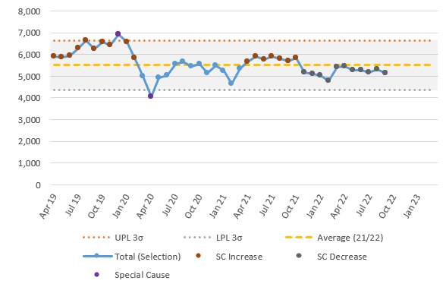

Figure 1: Emergency Department (ED) attendance for all >65 year excluding ambulatory care, minor injuries and walk-in centres. Source: AW Dashboard v2.0

Development of the information dashboard for Ageing Well continues. Worth noting this month is that attendance at the Emergency Department (ED) for people aged over 65-years remains stable. Also worth noting is that there is a sustained special cause decrease in those over 65 years attending ED. This is specifically seen in the age group 65-74 years. Activity for people aged over 75 years remains stable.

Workforce update – careers events

Of the many developments taking place in the Joined Up Care Derbyshire workforce, the Ageing Well Steering Group has been updated on a series of system-wide apprenticeship and career events planned for next year. Staged by Joined Up Careers Derbyshire, the events are aimed at anyone seeking a job or future career in health and social care. The events (two in January and two in March) provide an opportunity for those interested to meet with NHS employers and social care providers, find out about job roles and vacancies, and join ‘how-to’ workshops including application and interview skills. For further information for anyone wanting to attend or for employers wanting to book a stand, please email: ddicb.joinedupcareers@nhs.net or visit the Joined Up Careers website.

Further information

For further information about Team Up Derbyshire and Ageing Well, please contact:

- Helen Baxter, Deputy Ageing Well Programme Manager, helen.baxter@nhs.net
- Team Up Derbyshire website and Team Up Derbyshire blog

