

March 2023 bulletin of Team Up Derbyshire,
incorporating updates from the Ageing Well Steering Group



This latest bulletin from Team Up Derbyshire brings together news from the programme and updates from the Ageing Well Steering Group. Team Up Derbyshire is an ambitious programme in Derby and Derbyshire that is creating one team across health and social care who see all the people in a neighbourhood who are currently unable to leave home without support. For more information, visit the Joined Up Care Derbyshire website.

Update on falls recovery

Team Up Derbyshire is currently updating the Integrated Care System (ICS) executive team on the latest developments with falls recovery across Derby and Derbyshire. A key aspect of this is the proposal to establish the first year of implementing the Team Up enhanced community falls response model and then progress into year two. The provision of local authority assistive technology services (for example, pendant alarms) and falls recovery varies across the city and county. Team Up is proposing that future delivery of such services remains locally determined which may result in the provider being any one or a combination of NHS, local authority and independent sector in each area.

Progressing plans for home visiting services in the Dales

Team Up programme support is currently being offered to two primary care networks (PCNs) as they progress their proposals for providing home visiting services. The South Dales PCN plan has been endorsed by the Team Up Learning in Practice (TULiP) group although the Derbyshire Dales PCN plan requires further work before it can be formally approved.

Previously, in November 2022, Derbyshire Dales PCN had submitted an implementation plan for their home visiting service which was approved. Stakeholders have since agreed to split the delivery of the home visiting service into two, one service for Derbyshire Dales PCN (north and central) and another for South Dales PCN. This has meant that both PCNs have had to submit new plans for the implementation of their respective home visiting services.

Proposals to retain data curator role

Team Up is currently looking to extend the data curator role within the team which was initially set up as a 12-month fixed term post. The role is held by Liz Lawrence who has been helping transform the way that Team Up and the Ageing Well programme uses data and applies business intelligence. A review of the GP practice home visiting survey data, highlighted at the end of this bulletin as a special case study, is an example of how such insight is being utilised to better understand and inform the Team Up approach.

Two major health and care recruitment events in March

Joined Up Careers Derbyshire, with partner organisations, have staged two recruitment events this month to highlight apprenticeship opportunities and other entry-level roles. The events were on Tuesday 14 March at Chesterfield College and on Wednesday 15 March at Derby College Roundhouse. Both events showcased how students and the wider public can gain roles in the health and social care sector.

Further information

For further information about Team Up Derbyshire and Ageing Well, please contact:

- Helen Baxter, Deputy Ageing Well Programme Manager, helen.baxter@nhs.net
- Team Up Derbyshire website and Team Up Derbyshire blog

Special focus - the home visiting survey distributed to GP practices

What you said and what we are going to do…

We would like to thank all those who completed the GP Team Up home visiting service survey. We have taken time to review the results and want to let you know how we are responding to what you told us. It was great to hear all the positive comments from those that have felt the benefit of the home visiting services.

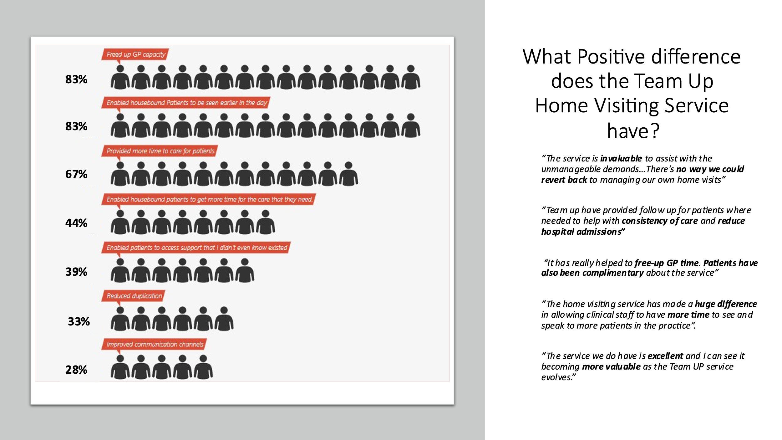

We know there are several services which are still developing and some soon to start - and we wanted to know areas you felt needed further development.

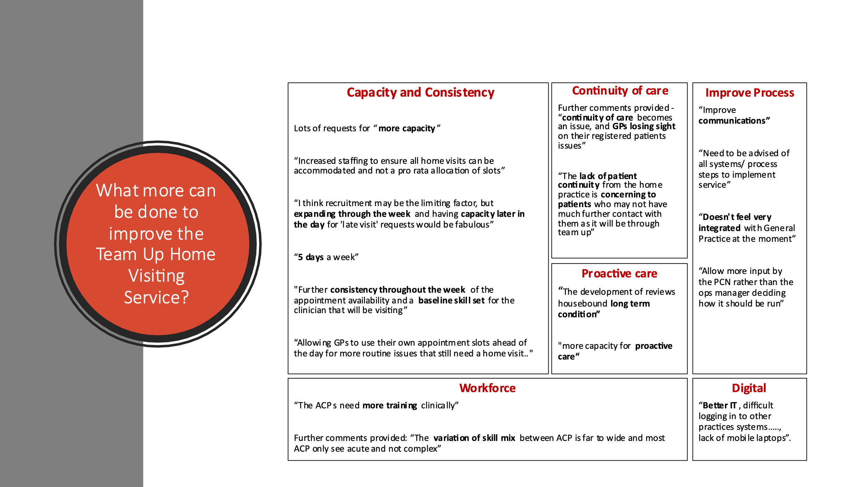

So, what are we doing about what you told us?

You said… | We are doing… | We will do...
A need for more capacity | By April 2023, we will have all but one primary care network (PCN) with a home visiting service running. All PCNs have plans in place to begin the service. We are collecting information to understand the number of visits provided and the days of the week each service operates.  In response to recognising the large trainee workforce, we have secured system funding to provide a programme of dedicated, direct educational support and supervision to all PCN advanced clinical practitioner (ACP) trainees. | Our expectation is by end July 2023 that all PCNs will have a home visiting service operating five days a week, 8am to 6.30pm.
Importance of continuity of care | Continuity in patient care and relational continuity in teams both contribute to quality care and require careful thought. The need for consistent GP leadership in home visiting teams is intended to bring relational continuity to support the wider team including ACPs and trainee ACPs.  Asking PCNs to lead home visiting services is intended to make sure GP practices and their home visiting service are closely aligned, and communication links are strong. There is no requirement to hand over home visiting to the service where individual continuity is particularly important (in end-of-life care for example). | Once home visiting services are fully established, continuity will improve for people who are permanently unable to leave their home without support as this is a relatively small population served by a dedicated multi-disciplinary team.  Your comments have made us consider deeper what we mean by continuity of care and how we work together with practices and home visiting teams to support continuity, with the resources available. We are going to consult with teams at the Team Up Learning in Practice (TULiP) forum.
Minimum skill level and training for ACPs | We know that recruitment is a challenge for all PCNs, which impacts on capacity and means that a lot of trainee posts have been generated as a result. Our Team Up workforce lead is supporting PCNs with these challenges.  We have looked at workforce information for home visiting services to understand their current workforce and training and support needs.  In recognition of the large trainee workforce, we secured system funding to provide a programme of dedicated, direct educational support and supervision to all PCN ACP trainees. This was carried out in conjunction with Health Education Derbyshire.  The training hub can support development of the primary care workforce through designing bespoke, quality-assured CPD and specialist training programmes, and helping with workforce planning. | You will be aware of the national core capability framework for ACPs in General Practice. We also have a locally developed pilot for a Community Urgent Care framework. The e-portfolio is available now. National teams are taking an interest in this work which may be rolled out further. You can access this now for your teams.  More broadly, we are linking in with our system’s groups looking at ACP development, at what we have and what we need with our wider workforce across the system, and how we provide a consistent level of training - so we Team Up.
More capacity for proactive care | The priority is getting home visiting services to pick up the on-day demand. Many PCNs have found the need to provide a wrap-around proactive response. We are understanding how that varies across the PCNs and sharing learning. | This links with the challenges of capacity and being able to recruit sufficient workforce.  The vision of Team Up has always been to provide the care for people who need care in their own home - that has not changed and we continue to work with a wide range of services to help integrate and Team Up the response.  You may be aware of wider work happening with Local Access Points and how we collaborate with partners, so that when someone accesses care in a crisis it triggers a proactive follow-on response.
Improve integration with General Practice | Each home visiting service is working closely with its general practices to ensure pathway development and learning. If you feel that this is not happening, please contact your operational lead. | We recognise the importance of this and will explore further with teams at the Team Up Learning in Practice (TULiP) forum.
Improve communication | As above, the home visiting service should be working closely with general practices. | We recognise that Team Up has changed, evolved and grown significantly over the last two years. It has gone from ‘we are going to do’ to ‘we are doing and continue to grow’. We recognise we will need to do more engagement and share progress later this year.
Improve digital systems | We know that to help teams work together better requires having the digital infrastructure in place. This is easier said than done. We are working with the Integrated Care Board (ICB) digital team, our commissioning support units (AGEM and NECS), partners across the home visiting services, Derbyshire Community Health Services and our local authority partners to develop solutions that work. | Priorities are infrastructure (Wi-Fi, PCs, laptops, phones), electronic records (SystmOne or EMIS units for PCNs) and diagnostics requesting and reporting (ICE).

We are grateful for everyone who has provided us with such valuable feedback. It has helped us to better understand what is important to you. To continue the conversation, please contact Liz Lawrence, Team Up data curator, email: liz.lawrence3@nhs.net

We will repeat the questionnaire in the autumn. In the meantime, please come to one of our engagement events in the spring to hear more and contribute further to Team Up.

