

October 2022 bulletin of Team Up Derbyshire,
incorporating updates from the Ageing Well Steering Group



This latest bulletin from Team Up Derbyshire brings together news from the programme and updates from the Ageing Well Steering Group. Team Up Derbyshire is an ambitious programme in Derby and Derbyshire that is creating one team across health and social care who see all the people in a neighbourhood who are currently unable to leave home without support. For more information, visit the Joined Up Care Derbyshire website.

Revised dementia strategy 2022-25

Following the impact of the Covid-19 pandemic, a revised dementia strategy 2022-25 has been produced and presented to the Team Up/Ageing Well Steering Group, setting out priority areas for the next three years. These are: (1) to recover all services to previous levels and embed learning and blended approaches; (2) mitigate impact of last two years and prioritise people missed or lost to service, and prioritise carers; and (3) initiate work planned in 2020-25 strategy and in response to demand created in the wake of the pandemic. Themes, from prevention to end-of-life care, are set out below:

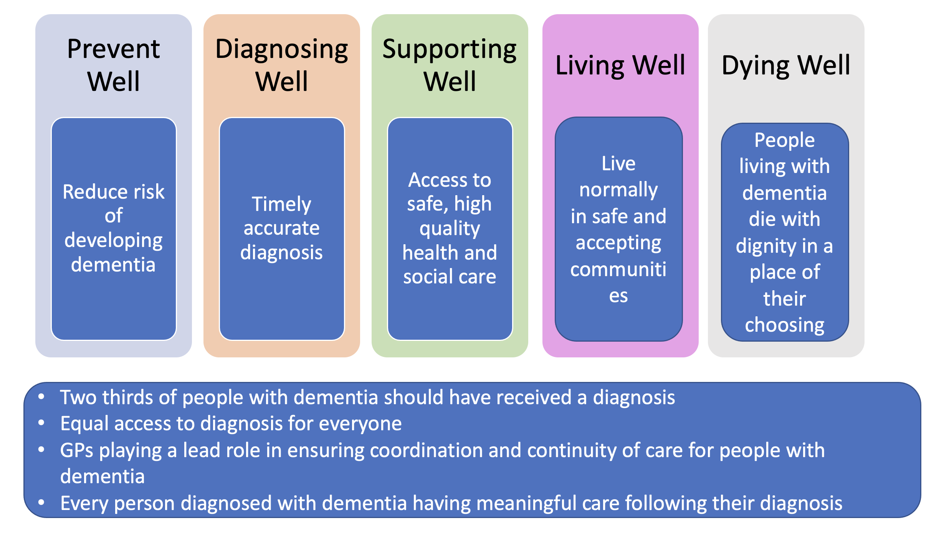
Supporting services through the winter

Team Up and Ageing Well representatives have been closely involved in the development of winter planning for the Joined Up Care Derbyshire system. More primary care networks (PCNs) are establishing home visiting services, helping build up resilience in primary care, and access is being increased to enhanced falls recovery services. A number of initiatives are being progressed within the enhanced health in care homes workstream, such as working with the Patient Safety Collaborative on helping identify deterioration in patients. In addition, the urgent community response service is exploring options to deliver on an increased scale and scope, much of which will require additional capacity and resource. The Team Up transformation programme is recording many notable achievements and is ready to flex support for services throughout the winter.

Making the most of metrics

Team Up is increasingly improving its understanding of data trends in areas such as hospital admissions and ambulance conveyances for people living with frailty. For all people aged over-65, there is variation between the PCNs in attendance at the emergency department. Overall attendances are down across both Derby and Derbyshire PCNs compared to the previous 12 months with further analysis underway to determine how more challenged parts of the county could be supported further. Variation also exists among PCNs for people aged over-65 requiring an urgent ambulance. All PCNs are showing reduced activity compared to the previous 12 months and Derby City has a larger reduction than the county.

Future proposals for home visiting services

Team Up has been reviewing progress with developing the home visiting service across Derby and Derbyshire, with services now running across 75% of the integrated care system footprint and other areas having plans in place. By year two, the service specification sets out an expectation for a service to be extended to 8am-8pm, Monday to Friday. For the time being, however, the Ageing Well Steering Group has recommended that Team Up should focus on making the existing in-hours services more robust before seeking to expand operating hours. This approach has since been supported by the Integrated Place Executive.

New clinical lead for care homes

Dr Jane Youde has been confirmed as the new Team Up Derbyshire clinical lead for the enhanced health in care homes programme, with her key priority areas including further developing the falls prevention work and supporting the large digitalisation agenda for care homes. She replaces Professor Adam Gordon of University Hospitals of Derby and Burton for whose many contributions Team Up is very grateful.

Dr Youde has been a Consultant in Medicine for the Elderly in Derby since 1999 with a special interest in falls. Some of the roles she has had locally, regionally and nationally include Clinical Director for Rehabilitation and Elderly Care Business Unit, clinical lead for the Falls and Bone Health QIPP work stream for East Midlands SHA and a collaborator in the writing of the BGS Fit for Frailty guidance. She has also been the co-chair of the British Geriatric Society Falls Section. Dr Youde was involved in the National Falls Audit in different roles for more than 10 years and involved in many of the quality improvement projects associated with this. Subsequently, she was Clinical Director for Audit and Accreditation for the Royal College of Physicians (RCP) and oversaw the delivery and development of the three national audit programmes and the five accreditation programmes hosted by the RCP. We are delighted to welcome Dr Youde to her new role.

Team Up in Derby pushing new boundaries

The launch of Team Up Derbyshire had a head-start in Derby City with many services already up and running which closely aligned to the aims of the national Ageing Well programme. In Derby City, there has been a home visiting service in place since 2018, (as opposed to the usual GP practice-delivered home visiting service) supported by a culture of strong partnership working between health and social care. In the latest Team Up Derbyshire blog post, we throw the spotlight on the Team Up work that is happening across the city, involving the five PCNs in Derby that have come together as one. Case studies are provided on both the home visiting and complex needs services.

Further information

For further information about Team Up Derbyshire and Ageing Well, please contact:

- Helen Baxter, Deputy Ageing Well Programme Manager, helen.baxter@nhs.net
- Team Up Derbyshire website and Team Up Derbyshire blog

