**Suppliers wanting to connect on Tradeshift with NHS Derby and Derbyshire ICB**

* **Tradeshift account creation and set-up** please go to <https://go.tradeshift.com/register> See the attached user manual to assist you. We recommend that for Business Name you use the name that NHS SBS uses for you. This can be found on the top left of any Remittance Advice we have sent you.

Primary email addresses can be changed by contacting Tradeshift directly see the links below to do this:

**If logged into an account :** [**https://go.tradeshift.com/#/Tradeshift.Support/?domain=nhssbs&path=requests/new**](https://gbr01.safelinks.protection.outlook.com/?url=https%3A%2F%2Fprotect-eu.mimecast.com%2Fs%2FIxLICPQnkHKq3pfzjvAR%3Fdomain%3Dgo.tradeshift.com&data=05%7C02%7Cddicb.communications%40nhs.net%7C6d09f8d208104987c32008dd4132a254%7C37c354b285b047f5b22207b48d774ee3%7C0%7C0%7C638738407899289692%7CUnknown%7CTWFpbGZsb3d8eyJFbXB0eU1hcGkiOnRydWUsIlYiOiIwLjAuMDAwMCIsIlAiOiJXaW4zMiIsIkFOIjoiTWFpbCIsIldUIjoyfQ%3D%3D%7C0%7C%7C%7C&sdata=jFaUL%2FMTxnv02vgXjJvj9xo56a51oiiVAoZohjAMTHA%3D&reserved=0)  
  
**If not logged into a Tradeshift account:** [**https://nhssbs.support.tradeshift.com/requests/new**](https://gbr01.safelinks.protection.outlook.com/?url=https%3A%2F%2Fprotect-eu.mimecast.com%2Fs%2F6HalCQ7olhkmo0HPQ5HK%3Fdomain%3Dnhssbs.support.tradeshift.com&data=05%7C02%7Cddicb.communications%40nhs.net%7C6d09f8d208104987c32008dd4132a254%7C37c354b285b047f5b22207b48d774ee3%7C0%7C0%7C638738407899303446%7CUnknown%7CTWFpbGZsb3d8eyJFbXB0eU1hcGkiOnRydWUsIlYiOiIwLjAuMDAwMCIsIlAiOiJXaW4zMiIsIkFOIjoiTWFpbCIsIldUIjoyfQ%3D%3D%7C0%7C%7C%7C&sdata=DaDfu7PMT0k4OUhDcn3HJ52QjNs68F3WTdnNc%2FN6O5Q%3D&reserved=0)

* **Once you are registered on Tradeshift**, you need to connect to the NHS organisation you wish to send invoices to. To do this, go to ‘Network’ on the left and go the ‘TRADESHIFT NETWORK’ tab and search for the organisation you want to connect to. Please note that all NHS SBS client organisations will show on Tradeshift in capital letters with their three-digit organisation code in brackets e.g. NHS DERBY AND DERBYSHIRE ICB (QJ2), with the NHS Shared Business Services logo. Click on the ‘Connect’ button to connect your account to the NHS organisation selected. Network. See the user manual for further details and images of this process.

After you click on ‘Connect’ the Status will change to ‘Invitation Sent.’ You will normally receive an email within two working days to confirm that you are connected.

* When your account has been connected you will receive an email asking you to ‘Accept’ the connection. There is a link on the email that will take you through to your ‘Tasks’ where you can accept the connection, or you can go into your ‘Network’ – ‘TRADESHIFT NETWORK’ and click on the ‘Accept’ button. Once you have accepted the connection the NHS organisation will then show in ‘My Network’ See the user guide for more information.
* Once you are connected on Tradeshift, the best way of sending invoices is to go into your ‘Network’ and on to the ‘My network’ tab, click on the three dots to the right of the organisation name then, ‘Create document’ – ‘Invoice.’ See the user guide for more information.
* See below the meanings of invoices in Tradeshift

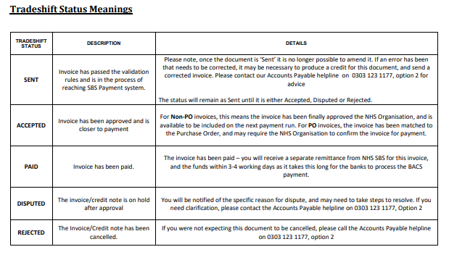

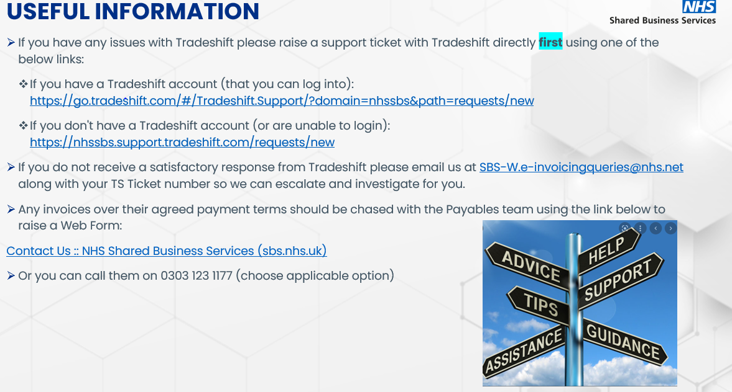

**Note – NHS Derby and Derbyshire ICB do not have access to the Tradeshift platform to assist in registering/connection queries. All queries must be directed to Tradeshift or SBS as above.**

**Further guidance below -**



