# Travel Assessment Report - Brailsford and Hulland

# Background:

Brailsford Surgery is proposing the potential closure of a branch, the Hulland Ward Medical Centre. Henmore Health has taken over management of Brailsford and Hulland Medical Practice and has improved access to healthcare by allowing patients to use services at both Brailsford Medical Practice and The Surgery Ashbourne.

The purpose of this report is to review and present current transport arrangements from Hulland Ward Medical Centre to Brailsford Medical Practice and The Surgery Ashbourne. It is recognised that transport considerations are important in understanding the impact of service changes to those delivering, accessing and visitors to the site. This report will outline the transport links available to the sites and will sit alongside considerations to onsite car parking.

This sites to be considered are:

Hulland Ward Medical Centre

The Surgery Ashbourne

Brailsford Medical Centre

## Hulland Ward Medical Centre:

Hulland Ward Medical Centre is situated just off the A517. The medical centre has been temporary closed for 3 years due to not adequately providing modern healthcare services and failing to meet CQC standards. Patients have been redirected to Brailsford Medical Practice or The Surgery Ashbourne so transport links to these 2 surgeries are important to explore.

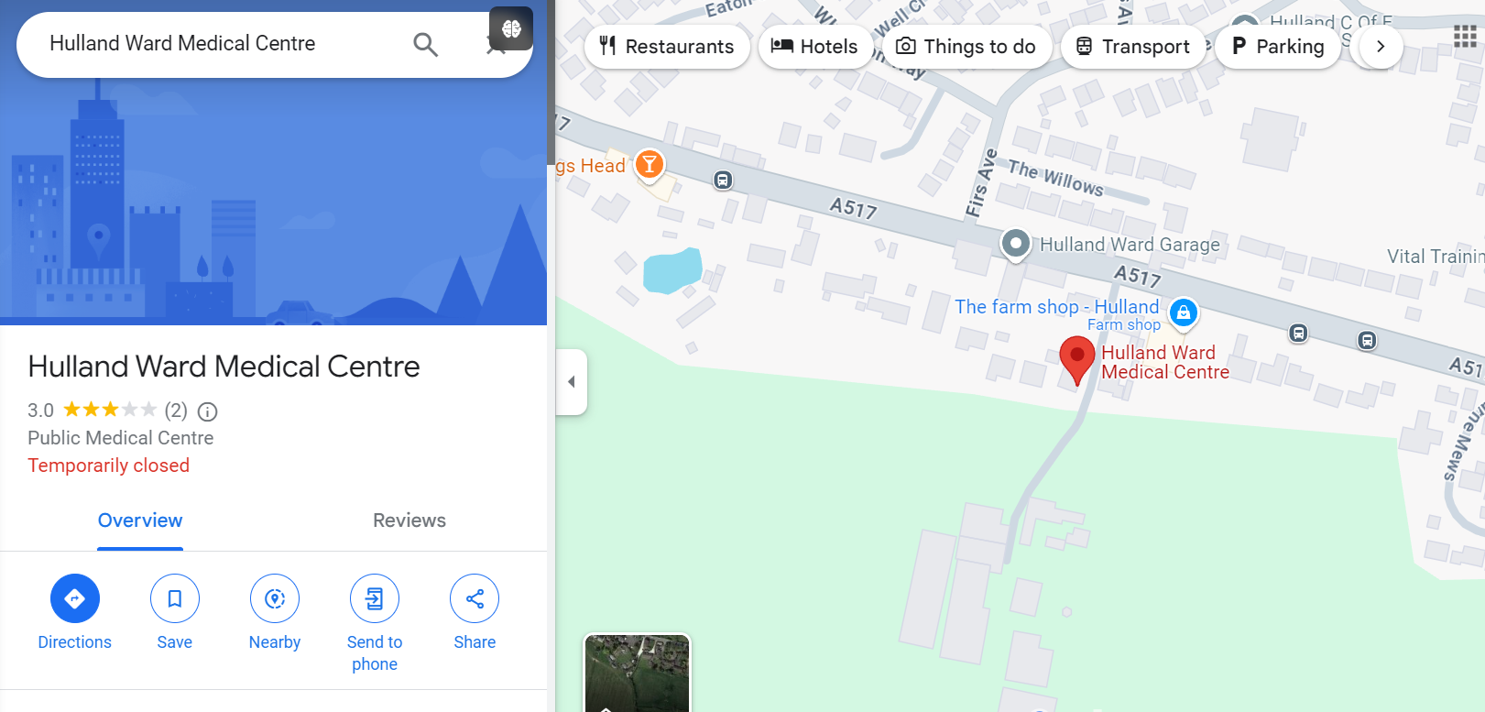

### Assess to the site:

Address: Main Road, Hulland Ward, Ashbourne DE6 3EA

## The Surgery Ashbourne:

The Surgery Ashbourne is approximately 5.5 miles away from Hulland Ward. It is situated next to Ashbourne Leisure Centre. It is proposed that patients can access services at The Surgery Ashbourne.

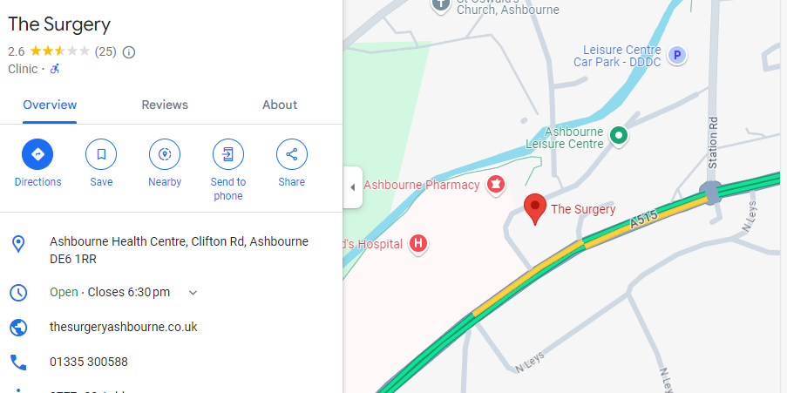

### Assess to the site:

**Address:** The Surgery Ashbourne Health Centre, Clifton Rd, Ashbourne DE6 1RR

**Car:** This is typically a 11-minute drive from Hulland Ward Medical Centre via A517.

**Parking:** The site roughly has around 20 parking spaces including a disable parking area. Located in front of the surgery's entrance.

**Bus:** There are 2 direct bus routes available to the public and is approximately a 22 min journey door to door.

**113 Ashbourne –** Bus stop is a 2-minute walk away from Hulland Ward and drops public off approximately 5-minute walk away from The Surgery Ashbourne. This bus runs every 2 hours all day.

**114 Ashbourne -** Bus stop is a 2-minute walk away from Hulland Ward and drops public off approximately 5-minute walk away from The Surgery Ashbourne. This bus is a morning service that runs every 2 hours until 12:33pm.

Bus times workout so there is either a 113 or 114 bus running every houruntil 1:33pm.

**Community Transport:**

Ashbourne Community Transport provides door to door demand responsive transport for groups, elderly, disabled and rurally isolated people within the Derbyshire Dales, South Derbyshire, High Peak and East Staffordshire. The Practices are aware of this service and encourage the use of it. Public will be required to book in advance and the service will advise what time they will be picked up as well as costings.

## Brailsford Medical Centre:

Brailsford Medical Centre is approximately 5.8 miles away from Hulland Ward. It is situated just off the A52. It is proposed that patients can also access services at Brailsford Medical Centre after the closure of the Hulland Ward Medical Centre.

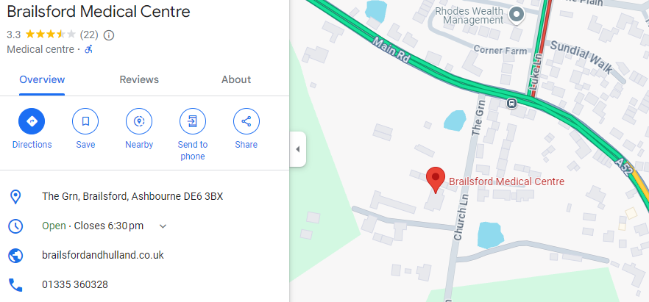

### Access to the site:

**Address:** The Green, Ashbourne DE6 3BX

**Car:** A car journey from Hulland Ward to Brildford Medical Centre would typically be 10-minute journey via Smith-Hall Lane.

**Parking:** This site has approximately 15 parking spaces as well as ample street parking around the site.

**Bus:** There are no direct bus routes to this sight from Hulland Ward, however members of the public would be able to arrive at Brailsford Medical Centre after 2 bus rides. The door-to-door journey from Hulland Ward to Brailsford Medical Centre would take approximately 40- 65 minutes.

**113 or 114 Ashbourne > Red Arrow** – Bus stop is a 2-minute walk away from Hulland Ward. Patients would need ride the 113 or 114 bus till the last stop and the board the Red Arrow bus which will stop at a bus stop two minutes away from Brailsford Medical Centre. The frequency of the 113 and 114 has been stated above. The Red Arrow Bus runs hourly.

**Community Transport:**

Ashbourne Community Transport provides door to door demand responsive transport for groups, elderly, disabled and rurally isolated people within the Derbyshire Dales, South Derbyshire, High Peak and East Staffordshire. The Practices are aware of this service and encourage the use of it. Public will be required to book in advance and the service will advise what time they will be picked up as well as costings.

## Conclusion:

As Hulland ward has been closed for several years, the local public will likely have provisions in place to attend appointment at either Brailsford medical Centre or The Surgery Ashbourne. Based on this assessment there're are various travel options available for local population to travel to these Practices that fall within a reasonable travel timeframe.