# [***Click here to see a Travel Assessment Report Example***](https://joinedupcarederbyshire.co.uk/download/travel-assessment-report-example/)

# Travel Assessment Report – Names of practices / surgeries

# Background

XXXXX is proposing XXXXX 1 to 3 lines outlining the proposal XXXXX

The purpose of this report is to review and present current transport arrangements from XXXXXX to XXXXXX. It is recognised that transport considerations are important in understanding the impact of service changes to those delivering, accessing and visitors to the site. This report will outline the transport links available to the sites and will sit alongside considerations to any onsite car parking.

This sites to be considered are:

LIST SITES STARTING WITH SITE TO BE CLOSED THEN ALTERNATIVE SITES

## NAME OF SITE 1: (THE ONE TO BE CLOSED)

NAME OF SITE 1 is situated XXXXX. DETAIL ABOUT SITE. Patients have been redirected to XXXX Practice or XXXX Surgery so transport links to these 2 surgeries are important to explore.

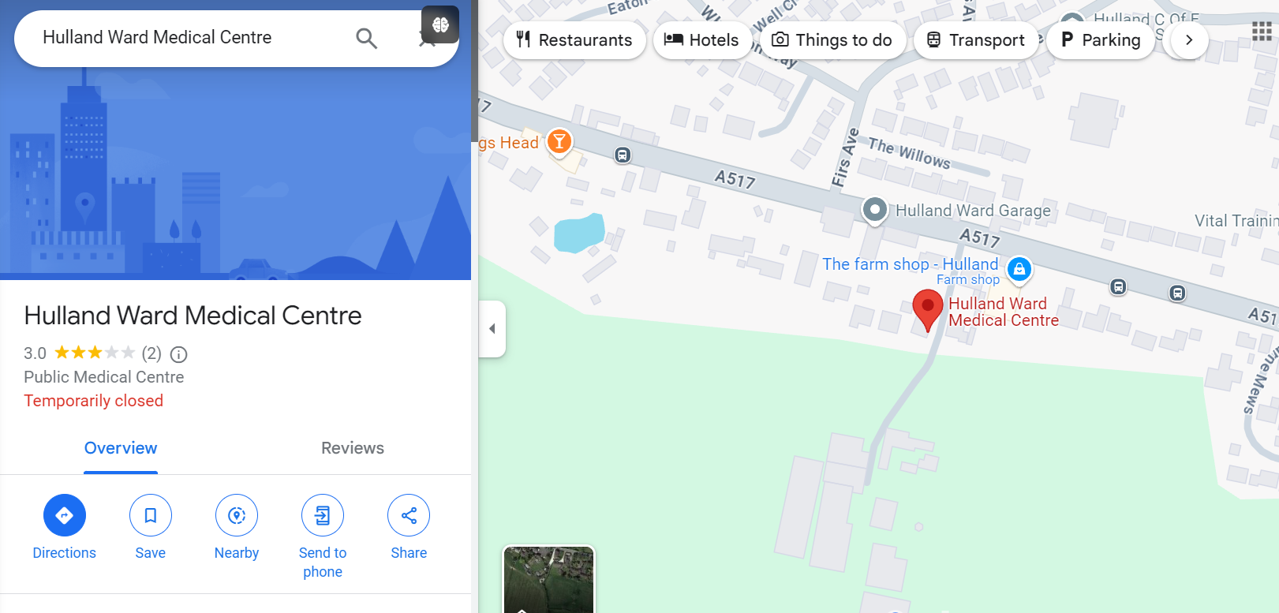

Screenshot from Google Maps showing site location

### Access to the site:

Address: XXXX Road, XXXXX, XXXXX POST CODE

## NAME OF SITE 2: (FIRST ALTERNATIVE SITE)

NAME OF SITE 2 is approximately X.X miles away from NAME OF SITE 1. It is situated XXXXX. It is proposed that patients can access services at NAME OF SITE 2.

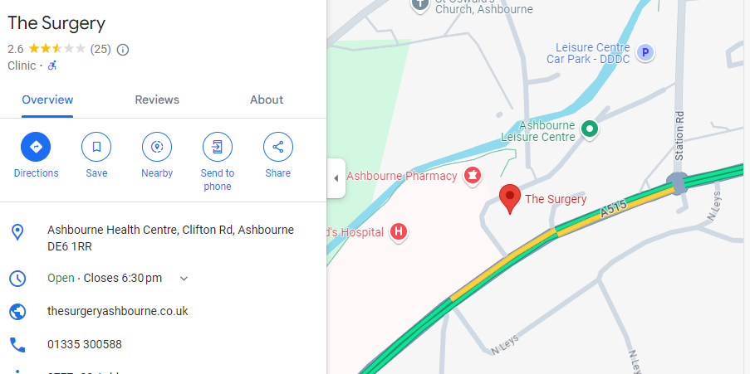

Screenshot from Google Maps showing site location

### Access to the site:

**Address:** XXXX Road, XXXXX, XXXXX POST CODE

**Walk:** The walk from NAME OF SITE 1 is approximately X.X miles, which typically will take XX minutes. ROUTE DESCRIPTION, POSSIBLY A SCREENSHOT FROM GOOGLE MAPS.

**Car:** This is typically an XX minute drive from NAME OF SITE 1 via road name or number.

**Parking –** The site has around XX parking spaces including a disabled parking area located XXXX.

**Bus:** There are X direct bus routes available to the public and it is approximately a XX minute journey door to door.

**BUS NUMBER / NAME –** Bus stop is a X-minute walk away from NAME OF SITE 1 and drops public off approximately X-minute walk away from NAME OF SITE 2. This bus runs every X hours / minutes all day / until X time.

**BUS NUMBER / NAME –** Bus stop is a X-minute walk away from NAME OF SITE 1 and drops public off approximately X-minute walk away from NAME OF SITE 2. This bus runs every X hours / minutes all day / until X time.

**Community Transport:** NAME OF Community Transport provides door to door demand responsive transport for groups, elderly, disabled and rurally isolated people within the geographical area. The Practices are aware of this service and encourage the use of it. Public will be required to book in advance and the service will advise what time they will be picked up as well as costings.

## NAME OF SITE 3: (SECOND ALTERNATIVE SITE)

SITE is approximately X.X miles away from NAME OF SITE 1. It is situated XXXXX. It is proposed that patients can access services at NAME OF SITE 3.

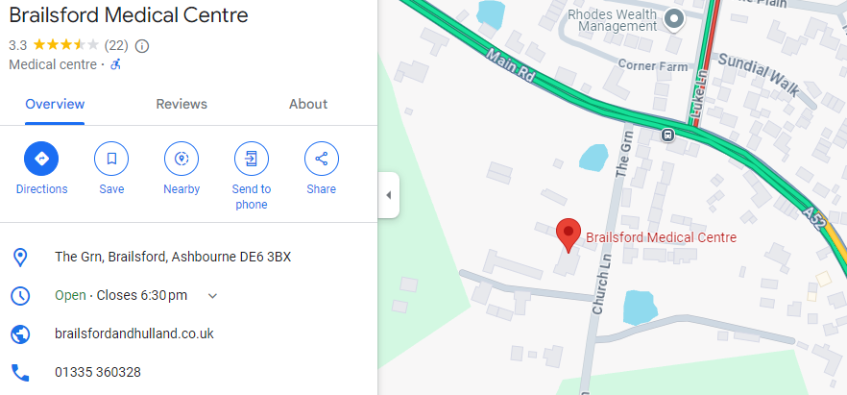

Screenshot from Google Maps showing site location

### Access to the site:

**Address:** XXXX Road, XXXXX, XXXXX POST CODE

**Walk:** The walk from NAME OF SITE 1 is approximately X.X miles, which typically will take XX minutes. ROUTE DESCRIPTION, POSSIBLY A SCREENSHOT FROM GOOGLE MAPS.

**Car:** This is typically an XX minute drive from NAME OF SITE 1 via road name or number.

**Parking –** The site has around XX parking spaces including a disabled parking area located XXXX.

**Bus:** There are X direct bus routes available to the public and it is approximately a XX minute journey door to door.

**BUS NUMBER / NAME –** Bus stop is a X-minute walk away from NAME OF SITE 1 and drops public off approximately X-minute walk away from NAME OF SITE 3. This bus runs every X hours / minutes all day / until X time.

**BUS NUMBER / NAME –** Bus stop is a X-minute walk away from NAME OF SITE 1 and drops public off approximately X-minute walk away from NAME OF SITE 3. This bus runs every X hours / minutes all day / until X time.

**Community Transport:** NAME OF Community Transport provides door to door demand responsive transport for groups, elderly, disabled and rurally isolated people within the geographical area. The Practices are aware of this service and encourage the use of it. Public will be required to book in advance and the service will advise what time they will be picked up as well as costings.

# Conclusion

Based on this assessment there are various travel options available for the local population who previously accessed NAME OF SITE 1 to travel to the alternative sites of NAME OF SITE 3 and NAME OF SITE 3, and they can be travelled to within a reasonable timeframe.