Travel Assessment Report - The Park Medical Practice, Oakwood to The Park Medical Practice, Borrowash and The Park Medical Practice, Chaddesden

Background:
The Park Medical Practice is proposing the potential closure of their branch surgery in Oakwood. This is because the site is no longer considered fit for purpose, and is unable to be upgraded or modified as required. There are also safety concerns for staff and patients because of gangs of youths in that specific location. It should also be noted that there is another practice's surgery, Lister House at Oakwood, just 150m away.
Park Medical Practice plans to develop the Borrowash branch surgery, providing an extra 6 clinical rooms for the increase in patients attending the site. Therefore, patients who currently attend the Oakwood surgery will have the option to either register with Lister House at Oakwood or another practice, or to remain with The Park Medical Practice and attend their main site in Chaddesden or the branch surgery in Borrowash.
The purpose of this report is to review and present current transport arrangements from the Oakwood surgery to the main site in Chaddesden or the branch surgery in Borrowash. It is recognised that transport considerations are important in understanding the impact of service changes to those delivering, accessing and visiting the site. This report will outline the transport links available to the sites and will sit alongside considerations to onsite car parking.
This sites to be considered are:
The Park Medical Practice, Oakwood
The Park Medical Practice, Chaddesden
The Park Medical Practice, Borrowash

The Park Medical Practice, Oakwood:
The Park Medical Practice, Oakwood is situated between the shopping centre and Oakwood Park, just off Oakwood Drive. It is proposed that this site be closed, and patients will have the option to go to The Park Medical Practice, Chaddesden or The Park Medical Practice, Borrowash, so transport links to these two surgeries are important to explore.
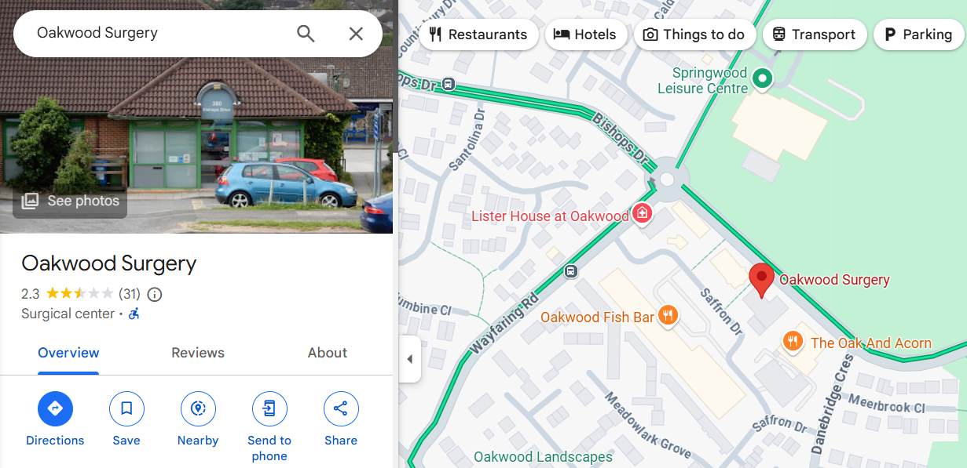

Access to the site:
Address: 380 Bishops Drive, Oakwood, Derby DE21 2DF

The Park Medical Practice, Chaddesden:
The Park Medical Practice, Chaddesden is approximately 0.9 miles away from The Park Medical Practice, Oakwood. It is situated off the traffic island on Chaddesden Lane, near to Chaddesden Hall and St Mary's Church. It is proposed that patients can access services at The Park Medical Practice, Chaddesden.
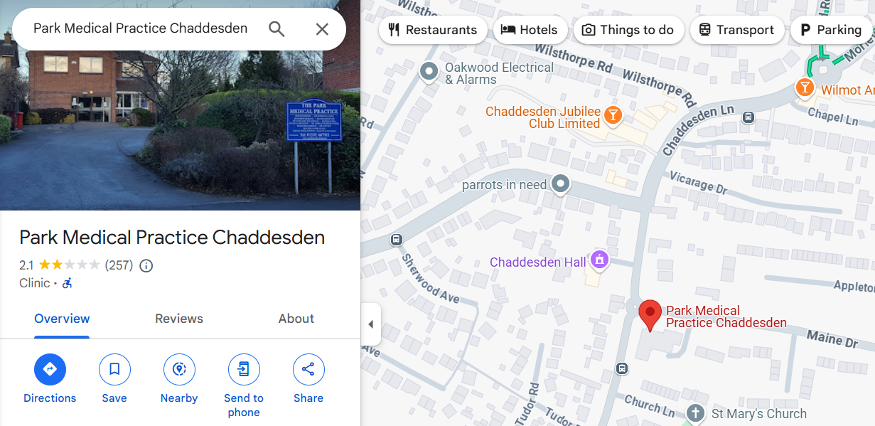

Access to the site:
Address: Maine Drive Chaddesden, Derby DE21 6LA
Walk: The walk to The Park Medical Practice, Chaddesden is approximately 0.9 miles, which typically will take 22 minutes. The walk is along Saffron Drive, cutting through to Wood Road, and along to Chaddesden Lane.
Car: This is typically a 3-minute drive from The Park Medical Practice, Oakwood via Wayfaring Road, Wood Road, and onto Chaddesden Lane.
Parking – The site has 22 parking spaces, as well as on-street parking. There is a reserved car parking space for the disabled at the side of the building.
Bus: There is no direct bus route. The bus stop for the number 26 or 22 bus is a 2-minute walk away from The Park Medical Practice, Oakwood on Wayfaring Road and takes you to Derby Bus Station, then take the number 20 bus which drops off on Rainier Drive, approximately 1 minute walk away from The Park Medical Practice, Chaddesden. These buses run every 30 minutes.

The Park Medical Practice, Borrowash:
The Park Medical Practice, Borrowash is approximately 3.6 miles away from The Park Medical Practice, Oakwood. It is situated on Derby Road, between the shops in Borrowash centre and St Hugh's Catholic Church. It is proposed that patients can access services The Park Medical Practice, Borrowash.
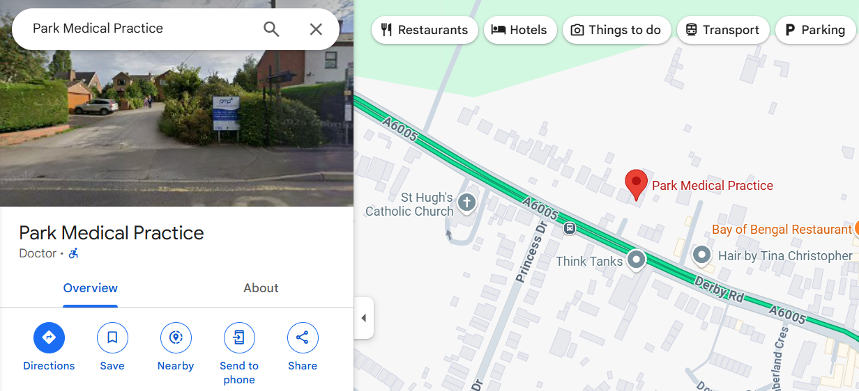

Access to the site:
Address: 46 Derby Road, Borrowash, Derby DE72 3HA
Walk: The walk from The Park Medical Practice, Oakwood is approximately 3.9 miles, which typically will take 1 hour 25 minutes. The route takes you along Wood Road, Chaddesden Brook, Valley Road, Lime Grove, Derby Road then along the Derby Road (A6005).
Car: This is typically an 8-minute drive from The Park Medical Practice, Oakwood via Acorn Way and the Derby Road (A6005).
Parking – The site has 24 parking spaces, as well as on-street parking. There are two designated disabled bays, with one located directly next to the door.
Bus: There is no direct bus route. The bus stop for the number 26 or 22 bus is a 2-minute walk away from The Park Medical Practice, Oakwood on Wayfaring Road and takes you to Derby Bus Station, then take the number i4 indigo bus which drops off on Derby Road, just outside The Park Medical Practice, Oakwood. These buses run every 30 minutes.

Conclusion
Based on this assessment there are various travel options available for the local population who previously accessed The Park Medical Practice, Oakwood to travel to the alternative sites of The Park Medical Practice, Chaddesden and The Park Medical Practice, Borrowash. They can be travelled to within a reasonable timeframe, especially The Park Medical Practice, Chaddesden.

