**Understanding and managing temporary service change**

Examples of temporary service change

Weston General Hospital closure of A&E overnight i.e., reduction from 24/7 to 14/7 service, opening from 08.00 – 20.00

* Triggered on safety grounds due to specialist staffing levels, reinforced by CQC findings
* Temporary change instigated in July 2017; permanent changes made October 2019.

Transfer of acute stroke services from Medway Hospital to Maidstone Hospital and Darent Valley Hospital

* Triggered on safety grounds due to specialist staffing levels at Medway Hospital
* Temporary change instigated in July 2020, ahead of final outcome of wider consultation for permanent change in November 2021.

**Legal Duties**

* NHS bodies may decide to change a service without allowing time for consultation with the relevant local authority, where they are genuinely satisfied there is an imminent risk to the safety or welfare of patients or staff.
* This is the only specific exception to the statutory duties for urgent changes. Other duties will still apply and should be addressed appropriately.
* It is not acceptable for NHS bodies to delay addressing fragile service situations that might lead to such a risk occurring until they are so urgent that an imminent risk exists.
* Where services need to be closed or suspended at short notice, NHS bodies and their partners should act in accordance with the [Joint Working Protocol](https://www.england.nhs.uk/wp-content/uploads/2018/02/joint-working-protocol-december-2017.pdf).
* In such a case the NHS must notify the local authority (HOSC) immediately of the decision taken and the reason why no consultation has taken place.
* A local authority may still choose to refer the matter to the Secretary of State for Health and Social Care for review if it is considered that the reasons given for not carrying out a consultation are inadequate.

**Even with a clear exemption on the duty to consult…**

* NHS bodies should ensure they keep good records of the factors that have been considered in making these decisions, and where and how and through which governance route the decision was made – the decision can still be legally challenged or referred.
* There should be a clear, planned, and comprehensive communications and engagement approach with key stakeholders, including staff, system partners, regulators, local politicians, Healthwatch, service users, etc. Regardless of whether there is consultation or not.
* Even with a short lead time there will be some planning time before implementation of the change. This should be explored to assess the extent to which some patient, public, staff and stakeholder engagement activity could take place to gather insights to feed into the planning and to ensure stakeholders understand the rationale for urgent change.
* There should be consideration around whether, how and when any emergency/temporary change would revert, and the data and information required to support decision-making. Or how any temporary change could be made permanent after immediate operational changes and issues have been addressed. Temporary changes can only be made permanent by following the full process set out in law.

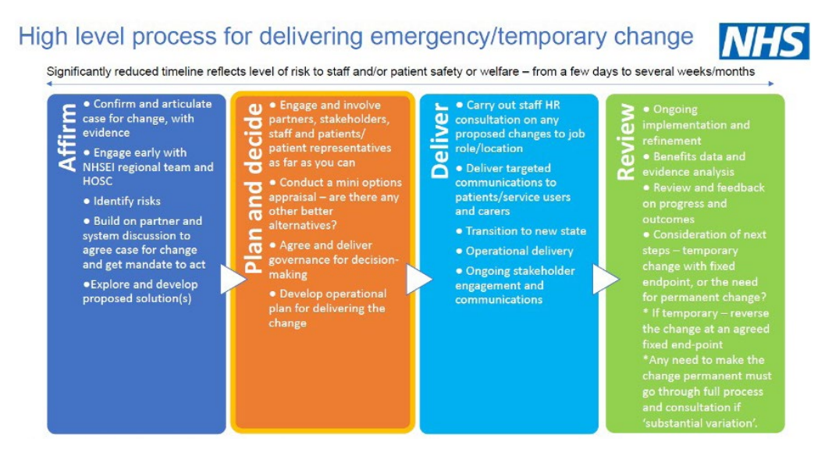

**Making a temporary change permanent - or not**

Once you have addressed the immediate/urgent patient and/or staff safety and welfare issues through a temporary or emergency change, you must then review your service position and either:

* Agree a fixed end point for the temporary change and plan to move services back, or
* Go through the recognised process for making a permanent change in discussion with HOSC and NHSE. This may warrant a pre-consultation business case and consultation, or you may agree with HOSC that a proportionate and appropriate process is focussed on information provision and an engagement period with the affected patient and community groups and stakeholders. Outline proposals and a clear sense of the extent of the impact of the change will guide your discussion with HOSC and NHSE and inform the process you should follow.
* Engage and communicate well with system partners, staff, patients, public and stakeholders at every stage, whichever path you take.

**Record keeping process**

* To help govern the risks involved in this process from legal challenge, the Engagement Team require a [Patient and Public Involvement Form](https://joinedupcarederbyshire.co.uk/download/patient-and-public-involvement-assessment-and-planning-form/). Guidance on the completion of this form can be found [here](https://joinedupcarederbyshire.co.uk/download/patient-and-public-involvement-ppi-form-guidance/).
* The Engagement Team will need to be assured that correct governance process have been followed, and will support with consultation with HOSC and the ICB Public Partnership Committee.

**Internal process**

* Assess if there are grounds for a genuine temporary service change, i.e. **imminent risk to the safety or welfare of patients or staff.**
* Check the change has been appropriately governed, this will include the QEIA panel.
* Log the details of the temporary change on the PPI log under 'Temporary Service Change' tab, and ensure the usual sign off process.
* Note predicted length of temporary service change.
* Inform HOSC either via a briefing, agenda item, or PPI log entry, depending on how substantial the change is.