Training Session Template – Supporting Managers

Introduction

- Introduce the Responding to Disclosures of Suicidality - Suicide Conversation Tool Process for Supporting Managers Guidance, and associated documents/resources.
- Encourage managers to access/review the Suicide Conversation Tool – Guidance for the Team document & associated training.

Frequently Asked Questions
- What happens when you call 999?
- Call 999 if there is an urgent risk to life. When calling 999, you will be asked which service you need and you should request the police.
- You will be connected to the local police force (e.g., Derbyshire Constabulary). The call handler will ask for your name, location, and contact number, as well as the reason for your call. They will guide you through the conversation, asking direct questions to ensure a quick and appropriate response.
- They will try to gather details about the person you are concerned about, such as their name, location, date of birth, address, phone number, physical description, and what they have disclosed to our service.
- It’s okay if you don’t have all the details—the more information you can provide, the easier it will be for the police to respond.
- The call handler will also ask for your job role and may give you a reference number for your records.

- What do I need to say when I call 999?
Let the call handler know you are calling due to an urgent risk to self or risk to life. Explain what the person has disclosed to our service.
The call handler will then guide the conversation and ask for any additional information they need.

- Why do we call the police and not the ambulance?
The police are the best service to contact when someone may be at risk of harming themselves or others.
If a person is unwell or vulnerable, the police have special powers under the Mental Health Act to enter a property without a warrant and take them to a safe place for a mental health assessment.
If they think that an ambulance is needed, they will request one.

- What if the person hangs up during an urgent situation?
If someone seems distressed during a call and the call ends, we should try to contact them again to confirm their location.
Once their location is confirmed or reasonably suspected, further contact is not needed. If necessary, the police may try to reach them by phone to continue the conversation.
- Do we have to tell the person we are contacting the emergency services?
No. If we feel a person is at immediate risk of harming themselves or others, we do not need to tell them if the police have been contacted, especially if this could cause more distress or escalate the situation. However, some people may feel reassured knowing that urgent support has been arranged for them.

- How do we find out what happens to the person once we have informed the GP/MH professionals/police?
We might not always know what support the person has received from their GP or mental health teams, but we can ask for an update to see if they’re well enough to get help from our service.
We can also ask the police for an update, but we may not get one.
By following the process, we can be sure that we’ve taken the right steps to help the person and that they’ll get the support they need.
- How can I support team members who have handled a call about suicidal thoughts?
Having a conversation about suicidal thoughts can be really difficult. Some team members may have personal experiences related to suicide, so it’s important they get the support they need from colleagues or managers if they’ve had a difficult call.
It’s encouraged for team members to take a break, like going for a walk, reaching out to a friend or family member, or stepping away from their desk for a while.
Talking about suicide can feel like a huge responsibility, and it’s normal for team members to wonder, ‘Did I do enough?’ or ‘Did I say the right thing?’. It’s helpful to reassure them that they followed the right steps and gave the person the support they needed.
In all cases, team members should have an immediate ‘check-in’ and a follow-up check-in (usually within 3 days) from their manager after a difficult call. If needed, they should also be signposted to staff wellbeing services or other emotional support services, like those listed in the Mental Health Support Signposting Information Template.
- What if I am not sure which ‘Level of Concern’ the person is at?

Every case will be different, and it can be hard to predict the outcome or follow guidance perfectly. We learn from each experience.

You have time to think about your actions during levels 1-3 of the Concern and Action Chart. It's okay to take a moment to decide on the next steps and ask a colleague for support.

If you're still unsure, you can call the Derbyshire Mental Health Support Line at 0800 028 0077 (or NHS 111, select option 2) for advice from a trained mental health professional. It's always better to take action than to do nothing.

At level 4 (immediate risk to life), the police control room will guide you and tell you what information is needed. It can help to have a pen and paper to write down the details you'll need to provide.

- What if the person does not want us to discuss their thoughts of suicide with their GP/mental health professional?
Information Governance should not stop us from sharing information with the right professionals. While it’s important to ask for consent from the person before sharing information, we have a legal duty to share it if we believe someone is at risk of harming themselves or others.

- How do I stay calm when talking to someone about thoughts of suicide/or responding as a manager?
Feeling anxious is a normal reaction when we’re worried about someone’s safety. You might feel anxious during or after dealing with the situation, but this feeling will pass. It can help to use relaxation techniques, like the 5-4-3-2-1 grounding technique or box breathing (see below), if you feel your anxiety rising.

5,4,3,2,1 Technique
With the 5-4-3-2-1 technique, focus on your surroundings using all five senses. Try to notice small details that you might usually overlook, like distant sounds or the texture of an everyday object.
 | What are 5 things you can see? E.g. look for small details such as a pattern on the ceiling, the colour of the wall paper, what can you see out the window, is there an object you never noticed before?
 | What are 4 things you can feel? Notice the sensation of clothing on your body, the heat of sun on your skin, the texture of the chair you are sitting in, the weight of a mug in your hand.
 | What are 3 things you can hear? Pay special attention to the sounds your mind has tuned out, e.g. distant traffic, a ticking clock, the sound of the rain on the roof.
 | What are 2 things you can smell? Try to notice smells in the air around you e.g. the scent of your clothing, mowed grass outside, air freshener.
 | What is 1 thing you can taste? Are there any tastes in your mouth, could you sip a drink/put a mint in your mouth.

Box Breathing
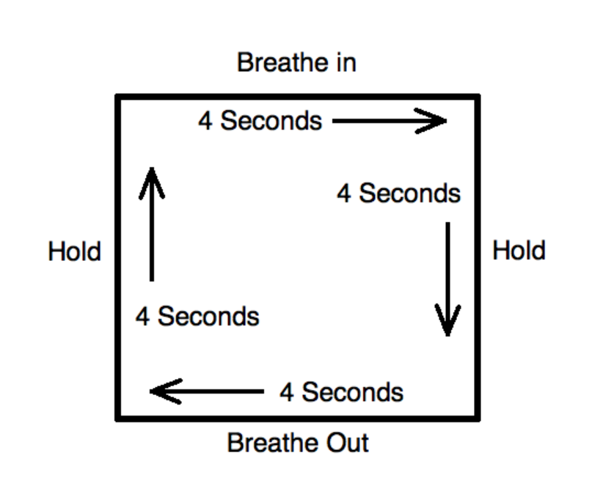

Important reminders
- We can do what’s within our control to connect the person with the services responsible for managing risks to themselves. However, there are pressures on the mental health system that we can’t control. If you follow the steps and don’t get the expected response, let your manager know.
- It's important to record the conversation with the person accurately and quickly. Team members and managers should take the time they need to write their notes. All actions taken should also be logged to show what support the person has received, including the names and contact numbers of professionals we’ve spoken to.
- Working with people who trust us enough to share such difficult thoughts can be emotionally challenging. Team members and managers who respond to these disclosures should know that support is available to them through internal and external wellbeing services.

